# STILL

## Building – Shade Facing

'~/Desktop/experiments/2_23_2014/still/lightClassificationbuilfingblocking.txt',#5.

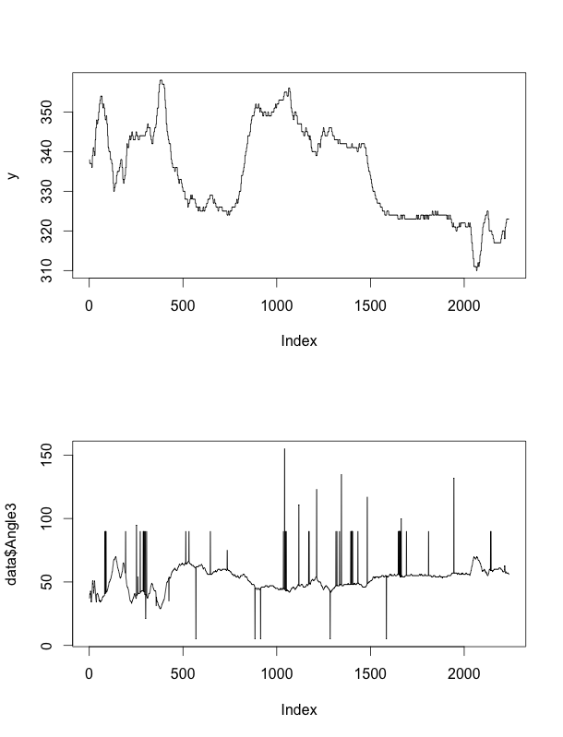

Min: 310.0000

Max: 358.0000

Mean: 334.5351

Median: 334.0000

Var: 132.4696

## Tree – Shade Away Facing

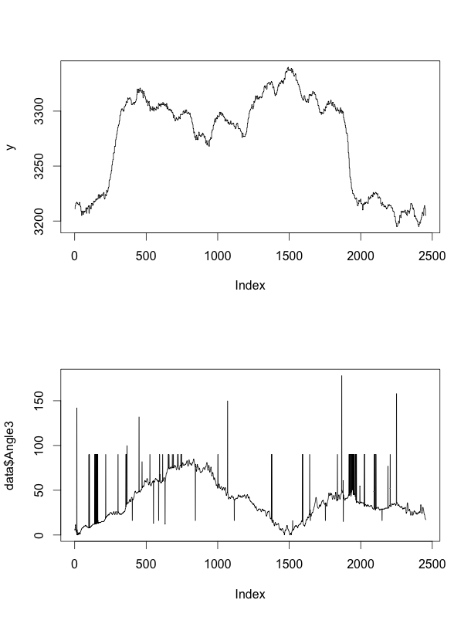 '~/Desktop/experiments/2_23_2014/still/lightClassificationshadeawayfacing.txt', Min: 3195.000

Max: 3340.000

Mean: 3273.904

Median: 3293.000

Var: 1870.010

## Tree – Shade Facing

'~/Desktop/experiments/2_23_2014/still/lightClassificationshadefacingsun.txt',

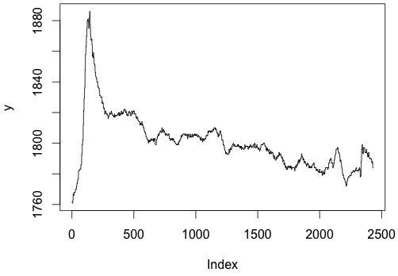

Min: 1761.0000

Max: 1886.0000

Mean: 1801.0415

Median: 1799.0000

Var: 345.3468

## Sun

'~/Desktop/experiments/2_23_2014/still/lightClassificationstillawayfacing.txt',

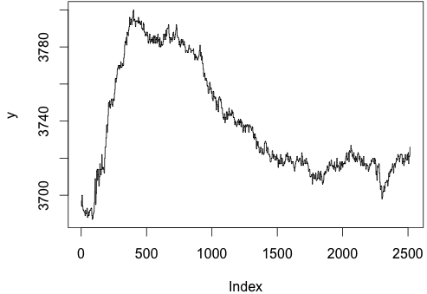

Min: 3687.0000

Max: 3800.0000

Mean: 3738. 743

Median: 3723.0000

Var: 908.937

'~/Desktop/experiments/2_23_2014/still/lightClassificationstillfacing.txt',

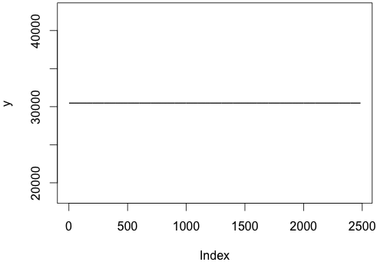 Mean: 30476.4

Var: 0

# TILT

## Building – Shade Facing

'~/Desktop/experiments/2_23_2014/tilt/lightClassificationbuildingshadesunfacing.txt'

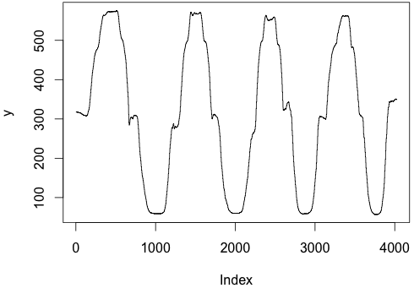Min: 57.0000

Max: 576.0000

Mean: 313.8531

Median: 310.0000

Var: 32525.9921

## Building – Shade Away Facing

'~/Desktop/experiments/2_23_2014/tilt/lightClassificationbuilfingshadeawayfacing.txt',

Min: 51.0000

Max: 578.0000

Mean: 277.9134

Median: 235.0000

Var: 37912.6872

## Tree

'~/Desktop/experiments/2_23_2014/tilt/lightClassificationshadetreeawayfacing.txt',

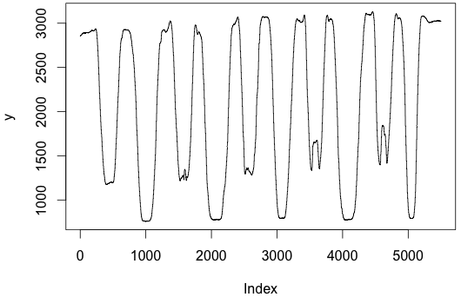

Min: 758.0000

Max: 3131.0000

Mean: 2064.817

Median: 2152.0000

Var: 733114.695

'~/Desktop/experiments/2_23_2014/tilt/lightClassificationshadetreefacingsun.txt',

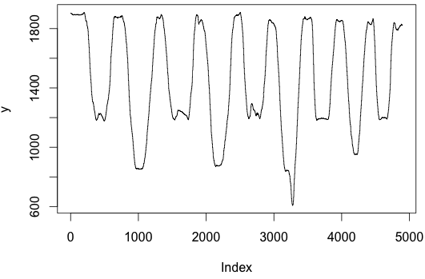Min: 608.000

Max: 1910.0000

Mean: 1446.849

Median: 1399.000

Var: 125285.015

## Sun

'~/Desktop/experiments/2_23_2014/tilt/lightClassificationtiltawayfacing.txt',

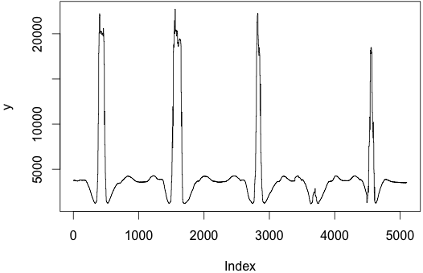Min: 1188.000

Max: 22720.014

Mean: 4359.879

Median: 3690.000

Var: 15658901.993

'~/Desktop/experiments/2_23_2014/tilt/lightClassificationtiltfacing.txt'

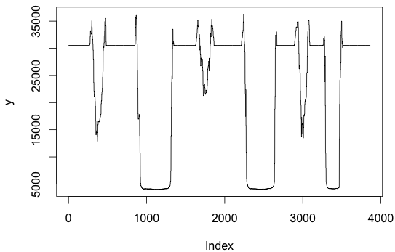Min: 3999.000

Max: 36301.72

Mean: 23230.59

Median: 3690.000

Var: 127662427.04

# SHAKE

## Building

'~/Desktop/experiments/2_23_2014/shake/lightClassificationshadebuildingawayfacing.txt'

Building – shade away

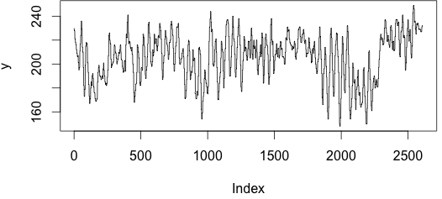

Min: 148.000

Max: 249

Mean: 205.4218

Median: 208.000

Var: 380.2792

'~/Desktop/experiments/2_23_2014/shake/lightClassificationshadebuildingfacingdun.txt'

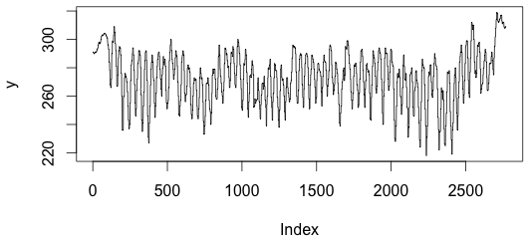Min: 218.000

Max: 319

Mean: 273.1047

Median: 274.000

Var: 337.0793

'~/Desktop/experiments/2_23_2014/shake/lightClassificationshadetreefacingsun.txt',

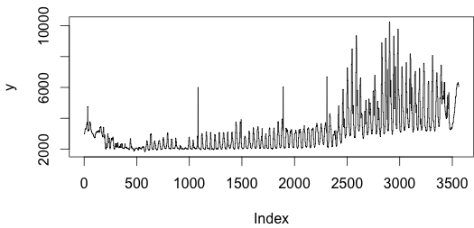

Min: 1827.000

Max: 10243.449

Mean: 3161.707

Median: 2808.000

Var: 1955330.361

'~/Desktop/experiments/2_23_2014/shake/lightClassificationsunawayfacing.txt',

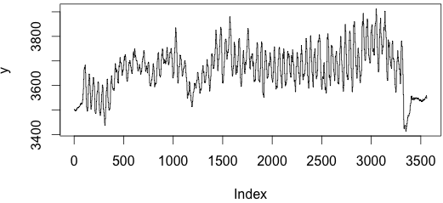Min: 3414.000

Max: 3912.449

Mean: 3662.862

Median: 3666.000

Var: 7816.192

'~/Desktop/experiments/2_23_2014/shake/lightClassificationsunfacing.txt',

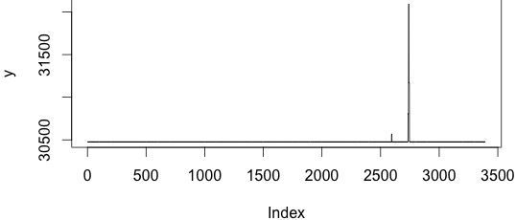 Min: 30476.398

Max: 32089.955

Mean: 30479.109

Median: 30476.398

Var: 2993.531

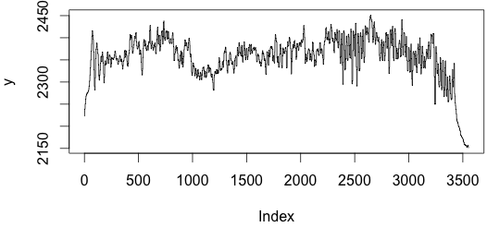'~/Desktop/experiments/2_23_2014/shake/lightClassificationtreeshadeawayfacing.txt'

Min: 2151.000

Max: 2451

Mean: 2356.411

Median: 2364.000

Var: 2316.946