1. Basic plot of the beer data

#plot beer data

plot(beer1$Production,type="l")

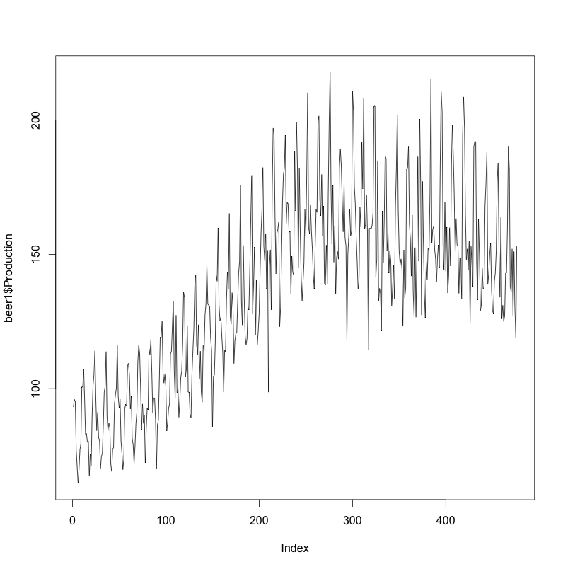

shows a seasonal (oscillating) pattern, where the data does not seem “stationary”

**NOTE: A *stationary* time series is one whose statistical properties such as mean, variance, autocorrelation, etc. are all constant over time. Another reason for trying to stationarize a time series is to be able to obtain meaningful sample statistics such as means, variances, and correlations with other variables. Such statistics are useful as descriptors of future behavior *only* if the series is stationary. For example, if the series is consistently increasing over time, the sample mean and variance will grow with the size of the sample, and they will always underestimate the mean and variance in future periods. And if the mean and variance of a series are not well-defined, then neither are its correlations with other variables. For this reason you should be cautious about trying to extrapolate *regression* models fitted to nonstationary data.**

**If the series has a stable long-run trend and tends to revert to the trend line following a disturbance, it may be possible to stationarize it by de-trending (e.g., by fitting a trend line and subtracting it out prior to fitting a model, or else by including the time index as an independent variable in a regression or ARIMA model), perhaps in conjunction with logging or deflating.   Such a series is said to be trend-stationary. If the mean, variance, and autocorrelations of the original series are not constant in time, even after detrending, perhaps the statistics of the *changes* in the series between periods or between seasons *will* be constant. 🡨- ¿(ie: What this example tutorial is all about)**

2. A plot of the Auto-correlation and Partial Auto-Correlation of the data shows

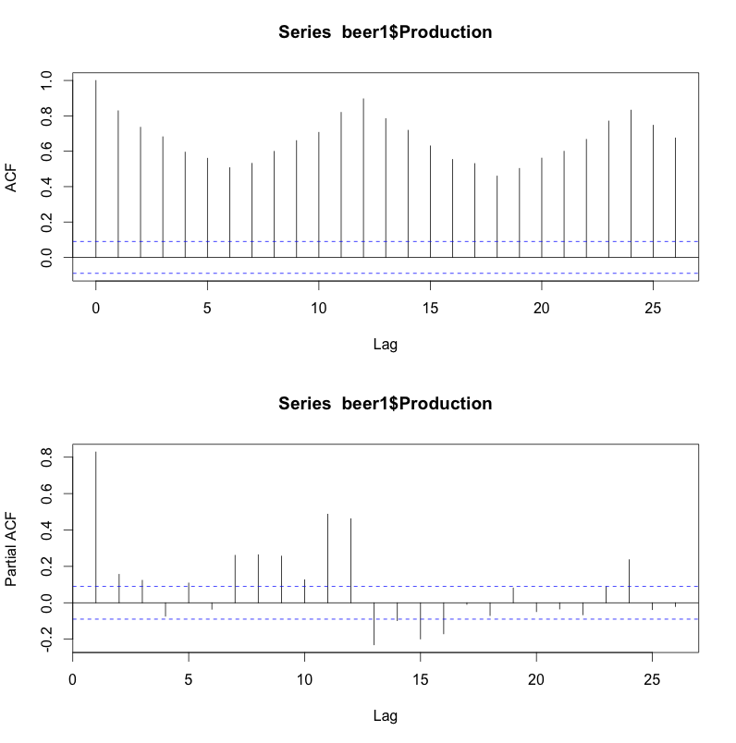

The ACF doesn’t tail off quickly so it’s not stationary (ie: you should see an inverse log function where the amplification lines should converge at 0. We also cannot see a trend, therefore, we will try differencing to see if there’s a seasonal periodic pattern.

**Autocorreation Notes**

**Positive Autocorrelation:** The Error around the mean regression line tends to be positive if previous error was positive & negative if previous was 🡪 More common (eg: GDP Growth)

**Negative Autocorrelation:** The Error around mean regression line flip-flops between +/- by nature. < -- (eg: excess inventory supply)

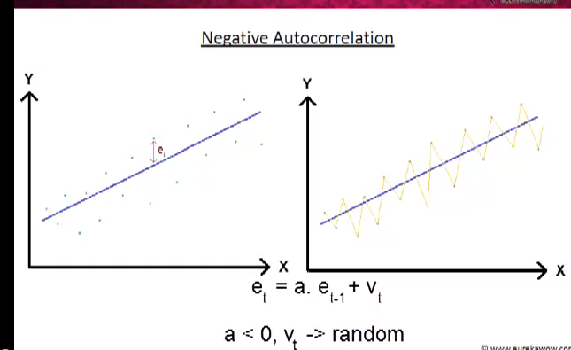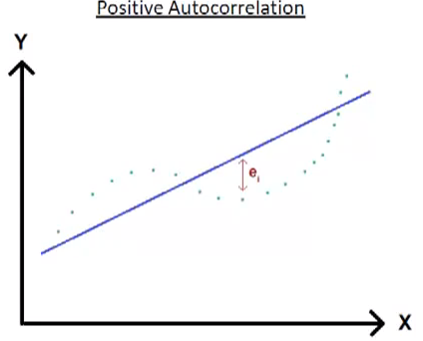

3. Since data does not look stationary, given the ACF (ie: variance does not quickly tail off), trying to find seasonal periodicity by differencing (as explained above). The plot for this data looks as such:

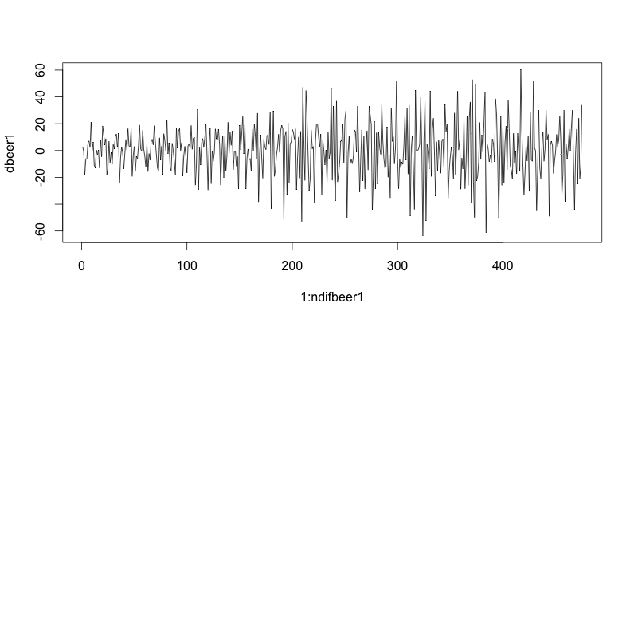

One sees the plot has no trend, however it seems to have larger oscillating spikes, which means there’s non constant variance (heterodicity), therefore you may want to take the log of the data to tail it.

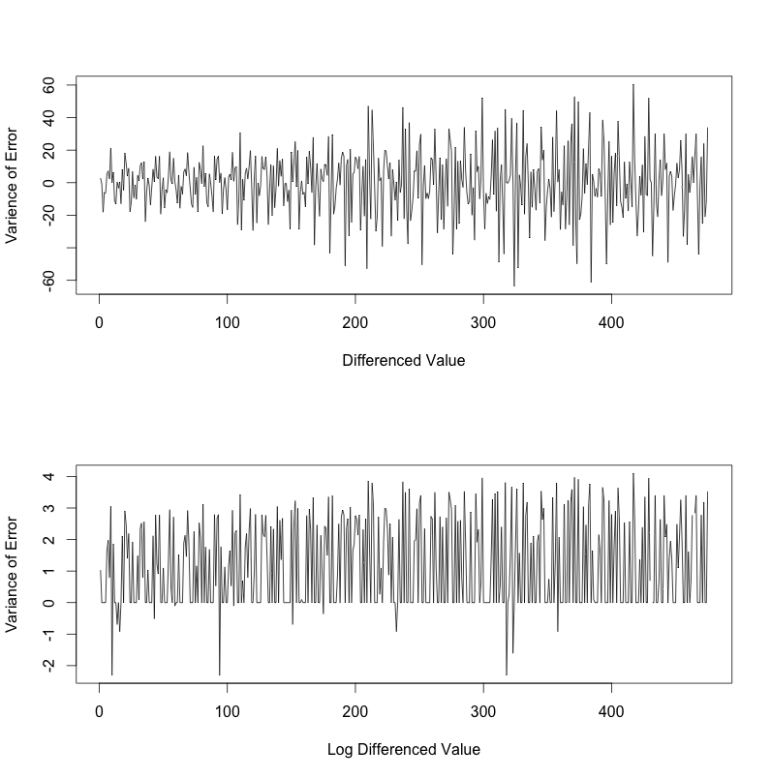Graphing the differences, the 1st plot shows that there’s non constant variance…Therefore, a weighting function can be applied to attempt to obtain constant variance. I applied the Log(difference). Now the oscillating spikes seem consistent therefore non constant.

4. Now that we see some constant variance in the data, we plot the ACF and PACF of the difference values

par(mfrow=c(2,1))

acf(dbeer1)

pacf(dbeer1)

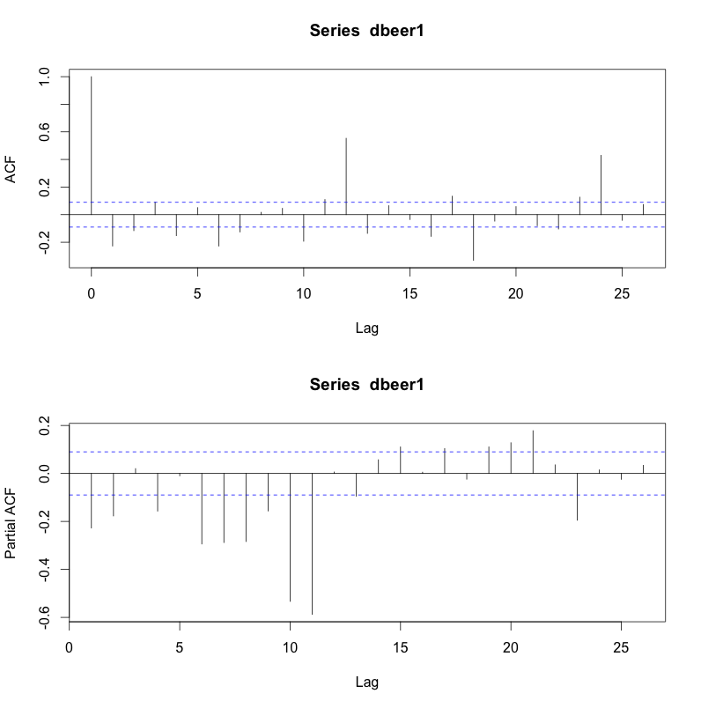We see:

1. There is periodicity every 12 ticks
2. The variance of the error tails off quickly

Therefore, we can assume a time window of 12 (ie: months) for data to be sufficient in ARIMA model, and incorporate this into a seasonal model.

5. Now we run the ARIMA model

arima(x = beer1$Production, order = c(1, 1, 0), seasonal = list(order = c(1,

1, 0), period = 12, include.mean = FALSE))

Coefficients:

ar1 sar1

Coefficients🡪 -0.4993 -0.3611

s.e. 0.0403 0.0431

sigma^2 estimated as 218.7: log likelihood = -1905.25, aic = 3816.51

We now see that the standard error (s.e.) is < .05 therefore it’s statistically significant to assume there is a trend.

Alternative option for Normalizing

<http://www.youtube.com/watch?v=npO0prBMs4E>