Trading Soybean Futures on Weather Stress
Gator Quant Hacks 2026, Systematic Trading Track. Main repo: github.com/jrile018/QuantHacks. Soybean engine: github.com/KushagraKatiyar06/soybeans_strategy

Core concept
Soybean yield is decided in July and August, when the crop sets pods and fills seed. Heat and a dry week in those two months do more damage than at any other time of year. We measure that stress every day from public NASA weather data across Iowa, Illinois, Minnesota and Indiana, and we ask one question: does stress that has already happened predict where soybean futures go over the next ten sessions?
We trade that forecast in July and August only, long or short at half of equity, and we are flat the other ten months. The rule was frozen in a written spec before its out-of-sample run, with a pass rule set in advance. Out of sample it made +10.0% net of costs at a Sharpe of 1.81 on 10 trades. Over the full 23 years the Sharpe is 0.35 with a 95% interval of −0.10 to +0.74.
How we got here. This was our second project of the weekend. Most of our time went into the main repo. An 8-K is supposed to be a market-moving event, so our idea was to predict it before the company announces it, by following where the money is going in public records: federal contract awards for software companies, clinical-trial registry listings for biotech. We built the 8-K option engine, a nextsession entry rule, and a tested data pipeline per industry. It did not reach a tested signal. The biotech branch came to about 40 usable events a year against roughly 225 needed to detect a 3% move. The soybean rule is the idea we could test end to end, and its saved outputs are in the main repo under commodities/.

Economic rationale
The chain is weather, then crop stress, then expected yield, then expected supply, then price. A farmer who has to hedge a crop and a processor who has to buy beans both trade on a schedule for business reasons and not on a view. Many other traders react to forecasts and to USDA's weekly crop-condition ratings and monthly Crop Production report. If those groups underreact to stress that has built up over 7 to 30 days, someone who can wait is paid for carrying weather risk through a short, risky window. That would be a risk premium and not a market error, which is why we thought it could survive being public.
We wrote the prediction down before the holdout run: positive net Sharpe in July and August, on soybeans specifically, with forecast rank correlation above zero. It fails if forecast skill is zero, if the profit comes from one period or one side, or if the rule does no better on soybeans than on other crops. We also wrote down the reason it might not work. Weather data and crop reports are public and closely watched, so the price may already hold the information by the time realized stress shows up in our numbers. Section 6 shows that this is what the data says.

Implementation
Every day in July and August:
- Pull daily temperature and rainfall from NASA POWER for the four states and turn each into a z-score against the same calendar day in earlier years only.
- Build heat (max above 35°C), cold (min below 15°C) and dry (under 30 mm in 7 days) stress measures, sum them over 7, 14 and 30 days, and average across states by production weight (30, 30, 20, 20).
- Add the soybean to corn price ratio and the NOAA ENSO index, lagged two months to match its publication date.
- Forecast the 10-session forward return with a Ridge regression, refit monthly on the trailing three years. Scaling and PCA are fitted on the training window only.
- Skip the trade if a logistic classifier disagrees on direction with probability above 0.65, or if 20-day volatility is above the 80th percentile of its trailing year.
- Go long or short 0.5x equity by the signal at the next day's close. Exit on a 5% loss from entry, on a signal flip, or on the first session of September.
Every entry fills one bar after its signal, so today's close never trades on itself. Prices are Yahoo Finance front-month soybean futures (ZS=F), daily. The series is not adjusted at contract rolls, so roll dates can add artificial returns, and we did not fix that. There is no survivorship issue with one futures market.
Costs. We charge 10 bps per trade plus 1 bp half-spread and stress it at 25 and 50 bps. One soybean tick is $12.50 on a contract worth roughly $50,000 to $60,000, about 2 to 2.5 bps, so a half-spread near 1 bp plus fees is a few bps. Eleven bps is a conservative all-in number that leaves room for slippage at the close.
The test. In-sample is 2000 through May 2025. Out-of-sample is June 2025 to October 2, 2026. The track rule of the most recent two years would start in October 2024, but because we only trade July and August both windows hold the same two seasons. The pass rule, set before the run: at 10 bps, net Sharpe above 0, drawdown no worse than −25%, and at least 10 trades. A fail rejects the spec and does not permit returning on the same holdout.
How we got to this rule. We did not start in July and August. The first grid tried April to June, May to August and June to August at three volatility caps in 2010 to 2023, and one cell of nine was positive. July and August came later, from a comparison of four biology windows on in-sample data, where it had the best recent period. So, the window has a biological reason, but it was also picked after looking at results. About 47 configurations ran before the freeze: that grid, 6 wetstress variants, 7 feature sets, the 4 windows, walk-forward selection, and cocoa tests. Cloud covers, soil moisture and a disease proxy all made it worse and are off. Every run is in soybean/spec/trial_log.md and trial_log.jsonl.

Risk
What would end it. The strategy assumes the market is slow to price stress that has already happened. If traders price it from forecasts before it arrives, there is nothing left, and our forecast-skill test suggests that is the case today. The forward protocol scores the unchanged spec once after August 2027 and again after 2028. If net Sharpe is not above 0 at both 10 and 25 bps, with at least 10 trades and drawdown inside −25%, the spec is retired.
Position limit and stop. One market, fixed at 0.5x equity long or short, with gross exposure capped at 1.0x. A position closes after a 5% adverse move from entry, so the planned loss per trade is about 2.5% of equity. Fills are at the next close, so a gap or a limit-move day can cost more than that, and a later signal can reopen the position.
Volatility filter. No new entries when volatility is in the top 20% of its trailing year. This keeps us out of the most violent weather markets, such as the 2012 drought, at the cost of missing the largest moves.
Seasonal exposure. The strategy has no equity beta by design, but it is not neutral. Over the full history the short side earned +54.4% of starting capital, and the long side lost 11.9%. Holding soybeans through July and August has a Sharpe of −0.46 over the full history, so simply being short in season would have scored about +0.46, above our 0.35. The strategy beats in-season buy-and-hold over the full history (p = 0.003) but not on the holdout (p = 0.21). The short profit may be a
known seasonal and not weather.
Drawdown and margin. The worst back test drawdown was −14.5%. At a Sharpe of 0.35 we would not have kept trading through it, and we would not put our own money in this today. We assume 10% initial margin, and the lowest cash balance in the back test was $908,389 on $1,000,000. Margin calls, daily settlement and exchange price limits are not modeled.

Capital and liquidity
CBOT soybeans are among the most liquid agricultural futures, trading on the order of 200,000 contracts a day across months (CME Group, an approximate figure). At $1,000,000 a 0.5x position is about $500,000 of notional, or 9 to 10 contracts, and the strategy turns over about 3 times capital a year. Impact at that size is negligible. At 10% margin the position ties up 5% of equity, and the book is flat ten months a year, so this is one small sleeve in a wider book and not a standalone fund.
Capacity is set by participation at the close. Staying under 1% of a day's volume allows about 2,000 contracts, near $110 million of notional, which at 0.5x supports roughly $200 million of capital. Three things cut that number. In July and August volume is split across the August, September and November contracts, and a continuous series does not say which one we would hold. We trade at the close on a
signal anyone can compute from public data. And costs already decide the outcome: the gross holdout return is +8.2%, and costs take 1.0%, 2.5% and 4.9% of starting capital at 10, 25 and 50 bps. Realistic capacity is in the tens of millions, and only if an edge exists.

Evidence
Backtested on Yahoo Finance soybean futures, NASA POWER weather and the NOAA Oceanic Niño Index, with USDA NASS data for side tests. All figures are net of 10 bps plus half-spread on $1,000,000, from the frozen spec with code defaults.
Out-of-sample | Jun 2025 to Oct 2026: +10.0% total, +7.4%/yr, Sharpe +1.81, 95% CI [+0.48, +3.18]
Out-of-sample risk | Max drawdown −2.5%, volatility 4.0%, 10 trades, 90% winners, turnover 7.5x/yr
In-sample | Sep 2003 to May 2025: +28.8% total, +1.2%/yr, Sharpe  +0.27, volatility 4.7%, 57 trades, turnover 2.6x/yr, max drawdown −14.5%
Full history | +41.7% total, +1.5%/yr, Sharpe +0.35, 95% CI [−0.10,  +0.74], volatility 4.7%
Trades | 67 over 23 years, 48% winners, turnover 2.9x/yr, costs  $75,854
Long vs short | Long −11.9% of starting capital, short +54.4%
Cost sweep (first holdout run) | Sharpe +1.28 at 10 bps, +1.01 at 25, +0.54 at 50, on 9 trades
Forecast skill | Rank correlation −0.04 in-sample (n=860, p=0.20), +0.19 out-of-sample (n=86, p=0.09), out-of-sample sign hit rate  43%
By period (insample) | Sharpe +0.37 (2000-09), +0.64 (2010-16), −0.86 (2017-  22), +2.72 (2023-25)
Same rule, other crops | Out-of-sample Sharpe −1.26 on corn, −1.74 on wheat
Walk-forward | Yearly choice among four soybean configs, 2005 to 2025:  Sharpe −0.37, drawdown −44.7%
Other settings | 10-year training, 0.10 size, 0.5 minimum signal: full  Sharpe +0.52 [+0.09, +0.91], holdout +0.93 [−1.15, +2.37]
Deflated Sharpe (47 trials) | 0.27 full history, 0.42 out-of-sample. Neither is near significance
Timing test | Shifting the same positions to random dates beats the gross Sharpe 2.8% of the time (5,000 shifts)
Sensitivity (insample) | 20 of 20 cells of volatility cap by stop-loss are positive,  Sharpe +0.01 to +0.37
Variants tried | About 47 before the freeze, 8 logged runs after
Return, volatility, Sharpe, drawdown and turnover are computed from the saved daily output, reference_frozen_exec2_full.csv. Intervals are a block bootstrap on 21session blocks.
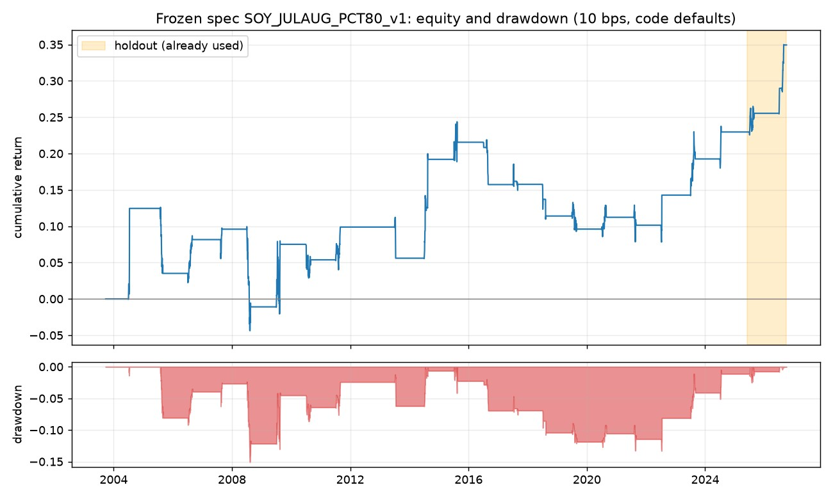
Figure 1. Equity curve and drawdown for the frozen spec, net of costs, on portfolio value. The shaded band is the out-of-sample period.
The pre-registered verdict is a fail. The first holdout run gave 9 trades, one short of the 10 the rule required. A later version of the engine, with spreads and margin added, gave 10 trades and a Sharpe of 1.81. By then the holdout had been seen, so we do not count it as a clean pass.
The model does not forecast. The out-of-sample sign hit rate is 43%. The strategy made money while calling direction worse than a coin, which points to a few large moves and not to skill. Five simpler season-level tests found no significant predictor after Bonferroni correction.
It is one period, one side and one crop. The 2017 to 2022 period is negative, the long side loses money, and corn and wheat lose out of sample. After correcting for 47 configurations the deflated Sharpe is 0.27 on the full history and 0.42 on the holdout, so a holdout Sharpe near 1.8 on two seasons is within what a search on noise can produce.
What is in its favor. The timing test says the positions carry some information before costs (p = 0.028). All 20 cells of an in-sample sensitivity grid are positive, the 80th percentile sits on a band from the 60th to the 80th and not on a spike, and the stop-loss moves the Sharpe by at most 0.05. These use the same years that chose the spec, so they are a reason to run the forward test and not a confirmation.

References
Bailey, D., Borwein, J., López de Prado, M., Zhu, Q. (2014). Pseudo-Mathematics and Financial Charlatanism. Notices of the AMS.
Bailey, D., López de Prado, M. (2014). The Deflated Sharpe Ratio. Journal of Portfolio Management.
Harvey, C., Liu, Y., Zhu, H. (2016). ...and the Cross-Section of Expected Returns. Review of Financial Studies.
NASA Langley Research Center, POWER Project. Daily agroclimatology data. power.larc.nasa.gov
NOAA Climate Prediction Center. Oceanic Niño Index. cpc.ncep.noaa.gov
USDA National Agricultural Statistics Service. QuickStats. quickstats.nass.usda.gov
Yahoo Finance, via the yfinance library. Tickers ZS=F, ZC=F, ZW=F.
CME Group. Soybean futures contract specifications. cmegroup.com
Software: numpy, pandas, scikit-learn, matplotlib. AI tools were used for coding and drafting. The team reviewed every line and claim.

