**Tools Install Guide**

The Eclipse IDE and Apache Tomcat will be used for this course.

* There are a number of variants of the Eclipse IDE to support various programming languages and platforms. For this course, we will use the latest version of the Java EE IDE, which can be downloaded by going to <https://www.eclipse.org/ide/> and selecting the Java EE icon. Download and install the Java EE Eclipse IDE for your operating system.
* One of the benefits of the Spring Framework is that you do not require the installation of a full Enterprise Java compliant Application Server. For this course, we will use the lightweight Apache Tomcat server to deploy and execute our Spring Framework based applications. Go to <http://tomcat.apache.org/> and click the Tomcat 8 download link. Then click on the 8.5.x 64-bit version download for your operating system. Unzip the Apache Tomcat download to any location on your file system.
* You will need the Oracle JDK 7. Go to <http://www.oracle.com/technetwork/java/javaee/downloads/java-ee-sdk-7-downloads-1956236.html> to download the universal zip installer. Install the JDK per the instructions in the installer.
* Validate your environment by performing the following steps:
  + Start Eclipse and create a new empty Workspace.
  + Click on the Servers tab. Click on the 'create new server' link. Refer to Figure 1.
  + Select Tomcat 8.5 under the Apache section. Click the Next button. Refer to Figure 2.
  + Click the Browse button and navigate to the root directory of the Tomcat installation. Click the Next button. Refer to Figure 3.
  + Click the Finish button. The new Tomcat server should be listed in the Servers tab of the Eclipse IDE.
  + Click the Start icon in the Servers tab to validate that the Tomcat server starts and runs without errors by validating the output in Console (which can be displayed by selecting the Console tab).

We will also be using the GitHub Source Code Repository for this course. Use the following steps to install the GIT Client, which will be used to connect your desktop environment to the cloud based GitHub Source Code Repository:

* The SourceTree GIT Client will be used for this class. Download and install from <https://www.sourcetreeapp.com/>

Figure 1

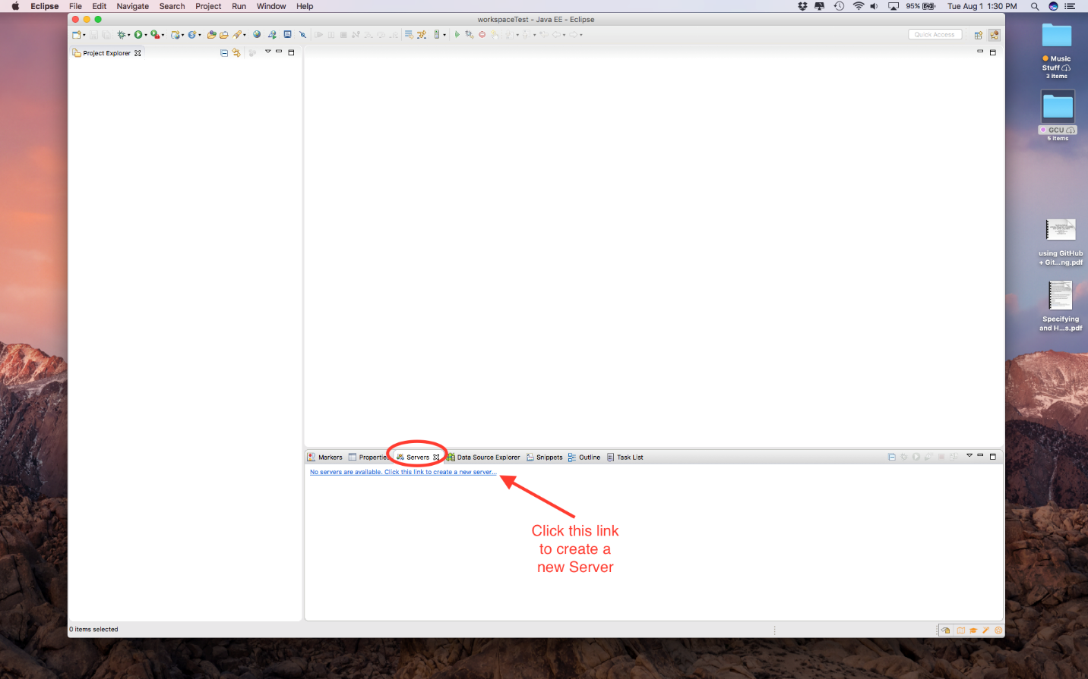

Figure 2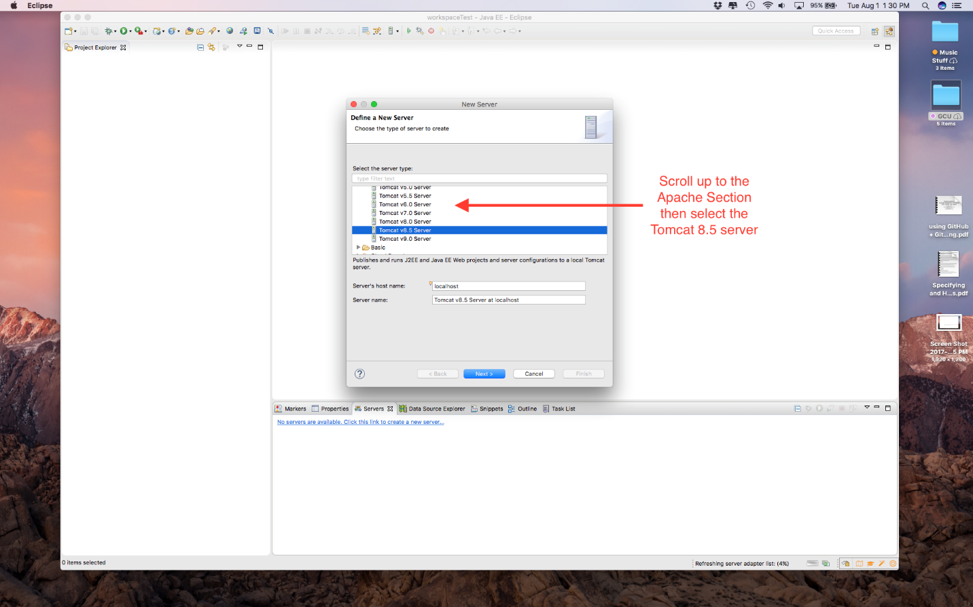

Figure 3