Project 1: Launch
Name: Jansen Rinck
Date: August 29th, 2026
Course: CSCI502

Research Question:
How did the spatial distribution of angling pressure in Montana change from 2019 to 2020 during the onset of the COVID-19 pandemic in relation to the proximity of population centers and the popularity of fishing rivers?
Hypothesis:
During the onset of the COVID-19 pandemic in 2020, angling pressure from residents and non-residents became more dispersed across rivers, with angling pressure increasing on less-popular rivers compared to 2019. Angling pressure also increased disproportionately on rivers located closer to population centers compared to 2019.
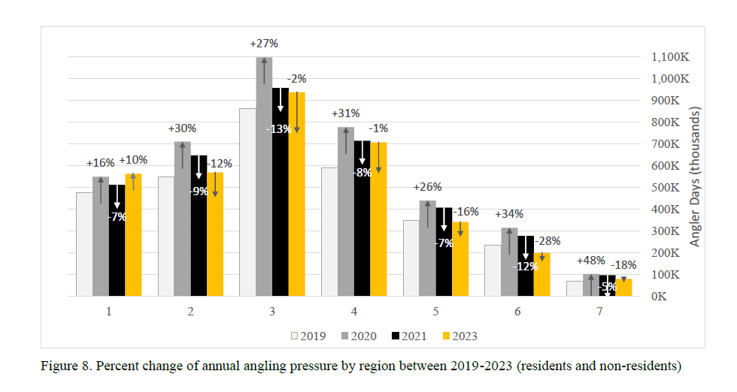
*We can see that angling pressure increased from 2019 to 2020, where did these increases happen?

Data Sources:
Vector
- Montana State Library: National Hydrography Dataset (NHD) (link)
  - Polyline and polygon data showing lakes, rivers, and streams in Montana
- Fish, Wildlife & Parks Fisheries Regions (link)
  - FWP administrative boundaries
- 2019 & 2020 Montana Statewide Angling Pressure Summary Report
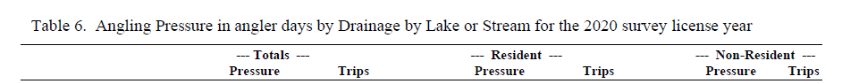
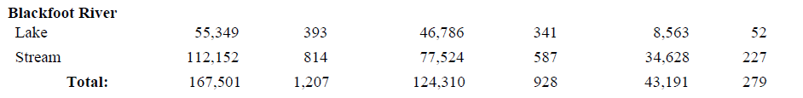
*Scrape and append data from reports to NHD dataset
Raster
- Gridded Population of the World v4.11, Population Density – NASA’s Socioeconomic Data and Applications Center (SEDAC) – population proximity variables (link)
  - Population density index
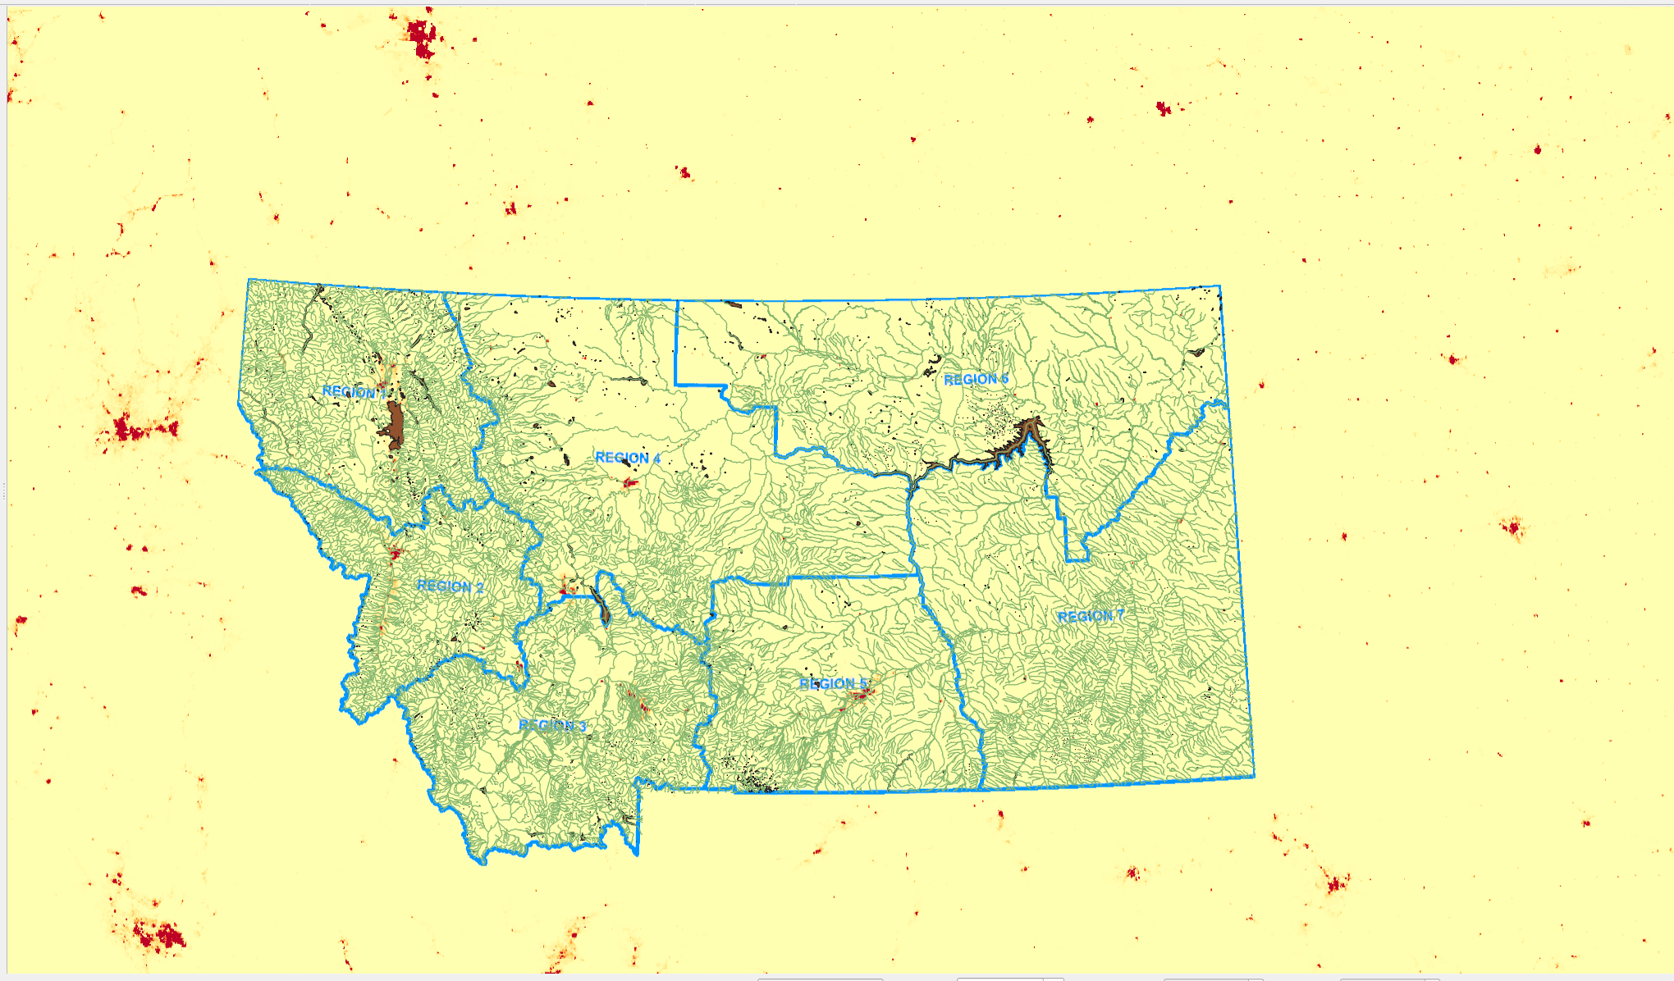

Measurement Methods:
- Total angling pressure values from the angling surveys will be joined with the NHD layer
- Use a color ramp to display which rivers experienced the greatest increase in angling pressure
- Rivers falling within 50 or 25 miles of population centers will be considered high-proximity
Potential Outputs:
- Bar graph showing the greatest increase in angling pressure
- Regional comparisons
- Exploded maps to look more closely at populated areas in Montana

