Forensic Lab 1

Student ID: C13432152

Student Name: Jonathan Riordan

Part A)

To become a forensic scientist a person will need at least a minimum bachelor degree. In addition to the bachelor’s degree, the forensic expert would require excellent verbal and written communications skills. These skills would be important because a forensic expert must be able to document the steps they undertook to uncover the evidence. They also must be able to clearly pass information to other people such as to other investigators or in court.

Other vital skills required would be computer savvy, the person must be experienced using different operating systems such as Windows or Linux. Dealing with data and databases. Another skill would be initiative, been able to think out side the box to solve computer related problems.

Part B)

The first file I will document is BCS CFSG - Briefing 17th January 2014.pdf from webcourses. The following information can be retrieved from the file such as the author, number of pages and what software was to to create the content.

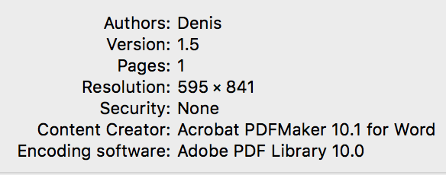

Also information such as the size of the file, and what type of file it is such as a PDF can be retrieved.

The second file that I will examine was the BlackBerry-490x289.jpg image.

Compared to the pdf file above, the information retrieved is different, no author was retrieved with a jpg file. The only important information retrieved from this was the size of the file and where the file came from. No additional information about what software created it or who created the file is provided.

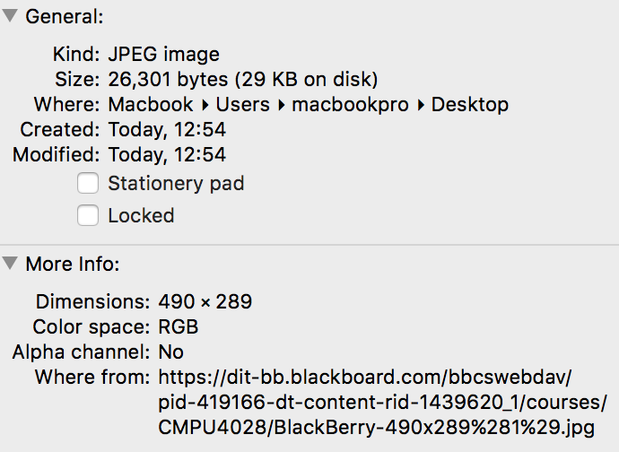

The third file downloaded was the chapter02 power point from web course. The information I retrieved from this was what kid of file the file was. The size of the file. Information such as it was last modified or edited. Additional information such as where the file was downloaded from and what time the file was downloaded to my computer.

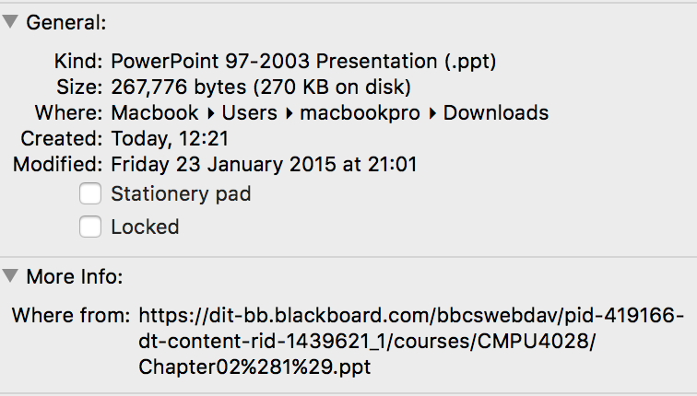

Part B)

The first step I did was to download a forensic recovery tool. The tool I used was EaseUS Data revovery wizard tool.

Second step was launching the application and selecting what type of file would I like to recover such as documents files, audio or graphic files. I selected the document file and clicked ‘Next”.

The third step was selecting the the hard drive in which the ‘Finglas’ file was deleted. I selected my current hard drive and started the scan. The scan of my hard drive took around 2-3 minutes. After the scan was complete, a list of all avaiallble files able to be recovered where displayed.

The fourth step I performed was choosing the ‘Finglas’ file from a list of deleted documents files on my hard drive. There were 73 files that were returned that could have been recovered from my hard drive. I selected the ‘Finglas’ file and chose a destination where the file should be saved to.