The interplay between excess mortality and laboratory-confirmed COVID-19-related deaths in Switzerland

Julien Riou (1,2,*), Anthony Hauser (1,2), …, Garyfallos Konstantinoudis (3) [1]

Report generated on Date: 2022-04-05 Time: 18:43

# Introduction

There are two main approaches to quantify the impact of COVID-19 mortality at the population level. The first approach relies upon the reporting of laboratory-confirmed deaths, i.e. deaths of people with a recent confirmed positive SARS-CoV-2 RT-PCR or rapid antigen test. This has the advantage of being available in real-time, but depends on the quality and comprehensiveness of the country’s deaths registration system and on the testing availability. It is therefore almost never exhaustive, as some deaths will remain unidentified because of a lack of test (e.g. due to testing practices, test shortages or overwhelmed health systems) [1]. Laboratory-confirmed deaths also do not include deaths that have been indirectly caused (or averted) by the SARS-CoV-2 pandemic (e.g. in consequence of control measures). The second approach is based on excess mortality, and relies upon all-cause mortality data and counter-factual reasoning [2]. The idea is to compare the observed number of deaths to what would have been expected had the SARS-CoV-2 pandemic not occurred, based on mortality data from the previous years, demographic changes in the population and a set of covariates. Excess mortality has the advantage of summing all the negative and positive effects of the COVID-19 pandemic on mortality, at the cost of not being able to disentangle them [3]. It is also highly dependent on model assumptions and methodological choices, such as for instance age-specific population trends [4].

There have been many attempts at estimating excess mortality associated with COVID-19 in various settings [3], but new approaches are needed to distinguish the proportion of excess mortality that can be directly attributed to SARS-CoV-2 infections [3]. While data on laboratory-confirmed COVID-19-related deaths are incomplete, more information can be gained by linking their variations across time, space and population groups with variations in excess mortality. Excesses of deaths observed during peaks of epidemic activity, when laboratory-confirmed deaths are high, may serve to estimate the total number of deaths that can be directly attributed to SARS-CoV-2 infections, together with the proportion that was confirmed in laboratories (the ascertainment proportion). On the other hand, deficits or excesses in mortality observed between epidemic waves, when there is no or a weak epidemic activity, may provide estimates of the indirect effect of the COVID-19 pandemic on mortality. Deficits in deaths observed in the weeks following large epidemic waves may be attributed to mortality displacement (sometimes called the “harvesting” effect). Variations in mortality distributed more uniformly across the pandemic period may be attributed to mandated or spontaneous changes in behaviors that led to a reduction or an increase of the risk of death. Examples include a diminution of social contacts preventing the spread of other pathogens such as influenza, work from home limiting traffic and thus road accidents, or in the other direction a general increase in anxiety levels or substance abuse.

In this nationwide study in Switzerland in 2020 and 2021, we aimed to characterize the similarities and discrepancies between laboratory-confirmed COVID-19-related deaths and excess mortality by time period, location and age group. We used a validated statistical approach to compute the expected number of all-cause deaths in 2020 and 2021 by week, age group and location using historical data from 2014-2019, accounting for the effect of temperature and population changes. We then developed a statistical method to decompose all-cause deaths into death excesses directly attributable to SARS-CoV-2 infections and deaths excesses or deficits indirectly attributable to the pandemic, and use this decomposition to study specific phenomenon such as death ascertainment, mortality displacement and other indirect effects of COVID-19 on all-cause mortality during different time periods of the pandemic.

# Methods

## Data

### Prediction model

We retrieved population estimates for the years 2014-2019 from the Federal Statistical Office in Switzerland [REF]. Estimates are available for the 31st of December of each year. To calculate populations at the 31st of December in 2020 and 2021 under the counterfactual scenario that the pandemic did not occur, we performed a two-stage linear interpolation as explained previously [6]. Briefly, we based on the 31st of December of years 2014-2019 and a linear regression model, we predicted the 31st of December of years 2020 and 2021, by age, sex, and canton. Then we calculated weekly population counts by age, sex, and canton by linearly interpolating the estimates of 31st of December of the consequent years. To help predictions we incorporated covariates related with ambient temperature and national holidays. Daily mean ambient temperature between 2014 and 2021 at 1km grid was retrieved from the MeteoSwiss website [REF] and aggregated by taking means per week and canton. National holidays were considered as dummy variables, and defined on a weekly basis for each canton, being 1 if there was at least 1 cantonal holiday in that week.

### Decomposition model

The declaration of laboratory-confirmed SARS-CoV-2-related deaths has been mandatory in Switzerland since February 2020. All collected data are centralized at the Federal Office of Public Health [REF]. Case definition (…). Available information include age, sex, canton of residence, and the date and type of the positive SARS-CoV-2 test. Individual data on all deaths occurring in Switzerland from death certificates are collected by the Federal Statistical Office [REF]. Information include (…). Details about the cause of death as listed in the death certificate are encoded with a delay of several months and were not available for this analysis.

## Statistical methods

### Prediction model

We estimated the expected number of all-cause deaths for each week between 24 February 2020, the day of the first confirmed SARS-CoV-2 case in Switzerland, and 19 December 2021 by age, sex and canton of residence using historical data (2014-2019) and expanding a previously proposed model [6]. Briefly, we used Bayesian spatio-temporal models accounting for population trends and including covariates related with temperature and national holidays. Since the effect of temperature on all-cause mortality is expected to be U-shaped, we used a random walk of order 2 to allow flexible fits. We accounted for seasonality using a random walk of order 1 at the weekly level, long term trend using a white noise process at the yearly level and for spatial autocorrelation using conditional autoregressive priors. In particular, we modeled spatial autocorrelation using an extension of the BYM model, allowing for a mixing parameter which measures the proportion of the marginal variance explained by the spatial autocorrelation term (citation). We fitted the model independently for the selected age and sex groups and using the entire posterior distribution of the expected deaths we retrieved estimates at any different aggregation desired [5]. The model has been internally validated and found to have high predictive accuracy in the older groups, whereas the results were less reliable in for people $40<$ years old [6].

### Decomposition model

We developed a method to decompose the observed all-cause deaths into 1) the number that can be expected given historical trends and 2) the number of deaths attributed to the COVID-19 pandemic. We used a Poisson regression model with an identity link and no intercept term of the form:

$${\text{O}}_{t}∼\text{Poisson}\left(β_{1}{\text{L}}_{t}+β_{2}{\text{E}}_{t}\right),$$

where ${\text{O}}_{t}$ is the observed number of all-cause deaths on week $t$, ${\text{L}}_{t}$ is the number of laboratory-confirmed SARS-CoV-2-related deaths, and ${\text{E}}_{t}$ is the expected number of all-cause deaths given historical trends.

Within this formulation, $β_{1}$ is the number of all-cause deaths for each unit increase in laboratory-confirmed deaths, after adjusting for the expected number of all-cause deaths given historical trends. That means that under perfect case ascertainment $β_{1}=1$. If $β_{1}>1$, then we observe a greater number of deaths attributed to SARS-CoV-2 infections compared with the number of laboratory-confirmed deaths. The ascertainment proportion of SARS-CoV-2-related deaths is obtained by $1/{β_{1}}$. This relies on the assumption that when there is at least one laboratory-confirmed death in a given week, then the excess in observed all-cause deaths can be directly attributed to SARS-CoV-2. In a similar way, $β_{2}$ is the number of all-cause deaths for each unit increase in the expected number of all-cause deaths, after adjusting for the direct effect of SARS-CoV-2. We expect $β_{2}=1$ when the net effect of the pandemic-related behavioral, societal and health system changes on all-cause deaths is zero. The estimate of $β_{2}$ can thus be interpreted as a measure of the indirect effect of the pandemic on mortality. If $β_{2}<1$, then there were fewer all-cause deaths than expected after removing the direct effect of SARS-CoV-2, which implies an indirect protective effect of all changes and control measures associated with the pandemic. Estimates of $β_{1}$ and $β_{2}$ thus provide a way to understand the interplay between laboratory-confirmed SARS-CoV-2-related deaths and excess all-cause deaths, and allow to differentiate between direct and indirect consequences of the SARS-CoV-2 pandemic on mortality.

Going beyond the general case at the country level for the whole period, we extended the model presented above to examine these associations by phase (from 1 to 6 as defined by the Federal Office of Public Health), by age group (0-39, 40-59, 60-69, 70-79 and 80+), and by area (26 cantons). To this end, we introduced multiple $β_{1}$ and $β_{2}$ for each phase, each age group or each area separately, with the additional constraint of a multilevel structure allowing a smoothing towards the global mean of the estimator [7].

# Results

In Switzerland, there were 140,535 observed all-cause deaths and 12,286 laboratory-confirmed COVID-19 from 24 February 2020 to 19 December 2021 (Table 1). Figure 1A illustrates the relative excess mortality in 2020 and 2021 in Switzerland compared to what would have been expected had the pandemic not occurred. We observe that during the two pandemic years there was overall increase in the relative excess mortality of 3.1% (95% CrI: -4.3, 11.2), with phase 3 (covering the period between 28 September 2020 and 15 February 2021) being the period with the highest relative excess mortality (24.4%, 95% CrI: 14.7, 35.5). We find evidence suggesting a harvesting effect during phase 4 (covering the period between 15 February 2021 and 21 June 2021) with the relative excess mortality being -11.7 (95% CrI: -20.0, -2.5), and weaker evidence during phases 2 and 5. The age groups affected most by the pandemic were the ones over 70, whereas the cantons affected the most during these 2 years were Glarus and Jura. During the first phase of the pandemic the areas hit the most were the ones near the borders with France and Italy (cantons of Ticino, Geneva and Vaud), whereas excess mortality was more homogeneous during phase 3 (Figure 1B).

Weekly counts of laboratory-confirmed SARS-CoV-2-related deaths were aligned with estimates of excess all-cause mortality in Switzerland during most of the time (Figure 2A). Quantitatively, the number of excess all-cause deaths was greater than the counts of laboratory-confirmed deaths during epidemic waves (phases 1, 3 and 6). This was translated into an overall estimate of $β_{1}$ of 1.36 (95%CrI: 1.25 to 1.47), suggesting that there were on average 36% (95%CrI: 25 to 47) more deaths directly attributable to SARS-CoV-2 than laboratory-confirmed deaths during the period (Table 1). Given that there have been 12,286 laboratory-confirmed SARS-CoV-2-related deaths between February 2020 and January 2022, this implies that the total number of deaths directly attributable to SARS-CoV-2 in Switzerland in 2020 and 2021 is 16,737 (15,342 to 18,007).

Outside of large epidemic waves (phases 2, 4 and 5), the observed number of all-cause deaths was generally lower than expected based on historical trends. The overall estimate of $β_{2}$ was 0.91 (95%CrI: 0.86 to 0.95), suggesting that there were 9% (95%CrI: 5 to 14) fewer all-cause deaths than expected during the COVID-19 pandemic (after adjusting for the direct effects of SARS-CoV-2 infection on mortality).

Looking at the variation of these indicators across phases brings further insights. The relative number of deaths directly attributable to SARS-CoV-2 for each laboratory-confirmed death ($β_{1}$) was estimated around 1.5 during phases 1 and 3 and around 2 during phase6, suggesting an ascertainment proportion of COVID-19 deaths ranging between 50 and 66% (Figure 1B). This estimate is less reliable during periods where counts of laboratory-confirmed cases were low (phases 2 and 5). The relative deficit in deaths indirectly attributable to the COVID-19 pandemic ($β_{2}$) also varied by phase. It was comparatively lower during large epidemic waves (phases 1 and 3), but also in the period following the second epidemic wave (phase 4), suggesting short-term mortality displacement.

Variation of $β_{1}$ by age group suggests that more deaths were not ascertained in age group 80+, while the data was compatible with close to 100% ascertainment ($β_{1}=1$) in other age groups. Estimates of $β_{2}$ also show a gradient by age, with the older age groups, more affected by COVID-19 mortality, also being the ones that show more deficit of all-cause deaths. Still, a reduction in all-cause mortality ($β_{2}<1$) was observed in all age groups above 40. Below 40, the data was compatible with no or a small reduction in all-cause mortality. Estimates by canton show generally homogeneous results for the whole of Switzerland. There were a few exceptions with higher estimates of $β_{1}$, potentially signaling an issue in the local reporting system.

# Discussion

Summary of main results:

* total excess deaths, total laboratory confirmed deaths
* general alignment between excess deaths and laboratory-confirmed deaths
* estimated total deaths directly due to covid-19, comment on ascertainment
* estimated reduction on other-than-covid deaths

Comment on beta_1:

* Variation of $β_{1}$ by age group suggests that more deaths were not ascertained in age group 80+, which points toward nursing homes as the place where incomplete ascertainment occurs, confirming other reports [1]

Comment on beta_2:

* This can be explained by a combination of three different phenomena. First, the model based on historical trends may have overestimated the expected all-cause mortality, which would lead to an underestimation of $β_{2}$ but would not impact $β_{1}$. Second, it could be explained by some level of mortality displacement, whereby SARS-CoV-2 precipitated deaths that would have occurred during the period anyway. Third, the deficit could be attributed to the indirect effect of the pandemic, including prevention and control measures and a large array of changes such as reductions in mobility and traffic, social contacts and activities, or air pollution levels.
* Estimates of $β_{2}$ also show a gradient by age, with the groups most affected by SARS-CoV-2 mortality also being the ones that show a deficit of all-cause deaths, an argument in favor of mortality displacement, but also pointing towards the protective effects of the non-pharmaceutical interventions in the older age groups (for instance resulting in a lack of influenza season).

Limitations:

* lack cause of deaths
* Estimates restricted on time periods defined by FOPH

Comparisons:

* Compare numbers to ref. 3 and <https://elifesciences.org/articles/69336> (see <https://github.com/dkobak/excess-mortality>). Karlinsky et al. report an excess mortality of 12,000 (18% of baseline annual deaths) and 90% ascertainment.

# Conclusions

# Table and figures

**Table 1.** Summary of mortality patterns in Switzerland between 24 February 2020 and 19 December 2021.

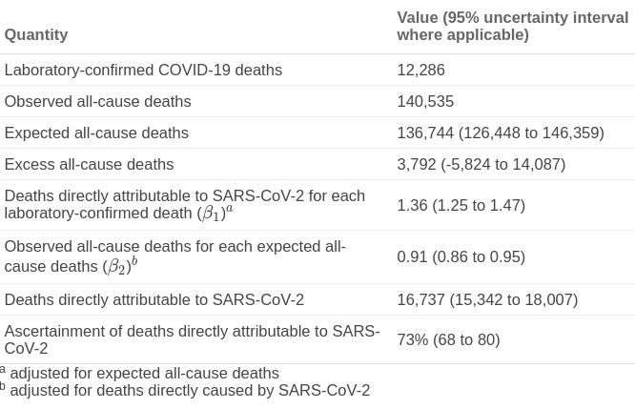

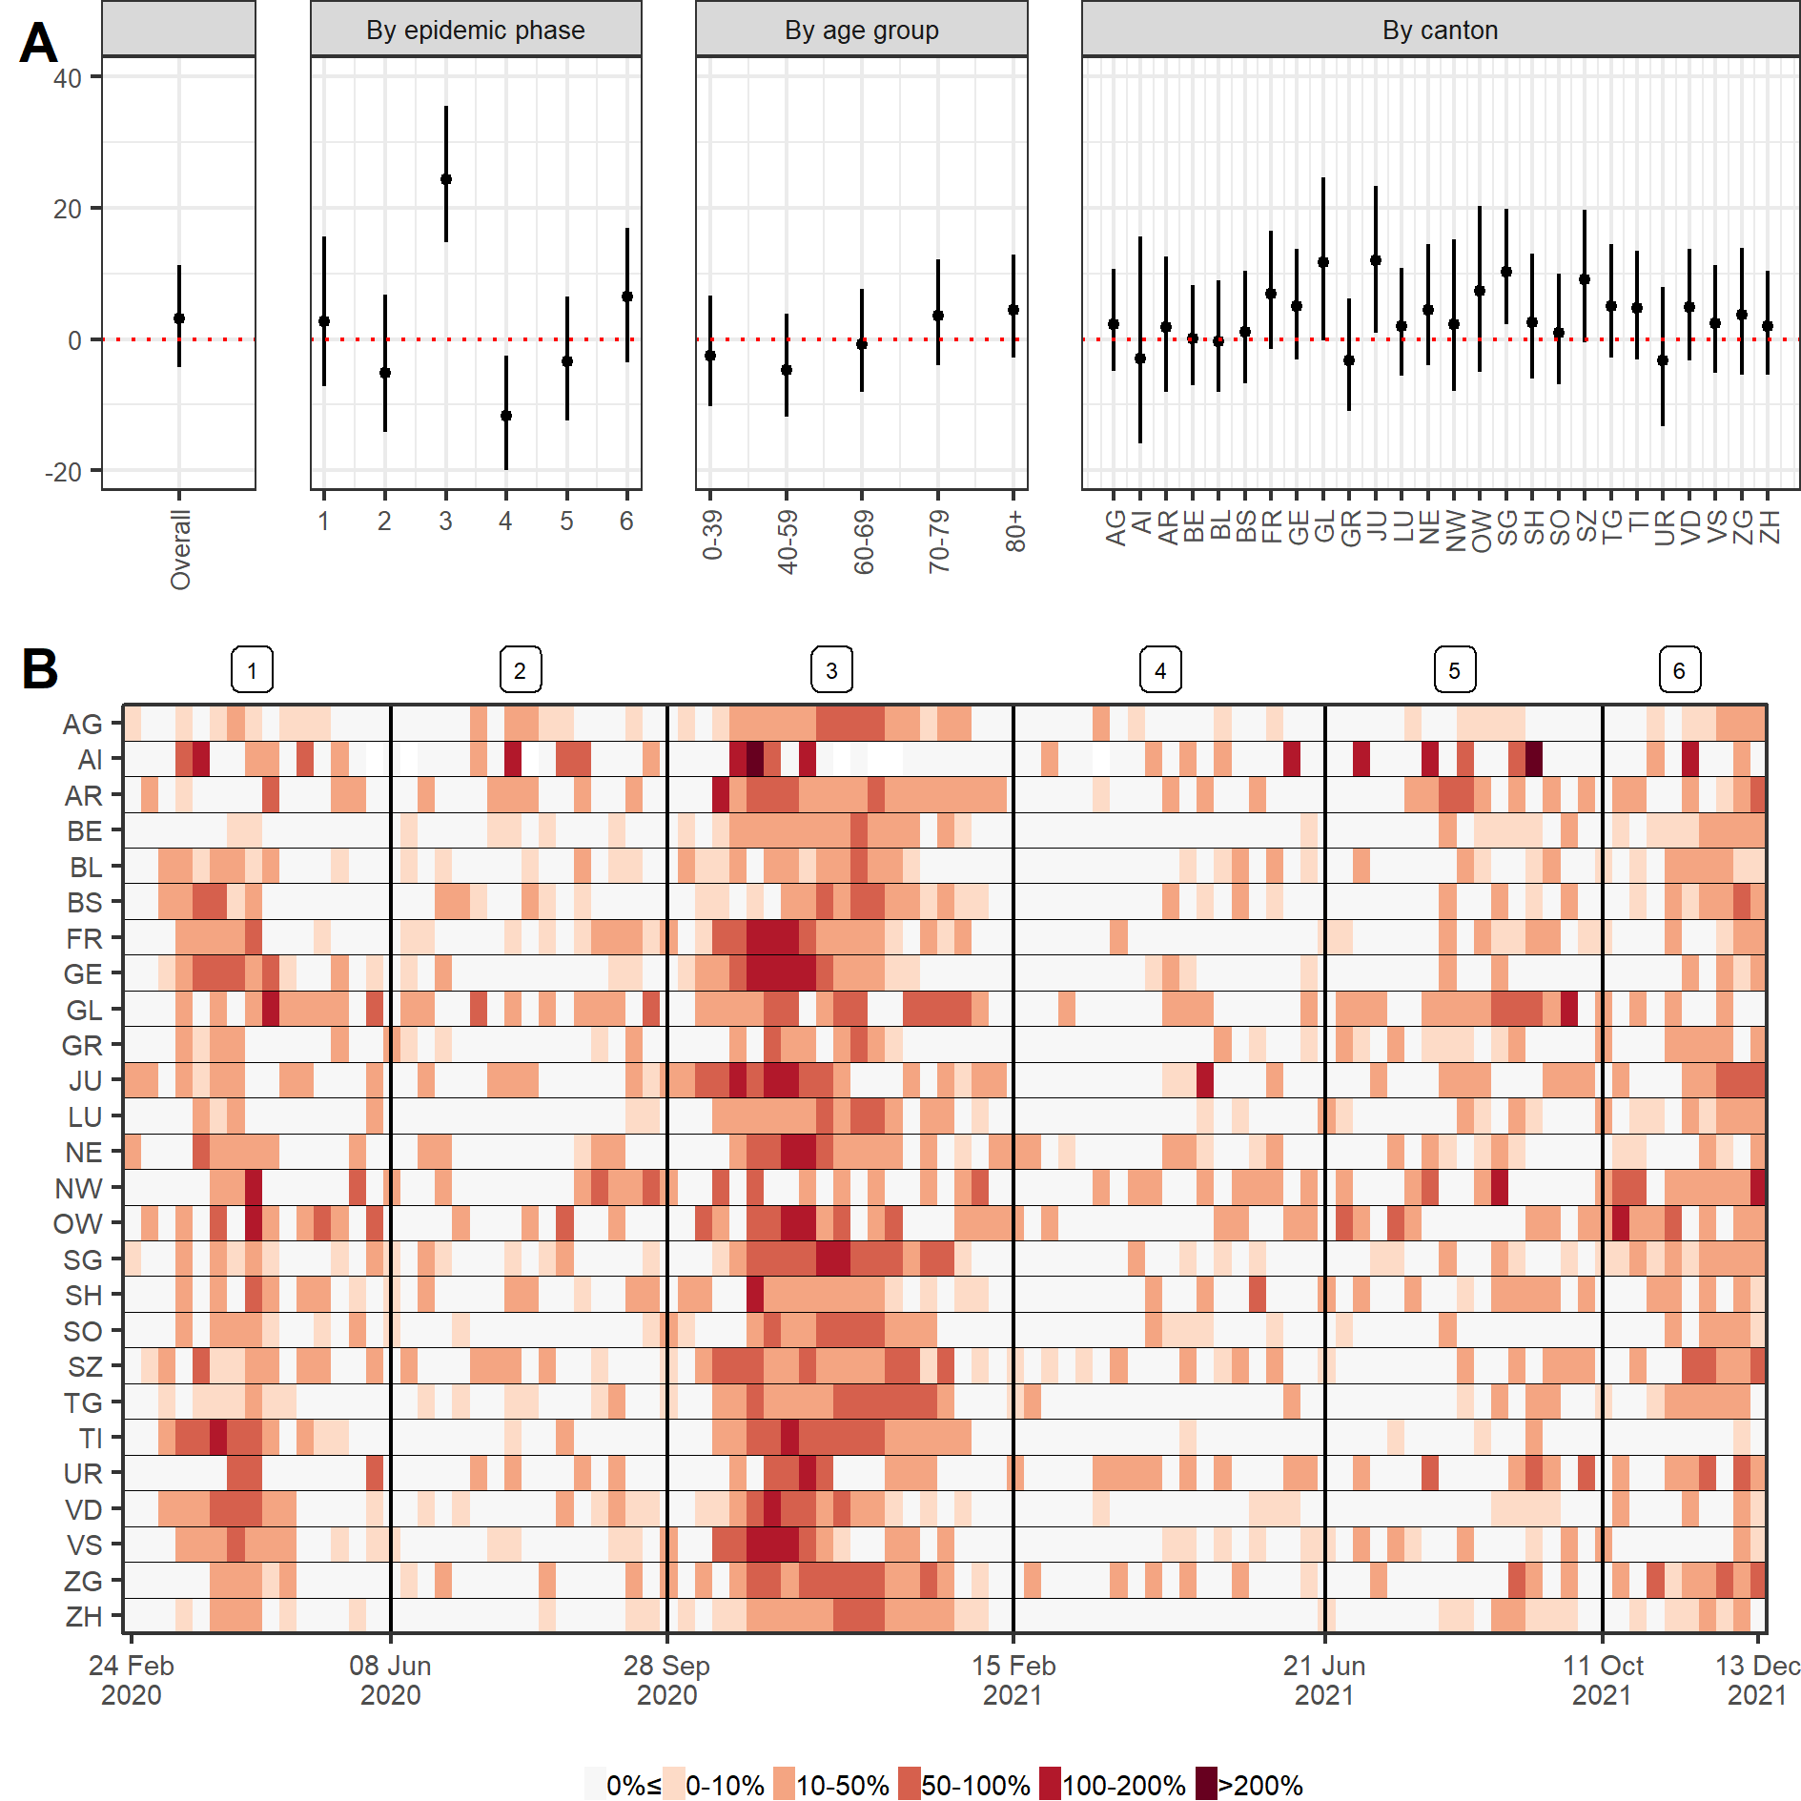

**Figure 1.** (A) Relative excess mortality in Switzerland between 24 February 2020 and 19 December 2021 overall, by epidemic phase, age group, and canton. (B) Weekly relative excess mortality in Switzerland during the same time period by canton.

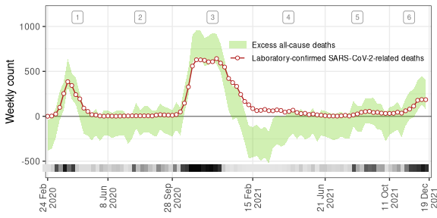

**Figure 2.** Weekly counts of excess all-cause deaths (95% uncertainty intervals) and of laboratory-confirmed SARS-CoV-2-related deaths between 24 February 2020 and 23 January 2022 in Switzerland. The bar at the bottom shows the probability that excess all-cause deaths is greater than laboratory-confirmed SARS-CoV-2-related deaths (light gray is 0, black is 1). Numbers at the top indicate phases 1 to 7.

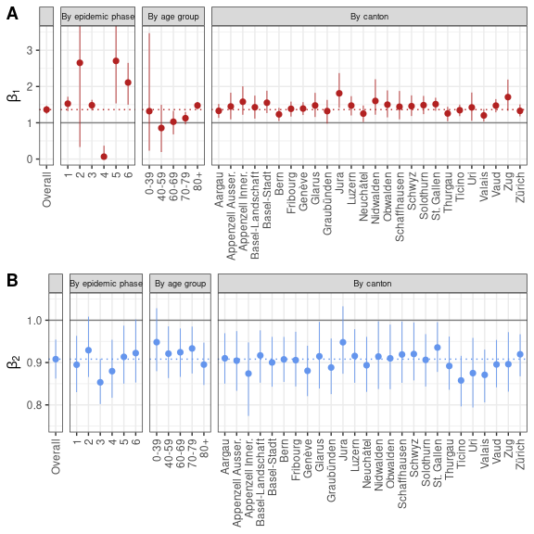

**Figure 3.** (A) Posterior estimates of $β_{1}$, the additional number of deaths to be observed for each unit increase in laboratory-confirmed deaths, after adjusting for the expected number of all-causes deaths given historical trends. (B) Posterior estimates of $β_{2}$, the additional number of deaths to be observed for each unit increase in the expected number of all-cause deaths, after adjusting for the direct effect of SARS-CoV-2 infections. Estimates of $β_{1}$ and $β_{2}$ are shown for the whole period, by phase, by age group and by canton.

**References**

[1] Y. Li, F. Fang, and M. He, “RESEARCHFactors associated with nursing Homesʼ late participation in COVID-19 reporting,” *Journal of the American Geriatrics Society*, vol. 68, no. 11, pp. 2468–2469, 2020.

[2] T. Beaney *et al.*, “Excess mortality: The gold standard in measuring the impact of COVID-19 worldwide?” *Journal of the Royal Society of Medicine*, vol. 113, no. 9, pp. 329–334, 2020.

[3] H. Wang *et al.*, “Estimating excess mortality due to the COVID-19 pandemic: A systematic analysis of COVID-19-related mortality, 2020–21,” *The Lancet*, 2022.

[4] G. De Nicola, G. Kauermann, and M. Höhle, “On assessing excess mortality in germany during the COVID-19 pandemic,” *AStA Wirtschafts-und Sozialstatistisches Archiv*, pp. 1–16, 2022.

[5] G. Konstantinoudis, V. Gómez-Rubio, M. Cameletti, M. Pirani, G. Baio, and M. Blangiardo, “A framework for estimating and visualising excess mortality during the COVID-19 pandemic,” *arXiv preprint arXiv:2201.06458*, 2022.

[6] G. Konstantinoudis *et al.*, “Regional excess mortality during the 2020 COVID-19 pandemic in five european countries,” *Nature Communications*, vol. 13, no. 1, pp. 1–11, 2022.

[7] A. Gelman, J. B. Carlin, H. S. Stern, and D. B. Rubin, *Bayesian data analysis*. Chapman; Hall/CRC, 1995.

1. (1) Institute of Social and Preventive Medicine, University of Bern, Switzerland. (2) Federal Office of Public Health, Switzerland. (3) MRC Centre for Environment and Health, Department of Epidemiology and Biostatistics, School of Public Health, Imperial College London, London, UK. *[julien.riou@ispm.unibe.ch](mailto:julien.riou@ispm.unibe.ch)