Excess and laboratory-confirmed COVID-19-related mortality in Switzerland, a nationwide study

Julien Riou (1,2,*), Anthony Hauser (1,2), Anna Fesser (2), Christian L. Althaus (1), Matthias Egger (1,3,4), Garyfallos Konstantinoudis (5)

(1) Institute of Social and Preventive Medicine, University of Bern, Switzerland. (2) Federal Office of Public Health, Switzerland. (3) Population Health Sciences, Bristol Medical School, University of Bristol, Bristol, UK. (4) Centre for Infectious Disease Epidemiology and Research, University of Cape Town, Cape Town, South Africa. (5) MRC Centre for Environment and Health, Department of Epidemiology and Biostatistics, School of Public Health, Imperial College London, London, UK. [*[julien.riou@ispm.unibe.ch](mailto:julien.riou@ispm.unibe.ch)]

Report generated on Date: 2022-07-08 Time: 13:49

# Introduction

The COVID-19 pandemic has resulted in widely differing levels of mortality across countries globally [[1]][2]. The impact of the COVID-19 pandemic on mortality at the population level is of great concern to public health but difficult to quantify. Two main approaches have been used to this aim. The first relies on reporting laboratory-confirmed deaths, i.e., deaths of people with a recent positive SARS-CoV-2 RT-PCR or rapid antigen test. It is available in real-time, but depends on the quality and comprehensiveness of the country’s registration system and on test availability. Therefore, quantification based on testing is rarely exhaustive, as some deaths will remain unidentified, for example due to testing policies, test shortages or overwhelmed health systems [3]. Further, laboratory-confirmed deaths ignore deaths that have been indirectly caused (or averted) by the pandemic, for instance due to stressed health care systems or as a consequence of non-pharmaceutical interventions (NPI). The second approach relies on excess mortality estimated from all-cause mortality data using counterfactual reasoning [4]. The observed number of deaths is compared to what would have been expected had the pandemic not occurred, based on mortality data from the previous years, demographic changes and covariates associated with mortality patterns. Excess mortality has the advantage of covering both the pandemic’s negative and positive effects on mortality, and the disadvantage of not being able to disentangle the difference effects [1]. Also, estimations of excess mortality depend on model assumptions and methodological choices, such as age-specific population trends [5].

There have been many attempts to estimate excess mortality associated with the COVID-19 pandemic in various settings [[6]][7][1]. Still, new approaches are needed to distinguish the proportion of excess mortality directly attributable to SARS-CoV-2 infections from indirect effects [1]. While data on laboratory-confirmed COVID-19-related deaths are incomplete, this may be overcome by analyzing trends in these deaths jointly with trends in excess mortality across time, space and population groups. Excess mortality observed during peak epidemic activity, when laboratory-confirmed deaths are high, may support the estimation of the total number of deaths directly attributable to SARS-CoV-2 infections, together with the proportion confirmed in laboratories (death ascertainment). On the other hand, mortality deficits or excesses in mortality observed after accounting for deaths directly caused by SARS-CoV-2 infection, or between epidemic waves when there is no or a weak epidemic activity, may provide estimates of the indirect effect of the COVID-19 pandemic on mortality. Deficits in deaths observed after large epidemic waves may reflect mortality displacement, i.e., deaths occurring earlier than expected due to the “harvesting” effect [[8]][9][10]. Changes in mortality that are evident over the entire pandemic period may be attributed to changes in behavior. Examples include reductions in social contact that prevent the spread of other pathogens such as influenza, working from home reducing traffic and road accidents, increases in anxiety levels or substance abuse that may increase suicide risk, or changes in healthcare-seeking behavior [11].

We studied laboratory-confirmed COVID-19-related deaths and excess mortality by time, space, and age group in Switzerland between February 2020 and April 2022. We computed the expected number of all-cause deaths in 2020 and 2021 by week, age group and location, accounting for the effect of temperature, national holidays, and population changes using a validated statistical approach [6]. We then developed a method to decompose all-cause mortality into deaths directly attributable to SARS-CoV-2 infection and deaths indirectly attributable to the pandemic. This approach allowed us to examine the completeness of ascertainment of COVID-19-related deaths and the indirect effects of the pandemic on all-cause mortality in Switzerland.

# Methods

## Data sources

We retrieved population data in Switzerland for the pre-pandemic years 2010 to 2019 from the *Federal Statistical Office* (FSO) [12]. Data was aggregated by age group (in five groups: 0-39, 40-59, 60-69, 70-79 and 80 and older), sex (two groups) and administrative region (26 cantons). Data on all-cause deaths were also obtained from the FSO [13]. These consisted of counts of deaths from any cause by age, sex and canton for each week from 2010 to 2019, and afterwards for each week up to April 3, 2022. Coding of the cause of death listed in the death certificate takes up to one year, and information on causes of death were therefore not available for this analysis. We used data on ambient temperature from the European Centre for Medium-Range Weather Forecasts Reanalysis version 5 (ERA5) reanalysis data set [14] and on national holidays from *nager.date* [15]. Daily mean ambient temperature between 2010 and 2022 at 0.25°x0.25° resolution was aggregated by taking means per week and canton. Holidays were considered as dummy variables and defined on a weekly basis for each canton (1 if there was at least one cantonal holiday, 0 otherwise). All data are available on github at <https://github.com/jriou/covid19_ascertain_deaths>.

The reporting of laboratory-confirmed COVID-19-related deaths has been mandatory in Switzerland since February 2020. The records are kept at the *Federal Office of Public Health* (FOPH), and are available online [16] [CHECK]. Available information include age, sex, canton of residence, and the date and type of the positive SARS-CoV-2 test. Dates were grouped into seven epidemic phases by the FOPH: February 24, 2020 to June 7, 2020 (phase 1); June 8, 2020 to September 27, 2020 (phase 2); September 28, 2020 to February 14, 2021 (phase 3); February 15, 2021 to June 20, 2021 (phase 4); June 21, 2021 to October 10, 2021 (phase 5); October 11, 2021 to December 19, 2021 (phase 6) and December 20, 2021 to April 3, 2022 (phase 7).

## Statistical methods

### Population model

We used population size on December 31, 2010 to 2019 by age group, sex and canton was used to predict population sizes in each stratum and week of the entire study period (January 1, 2010 to April 3, 2022) in a two-step procedure. First, we fitted a Poisson regression model to population data from 2010 to 2019. This model included a linear yearly trend, a fixed effect by sex, and independent random effects by week (for seasonality), age group, sex and canton. We compared different models using higher interactions and yearly linear trends that vary by space, age and sex. Model comparison using a cross-validation scheme excluding the last three years of available data (2017-2019) determined that the best model included all possible two-way interactions between sex, age, canton, and week, and an overdispersion parameter. We obtained posterior distributions of the population in each stratum for December 31 2020, 2021 and 2022, under the counterfactual scenario that the pandemic did not occur. In a second step, we used linear interpolation to obtain weekly population size (estimates, with uncertainty). Online Supplement Section 1.1 provides further details.

### Expected deaths model

We estimated the expected number of all-cause deaths for each week between February 24, 2020, the day of the first confirmed COVID-19 case in Switzerland, and April 3, 2022 by age, sex and canton of residence using the historical data (2010 to 2019) and expanding a previously proposed model [17]. We used Bayesian spatio-temporal models accounting for population trends and including covariates related to temperature and national holidays. To account for uncertainty in population estimates, we applied the model multiple times over the samples of the posterior distributions of the population predictions. Since the effect of temperature on all-cause mortality is expected to be U-shaped [18], we used a random walk of order 2 to allow for a flexible fit. We accounted for seasonality using a random walk of order 1 at the weekly level, and for exceptional events using week-level independent random effects. We accounted for long-term trends with a linear slope at the yearly level, and for spatial autocorrelation using conditional autoregressive priors. In particular, we modeled spatial autocorrelation using an extension of the Besag-York-Mollié model, allowing for a mixing parameter measuring the proportion of the marginal variance explained by the spatial autocorrelation term [[19]][20]. The model has been internally validated and found to be unbiased, having a high predictive accuracy in age groups above 40 [17]. We used the fitted model to obtain posterior distributions of the expected number of all-cause deaths by age group, sex and canton in each week between February 24, 2020 and April 3, 2022. Estimates of excess mortality (with uncertainty) were then obtained by substracting the expected (across the posterior samples) from the observed all-cause deaths in each stratum. Online Supplement Section 1.2 provides further details.

### Decomposition model

We first studied the alignment between excess mortality and laboratory-confirmed COVID-19-related deaths using Pearson’s correlation coefficient (applied across the posterior samples of excess mortality to propagate uncertainty). We then developed a method to decompose the number of all-cause deaths observed in the pandemic period based on 1) the number of laboratory-confirmed COVID-19-related deaths and 2) the number of expected deaths given historical trends. We included multiplicative parameters to measure the respective contributions of these two quantities. We used a Poisson regression model with an identity link and no intercept term of the form:

$${\text{O}}_{t}∼\text{Poisson}\left(β_{1}{\text{L}}_{t}+β_{2}{\text{E}}_{t}+u_{t}\right),$$

where ${\text{O}}_{t}$ is the observed number of all-cause deaths on week $t$, ${\text{L}}_{t}$ is the number of laboratory-confirmed COVID-19-related deaths, ${\text{E}}_{t}$ is the expected number of all-cause deaths given historical trends, and $u_{t}$ is a normally-distributed overdispersion term centered at zero.

Within this formulation, $β_{1}$ is the number of all-cause deaths for each unit increase in laboratory-confirmed deaths, after adjusting for the expected number of all-cause deaths given historical trends. That means that under perfect case ascertainment $β_{1}=1$. If $β_{1}>1$, then we observe a greater number of deaths attributed to SARS-CoV-2 infections compared with the number of laboratory-confirmed deaths. The ascertainment proportion of COVID-19-related deaths is obtained by $1/{β_{1}}$. This relies on the assumption that when there is at least one laboratory-confirmed death in a given week, then the excess in observed all-cause deaths can be directly attributed to COVID-19. In a similar way, $β_{2}$ is the number of all-cause deaths for each unit increase in the expected number of all-cause deaths, after adjusting for the direct effect of COVID-19. We expect $β_{2}=1$ when the net effect of the pandemic-related behavioral, societal and health system changes on all-cause deaths is zero. The estimate of $β_{2}$ can thus be interpreted as a measure of the indirect effect of the pandemic on mortality. If $β_{2}<1$, then there were fewer all-cause deaths than expected after removing the direct effect of COVID-19, which implies an indirect protective effect of all changes and control measures associated with the pandemic. Estimates of $β_{1}$ and $β_{2}$ thus provide a way to understand the interplay between laboratory-confirmed COVID-19-related deaths and excess all-cause deaths, and allow to differentiate between direct and indirect consequences of the COVID-19 pandemic on mortality.

We extended the model presented above to examine these associations by phase (from 1 to 6 as defined by the Federal Office of Public Health), by age group (0-39, 40-59, 60-69, 70-79 and 80+ years old), and by area (26 cantons). To this end, we introduced multiple $β_{1}$ and $β_{2}$ for each phase, age group or area separately, with the additional constraint of a multilevel structure allowing a smoothing towards the global mean of the estimator [21]. To propagate the uncertainty of the expected number of deaths, we fitted the above models using 200 samples of the posterior distribution of the expected number of deaths. We then combined the resulting posterior samples of $β_{1}$ and $β_{2}$.

All inferences were done in a Bayesian framework. Posterior distributions were approximated by samples, and summarized by their median, 2.5% and 97.5% percentiles to obtain point estimates and 95% credible intervals (95% CrI). The population and expected deaths models were implemented in R-INLA [22], and the decomposition model in NIMBLE [23]. Online Supplement Sections 1.1 and 1.2 provides further details about model specification, prior specification and cross validation.

# Results

A total of 156,193 deaths from all causes in Switzerland from February 24, 2020 to April 3, 2022, compared to an expected 142,408 (95% CrI: 138,044 to 149,125) had the pandemic not occurred. This translates into 13,786 (95% CrI: 7,068 to 18,149) excess all-cause deaths over the pandemic period, a relative increase of 9.7% (95%CrI: 4.7 to 13.1). There were three periods of substantial relative excess mortality: 7.3% (95%CrI: 3.8 to 10.8) during phase 1, 33.9% (95%CrI: 26.4 to 41.4) during phase 3 and 15.9% (95%CrI: 8.3 to 22.8) during phase 6 (Table 1). There was some evidence suggesting for mortality displacement during phase 4, with a relative excess mortality of -4.3% (95%CrI: -9.9 to 0.2). The age groups affected most by excess mortality were those over 70 years of age (Figure 1A).

During the period, 13,130 laboratory-confirmed COVID-19-related deaths were reported. Weekly counts of laboratory-confirmed deaths generally aligned with estimates of excess all-cause mortality in Switzerland (Figure 2 and Figure 3A), with a correlation coefficient of 0.89 (95%CrI: 0.85 to 0.92) on aggregate, and of 0.92 (95%CrI: 0.86 to 0.94) when stratifying by age group. The number of excess all-cause deaths was greater than the counts of laboratory-confirmed deaths during epidemic waves (phases 1, 3 and 6). This translated into an overall estimate of $β_{1}$ of 1.38 (95%CrI: 1.22 to 1.54), suggesting that there were on average 38% (95%CrI: 22 to 54) more deaths directly attributable to COVID-19 than laboratory-confirmed deaths during the period, or that the ascertainment proportion was 72% (95%CrI: 65 to 82) (Table 1). Given the 13,130 laboratory-confirmed deaths over the period, this implies that the total number of deaths directly attributable to COVID-19 in Switzerland until April 3, 2022 can be estimated at 18,140 (95% CrI: 15,962 to 20,174) deaths.

After accounting for deaths directly attributable to COVID-19, the observed number of all-cause deaths was slightly lower than expected based on historical trends. This is quantified by $β_{2}$, estimated at 0.97 (95%CrI: 0.93 to 1.01), indicating that there have been 3% (95%CrI: -1 to 7) fewer all-cause deaths than expected during the COVID-19 pandemic (after adjusting for the direct effects of SARS-CoV-2 infection on mortality). This corresponds to 4,406 (95% CrI: -1,776 to 10,700) fewer deaths overall compared to expected. Still, the data are compatible with no indirect beneficial effect or a slightly harmful indirect effect.

The coefficients $β_{1}$ and $β_{2}$ varied across age groups and time periods. The relative number of deaths directly attributable to COVID-19 for each laboratory-confirmed death ($β_{1}$) was around 1.5 during phases 1 and 3 and around 2 during phase 6, suggesting an ascertainment proportion of COVID-19 deaths during large epidemic waves ranging between 50 and 66% (Figure 3B). This estimate is less precise during periods of low epidemic activity (phases 2, 4, 5 and 7), and remain compatible with 1 (perfect ascertainment). Variation of $β_{1}$ by age group suggests that more deaths were not ascertained in age groups 70-79 and 80+, while the data were compatible with 100% ascertainment ($β_{1}=1$) in age groups below 80 (Figure 3A and 3B). The relative deficit in all-cause deaths that can be indirectly attributed to the COVID-19 pandemic ($β_{2}$) showed less variation by phase and age group (Figure 3B), but the indirect beneficial effect was more pronounced during phases 1, 3 and 4 (corresponding to the periods with the most stringent control measures) and in age groups 40 to 69. Estimates of $β_{1}$ and $β_{2}$ acroess administrative regions show generally homogeneous results for the whole of Switzerland, bringing more weight to our results (online supplement **TO ADD**).

# Discussion

## Summary of principal findings (I’ll remove the subheadings)

In this study, we examined the patterns of all-cause mortality in Switzerland from the diagnosis of the first case at the end of February 2020 to spring 2022. Detailed data on the population structure, mortality, weather and national holidays from the ten years before the COVID-19 pandemic allowed us to estimate what mortality would have been in 2020-2022 had the pandemic not occurred. This allowed a detailed characterization of excess all-cause mortality during the pandemic period by time, space and age, appropriately propagating uncertainty from all sources. The novelty of our work comes from the detailed juxtaposition of excess mortality with laboratory-confirmed COVID-19-related deaths. As expected, we found that these two time-series were aligned, although imperfectly. We decomposed all-cause deaths into mortality excesses directly attributable to COVID-19 and mortality excesses or deficits indirectly attributable to the pandemic. We found that the estimated number of deaths directly caused by COVID-19 was about 40% higher than the number of laboratory-confirmed deaths. Overall, COVID-19 was responsible for an estimated 18,000 deaths during the study period during which only around 13,000 laboratory-confirmed COVID-19-related deaths were reported in Switzerland. Besides directly causing a large number of deaths, we found evidence that the COVID-19 pandemic had an indirect beneficial effect on all-cause mortality. Overall, this reduction of all-cause mortality was estimated to 3% (corresponding to about 4,000 fewer deaths that expected), but the wide credibility intervals are compatible with no indirect effect or a very small harmful indirect effect. Interestingly, we found that this small but meaningful protective effect primarily concerned age groups 40 to 69.

## Strenghts and weaknesses

This study has several strengths and limitations. We used a statistically rigorous approach to estimate the expected number of deaths in 2020-2022 had the pandemic not occurred by age group and over space and time. Our approach has been thoroughly validated, and accounts for the most important determinants of deaths count data, including projected population sizes and observed temperature. We also properly handle the uncertainty coming from different sources of data, and propagate it into the final estimates. We then developed a statistical method to differentiate all-cause deaths into deaths directly attributable to SARS-CoV-2 infections and deaths excesses or deficits indirectly attributable to the pandemic. This approach was tailored to the research question, and allowed us to bring further insights about the mortality patterns during the COVID-19 pandemic. This work also has a few limitations. Most importantly, we could not access information about the cause of death, that could help solving some remaining questions about the mechanisms of the indirect beneficial effect of the COVID-19 pandemic on mortality. We considered that all deaths with a positive SARS-CoV-2 test as caused by COVID-19. However an unrelated, coincidental SARS-CoV-2 infection could only concern a proportion of deaths equivalent to the prevalence of the disease in the general population, which never passed a few percentage points at its highest in cross-sectional studies [24]. We did not stratify by sex, but previous analysis suggested small, if any, discrepancies in the observed and excess number of deaths across the different sexes [17]. Our study also remain subject to ecological bias [25].

## Relations with other studies

Our estimates of excess mortality during the COVID-19 pandemic in Switzerland are consistent with other studies in which different methods were used. The Federal Statistical Office reported well over 10% more deaths than expected from January 2020 to August 2021 [26]. Karlinksy & Kobak estimated an excess mortality of 13,000 from March 2020 to June 2022 [[2]][27]. Wang et al. [1] estimated 15,500 (95% uncertainty interval [UI]: 14,000 to 17,000) excess deaths in Switzerland in 2020 and 2021, which corresponds to 1.29 (95% UI: 1.16 to 1.42) times the number of laboratory-confirmed COVID-19 deaths. WHO estimates for Switzerland were somewhat lower with 8,200 (95% confidence interval: 6,900 to 9,700) estimated excess deaths in 2020 and 2021 [28]. However, the WHO estimates have been shown to be prone to bias [29]. Finally, *The Economist* estimated 14,700 (95% UI: 14,400 to 15,400) excess deaths from January 2020 to June 2022 [30]. Going beyond estimates of excess mortality, our work answers open questions about the direct and indirect effects of COVID-19 on mortality that were mentionned as limitations in several of these studies.

## Meaning of the study

Overall, we found that the estimated number of deaths directly caused by COVID-19 was higher than the number of laboratory-confirmed deaths by on average 40%, or interchangeably that only 70% of deaths caused by COVID-19 were properly ascertained. Ascertainment was markedly lower during periods of high epidemic activity, suggesting shortcomings concerning testing or reporting in overwhelmed healthcare institutions. Under-ascertainment was also concentrated in older age groups, pointing towards retirement and nursing homes as the places where incomplete ascertainment occurs, in line with other reports [3]. The even lower ascertainment towards the end of the study period could be partially explained by reduced testing due to the availability of vaccines. We also found that in Switzerland, a country characterized by high socio-economic development and a strong healthcare system, the COVID-19 pandemic had an indirect, beneficial effect on all-cause mortality. A first explanation could be mortality displacement or a “harvesting effect”, whereby COVID-19 precipitated deaths that would have occurred shortly anyway [[31]][8][[9]][10]. Mortality displacement was likely following the largest wave of mortality in autumn and winter 2020/21, but it cannot explain the slightly lower mortality found during other periods. Of note, the deficit of deaths not directly related to COVID-19 was mostly evident in age groups 40 to 69, and not in in the elderly where mortality displacement is to be expected. Second, the deficit could be attributed to the indirect effect of the pandemic, including NPIs and its consequences such as reductions in mobility and traffic, social contacts and activities, or air pollution levels [[32]][33]. This explanation is supported by the observation that the indirect beneficial effect was more pronounced during phases 1, 3 and 4, corresponding to the periods with the most stringent control measures [34]. The fact that it mostly occurred in age groups 40 to 69 favors explanations relating to reductions in mobility, traffic and outdoor activities, as opposed to a reduced circulation of other pathogens such as influenza, which would have led to mortality deficits in the elderly. In any case, we find no argument in favor of an overall detrimental effect of NPIs on mortality, which does not presume of any other harmful effects such as delays or avoidance of medical care [[35]][36], increases in substance use and suicidal ideation [[37]][38] or increases in interpersonal violence [39].

## Unanswered questions and future research

Our results in the Swiss population cannot be extrapolated to other areas. Switzerland is a high-income country, with a relatively old but healthy population. The stringency of NPIs was also comparatively mild compared to other European countries [40]. While the harmful indirect effects of NPIs on mortality may have been offsetted by its benefits in this particular country, further research is required to quantify indirect effects in other areas. While we propose a framework to disentangle the direct and indirect effect of the pandemic on mortality on aggregate, our approach provides no information about the pathways leading to an increase or a decrease of the risk of death. Further research including data about the specific cause of death mentionned in the death certificate are needed to answer this question. Our study focuses on the short-term effect of the COVID-19 pandemic and does not provide any insights about the long-term effect of the pandemic, such as reduced cancer screening, which might impact mortality in the long run [35].

# Conclusions

# Table and figures

**Table 1.** Number of expected and observed deaths from all causes, estimated excess mortality and laboratory-confirmed COVID-19-related deaths by seven epidemic phases between February 2020 to April 2022.

flextable::regulartable(table1,cwidth = c(1,5,5,2,4,5,2))

| Epidemic phase | Dates | Expected all-cause deaths (95% credible interval) | Observed all-cause deaths | Excess all-cause deaths (95% credible interval) | Relative excess all-cause deaths (95% credible interval) | Laboratory-confirmed COVID-19 deaths |
| --- | --- | --- | --- | --- | --- | --- |
| 1 | Feb 24, 2020 to Jun 7, 2020 | 19,376 (18,767 to 20,033) | 20,791 | 1,415 (758 to 2,024) | 7% (4 to 11) | 1,725 |
| 2 | Jun 8, 2020 to Sep 27, 2020 | 19,180 (18,440 to 20,042) | 19,103 | -76 (-939 to 663) | -0% (-5 to 4) | 104 |
| 3 | Sep 28, 2020 to Feb 14, 2021 | 27,004 (25,569 to 28,604) | 36,157 | 9,154 (7,553 to 10,588) | 34% (26 to 41) | 7,652 |
| 4 | Feb 15, 2021 to Jun 20, 2021 | 23,386 (22,320 to 24,834) | 22,369 | -1,017 (-2,465 to 49) | -4% (-10 to 0) | 895 |
| 5 | Jun 21, 2021 to Oct 10, 2021 | 19,174 (18,284 to 20,223) | 20,007 | 832 (-216 to 1,723) | 4% (-1 to 9) | 380 |
| 6 | Oct 11, 2021 to Dec 19, 2021 | 13,036 (12,298 to 13,944) | 15,105 | 2,070 (1,161 to 2,807) | 16% (8 to 23) | 956 |
| 7 | Dec 20, 2021 to Apr 3, 2022 | 21,370 (20,067 to 22,894) | 22,661 | 1,291 (-233 to 2,594) | 6% (-1 to 13) | 1,418 |

da_409_figure1()

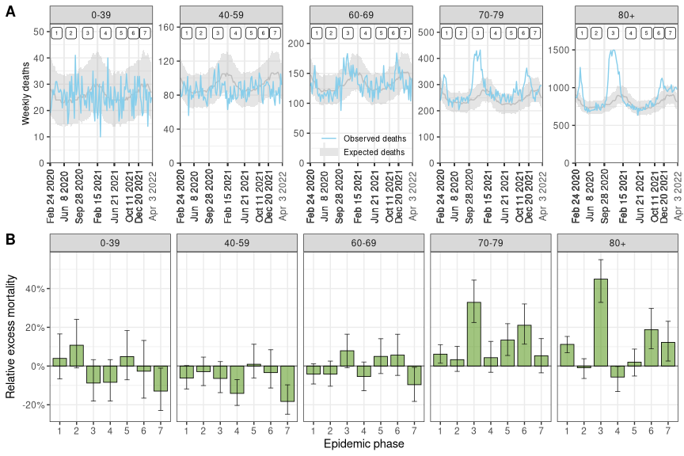

**Figure 1.** (A) Observed and expected number of weekly deaths by age group in Switzerland from February 2020 to April 2022. Model-predicted expected deaths are shown with median and 95% credibility interval. Numbers at the top indicate epidemic phases 1 to 7. (B) Estimated relative excess mortality by seven epidemic phases from February 2020 to April 2022 and five age groups. Medians with 95% credible intervals are shown.

da_303_summary_plot_by(summ_week_age_temp)

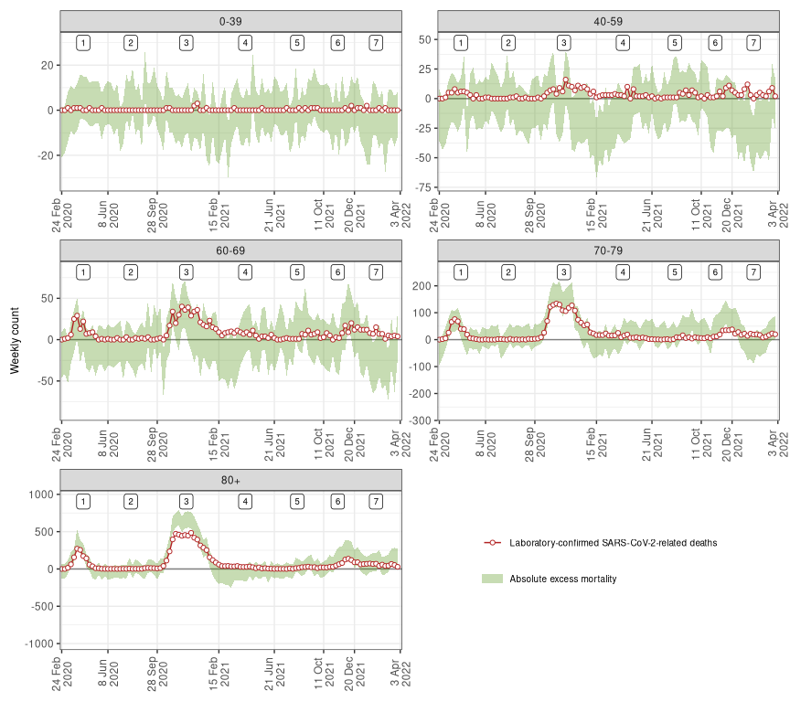

**Figure 2.** Weekly counts of excess all-cause deaths (95% credibility intervals) and of laboratory-confirmed COVID-19-related deaths between February 24, 2020 and April 3, 2022 in Switzerland by five age groups. Numbers at the top indicate epidemic phases 1 to 7.

da_410_figure3(summ_regbma,merg)

## Joining, by = "age_group"Joining, by = "age_group"

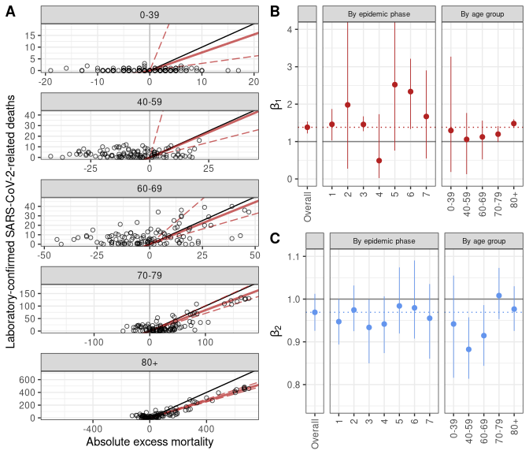

**Figure 3.** (A) Association between weekly laboratory-confirmed COVID-19-related deaths and absolute excess mortality by age group. The black line shows the slope of association corresponding to a 1 to 1 relation. The red lines show the association estimated with the model (corresponding to the $β_{1}$ coefficients shown in panel B, the full line represents the point estimate and the dashed lines the lower and upper bounds of the 95% credible interval). (B) Estimates of $β_{1}$, the additional number of deaths to be observed for each unit increase in laboratory-confirmed deaths, after adjusting for the expected number of all-causes deaths given historical trends. (C) Estimates of $β_{2}$, the additional number of deaths to be observed for each unit increase in the expected number of all-cause deaths, after adjusting for the direct effect of SARS-CoV-2 infections. Estimates of $β_{1}$ and $β_{2}$ are shown for the whole period, by phase and by age group.

**References**

[1] H. Wang *et al.*, “Estimating excess mortality due to the COVID-19 pandemic: A systematic analysis of COVID-19-related mortality, 2020–21,” *The Lancet*, 2022.

[2] A. Karlinsky and D. Kobak, “Tracking excess mortality across countries during the COVID-19 pandemic with the World Mortality Dataset,” *Elife*, vol. 10, 2021.

[3] Y. Li, F. Fang, and M. He, “RESEARCHFactors associated with nursing Homesʼ late participation in COVID-19 reporting,” *Journal of the American Geriatrics Society*, vol. 68, no. 11, pp. 2468–2469, 2020.

[4] T. Beaney *et al.*, “Excess mortality: The gold standard in measuring the impact of COVID-19 worldwide?” *Journal of the Royal Society of Medicine*, vol. 113, no. 9, pp. 329–334, 2020.

[5] G. De Nicola, G. Kauermann, and M. Höhle, “On assessing excess mortality in germany during the COVID-19 pandemic,” *AStA Wirtschafts-und Sozialstatistisches Archiv*, pp. 1–16, 2022.

[6] G. Konstantinoudis, V. Gómez-Rubio, M. Cameletti, M. Pirani, G. Baio, and M. Blangiardo, “A framework for estimating and visualising excess mortality during the COVID-19 pandemic,” *arXiv preprint arXiv:2201.06458*, 2022.

[7] K. Staub *et al.*, “Historically high excess mortality during the COVID-19 pandemic in switzerland, sweden, and spain,” *Annals of internal medicine*.

[8] H. Kim, J.-T. Lee, R. D. Peng, K. C. Fong, and M. L. Bell, “Implications of mortality displacement for effect modification and selection bias,” *arXiv preprint arXiv:2203.13982*, 2022.

[9] L. Toulemon and M. Barbieri, “The mortality impact of the august 2003 heat wave in france: Investigating the ‘harvesting’effect and other long-term consequences,” *Population studies*, vol. 62, no. 1, pp. 39–53, 2008.

[10] J. Schwartz, “Harvesting and long term exposure effects in the relation between air pollution and mortality,” *American journal of epidemiology*, vol. 151, no. 5, pp. 440–448, 2000.

[11] K. E. Mansfield *et al.*, “Indirect acute effects of the COVID-19 pandemic on physical and mental health in the UK: A population-based study,” *The Lancet Digital Health*, vol. 3, no. 4, pp. e217–e230, 2021.

[12] “Federal Statistical Office. STAT-TAB interactive tables.” <https://www.pxweb.bfs.admin.ch/pxweb/en/>.

[13] “Federal Statistical Office. Births and deaths.” <https://www.bfs.admin.ch/bfs/en/home/statistics/population/births-deaths.html>.

[14] H. Hersbach *et al.*, “The ERA5 global reanalysis. Quarterly journal of the royal meteorological society.(in in print),” 2020.

[15] “Nager.date: Worldwide public holiday.” <https://date.nager.at/>.

[16] “Federal Office of Public Health. COVID-⁠19 Switzerland.” <https://www.covid19.admin.ch/en/overview>.

[17] G. Konstantinoudis *et al.*, “Regional excess mortality during the 2020 COVID-19 pandemic in five european countries,” *Nature Communications*, vol. 13, no. 1, pp. 1–11, 2022.

[18] A. Gasparrini *et al.*, “Mortality risk attributable to high and low ambient temperature: A multicountry observational study,” *The lancet*, vol. 386, no. 9991, pp. 369–375, 2015.

[19] A. Riebler, S. H. Sørbye, D. Simpson, and H. Rue, “An intuitive bayesian spatial model for disease mapping that accounts for scaling,” *Statistical methods in medical research*, vol. 25, no. 4, pp. 1145–1165, 2016.

[20] J. Besag, J. York, and A. Mollié, “Bayesian image restoration, with two applications in spatial statistics,” *Annals of the institute of statistical mathematics*, vol. 43, no. 1, pp. 1–20, 1991.

[21] A. Gelman, J. B. Carlin, H. S. Stern, and D. B. Rubin, *Bayesian data analysis*. Chapman; Hall/CRC, 1995.

[22] F. Lindgren and H. Rue, “Bayesian spatial modelling with r-INLA,” *Journal of statistical software*, vol. 63, pp. 1–25, 2015.

[23] P. de Valpine, D. Turek, C. J. Paciorek, C. Anderson-Bergman, D. T. Lang, and R. Bodik, “Programming with models: Writing statistical algorithms for general model structures with NIMBLE,” *Journal of Computational and Graphical Statistics*, vol. 26, no. 2, pp. 403–413, 2017.

[24] M. Chadeau-Hyam *et al.*, “REACT-1 round 15 final report: Increased breakthrough SARS-CoV-2 infections among adults who had received two doses of vaccine, but booster doses and first doses in children are providing important protection,” *medRxiv*, 2021.

[25] J. Wakefield, “Ecologic studies revisited,” 2007.

[26] R. Weitkunat, C. Junker, S. Caviezel, and K. Fehst, “Mortality monitoring in switzerland,” *Swiss Medical Weekly*, no. 37, 2021.

[27] “A. Karlinsky and D. Kobak. Excess mortality during the COVID-19 pandemic (updated estimates).” <https://github.com/dkobak/excess-mortality>.

[28] “World Health Organization. Global excess deaths associated with COVID-19.” <https://www.who.int/data/sets/global-excess-deaths-associated-with-covid-19-modelled-estimates>.

[29] “R. Van Noorden. COVID death tolls: scientists acknowledge errors in WHO estimates. Nature news feature.” <https://www.nature.com/articles/d41586-022-01526-0>.

[30] “The Economist and Solstad, S. The pandemic’s true death toll. The Economist, issue 20, 2021.” <https://www.economist.com/graphic-detail/coronavirus-excess-deaths-estimates>.

[31] S. Hajat, B. G. Armstrong, N. Gouveia, and P. Wilkinson, “Mortality displacement of heat-related deaths: A comparison of delhi, sao paulo, and london,” *Epidemiology*, pp. 613–620, 2005.

[32] Ò. Saladié, E. Bustamante, and A. Gutiérrez, “COVID-19 lockdown and reduction of traffic accidents in tarragona province, spain,” *Transportation research interdisciplinary perspectives*, vol. 8, p. 100218, 2020.

[33] K. Chen, M. Wang, C. Huang, P. L. Kinney, and P. T. Anastas, “Air pollution reduction and mortality benefit during the COVID-19 outbreak in china,” *The Lancet Planetary Health*, vol. 4, no. 6, pp. e210–e212, 2020.

[34] “Federal Office of Public Health. Coronavirus: Measures and ordinances.” https://www.bag.admin.ch/bag/en/home/krankheiten/ausbrueche-epidemien-pandemien/aktuelle-ausbrueche-epidemien/novel-cov/massnahmen-des-bundes.html .

[35] R. Riera, Â. M. Bagattini, R. L. Pacheco, D. V. Pachito, F. Roitberg, and A. Ilbawi, “Delays and disruptions in cancer health care due to COVID-19 pandemic: Systematic review,” *JCO Global Oncology*, vol. 7, no. 1, pp. 311–323, 2021.

[36] M. É. Czeisler *et al.*, “Delay or avoidance of medical care because of COVID-19–related concerns—united states, june 2020,” *Morbidity and mortality weekly report*, vol. 69, no. 36, p. 1250, 2020.

[37] S. Zaami, E. Marinelli, and M. R. Varı̀, “New trends of substance abuse during COVID-19 pandemic: An international perspective,” *Frontiers in Psychiatry*, vol. 11, p. 700, 2020.

[38] M. É. Czeisler *et al.*, “Mental health, substance use, and suicidal ideation during a prolonged COVID-19-related lockdown in a region with low SARS-CoV-2 prevalence,” *Journal of psychiatric research*, vol. 140, pp. 533–544, 2021.

[39] M. Mazza, G. Marano, C. Lai, L. Janiri, and G. Sani, “Danger in danger: Interpersonal violence during COVID-19 quarantine,” *Psychiatry research*, vol. 289, p. 113046, 2020.

[40] T. Hale *et al.*, “A global panel database of pandemic policies (oxford COVID-19 government response tracker),” *Nature human behaviour*, vol. 5, no. 4, pp. 529–538, 2021.