Ascertainment of laboratoy-confirmed COVID-19 deaths in Switzerland until January 2022

Julien Riou (1,2,*), Anthony Hauser (1,2), Garyfallos Konstantinoudis (3)[1]

Report generated on Date: 2022-02-18 Time: 18:17

# Summary

**Background.**

**Methods.**

**Results.**

**Conclusions.**

# Introduction

* Two ways to estimate the global impact of covid-19 in terms of mortality.
* Excess mortality: assumptions, advantages and limitations
* Mandatory reporting of laboratory-confirmed deaths
* Public debate in Switzerland
* Problems with BFS method
* Aims

# Methods

## Reporting of laboratory-confirmed deaths in CH

## Statistical model

* Nature Com [1]
* 95% CrI

## Metrics

* Full propagation of uncertainty
* Define current excess (lower bound 95% CrI > 0)
* Coverage (laboratory-confirmed deaths within the 95% CrI of excess)
* Absolute difference (excess - laboratory-confirmed deaths, with 95% CrI)
* Ascertainment of deaths (laboratory-confirmed deaths / excess, with 95% CrI), assuming that excess is only due to COVID-19

# Results

Table 1. Laboratory-confirmed deaths and excess deaths in Switzerland by epidemic phase.

| Phase | Start | End | Laboratory-confirmed deaths | Excess deaths (95% CrI) | Excess deaths, accounting for temperature (95% CrI) |
| --- | --- | --- | --- | --- | --- |
| 1 | 2020-02-24 | 2020-06-07 | 1,683 | 566 (-1,498 to 2,624) | 554 (-1,623 to 2,798) |
| 2 | 2020-06-08 | 2020-09-27 | 97 | -1,032 (-3,066 to 945) | -1,028 (-3,160 to 1,213) |
| 3 | 2020-09-28 | 2021-02-14 | 7,159 | 7,058 (4,907 to 9,304) | 7,075 (4,634 to 9,461) |
| 4 | 2021-02-15 | 2021-06-20 | 828 | -2,875 (-5,502 to -521) | -2,942 (-5,573 to -565) |
| 5 | 2021-06-21 | 2021-10-10 | 354 | -661 (-2,613 to 1,328) | -706 (-2,795 to 1,213) |
| 6 | 2021-10-11 | 2021-12-19 | 860 | 946 (-424 to 2,301) | 906 (-559 to 2,165) |
| 7 | 2021-12-20 | 2022-01-23 | 543 | -240 (-900 to 360) |  |
| Total |  |  | 11,524 | 3,792 (-5,824 to 14,087) | 4,188 (-6,068 to 13,875) |

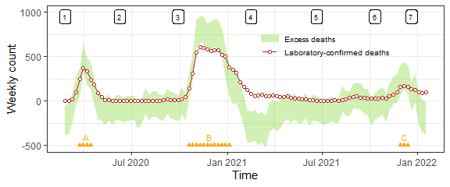

*Figure 1*. Comparing weekly counts of laboratory-confirmed deaths with weekly excess deaths over the 7 phases of the epidemic in Switzerland (shown at the top). Orange triangles on the bottom signal the three periods A, B and C of high excess mortality (defined as when the lower bound of excess mortality is greater than 0).

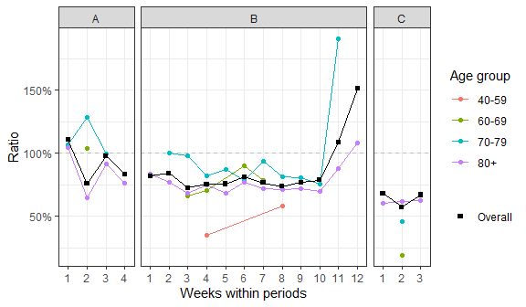

*Figure 2*. Ratio of laboratory-confirmed deaths over median excess deaths during the three periods of high excess mortality A, B and C. Only age groups with high excess mortality during a given week (i.e. the lower bound of excess mortality is above 0) are shown.

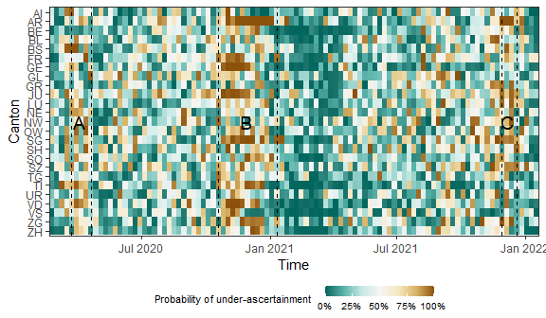

*Figure 3*. Probability that the number of laboratory-confirmed deaths is lower than the number of excess deaths in a given week by canton. The three periods of high excess mortality are highlighted.

References

[1] G. Konstantinoudis *et al.*, “Regional excess mortality during the 2020 covid-19 pandemic in five european countries,” *Nature Communications*, vol. 13, no. 1, pp. 1–11, 2022.

1. (1) Institute of Social and Preventive Medicine, University of Bern, Switzerland. (2) Federal Office of Public Health, Switzerland. (3) MRC Centre for Environment and Health, Department of Epidemiology and Biostatistics, School of Public Health, Imperial College London, London, UK. *[julien.riou@ispm.unibe.ch](mailto:julien.riou@ispm.unibe.ch)