Assessing real-world vaccine effectiveness against severe forms of SARS-CoV-2 infection from routine surveillance data in Switzerland

Nanina Anderegg (1,2), Samuel Colin (2), Anne Laube (2), Mirjam Mäusezahl (2), Biagio Zaffora (2), Christian L. Althaus (1), Anthony Hauser (1), Julien Riou (1,2,*)[1]

Report generated on Date: 2021-12-03 Time: 18:40

# Abstract

Vaccine effectiveness against severe forms of SARS-CoV-2 infection can be monitored using routine surveillance data including the vaccination status of COVID-19 hospitalizations and deaths and the dynamics of vaccine coverage in the country. In Switzerland, we find that the relative risk of COVID-19 related hospitalization is 12.5 (95%CI: 11.7 to 13.4) times higher for non-fully vaccinated than for fully vaccinated individuals. This translates into a vaccine effectiveness against hospitalization of 92.0% (95%CI: 91.4 to 92.5%). Effectiveness appears comparatively lower in age groups over 70, suggesting the importance of booster vaccinations. We find some evidence that the effectiveness is moderately waning over time. This approach could be implemented in most routine surveillance settings to monitor vaccine effectiveness in real time.

# Introduction

The continuous assessment of vaccine efficacy and effectiveness against SARS-CoV-2 is critically important for informing national vaccination campaigns and the public health response against the COVID-19 pandemic. Randomized controlled trials (RCT) are the gold standard to estimate vaccine efficacy against symptomatic infection, hospitalization and death. Several RCTs have reported high levels of efficacy for several SARS-CoV-2 vaccines [1][2]. For technical and ethical reasons, RCTs have limitations when it comes to estimate vaccine effectiveness in real world conditions and over longer periods of time[3][4]. Even though not ideal in terms of potential bias, observational data can be used to estimate vaccine effectiveness. When rich, longitudinal data is available (e.g. insurance data or cohort studies), it becomes possible to directly estimate and compare the risk of symptomatic infection, hospitalization or death in vaccinated and non-vaccinated individuals (adjusting for key characteristics) [5][6]. When the vaccination status of SARS-CoV-2-negative controls is collected, a test-negative design can be used [7][8].

Routine surveillance data often does not include any follow-up or control group. In Switzerland, routine surveillance data on COVID-19 only contains detailed information on reported confirmed cases, hospitalizations and deaths. Observing the proportion of vaccinated in surveillance reports can however be misleading as it is highly dependent on vaccine coverage [9]. Vaccine coverage can be heterogeneous and can vary by time, location and other characteristics, first of all age. In Switzerland, SARS-CoV-2 vaccination campaigns started in early 2021, first focusing on vulnerable groups (i.e. aged above 65 with comorbid conditions), then being gradually extended to younger age groups.

In this study, we use a reformulation of the screening method [10][11] to estimate vaccine effectiveness against severe forms of SARS-CoV-2 infection in real-world settings from routine surveillance data in Switzerland, accounting for the levels of vaccine coverage by week, age group and location. We also assess the variation in vaccine effectiveness by age, vaccine type, by calendar time and - importantly - by time since vaccination.

# Routine surveillance data

We consider all routine surveillance data on COVID-19-related hospitalizations and deaths received at the Federal Office of Public Health until 1 December 2021. This data includes vaccination status at the individual level, which accounts for the type of vaccine, the number of doses, and the existence of a previous positive test (supplementary appendix). The proportion of missing vaccination status among hospitalizations and deaths was high (30-60%) during the early months of 2021, but rapidly decreased to around 10%-15% from July, 2021 onward (supplementary Figure S1). Among all hospitalizations and deaths the proportion of fully-vaccinated has increased over time (Figure 1A). At the same time, vaccine coverage in the population has increased with differences by age groups (Figure 1B). There are also geographical differences in vaccine coverage and the type of vaccine used (Figure 1C).

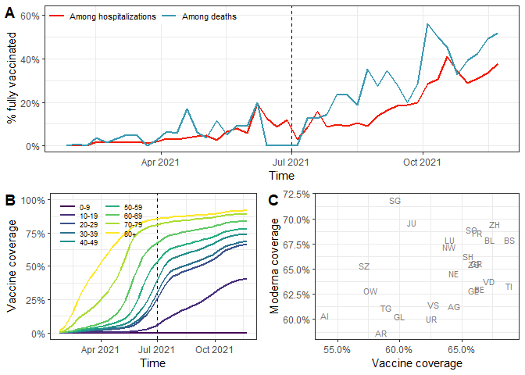

**Figure 1.** (A) Proportion of hospitalizations and deaths reported as fully vaccinated among all reported COVID-19-related hospitalizations and deaths. The dashed vertical line corresponds to the starting date of our analyses. (B) Evolution of vaccine coverage in the population by age group. (C) Cantonal differences regarding the overall vaccine coverage and the proportion of fully vaccinated individuals having received Moderna (as of one week before the end of the study period).

Due to the large proportion of missing vaccination status in the early months of 2021, we focus our analysis on the hospitalizations and deaths from 1 July 2021 to 1 December 2021. Delta was the dominant SARS-CoV-2 variant in Switzerland during this time period. This corresponds to a total of 5,948 hospitalizations and 739 deaths (Table 1). Of hospitalized individuals, 1,245 (21%) were reported as being fully vaccinated (Table 1). This number was 259 (35%) for deaths. Almost all individuals received the mRNA vaccines of Moderna or Pfizer-BioNtech. Vaccination status was missing for 834 (14%) of hospitalizations and 98 (13%) of deaths.

**Table 1.** Description of included COVID-19-related hospitalized and deceased persons from 1 July 2021 to 1 December 2021.

|  |  | Hospitalizations | Deaths |
| --- | --- | --- | --- |
|  | Total | 5,948 (100%) | 739 (100%) |
| Vaccination status | Fully vaccinated | 1,245 (21%) | 259 (35%) |
|  | Partially vaccinated | 69 (1%) | 6 (1%) |
|  | Not vaccinated | 3,800 (64%) | 376 (51%) |
|  | Missing | 834 (14%) | 98 (13%) |
| Age [years] | 0-9 | 115 (2%) | 0 (0%) |
|  | 10-19 | 57 (1%) | 0 (0%) |
|  | 20-29 | 224 (4%) | 1 (0%) |
|  | 30-39 | 516 (9%) | 4 (1%) |
|  | 40-49 | 773 (13%) | 8 (1%) |
|  | 50-59 | 1,050 (18%) | 44 (6%) |
|  | 60-69 | 999 (17%) | 80 (11%) |
|  | 70-79 | 993 (17%) | 138 (19%) |
|  | 80+ | 1,221 (21%) | 464 (63%) |
| Vaccine type (among fully vaccinated) | Moderna | 310 (25%) | 54 (21%) |
|  | Pfizer-BioNtech | 357 (29%) | 120 (46%) |
|  | Johnson-Johnson | 14 (1%) | 0 (0%) |
|  | Missing | 564 (45%) | 85 (33%) |
| Weeks since vaccination (among fully vaccinated) | 0 to 12 weeks | 88 (7%) | 17 (7%) |
|  | 13 to 24 weeks | 200 (16%) | 26 (10%) |
|  | 25+ weeks | 373 (30%) | 133 (51%) |
|  | Missing | 584 (47%) | 83 (32%) |

For this analysis, we aim at assessing the real-world vaccine effectiveness by studying the proportion of fully and non-fully vaccinated among hospitalizations and deaths while accounting for vaccine coverage. For the main analysis, we define non-fully vaccinated as individuals reported to be either non-vaccinated or partially-vaccinated. We exclude individuals with missing vaccination status. This assumes that vaccination status was missing at random (i.e. non-fully vaccinated individuals are equally likely to have missing vaccination status as fully vaccinated individuals). We do several sensitivity analyses. First, we multiply impute missing vaccination status based on age group, canton, week, and vaccination coverage. Second, we assume that all individuals with missing vaccination status are non-fully vaccinated (“Best case scenario”). Third, we assume that all individuals with missing vaccination status and all partially-vaccinated are fully-vaccinated (“Worst case scenario”).

# Assessing vaccine effectiveness

Here we focus on the relative risk of hospitalization ($RR$) among non-fully vaccinated individuals ($\overline{V}$) compared to fully vaccinated ($V$):

$$RR=\frac{\text{Pr}(H|\overline{V})}{\text{Pr}(H|V)}$$

where $\text{Pr}(H|\overline{V})$ refers to the probability of hospitalization given non-fully vaccinated status and $\text{Pr}(H|V)$ to the probability of hospitalization given fully vaccinated status. We propose a statistical model to estimate $RR$ while accounting for the dynamics of vaccine coverage over time, by age group and canton. The approach, which is detailed in the supplementary appendix, is equivalent to the screening method [10]. Briefly, we consider the expected probability that a hospitalized individual is vaccinated ($\text{Pr}(V|H)$) given the vaccination coverage at the time of hospitalization in the same age group and canton ($P(V)$), and given the value of $RR$:

$$\text{Pr}(V|H)=\frac{\text{Pr}(V)}{\text{Pr}(V)+RR(1−\text{Pr}(V))}.$$

We estimate the $RR$ by comparing the expected probability $P(V|H)$ to the actual vaccination status of every individual using a maximum likelihood approach. The $RR$ can also be expressed as a relative risk reduction ($1−1/RR$). This last quantity is closely related to vaccine effectiveness against hospitalization if we make the assumption that all the other factors influencing the risk of COVID-19 hospitalization (e.g. behavior or exposure) are independent from the vaccination status. This model also applies to vaccine effectiveness against death, and can be extended to assess variations in vaccine effectiveness across different groups.

# Relative risk of hospitalization or death

Accounting for vaccine coverage by week, age group and canton, we find that the $RR$ of hospitalization without full vaccination compared to full vaccination is 12.5 (95%CI: 11.7 to 13.4) (Figure 2A). This corresponds to a relative risk reduction against hospitalization (or vaccine effectiveness) of 92.0% (95%CI: 91.4 to 92.5%). This is in agreement with other studies about vaccine effectiveness of mRNA vaccines [12][13][14][15]. Results from sensitivity analyses with alternative handling of missing vaccination status ranged between $RR=$ 6.6 (95%CI: 6.2 to 7.0) and 15.7 (95%CI: 14.7 to 16.8). The relative risk of hospitalization decreases in older age groups. This could be linked to a weaker immune response in older people. It could also be indirect evidence of waning, as older age groups were vaccinated first. We also find a decrease of the relative risk of hospitalization over time, which also constitutes indirect evidence of waning. When stratifying by both age group and month, we find evidence for a decrease in $RR$ in October and November 2021 in age groups 70-79 and 80+, but inconclusive evidence for other age groups (supplementary Figure S3).

The $RR$ of death without full vaccination compared to full vaccination is 10.4 (95%CI: 8.8 to 12.2) (Figure 2B), corresponding to a relative risk reduction against death of 90.3% (95%CI: 88.6 to 91.8%). The $RR$ of death decreases for older ages and over time, which again constitutes indirect evidence of waning. However, the small number of deaths led to imprecise estimates with large confidence intervals.

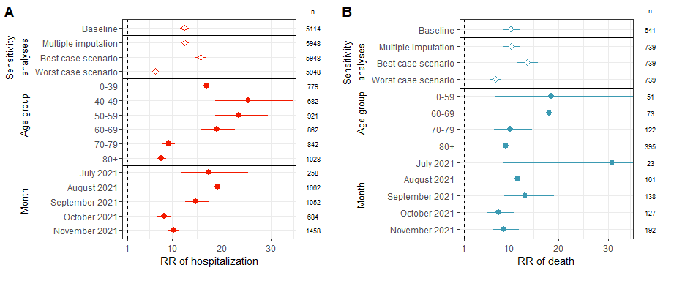

**Figure 2.** (A) Relative risk of COVID-19-related hospitalization for non-vaccinated individuals compared to vaccinated individuals in the baseline analysis, in three sensitivity analyses, by age group, and by month. (B) Relative risk of death for non-vaccinated individuals compared to vaccinated individuals in the baseline analysis, in three sensitivity analyses, by age group, and by month. Numbers correspond to sample sizes (n).

# Waning of vaccine effectiveness

To study direct evidence of waning, we restrict analyses only to fully vaccinated individuals with information about time since vaccination. We use the same methodological approach, this time comparing the proportions of individuals depending on the time since vaccination. The outcome of interest is then the relative change in the $RR$ of hospitalization compared to the reference group of individuals vaccinated for up to 12 weeks. Compared to the reference group, the $RR$ of hospitalization does not change when the time since vaccination is between 13 and 24 weeks, but increases by 1.5 (95%CI: 1.1 to 2.1) when the time since vaccination is above 25 weeks (Figure 3A). Because of missing data on time since vaccination, we could only estimate the relative change in RR. To give a sense of the effect size, this value of 1.5 would correspond to a reduction of vaccine effectiveness from 92 to 88% 25 weeks after vaccination. When stratifying by age group, this increase in the $RR$ of hospitalization 25 weeks after vaccination is only visible in the age group 60-69, and to a lesser extent in the age group 70-79, but not in the age group 80+ (Figure 3B). The scarcity of hospitalization data in the younger age groups does not allow for further stratification. We thus find some direct but inconclusive evidence of a moderate waning of vaccine effectiveness against hospitalization after 25 weeks, which is in agreement with data from Israel [16], Qatar [17] and New York state [18]. However, our findings are in contrast with other studies that showed considerably faster waning among older individuals after more than 6 months [19].

When stratifying by vaccine type, the increase in $RR$ of hospitalization appears for both Pfizer-BioNtech and Moderna (Figure 3C). Of note, the direct comparison of vaccine types suggests that Pfizer-BioNtech is associated with a slightly higher $RR$ of hospitalization than Moderna (relative change of 1.8 (95%CI: 1.5 to 2.1), supplementary Figure S4), as was shown in previous studies [13].

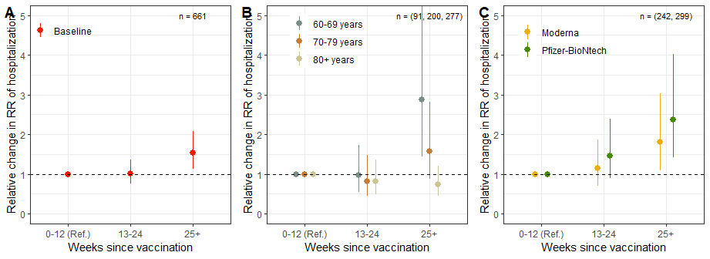

**Figure 3.** Change in the relative risk of COVID-19-related hospitalization depending on the time since vaccination in weeks (reference is 0 to 12 weeks), overall (panel A), by age group (panel B), and by vaccine type (panel C). Numbers correspond to sample sizes (n).

# Strengths and limitations

Applicable without control group or long follow-up times, the screening method uses individual data and reverse conditionality to estimate the relative risk of hospitalization or death for non-fully vaccinated compared to fully vaccinated, taking into account the dynamics of vaccine coverage by age group and location. This quantity can be estimated with uncertainty and using different stratifications, and is closely related to vaccine effectiveness.

Our approach relies on several assumptions. In order to interpret the $RR$ in terms of vaccine effectiveness, we assume that within a population of the same age group, in the same location and the same time frame, fully vaccinated and non-fully vaccinated individuals (1) are as likely to be exposed to the disease; (2) are as likely to be reported to surveillance authorities if they are hospitalized or deceased; and (3) are as likely to disclose their vaccination status if they are reported.

We do not account for other potential confounding factors associated to both vaccination and the risk of hospitalization or death besides age, time and location. For instance, vaccination coverage may be higher in individuals with comorbid conditions. This would lead to an underestimation of the overall $RR$ of hospitalization or death in our results. However, as people with comorbid conditions were initially prioritized in the vaccination campaigns, This bias could explain the comparatively higher $RR$ of hospitalization among people vaccinated for more than 25 weeks. Other potential confounding factors include occupation or socio-economic status [20]. We also do not account for increasing levels of natural immunity among non-vaccinated people as time passes, which would lead to an underestimation of effectiveness of vaccines.

# Conclusions

We assess real-world vaccine effectiveness against severe forms of SARS-CoV-2 infection from routine surveillance data in Switzerland, confirming the high effectiveness of mRNA vaccines from Moderna and Pfizer-BioNtech against hospitalization and death in all age groups. Effectiveness appears comparatively lower in age groups over 70, suggesting the importance of booster vaccinations. We find some evidence that the effectiveness is moderately waning over time. However, confounding by comorbid conditions and the increasing levels of natural immunity among non-vaccinated in time was not accounted for. Repeated analyses will be able to better assess waning and the effect of boosters. This approach could be implemented in most routine surveillance settings to monitor vaccine effectiveness in real time.

# References

[1] F. P. Polack *et al.*, “Safety and efficacy of the bnt162b2 mRNA covid-19 vaccine,” *New England Journal of Medicine*, 2020.

[2] L. R. Baden *et al.*, “Efficacy and safety of the mRNA-1273 sars-cov-2 vaccine,” *New England Journal of Medicine*, vol. 384, no. 5, pp. 403–416, 2021.

[3] S. J. W. Evans and N. P. Jewell, “Vaccine effectiveness studies in the field,” *New England Journal of Medicine*, vol. 385, no. 7, pp. 650–651, 2021, doi: [10.1056/NEJMe2110605](https://doi.org/10.1056/NEJMe2110605).

[4] M. K. Patel *et al.*, “Evaluation of post-introduction covid-19 vaccine effectiveness: Summary of interim guidance of the world health organization,” *Vaccine*, 2021.

[5] N. Dagan *et al.*, “BNT162b2 mRNA covid-19 vaccine in a nationwide mass vaccination setting,” *New England Journal of Medicine*, vol. 384, no. 15, pp. 1412–1423, 2021, doi: [10.1056/NEJMoa2101765](https://doi.org/10.1056/NEJMoa2101765).

[6] B. Nunes *et al.*, “MRNA vaccine effectiveness against covid-19-related hospitalisations and deaths in older adults: A cohort study based on data linkage of national health registries in portugal, february to august 2021,” *Eurosurveillance*, vol. 26, no. 38, p. 2100833, 2021.

[7] J. L. Bernal *et al.*, “Effectiveness of the pfizer-biontech and oxford-astrazeneca vaccines on covid-19 related symptoms, hospital admissions, and mortality in older adults in england: Test negative case-control study,” *bmj*, vol. 373, 2021.

[8] E. Kissling *et al.*, “Vaccine effectiveness against symptomatic sars-cov-2 infection in adults aged 65 years and older in primary care: I-move-covid-19 project, europe, december 2020 to may 2021,” *Eurosurveillance*, vol. 26, no. 29, p. 2100670, 2021.

[9] W. H. Organization, “Evaluation of covid-19 vaccine effectiveness,” *INTERIM GUIDANCE*, 2021.

[10] C. Farrington, “Estimation of vaccine effectiveness using the screening method,” *International journal of epidemiology*, vol. 22, no. 4, pp. 742–746, 1993.

[11] C. Mazagatos *et al.*, “Effectiveness of mRNA covid-19 vaccines in preventing sars-cov-2 infections and covid-19 hospitalisations and deaths in elderly long-term care facility residents, spain, weeks 53 2020 to 13 2021,” *Eurosurveillance*, vol. 26, no. 24, p. 2100452, 2021.

[12] S. Y. Tartof *et al.*, “Effectiveness of mRNA bnt162b2 covid-19 vaccine up to 6 months in a large integrated health system in the usa: A retrospective cohort study,” *The Lancet*, vol. 398, no. 10309, pp. 1407–1416, 2021.

[13] W. H. Self *et al.*, “Comparative effectiveness of moderna, pfizer-biontech, and janssen (johnson & johnson) vaccines in preventing covid-19 hospitalizations among adults without immunocompromising conditions-united states, march–august 2021,” *Morbidity and Mortality Weekly Report*, vol. 70, no. 38, p. 1337, 2021.

[14] J. Lopez Bernal *et al.*, “Effectiveness of covid-19 vaccines against the b. 1.617. 2 (delta) variant.” *N Engl J Med*, pp. 585–594, 2021.

[15] K. Bruxvoort *et al.*, “Effectiveness of mRNA-1273 against delta, mu, and other emerging variants,” *medRxiv*, 2021.

[16] Y. Goldberg *et al.*, “Waning immunity after the bnt162b2 vaccine in israel,” *New England Journal of Medicine*, 2021.

[17] H. Chemaitelly *et al.*, “Waning of bnt162b2 vaccine protection against sars-cov-2 infection in qatar,” *New England Journal of Medicine*, 2021.

[18] E. S. Rosenberg *et al.*, “Covid-19 vaccine effectiveness in new york state,” *New England Journal of Medicine*, vol. 0, no. 0, p. null, doi: [10.1056/NEJMoa2116063](https://doi.org/10.1056/NEJMoa2116063).

[19] P. Nordström, M. Ballin, and A. Nordström, “Effectiveness of covid-19 vaccination against risk of symptomatic infection, hospitalization, and death up to 9 months: A swedish total-population cohort study,” *Hospitalization, and Death Up to*, vol. 9, 2021.

[20] J. Riou *et al.*, “Socioeconomic position and the covid-19 care cascade from testing to mortality in switzerland: A population-based analysis,” *The Lancet Public Health*, vol. 6, no. 9, pp. e683–e691, 2021.

1. (1) Institute of Social and Preventive Medicine, University of Bern, Switzerland. (2) Federal Office of Public Health, Switzerland. *[julien.riou@ispm.unibe.ch](mailto:julien.riou@ispm.unibe.ch)