# Chicago Police Officer Work Assignment Data 2012 - 2015

## Why do we trust the data?

1. The work assignment data come directly from a FOIA request of the Chicago Police Department (CPD) (Ba et al. 2021, Appendix S1.2).
2. There is a high degree of regularity in officer work assignments and placements.
   * During this 4-year period, most officers (~70%) only ever work for 1 unit. ~20% only ever work for 2 units.
   * The median police officer works their most common work assignment 50% of the time.
   * The median police officer works only 13 unique work assignments across this 4-year period.
   * On average, a police officer is assigned to 4 (usually 9-hour) work assignments per week.
   * These are *conservative estimates* of the regularity in police officer work assignments.
     + We define work assignments as: a unit, a alphanumeric beat code (i.e., a location), and a shift (i.e., morning, afternoon, evening).
     + E.g.,

|  |  |  |  |  |
| --- | --- | --- | --- | --- |
| **Officer ID** | **Assigned Unit** | **Assigned Beat** | **Shift Timing** | **Work Assignment ID** |
| 3325 | 1 | 102A | Morning | 1 (Unit + Beat + Shift) |
| 3325 | 1 | 102 | Morning | 2 |
| 3326 | 2 | 102A | Morning | 3 |

* + - One could argue a work assignment should not include the officer’s assigned unit. Usually a beat is unit-specific, but there are a few cases where a beat is shared by multiple units. Regardless of the unit, officers assigned to the same beat at the same time will be working together. Under this definition, the 1st and 3rd rows would be the same work assignment.
    - One could also argue work assignments should should only consider the *numeric* portion of the beat code. It is a bit complicated, but generally speaking, the numeric portion of the beat code designates the task/location, and the letter portion designates the (rotating) squad to work that beat. Generally, there is overlap between squads working the same beat at the same time. Under this definition, the 1st and 2nd rows would be the same work assignment.

1. Officers work together with other officers work the same work assignment.
   1. ~80% of stops involving more than one officer occurred between officers in the same work assignment. ~70% of arrests involving more than one officer occurred between officers in the same work assignment.
2. We can link the officer data to other CPD data such as from the Invisible Institute. The match rate is not 100% (but is very close, around 95% - 99%). We could use this extra data to further confirm our findings.

## Reasons for being skeptical of the data

1. This is not a cause for concern per se, but we want to make clear that linking a stop or an arrest to a specific officer while they were working a specific work assignment is not a clean matching process. It involves some data cleaning decisions. This is because there is no event-level ID so to speak. We must make use of when/where a stop/arrest happened as well as which officer made the stop/arrest, and use this information to match to a specific officer and a specific work assignment.
   1. If a police officer is missing their start/end times for their work assignment or the stop/arrest data is missing their time, matching is generally not possible. Thankfully, this does not affect too many work assignments or stops/arrests, but it is something to be aware of.
   2. Additionally, many stops/arrests do not seem to have occurred while a police officer had a work assignment. We are not sure what this means. Was the officer off-duty? Is there work assignment missing from the data? Were they working as part of a group that does not use the work assignment process (so they would not show up in the data)? When we include these stops/arrests which seemingly did not happen during an officer’s work assignment in the stop/arrest analysis, ~50% of stops involving more than one officer occurred between officers in the same work assignment, and ~40% of arrests involving more than one officer occurred between officers in the same work assignment. The hope is that data from other sources might be able to help us make sense of what these other officers were doing if they did not have a work assignment.
2. The beat codes are messy. Generally speaking, you would imagine that the numeric portion of each beat code corresponds to a real, physical beat location. They do in some cases but not all, and we do not have a dictionary or code book available to tell us what these numeric beat codes might mean. Additionally, there definitely appear to be typos in the beat codes themselves or very non-standard beat codes (e.g., S1174S, TIME508A). The good news is most beat codes are standardized, but it will require some cleaning to determine which beat codes to keep and which to throw away/collapse.

## Initial Analyses and Research Questions

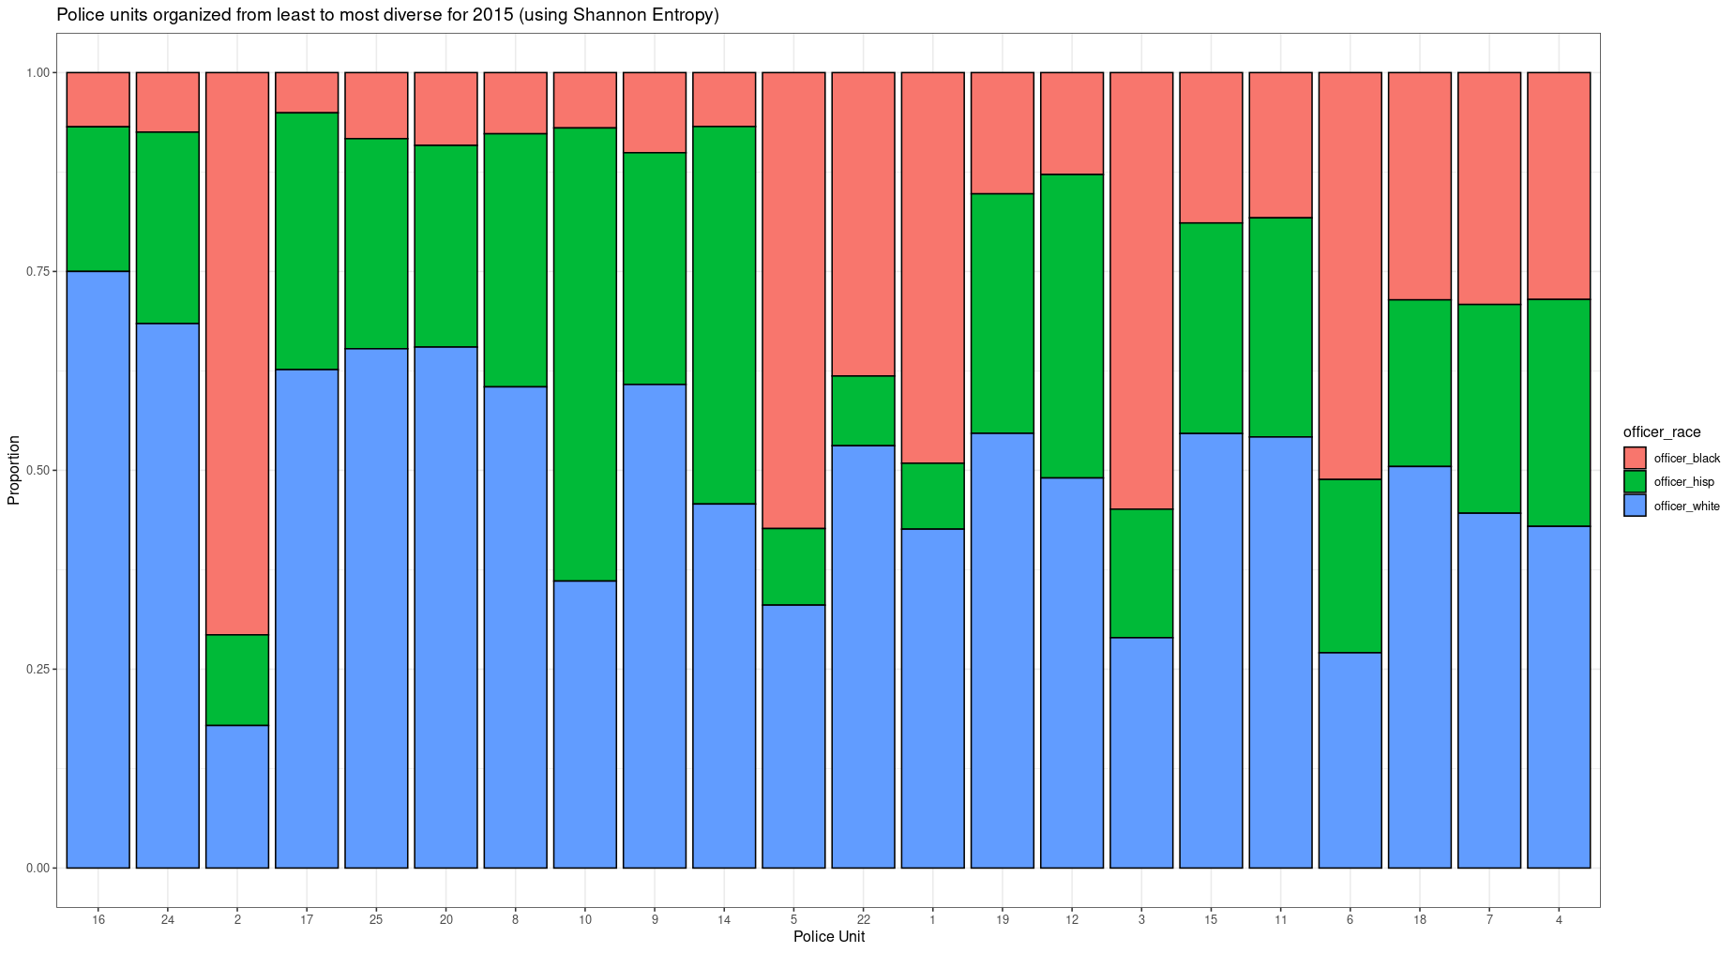

This graph shows the racial diversity (as measured by Shannon entropy) of each police unit in the CPD (for the year 2015) by looking at the racial breakdown of all officers who worked in that unit. Notice there is considerable variation in officer racial diversity across units. One potential limitation of using Shannon entropy as a diversity measure is that it treats all racial groups as the same. So notice unit 2 which has a very high proportion of Black officers is not considered very diverse. Rather than diversity, it might be said the Shannon entropy is measuring homogeneity.

However, the thrust of our interest is in how does segregation complicate diversity. Might very diverse units be the most segregated? Or perhaps it is the other way around and the least diverse units are the most segregated? In particular, we are interested in how units might be segregated on the basis of officer work assignments. The intuition being perhaps a unit is relatively diverse (unit 4), but this surface-level diversity hides how only White officers work with White officers, Black officers only work with Black officers, etc. This document focuses on officer for now, but we would eventually like to expand it to officer sex and officer work experience.

We can calculate the segregation of police units on the basis of these work assignments using the Theil Index. The Theil Index is the weighted average deviation of each work assignment’s entropy from the unit-wide entropy expressed as a fraction of the unit’s total entropy. Interpreting the index in the segregation context, if it has a value of 0, then all work assignments have the same composition as their unit (maximum integration). If it has a value of 1, then all work assignments contain one racial group only and are thus is maximally different from the unit-wide composition (maximum segregation).

The Theil Index across all police units on the basis of work assignments is: 0.375 which indicates moderate segregation. How much is police unit contributing to this total segregation, though? And are more segregated units more diverse?

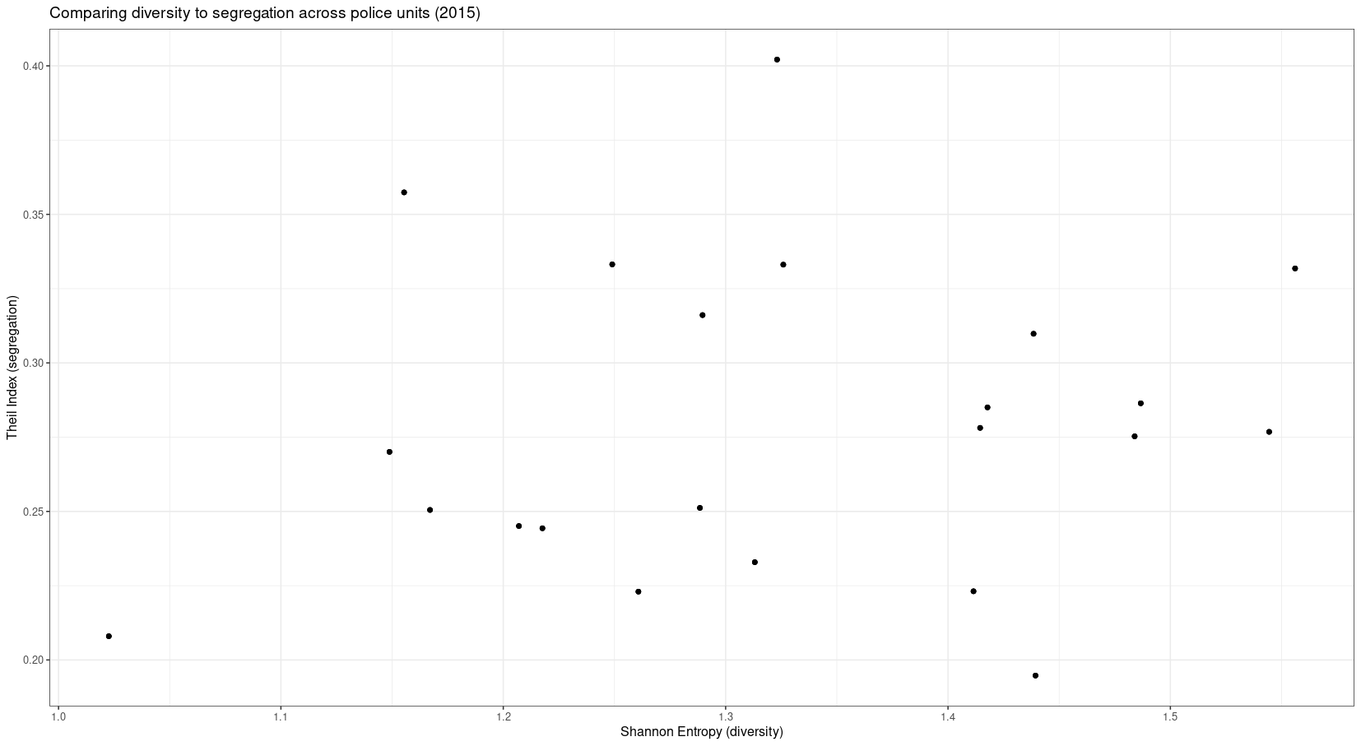

Units with higher entropy are more diverse and units with a higher Theil Index are more segregated. So the upper right hand quadrant would be highly diverse but highly segregated units. The bottom right hand quadrant would be highly diverse and not segregated. The upper left hand quadrant would be not very diverse yet still very segregated. The bottom left hand quadrant would be not very diverse and not very segregated. As we can see, diversity has a weak relationship with segregation (Pearson correlation coefficient = 0.15). So expanding upon Linda’s previous work, studies which look at surface-level diversity without considering segregation, are missing an important part of the picture.

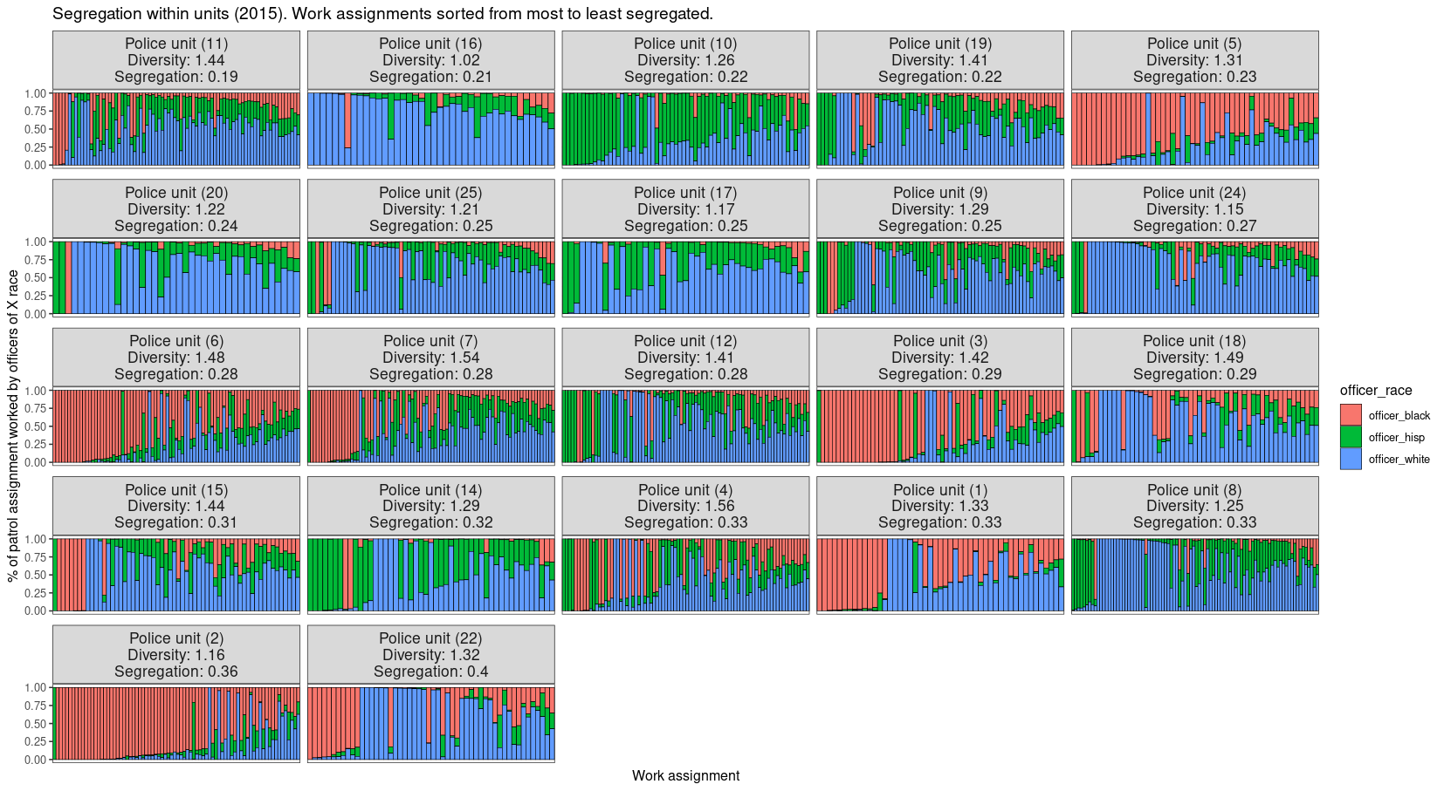

To drive this all home, see the above plot. The x-axis are work assignments and the y-axis is the proportion of each racial group which works each work assignment. Then the work assignments are divided by unit. This allows us to see qualitatively how diversity and segregation are related and how this then relates to the changing racial makeup of the officers who work shift assignments. For example, consider unit 19 and unit 4. Both are relatively diverse although unit 19 is a bit less diverse than unit 4. However, unit 19 has much less segregation, and its work assignments are more racially integrated.

Our main research questions are on the basis of these descriptive, visual results:

1. How does working in a segregated unit affect an officer’s behavior? Might it counteract the expected benefits which are supposed to come with diversification?
2. How do work assignments constrain network activity? To what extent do homogeneous (heterogeneous) work assignments contribute to network segregation (integration)? For example, we can make an arrest network where a tie represents two officers having made an arrest together. We can decompose the network on the basis of if officers worked together. If we see it is mostly officers who worked together who make arrests together, then to the extent that work assignments are homophilous (or heterophilous), then that is the extent to which work assignments enforce network-wide homophily (or heterophily).
3. We can break down work assignments even further into their various shift timings to understand if *within work assignments* are officers segregated?