（5）Carbon Tax

Survey results indicate that over 60% of respondents perceive significant challenges across four key dimensions: technical, economic, social, and institutional/policy. Notably, public awareness of carbon taxes and prerequisite conditions for implementation remain underdeveloped

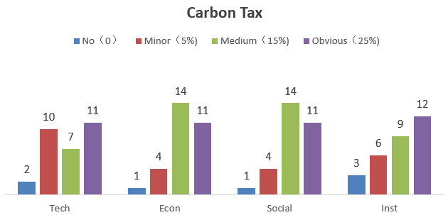

Fig6 carbon tax