Table of Contents

[Aim of This Document 2](#_Toc370894288)

[Installation 2](#_Toc370894289)

[What’s Included? 2](#_Toc370894290)

[Locations 2](#_Toc370894291)

[Windows 7 2](#_Toc370894292)

[Windows XP 2](#_Toc370894293)

[Installing the Add-in 2](#_Toc370894294)

[Using the SimulEICon Add-In 3](#_Toc370894295)

[Startup 4](#_Toc370894296)

[Viewing Previous Results 4](#_Toc370894297)

[Defining Component and Precedence Files for Optimization 6](#_Toc370894298)

[Creating the Component File 6](#_Toc370894299)

SimulEICon Multi-Objective Decision-Support Tool for Autodesk Revit 2012

# Aim of This Document

This document contains information on the purpose and usage of the ***SimulEICon Multi-Objective Decision-Support Tool*** add-in for Autodesk Revit. For more information, please visit <http://web.eng.fiu.edu/~zhuy/BESI/Research/tcei.html>

# Installation

## What’s Included?

You can download a zip file from <http://web.eng.fiu.edu/~zhuy/BESI/Research/tcei.html>. It contains the following files:

* Add-in manifest file
* Add-in DLL file
* NSGAII executable

## Locations

In order to use the add-in, you will need to move certain files into an appropriate location. Below, example Revit Add-in locations are given for different Windows versions.

### Windows 7

* “C:\ProgramData\Autodesk\Revit\Addins\2012\”

### Windows XP

* “C:\Documents and Settings\All Users\Application Data\Autodesk\Revit\Addins\2012\”

## Installing the Add-in

1. Extract the zip archive (downloadable at <http://web.eng.fiu.edu/~zhuy/BESI/Research/tcei.html>).
2. Place the Add-in DLL file in the desired location (e.g. “C:\Program Files\Autodesk\”)
3. Edit the Add-in manifest file to point to the DLL location. (See )
   1. Set the both **<Assembly>** tag values to the path to the DLL file chosen in the previous step.
4. Place the Add-in manifest file in the appropriate location. (See section)

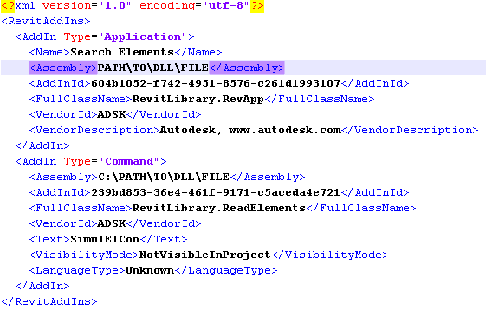

Figure

# Using the SimulEICon Add-In

revit2012_ribbon.pngOnce installed, the SimulEICon add-in will be available from the Add-Ins tab of the ribbon. Figure 2 shows the tab within the ribbon. shows the SimulEICon button available within the Add-ins tab choices. **Note:** At this time, in order to select the SimulEICon button, a Revit model must be open. While viewing previous results does not require a model, using any other functionality does.

Figure

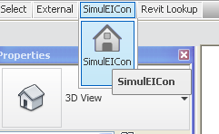

Figure

## Startup

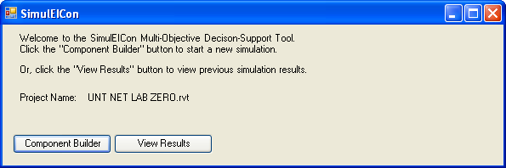The main window of the Add-in displays the current model name and allows users to view previous simulation results, or begin using the primary functionality. shows the main window.

Figure

## Viewing Previous Results

To view previous simulation results, click on the “View Results” button in the main window. The user will be prompted for a results file, which is in the XML file format. Once selected, you may view the list of the resulting projects from the simulation. shows an example set of results.

Selecting a single project will display basic information about it, including its name and estimated objective values. Listed projects can also be sorted in ascending order based on one of three objectives: time, cost, or environmental impact (EI). Users can also view scatter plot graphs comparing the different objectives. shows the different graphs available.

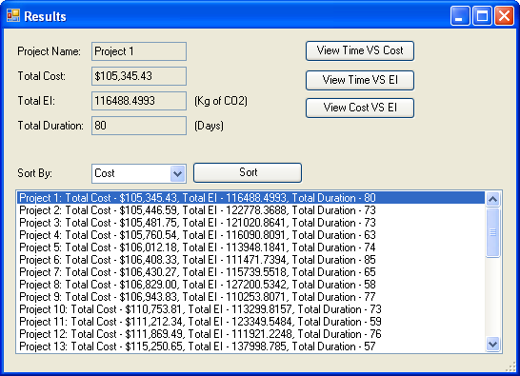

Figure

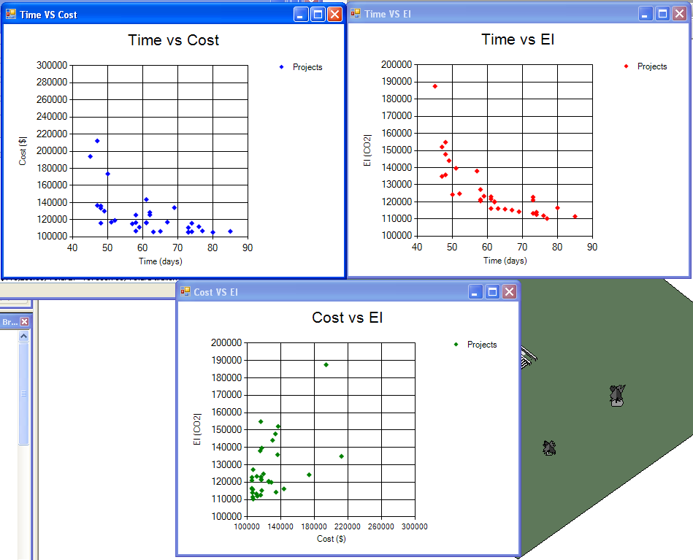

Figure

## Defining Component and Precedence Files for Optimization

SimulEICon attempts to find a set of solutions that optimize three objectives: time, cost, and EI. Valid solutions are “balanced”, meaning that no one solution completely beats out another in all three objectives. The objectives in this case aim to be minimized. The lower the time, cost, and environmental impacts are, the more optimal the solution. The NSGA-II[[1]](#footnote-2) is currently used to solve this multi-objective optimization problem.

In order to use the NSGA-II algorithm, two primary files require definition by the user. The first contains a set of components (or activities) based on the selected BIM model. For each component, one or more options may be selected. Each option contains information about itself, including estimated time, cost and EI. The second file contains the precedence order of the defined components. This is similar to a project schedule. It is used to help calculate the total duration of a project (one of the objectives) based on the time needed for each individual component.

A third, optional file may also be specified by the user. This file is used to incorporate EnergyPlus[[2]](#footnote-3) energy simulation data into cost and EI calculations for projects. If this file is included, it is assumed that energy simulation data already exists and can be referenced.

The following sections give details on the functionalities available to help users define these files.

### Creating the Component File

1. For more information on NSGA-II, please see: <http://ieeexplore.ieee.org/xpls/abs_all.jsp?arnumber=996017> . [↑](#footnote-ref-2)
2. Visit [here](http://apps1.eere.energy.gov/buildings/energyplus/?utm_source=EnergyPlus&utm_medium=redirect&utm_campaign=EnergyPlus%2Bredirect%2B1) for information about EnergyPlus. [↑](#footnote-ref-3)