**Title**

Speech intelligibility: A generalized latent variable approach on utterances’ transcriptions

**Abstract**

*Intelligibility* is defined as “the extent to which a speaker’s message is understood by the listener” [15]. Its attainment carries an important societal value, as it is a milestone in language development [4]. For its measurement, orthographic transcriptions of utterances are used to construct an entropy score, which express the degree of (dis)agreement in such transcriptions [2,22]. However, although the benefits of using transcriptions to (indirectly) quantify *intelligibility* are clear [1,2,7], the statistical procedures used to model such data are not as sophisticated as the measurement procedures.

Consequently, we propose a novel data analysis using a Bayesian implementation of the Generalized Linear Latent and Mixed Model (GLLAMM) [17,18,19,20,23]. The statistical procedure offers four benefits. First, it allows to model the bounded entropy data. Second, it ‘constructs’ a speaker’s latent *intelligibility* scale. Third, it test our research hypothesis at the appropriate level. And fourth, it avoids ‘manufacturing’ false confidence in the parameter estimates, producing correct statistical inferences [11].

As a resultwe find that, not modeling the bounded nature of the data could lead us to an overestimation of the parameter estimates’ precision. For our hypothesis, we see that HI/CI children with genetic etiology have similar levels of *intelligibility* as NH kids, at ‘hearing ages’ of five. However, children with other etiologies have a significantly lower levels of *intelligibility*, at same ages. Moreover, we find that NH children develop their *intelligibility* with each ‘hearing year’ at a higher rate than HI/CI kids, contrary to what was previously found [2].

**Summary**

*Intelligible* spoken language requires all core components of speech perception, cognitive processing, linguistic knowledge, and articulation to be mastered [5]. In that sense, its attainment carries an important societal value, as it is considered a milestone in children’s language development; and more practically, it is qualified as the ultimate checkpoint for the success of speech therapy, and the ‘gold standard’ for assessing the benefit of cochlear implantation [4].

But what is *speech intelligibility*?. *Intelligibility* can be broadly defined as “the extent to which a speaker’s message is actually understood by the listener” [15]. But in a more narrow sense, it refers to the listener’s ability to successfully identify (decode) the words in a message [5,9,26,28]. The latter definition is more helpful, as it sets a clear contrast with comprehensibility, which involves the listener’s ability to understand the message, and its intent [12,24].

However, indifferent of its broad or narrow definition, the literature reveals that *intelligibility* can be further compromised by features of the communicative environment, such as noise [13]; by features of the speaker, like speaking rate [14] or accent [8,16]; or features of the listener, like vocabulary mastery [27]. Moreover, the latter emphasizes its highly dynamic nature, where changes in *intelligibility* stem from online adaptations of the speaker, to the listener and/or the context.

Therefore, we can say that *speech* *intelligibility* generates considerable interest for its societal value, but its measurement poses interesting challenges, particularly because of its entanglement with other features of communication.

Considering the previous, the literature suggests two perspectives from which *intelligibility* can be assessed: the message and the listener’s perspective [1,2]. The ﬁrst, also known as acoustic studies, is focused on assessing separately particular characteristics of the speech samples, e.g. their pitch, duration, stress, or the articulation of vowels and consonants [21]. Whereas the second, also known as perceptual studies, is centred on making holistic assessments of the speech stimuli, e.g. measuring their overall quality [1,2]. The former is justified by the fact that by using speech samples, we can detect articulatory, acoustic, and auditory characteristics of *intelligible* utterances. In contrast, the latter is justified by the notion that *intelligibility* is a concept ‘that everyone can judge’, but can only be measured indirectly [6,25].

Focusing our attention on perceptual studies, ‘objective’ rating methods on children’s utterances recovered from spontaneous speech tasks, have received special attention [2,7]. In these methods, listeners transcribe children’s utterances orthographically (or phonetically), and use these transcriptions as information to construct an intelligibility score; more precisely, an entropy score that expresses the degree of (dis)agreement in the transcriptions [2,22]. As a result, we obtain scores that are clustered and bounded in nature. Clustered because we get multiple measurements per child (one per utterance), and bounded because their values are in the continuum between zero and one.

Therefore, ‘objective’ rating methods try to infer *intelligibility* from the extent to which a set of transcribers can identify the words contained in the utterances [2]. In other words, we get a ‘proxy’ measure of the speaker’s *intelligibility* as judged by a listener, a snapshot of his/her performance under a specific set of circumstances [7]. Moreover, the epistemological certainty in such a ‘snapshot’ as a measure of *intelligibility* stems from the design and steps taken to collect the data.

However, although the literature is clear on the benefits of ‘objective’ rating methods to (indirectly) quantify *intelligibility* [1,2,7], we notice the statistical procedures used to model such data are not at par with the measurement procedure’s sophistication.

Previous research has considered the clustered nature of the data but ignored its bounded nature, where averaging was considered a ‘valid’ option for modelling [2]. We argue that the latter practice is not appropriate, as with bounded data not only the location (average), but also the spread (variance) of the distribution, might inform about the speaker’s *intelligibility* [10].

Furthermore, in order to understand or intervene on the factors that drives *speech intelligibility*, first one needs to ‘construct an error free’ *intelligibility* scale [3], a characteristic not possessed by the entropy measures nor its averages.

Considering all of the above, we propose a novel analysis of the entropy data using a Bayesian implementation of the Generalized Linear Latent and Mixed Model (GLLAMM) [17,18,19,20,23]. The statistical procedure oﬀers four benefits. First, it allows to appropriately model the bounded entropy data. Second, it provides a way to ‘construct’ the speaker’s latent *intelligibility* scale. Third, it allow us to test our research hypothesis at the appropriate level. And fourth, as a result from the first two, we successfully avoid producing false conﬁdence in the parameter estimates, which help us to produce correct statistical inferences [11].

XXX Here is the place where you could highlight how this study will look like. For instance, we will do this by revisiting the data of a recently published paper and step by step argue how this data could be approached with this model. We will demonstrate how the model is applied and the type of insights and conclusions that can come from applying this model to answer the question on impact of hearing status and hearing age on the intelligibility of …

###

From here you are writing indeed a short summary of the findings, something different from what would come into an introduction 😉

We ﬁnd the proposed method bring new insights about the use of replicated entropy scores to measure *intelligibility*, and on how some factors affect the (under)development of children’s *intelligibility*.

On the one hand the method reveal that, not integrating the bounded nature of the data in the modeling procedure could lead us to wrongful statistical conclusions (see Figure 2). More precisely, it could lead us to an overestimation of the parameter estimates’ precision.

Lastly, our hypothesis tests reveal that hearing impaired children with cochlear implants (HI/CI) and genetic etiology have similar levels of *intelligibility* as normal hearing kids (NH), when both groups have a ‘hearing ages’ of five. However, the same cannot be said for children with other etiologies, like CMV infection or other causes, as they start a significantly lower level of *intelligibility* at same ‘ages’(see Table 2). Moreover, our tests found enough evidence to assert that NH children develop their *intelligibility* with each ‘hearing year’ at a higher rate than HI/CI kids. This offer evidence contrary to what was previously found [2].

Finally, we observe our results support the hypothesis that HI/CI children with severe hearing loss, as accounted by the pure tone average, develop their language at a slower rate than their NH counterparts.

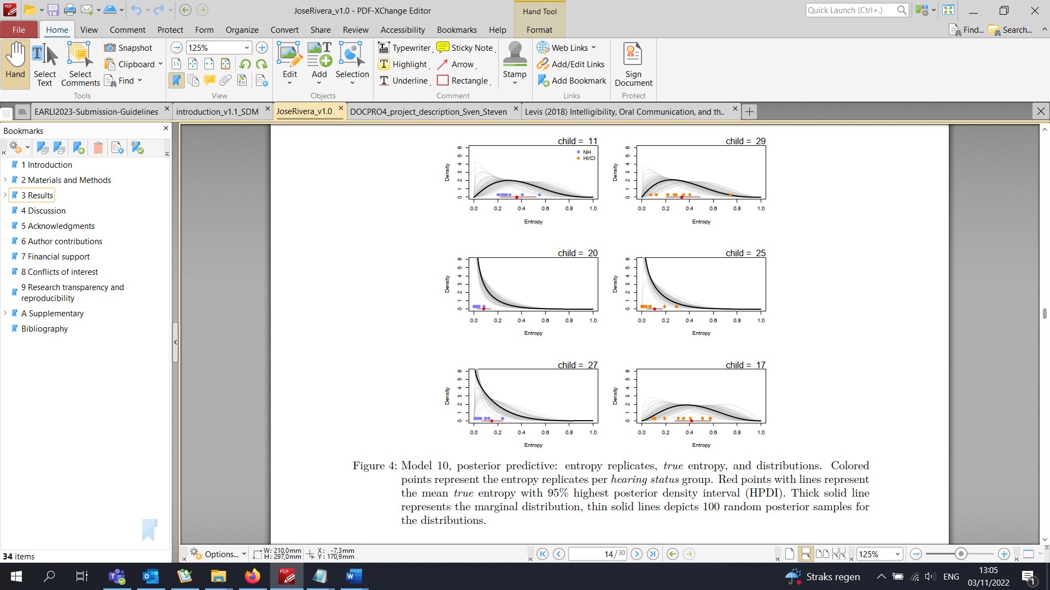

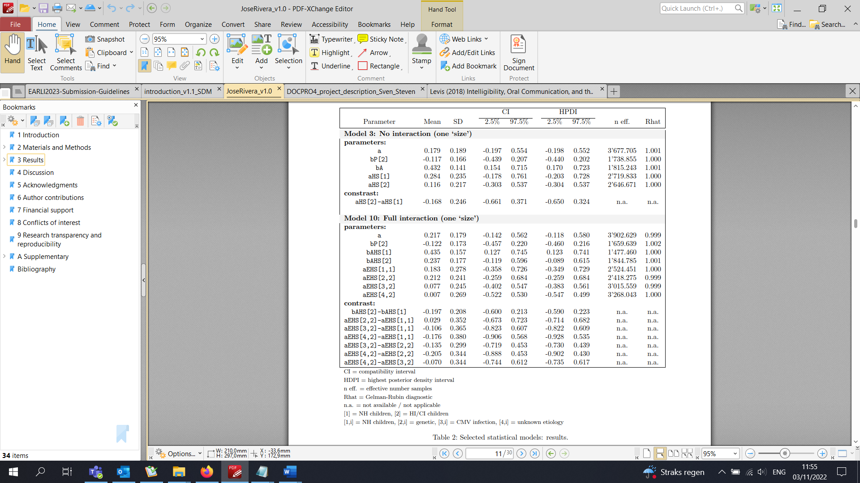

[1] Boonen, N., Kloots, H. and Gillis, S. [2020]. Rating the overall speech quality of hearing-impaired children by means of comparative judgements, Journal of Communication Disorders 83: 1675-1687. doi: <https://doi.org/10.1016/j.jcomdis.2019.105969>.

[2] Boonen, N., Kloots, H., Nurzia, P. and Gillis, S. [2021]. Spontaneous speech intelligibility: early cochlear implanted children versus their normally hearing peers at seven years of age, Journal of Child Language pp. 1-26. doi: <https://doi.org/10.1017/S0305000921000714>.

[3] Carroll, J. [2006]. Measurement error in nonlinear models: a modern perspective, Chapman and Hall/CRC. doi: <https://doi.org/10.1201/9781420010138>.

[4] Chin, S., Bergeson, T. and Phan, J. [2012]. Speech intelligibility and prosody production in children with cochlear implants, Journal of Communication Disorders 45: 355-366. doi: <https://doi.org/10.1016/j.jcomdis.2012.05.003>.

[5] Freeman, V., Pisoni, D., Kronenberger, W. and Castellanos, I. [2017]. Speech intelligibility and psychosocial functioning in deaf children and teens with cochlear implants, Journal of Deaf Studies and Deaf Education 22(3): 278-289. doi: <https://doi.org/10.1093/deafed/enx001>.

[6] Guilford, J. (1954). Psychometric methods. New York: McGraw-Hill.

[7] Hustad, K., Mahr, T., Natzke, P. and Rathouz, P. [2020]. Development of speech intelligibility between 30 and 47 months in typically developing children: A cross-sectional study of growth, Journal of Speech, Language, and Hearing Research 63(6): 1675-1687. doi: <https://doi.org/10.1044/2020JSLHR−20−00008>. url : <https://pubs.asha.org/doi/abs/10.1044/2020JSLHR−20−00008>.

[8] Jenkins, S. [2000]. Cultural and Linguistic Miscues: A Case Study of International Teaching Assistant and Academic Faculty Miscommunication. International Journal of Intercultural Relations, 24: 477-501.   
doi: <https://doi.org/10.1016/S0147-1767(00)00011-0>.

[9] Kent, R., Weismer, G., Kent, J. and Rosenbek, J. [1989]. Toward phonetic intelligibility testing in dysarthria, Journal of Speech and Hearing Disorders 54(4): 482-499. doi: <https://doi.org/10.1044/jshd.5404.482>.

[10] McCullagh, P. and Nelder, J. [1983]. Generalized Linear Models, Monographs on Statistics and Applied Probability, Routledge. doi: <https://doi.org/10.1201/9780203753736>.

[11] McElreath, R. [2020]. Statistical Rethinking: A Bayesian Course with Examples in R and STAN, Chapman and Hall/CRC.

[12] Munro, M. & Derwing, T. [1995]. Foreign Accent, Comprehensibility, and Intelligibility in the Speech of Second Language Learners. Journal of Language Learning 45(1). doi: <https://doi.org/10.1111/j.1467-1770.1995.tb00963.x>

[13] Munro, M. [1998]. The effects of noise on the intelligibility of foreign-accented speech. Studies in Second Language Acquisition, 20: 139-154. doi: <https://doi.org/10.1017/S0272263198002022>.

[14] Munro, M. & Derwing, T. [1998], The Effects of Speaking Rate on Listener Evaluations of Native and Foreign-Accented Speech. Language Learning, 48: 159-182. doi: <https://doi.org/10.1111/1467-9922.00038>

[15] Munro, M. & Derwing, T. [1999], Foreign Accent, Comprehensibility, and Intelligibility in the Speech of Second Language Learners. Language Learning, 49: 285-310. <https://doi.org/10.1111/0023-8333.49.s1.8>, pp. 289.

[16] Ockey, G. & Papageorgiou, S. & French, R. [2016]. Effects of Strength of Accent on an L2 Interactive Lecture Listening Comprehension Test. International Journal of Listening, 30(1-2): 84-98. doi: <https://doi.org/10.1080/10904018.2015.1056877>.

[17] Rabe-Hesketh, S., Skrondal, A. and Pickles, A. [2004a]. Generalized multilevel structural equation modeling, Psychometrika 69(2): 167-190. doi: <https://www.doi.org/10.1007/BF02295939>.

[18] Rabe-Hesketh, S., Skrondal, A. and Pickles, A. [2004b]. GLLAMM Manual, UC Berkeley Division of Biostatistics. url: <http://www.biostat.jhsph.edu/fdominic/teaching/bio656/software-gllamm.manual.pdf>.

[19] Rabe-Hesketh, S., Skrondal, A. and Pickles, A. [2004c]. Maximum likelihood estimation of limited and discrete dependent variable models with nested random eﬀects, Journal of Econometrics 128(2): 301-323. doi: <https://www.doi.org/10.1016/j.jeconom.2004.08.017>. url: <http://www.sciencedirect.com/science/article/pii/S0304407604001599>.

[20] Rabe-Hesketh, S., Skrondal, A. and Zheng, X. [2012]. Multilevel structural equation modeling, in R. Hoyle (ed.), Handbook of Structural Equation Modeling, The Guilford Press, chapter 30, pp. 512-531.

[21] Rowe, B. and Levine, D. [2018]. A Concise Introduction to Linguistics, Routledge.

[22] Shannon, C. [1948]. A mathematical theory of communication, The Bell System Technical Journal 27(3): 379-423. doi: <https://doi.org/10.1002/j.1538-7305.1948.tb01338.x>.

[23] Skrondal, A. and Rabe-Hesketh, S. [2004]. Generalized Latent Variable Modeling: Multilevel, Longitudinal, and Structural Equation Models, Interdisciplinary Statistics, Chapman Hall/CRC Press.

[24] Smith, L. & Nelson, C. [1985]. International intelligibility of English: directions and resources. World Englishes, 4: 333-342. doi: <https://doi.org/10.1111/j.1467-971X.1985.tb00423.x>

[25] Stevens, S. (1946). On the theory of scales of measurement. Science, 103: 677-680. Doi: <https://doi.org/10.1126/science.103.2684.677>.

[26] van Heuven, V. [2008]. Making sense of strange sounds: (mutual) intelligibility of related language varieties. a review, International Journal of Humanities and Arts Computing 2(1-2): 39-62. doi: <https://doi.org/10.3366/E1753854809000305>.

[27] Varonis, E. & Gass, S. [1985]. Non-native/non-native conversation: A model for negotiation of meaning. Applied Linguistics, 6: 71-90. doi: <https://doi.org/10.1093/applin/6.1.71>.

[28] Whitehill, T. and Chau, C. [2004]. Single-word intelligibility in speakers with repaired cleft palate, Clinical Linguistics and Phonetics 18: 341-355. doi: <https://doi.org/10.1080/02699200410001663344>*.*