CSC 120 Final Exam

This is an open book exam. What this means is you can refer to online material, book for this exam. However, to get all the credits please make sure that you cite the references for every answer. **Also do not copy paste text directly from the websites/other sources.Points will be deducted. Your interpretation is what this test is about**. You can cite the webpage url or the text book name and chapter details as a reference. The aim of this assignment is to help you become self learners. It will test your understanding of basics and how you apply the basics to new scenarios. We are moving away from a learning style which is only memory based and trying to develop skills to learn any new skill by using all the resources available. Make sure you attempt everything as

there are points for attempting. Good luck!\

**Due Date 05/10/2021**

**Course Feedback (20 points)**

**Please paste a screenshot of the confirmation email received after posting the feedback. Not the actual feedback!**

Did you know you can GRADE YOUR INSTRUCTOR???? It is that time of the semester for Course Evaluations. Please know I VALUE your feedback, and I read every student evaluation for every Programming and Information Science course. We can only improve as instructors with your feedback. Tell us what you liked about the course....tell us what needs to change, your voice matters.

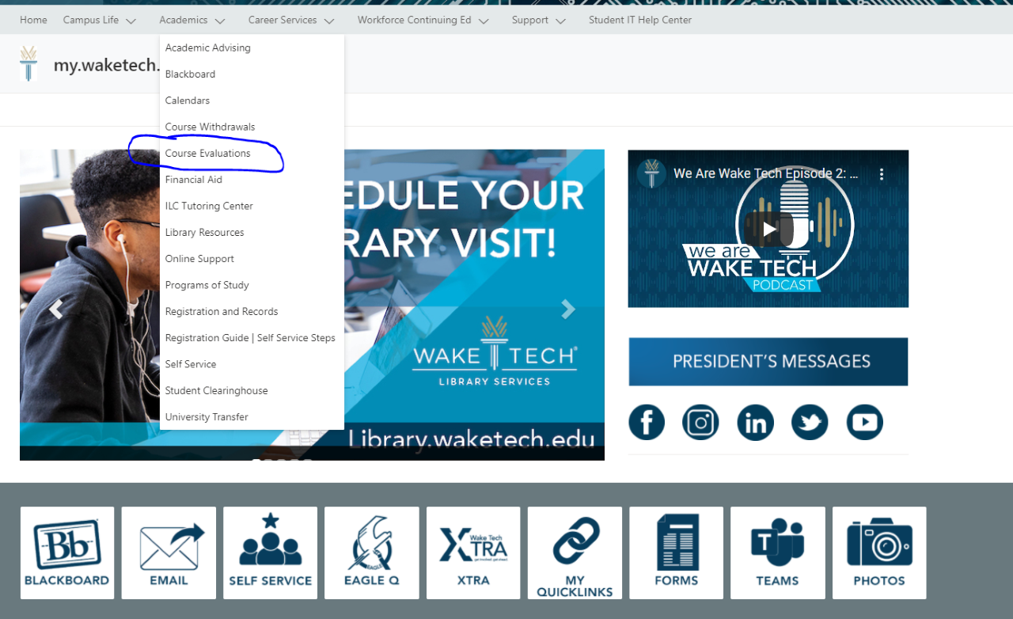

**Please take a moment to log into my.waketech.edu,** under the ACADEMICS drop down and select Course Evaluations.

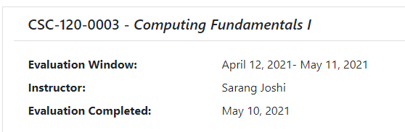

**Part A Software Engineering - Version Control with git (45 points)**

* Watch the following videos for reference and to understand how to use a distributed version control system such as git. Git is a tool that you use on your local machines for version control. Why version control and the course lectures to understand why you are doing these tasks.

**Why version control?** https://www.youtube.com/watch?v=9GKpbI1siow

**Git basics reference video:** <https://www.youtube.com/watch?v=SWYqp7iY_Tc>

* (+5)Download and install Git version control on your system.

* + **Download link:** <https://git-scm.com/downloads>
  + **Verify the installation**

Starting a new command prompt and type git --version

* + **Paste a screenshot** of the installation for points.



**Points scored (for instructor only): /5**

**Feedback:**

* (+5)Create an online account on Github or Bitbucket. Paste a screenshot of the account

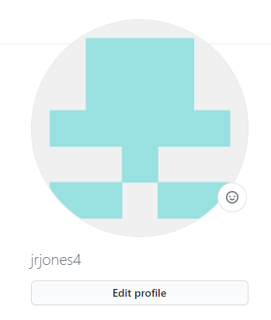

**Points scored (for instructor only): /5**

**Feedback:**

* (+10)Create a new repository called ***CSC 120 Computer Fundamentals*** on the online account. Paste a link to your repository

**https://github.com/jrjones4/CSC-120-Computer-Fundamentals-.git**

**Points scored (for instructor only): /10**

**Feedback:**

* (+5)Clone the repository on your local machine using the following command
  + git clone <repo_name>

**Points scored (for instructor only): /5**

**Feedback:**

* (+5)Copy the files that you created for this course into the repository folder.

**Points scored (for instructor only): /5**

**Feedback:**

* (+5)Add the Python files that you have created during this course to the repository. Use the command.
  + git add file1.py file2.py

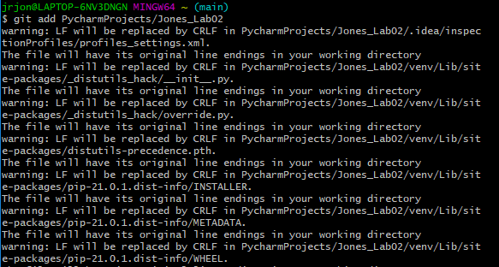

**Points scored (for instructor only): /5**

**Feedback:**

* (+5)Commit the changes using the following command
  + Git commit -m “Added files for the CSC 120 course”.

**Points scored (for instructor only): /5**

**Feedback:**

* (+5)Push the changes to the remote repository. Paste the link to your repository below.

**Points scored (for instructor only): /5**

**Feedback:**

**Part B Software Engineering - Conceptual question (+25)**

In Part A, we created our own git repository and added files to it for managing the code for CSC 120. In this section, we will explore how to use code others have created by working the following sample repository

**Points scored (for instructor only): /25**

**Feedback:**

**Practical Data Visualization with Python**

https://github.com/pmaji/practical-python-data-viz-guide

* (+5) Explain the difference in your own language between git and github/bitbucket. When would you use each?
* (+5) Clone this repository on your local machine. Paste a screenshot.
* (+15) You wanted to contribute to this repository. How would you go about doing this. Try and answer in detail and not 1-2 lines. Outline the possible steps that you would take and why. Research on topics such as git branches, forking. Be sure to include them in your answer.

**Part C General Awareness (15 points)**

Read the following article on e-waste. Use **Google Scholar (https://scholar.google.com/)** to conduct research on how to recycle e-waste. What threats and opportunities can you identify? How would you solve this problem?

[**https://dl.acm.org/doi/fullHtml/10.1145/3398390**](https://dl.acm.org/doi/fullHtml/10.1145/3398390)

This article has been published in the magazine Communications of the ACM. This is a great academic magazine to understand the state of the computer science field for a broader audience. Research on what is ACM and IEEE. Learning how to read scientific papers is a great step towards countering the spread of misinformation.

**Points scored (for instructor only): /15**

**Feedback:**

**Part D Create an online portfolio to showcase your projects. (15 points)**

The goal of this exercise is to get you started in building an online portfolio where you can showcase your professional work to prospective employers. You should definitely consider creating your own website either programmatically or using a third party service like Wix, Wordpress or Github pages or anything else that you can find. You are not required to have a complete portfolio in 5 days! The aim is to get started on it. If you already have it, your job is already done.

For example, here is my professional website

<https://www.sarangjoshi.com>

Create a quick and dirty online portfolio that you can edit over the next several months and post a link to it below.

**Points scored (for instructor only): /15**

**Feedback:**

Instructions: Upload the file with your firstname_lastname on Blackboard.