**Apple Vision Pro**

<https://developer.apple.com/design/human-interface-guidelines/touch-bar>

How to setup Project

Equipment: App development: MAC/Windows; Tests & debugging: MAC or Windows with Virtual Machine and MAC on it or on Windows through cloud services with MAC on it.

XR.sdk.visonOS - instaled in Unity

XR plug-manager in Unity for visionOS

Packages: com.unity.polyspatial, com.unity.polyspatial.visionos, com.unity.polyspatial.xr

Technicals: 23mln pixels, 90Hz/96Hz/100Hz, FOV 100°-110°

1. Digital Crown
2. Eyes
3. Focus and selection
4. Game controls
5. Gestures
6. Gyroscope and accelerometer
7. Keyboard

1. Digital Crown

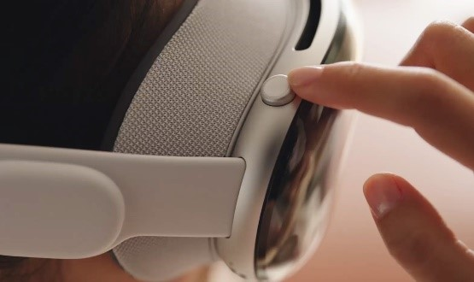

Functions include adjusting volume, modifying the level of immersion in a portal, environment, or app/game running in Full Space, easily accessing recently used content, opening accessibility settings, and exiting an app to return to the Home screen.

It’s important to adjust the immersion level in any portal, environment, or app/game within Full Space.

The Digital Crown allows users to press and hold to recenter content within their field of view or double-click to hide all content, enhancing passthrough.

Additionally, the system reacts to certain events, such as moving too quickly, getting too close to physical objects, exceeding boundary limits, or re-entering defined boundaries.

2. Eyes

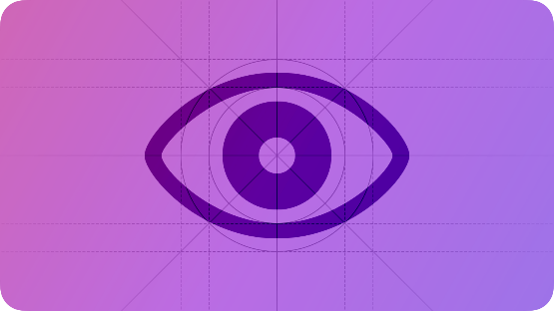

When people look at an interactive element, visionOS highlights it as a confirmation of their choice. **The hover effect** provides visual feedback, indicating that it is possible to use an indirect gesture to interact with the element. Indirect gestures involve looking at something and manipulating it with hand gestures. In some cases, using a gesture may not be necessary, as certain objects can reveal their content on their own.

3. Focus effect – provides navigation through elements in the FOV by using inputs like remote, controller, keyboard etc.

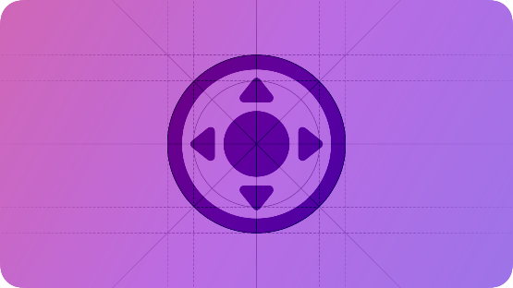

It’s not related to hover effect.

4. Game controls

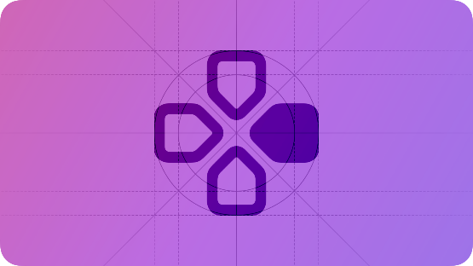

Input that every player can use and which is familiar to most of the users.

5. Gestures & hand tracking

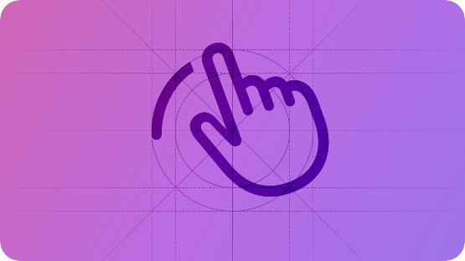

Data from hand tracking: anchor, skeleton, live data about the position of a person’s hands and hand joints, location and orientation of a hand in world space, joints on a hand, state of tracking.

Gesture – physical motion that is affecting an object in an app. We can differentiate gestures on a touchscreen, in the air, on a trackpad, remote or game controller that includes a touch surface. **Direct gestures** serve to physically touch an interactive object. Direct interaction would be using visionOS keyboard, or virtual mouse.

Advice: people tent to get tired ones they need to use direct gestures all the time. So, direct gestures are best for infrequent use.

Object should provide interaction through direct and indirect gestures.

Standard direct gestures

|  |  |
| --- | --- |
| **Direct gesture** | **Common use** |
| Touch | Directly select or activate an object. |
| Touch and hold | Open a contextual menu. |
| Touch and drag | Move an object to a new location. |
| Double touch | Preview an object or file; select a word in an editing context. |
| Swipe | Reveal actions and controls; dismiss views; scroll. |
| With two hands, pinch and drag together or apart | Zoom in or out. |
| With two hands, pinch and drag in a circular motion | Rotate an object. |

Standard gestures (indirect)

|  |  |  |
| --- | --- | --- |
| **Gesture** | **Supported in** | **Common action** |
| Tap | iOS, iPadOS, macOS, tvOS, **visionOS**, watchOS | Activate a control; select an item. |
| Swipe | iOS, iPadOS, macOS, tvOS**, visionOS**, watchOS | Reveal actions and controls; dismiss views; scroll. |
| Drag | iOS, iPadOS, macOS, tvOS, **visionOS**, watchOS | Move a UI element. |
| Touch (or pinch) and hold | iOS, iPadOS, tvOS**, visionOS**, watchOS | Reveal additional controls or functionality. |
| Double tap | iOS, iPadOS, macOS, tvOS, **visionOS**, watchOS | Zoom in; zoom out if already zoomed in; perform a primary action on Apple Watch Series 9 and Apple Watch Ultra 2. |
| Zoom | iOS, iPadOS, macOS, tvOS, **visionOS** | Zoom a view; magnify content. |
| Rotate | iOS, iPadOS, macOS, tvOS, **visionOS** | Rotate a selected item. |

Custom gestures - if there is no standard gesture that responds to certain behaviour that we want to perform in an app it’s possible to create custom gesture.

Basic requirements:

* App running in Full Space
* Request for people’s permission to access information about their hands

Advice:

* Avoid custom gesture just for specific hand
* Diminish complexity of custom gestures, it should require usage of both hands and multiple fingers
* Consider the time and number of repetitions of gestures, not to make it too tiring

System overlay – layer concerning basic system short cuts for user like Home and Control Centre.

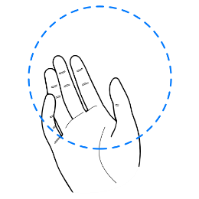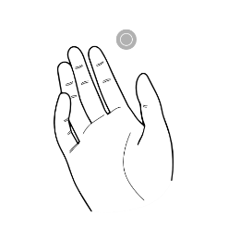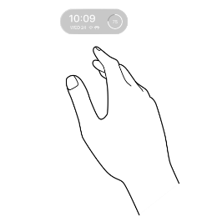

Deferring System overlay behaviour – depending on background or being in Full Space System overlay can be modified and require gestures to reveal features.

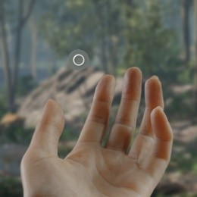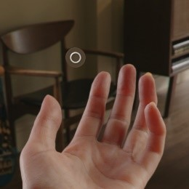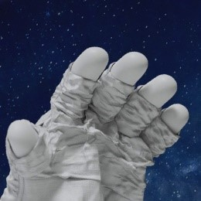

Image a) Shared Space, b) Full Space, c) deferred behavior in a Full Space

6. Gyroscope and accelerometer

On-device gyroscopes and accelerometer supply data about a device’s movement in physical world within raw or processed values. Processed values eliminate forms of bias that might affect usage of the data. For example, accelerometer raw data will consider gravity, while processed data only user’s movement.

7. Keyboards

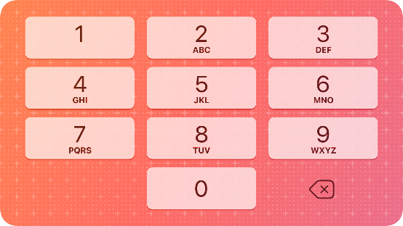

Virtual keyboards come with variety of types accordingly to the needs of a user. For example, to enter an email keyboard can contain straight buttons like “.com”

Should behave like physical keyboard in the matter of sound. System should support direct and indirect gestures and should appear in separate window witch user can move wherever one wants.

**Pico**

[Controller & HMD input mapping | PICO Developer (picoxr.com)](https://developer.picoxr.com/document/unity/input-mapping/)

Equipment: App development: MAC/Windows; Tests & debugging: Windows or MAC through Android Studio

Technicals: 72Hz/90Hz, 105°

1. System Keyboard

2. Eye Tracking

3. Hand Tracking

4. Face Tracking

5. Body Tracking

6. Object Tracking

7. Field of recognition

1. System keyboard

Virtual keyboard enabled when typing input in app.

2. Eye Tracking

Sensor technology that is tracking users gaze in real time. Eye movement is converted into data streams containing pupil distance, gaze vector, gaze point, openness, blink as a device’s input. The device then decodes the data to display what the eyes are capturing in real time.

Optimalisation: Eye tracking can be dynamically started/stopped – optimized solution

3. Hand Tracking

PICO SDK's hand tracking feature follows the hand joint conventions outlined by OpenXR and supports the 26 hand joints, using it as the primary input source. Some hand poses can trigger different events like, pinch enables the ray pointer which can be used to click and drag objects.

Hand tracking data

Call GetSettingState to get the status of hand tracking for your app. The request returns a bool value, true indicates "enabled" and false indicates "disabled".

Call GetActiveInputDevice to get the current active input device, which can be the HMD, controllers, or hands.

Call GetAimState to get the status of hand interaction. The response returns the pose of the ray, whether the ray is displayed and touched.

Call GetJointLocations to get the overall level (high/low) of confidence for hand tracking as well as hand pose data which includes the number of joints tracked, the scale of hand, the locations and orientations of joints, the radius of joints.

|  |  |
| --- | --- |
| // Provided by XR_EXT_hand_tracking  typedef enum XrHandJointEXT {     XR_HAND_JOINT_PALM_EXT = 0,     XR_HAND_JOINT_WRIST_EXT = 1,     XR_HAND_JOINT_THUMB_METACARPAL_EXT = 2,     XR_HAND_JOINT_THUMB_PROXIMAL_EXT = 3,     XR_HAND_JOINT_THUMB_DISTAL_EXT = 4,     XR_HAND_JOINT_THUMB_TIP_EXT = 5,     XR_HAND_JOINT_INDEX_METACARPAL_EXT = 6,     XR_HAND_JOINT_INDEX_PROXIMAL_EXT = 7,     XR_HAND_JOINT_INDEX_INTERMEDIATE_EXT = 8,     XR_HAND_JOINT_INDEX_DISTAL_EXT = 9,     XR_HAND_JOINT_INDEX_TIP_EXT = 10,     XR_HAND_JOINT_MIDDLE_METACARPAL_EXT = 11,     XR_HAND_JOINT_MIDDLE_PROXIMAL_EXT = 12,     XR_HAND_JOINT_MIDDLE_INTERMEDIATE_EXT = 13,     XR_HAND_JOINT_MIDDLE_DISTAL_EXT = 14,     XR_HAND_JOINT_MIDDLE_TIP_EXT = 15,     XR_HAND_JOINT_RING_METACARPAL_EXT = 16,     XR_HAND_JOINT_RING_PROXIMAL_EXT = 17,     XR_HAND_JOINT_RING_INTERMEDIATE_EXT = 18,     XR_HAND_JOINT_RING_DISTAL_EXT = 19,     XR_HAND_JOINT_RING_TIP_EXT = 20,     XR_HAND_JOINT_LITTLE_METACARPAL_EXT = 21,     XR_HAND_JOINT_LITTLE_PROXIMAL_EXT = 22,     XR_HAND_JOINT_LITTLE_INTERMEDIATE_EXT = 23,     XR_HAND_JOINT_LITTLE_DISTAL_EXT = 24,     XR_HAND_JOINT_LITTLE_TIP_EXT = 25,     XR_HAND_JOINT_MAX_ENUM_EXT = 0x7FFFFFFF  } XrHandJointEXT; |  |

PICO hand model prefabs

The SDK provides two standard hand model prefabs: HandLeft and HandRight. Each model consists of 1209 vertices, 1198 quadrilateral faces, and 2414 triangular faces.

Customize hand poses and events

 Hand gestures customisation – gives possibility to create margins for smooth transitions and smooth activation avoiding jittering between two states. It provides Hold duration with state that maintains before switching. Also, it provides the shapes of the fingers like flexion, curl and abduction.

Hand pose script – it serves for tracking the hand events: Start(), Update(), End(). The track type is: Any/Left/Right Hand.

Self-adaptive hand models

PICO's official hand models are self-adaptive, where its size can dynamically change based on the change in the size of the user's real hands. – with custom models GetHandScale needs to be called

[https://developer.picoxr.com/document/unity/about-the-pxr-hand-pose-generator-script/https://developer.picoxr.com/document/unity/about-the-pxr-hand-pose-generator-script/](https://developer.picoxr.com/document/unity/about-the-pxr-hand-pose-generator-script/https:/developer.picoxr.com/document/unity/about-the-pxr-hand-pose-generator-script/)

 4. Face tracking

PICO Neo3 and PICO 4 series - Lipsync Only

PICO 4 Pro and PICO 4 Enterprise – Face Only / Hybrid (Viseme) / Hybrid (Blendshape) - API converts data into 52 blendshapes and 20 visemes, which can be retrieved in array od length 72 (52+20)

Dynamically start/stop face tracking by calling Call StartFaceTracking and Call StopFaceTracking.

 Blend shapes

The 52 blend shapes describe the movements of facial features. The following table describes the BlendShapeIndex enums numbered 0 to 51. The blend shapes listed below are arranged by the order of data output.

 Visemes

PICO's Lipsync capability maps human speech to a set of 20 mouth shapes using visemes. Visemes are visual analogy of phonemes that are used to simulate natural mouth movements. Each viseme depicts the mouth shape for a specific set of phonemes.

5. Body tracking

**Body trackers** - Data that we can retrieve from body trackers: position, orientation data.

Stepping recognition – maximum 4 steps per second, small amplitude steps is also unadvised, as well as half-toe stepping.

Can be use as object tracking. Maximum trackers usage – 3

PICO SDK's Body Tracking feature supports tracking 24 human body joints as shown below.

|  |  |
| --- | --- |
| public enum BodyTrackerRole     {         Pelvis = 0,         LEFT_HIP = 1,         RIGHT_HIP = 2,         SPINE1 = 3,         LEFT_KNEE = 4,         RIGHT_KNEE = 5,         SPINE2 = 6,         LEFT_ANKLE = 7,         RIGHT_ANKLE = 8,         SPINE3 = 9,         LEFT_FOOT = 10,         RIGHT_FOOT = 11,         NECK = 12,         LEFT_COLLAR = 13,         RIGHT_COLLAR = 14,         HEAD = 15,         LEFT_SHOULDER = 16,         RIGHT_SHOULDER = 17,         LEFT_ELBOW = 18,         RIGHT_ELBOW = 19,         LEFT_WRIST = 20,         RIGHT_WRIST = 21,         LEFT_HAND = 22,         RIGHT_HAND = 23     } |  |

 Below are the descriptions of related concepts:

|  |  |
| --- | --- |
| Concept | Description |
| Coordinate | Body joint data uses the same global coordinate system as the HMD data |
| Root joint | 0 (Pelvis) |
| Parent/child joint | Joints numbered from 1 to 23. Parent joints are located near the root joint, while the child joints are located near the end of the limbs. |
| Bone | A bone is a rigid part between two joints, and its pose is stored in the parent joint which is located near the root joint. For example, the pose of the bone of the lower leg is stored in the knee joint.  More examples:  Joint 4 (LEFT_KNEE): It stores the location information of the left knee joint and the pose of the bone of the left lower leg.  Joint 7 (LEFT_ANKLE): It stores the location information of the left ankle joint and the pose of the bone of the left foot. |

**Waist-worn tracker**

Waist-worn trackers can refine the capture of actions like bending over and twisting the waist and can also improve the stability of tracking in sitting and lying poses.

 6. Object recognition

**Information of external devices**

**Type-C interface of PICO Sense tracker provides connection to external devices and exchanges data with PICO headset. That can allow to access information such as: batteries level, button operations, vibration commands and key values of external device to be passed.**

7. Field of recognition

**Meta**

<https://developers.meta.com/horizon/documentation/unity/unity-ovrinput>

Equipment: App development: Windows/MAC; Tests & debugging: Windows or MAC with Meta Integration package.

Technical: 110° horizontal / 96° vericaly / 72Hz – 120Hz

1. Hand tracking

2. Keyboard

3. Body tracking

4. Face tracking

5. Eye tracking

6. Voice

Controller Animation – useful to provide indication for some actions. Shows short animation over an interactable object and input that needs to be provided while this action. – is there hand animations or is just a normal animation?

2. Hand tracking

Interactions SDK – provides standardized gestures and interactions facilitating tasks like tool usage, communication and tactile exploration. HD – Hand data is captured by HMD – head mounted display, and processed by software algorithms, involving machine learning and computer vision to recognize hand position and movement. Software interprets actions allowing user interaction with environment

Terminology

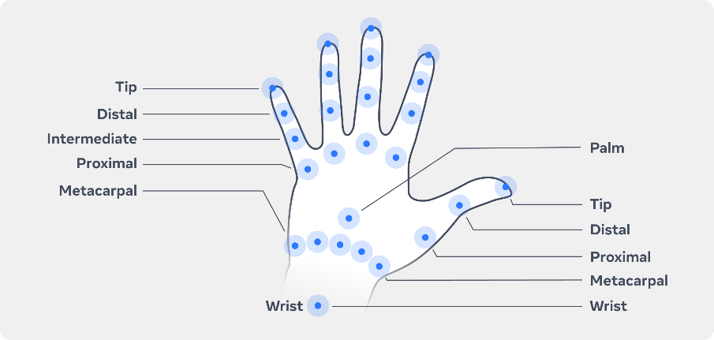

Joints - Joints in the hand provide flexibility and mobility. In XR these are referenced in code for determining interactions. See image above.

Wrist - The joint connecting the hand with the forearm, often tracked in code for hand position.

Fingers & thumb - The five digits of the human hand, consisting of four fingers and one opposable thumb, are essential for performing tactile interactions.

3D hand model – is generated from OVR Skeleton and OVR Mesh data. OVR Skeleton returns: bind pose, bone hierarchy and capsule collider data.

Root Pose – position of the hand in the tracking space. To adjust that we use – OVRHandPrefab. Depending on preferences if hand position depends on cameraRig position, we leave it unchecked, if hand position should be independent, we select checkbox – Update Root Pose.

Root Scale – Update Root Scale provides scaling of user hand  model. Base scale is 100%.

Physic Capsules – is the volume of users bones use for collisions and triggering events. We use OVR Skeleton to adjust that by selecting – Enable Physic Capsules.

Customization – materials, shadows and probes.

Differences between OpenXR Hand Skeleton (New type in OpenXR, standard which gives compatibility across different platforms) and OVR Hand Skeleton

|  |  |  |
| --- | --- | --- |
|  | OpenXR Hand Skeleton | OVR Hand Skeleton |
| Forearm | Not Included | Included |
| Palm | Included | Not Included |
| Thumb | Metacarpal, Proximal, Distal, Tip | Trapezium, Metacarpal, Proximal, Distal, Tip |
| Index | Metacarpal, Proximal, Intermediate, Distal, Tip | Proximal, Intermediate, Distal, Tip |
| Middle | Metacarpal, Proximal, Intermediate, Distal, Tip | Proximal, Intermediate, Distal, Tip |
| Ring | Metacarpal, Proximal, Intermediate, Distal, Tip | Proximal, Intermediate, Distal, Tip |
| Pinky | Metacarpal, Proximal, Intermediate, Distal, Tip | Metacarpal, Proximal, Intermediate, Distal, Tip |
| Total | 26 Joints | 24 Joints |
| Alignment | Joints aligned z-forward, y-up for both hands | Joints aligned x-forwards, y-up for the right hand, and joints are mirrored for the left hand |

Information provided from OVR Skeleton and OVR Hand:

* Bone information
* Hand and finger position and rotation
* Pinch strength
* Pointer pose for UI raycasts
* Tracking confidence
* Hand size
* System gesture for opening universal menu

OVR Skeleton contains a full list of bone IDs, methods to implement interactions and detect gestures, calculate gesture confidence, target a particular bone, or trigger a collision event in the physics system. Examples:

* GetCurrentStartBoneId() / GetCurrentEndBoneId() – used to iterate through subset of bones
* GetCurrentNumBones() / GetCurrentNumSinnableBones() – return number of bones in the skeleton that are skinnable. Skinnable – bones with anchors for the fingertips.

OVR Hand provides pointer pose and pinch gesture

Pinch can provide other information’s like: is hand currently pinching, pinch strength and confidence level

* GetFingerIsPinching() – returns bool
* GetFingerPinchStrength() – returns float 0-1
* GetFingerConfidence()

Pointer pose – consistent pose across Meta Quest apps. It indicates starting point position of the ray in the tracking space. Mostly use for UI indications.

Hand Confidence – returns low or high ?

Hand Scale – gets scale of the user hand relatively to the hand model, returns float as a scale for example: 1.05 which means that hand is 5% bigger than model.

Check System Gestures – allows to transition to universal menu through palm gesture facing user and pinch. With non-dominant hand it turns on Button – Start event.

Features:

WMM – Wide Motion Mode – allows to track hand and display plausible hand poses even when hands are out of the headset FOV. Its thanks to IOBT. Requires Body tracking to estimate hand position

Capsense – animations provided to create indication for user holding controllers. Natural – when user is holding controllers which are not displayed, Controller hand pose – when user is holding controllers and virtually animated hand models are visible.

Multimodal  - provides simultaneous tracking for both controllers and hands. Multimodal overrides others transition methods.

Fast Motion Mode – high frequency hand tracking, advised due to fast hands movement.

3. Keyboard

Provides users with their physical keyboard inside VR environment. Keyboard is from inside Meta XR All in One SDK which is expecting from user to have one of the keyboards models from the list.

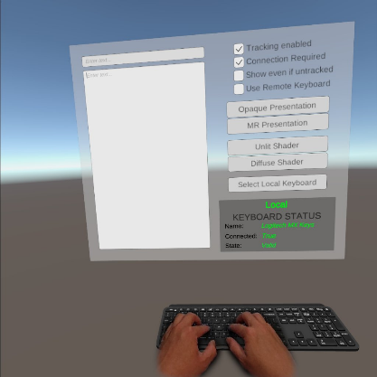

4. Body tracking

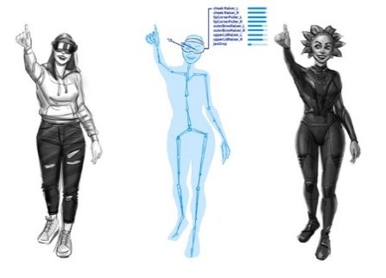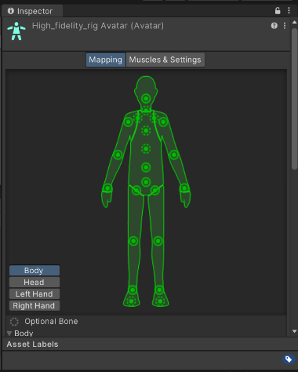

Body tracking is defined as OpenXR Extension. For Unity there are scripts like OVRBody() that abstract OpenXR interface.

API that uses hands/controllers and headset to infer the body pose which is after transformed into a body tracking skeleton. Body tracking API infer the movement of the person by repetitive calls for it. Body tracking allows to work with upper body part or full skeleton. Lower body is based on upper body is doing. It doesn’t reflect accurately the legs.

Movement SDK provides access to the skeleton tracking and allows to animate with Unity Mecanim humanoid. Full raw data is in Avatar SDK.

Use cases:

* Use to analyze the movement of person,
* To animate the character to reflect human motions,
* To hit targets in gameplay by usage of body joints data
* Mapping body pose to non-playable characters.

5. Face tracking

The Face Tracking API converts the facial movements detected by the headset sensors into activations of expressions based on Facial Action Coding System (FACS). Cause people normally trigger couple of facial actions at once, the API returns a weight corresponding to the strength of the expression. This list of expressions along with their strength activate the blendshapes. Blendshapes can be restricted to creators needs, for example we can map only expressions like lip corner raiser. The Face Tracking API provides representation of most of the face like nose, jaw, eyebrows and close eyes area.

**Which headset models support face tracking?**   
Natural Facial Expressions, which estimates facial movements based on inward facing cameras, is only available on Meta Quest Pro headsets. However, audio-driven face tracking is also available on Meta Quest 2 and Meta Quest 3 devices with the same API.

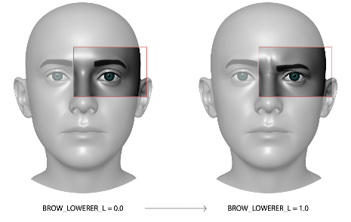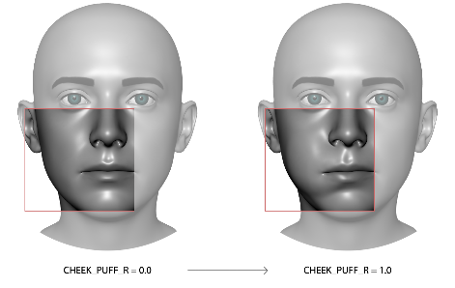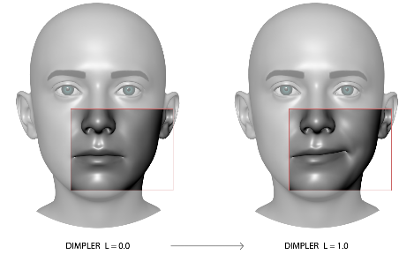

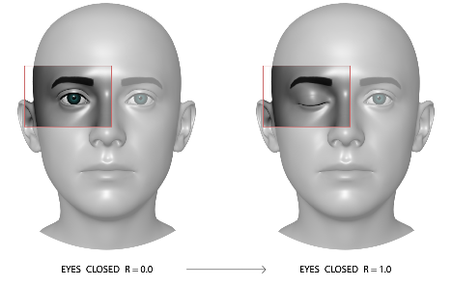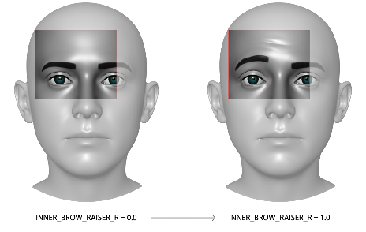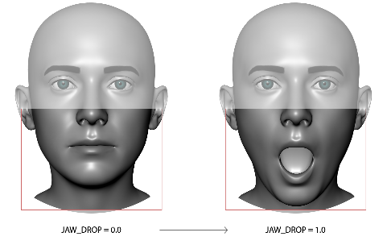

6. Eye tracking

The Meta Quest Pro is the only device that supports this feature, utilizing the OVREyeGaze script. OVREyeGaze provides eye tracking or gaze information. Eye pose data is retrieved from OVRPlugin. When OVREyeGaze component added to a GameObject, it can simulate an eye based on actual human eye. Component can also select objects in a scene using raycasts. Currently, only the Quest Pro supports Eye Tracking.

7. Voice Tracking

The Voice SDK enables voice interaction in the app. Powered by Wit.ai Natural Language Understanding (NLU) can be used without prior AI/ML knowledge.

Pross: minimization usage of virtual keyboard while searching through nested menus; voice FAQ; usage as actions trigger during a gameplay.

VIVE – HTC Vive XR Elite

[Unity: Overview | VIVE OpenXR - Developer Resources](https://developer.vive.com/resources/openxr/unity/overview/)

[Download: OpenXR for Unity - Developer Resources (vive.com)](https://developer.vive.com/resources/openxr/unity/download/latest/)

[Unity: Tutorials | VIVE OpenXR - Developer Resources](https://developer.vive.com/resources/openxr/unity/tutorials/)

Equipment: App development: MAC/Windows; Tests & debugging: Both from Windows and MAC it needs to be tested and debugged through SteamVR and Steam accordingly.

Technical : 110° / 90Hz

1. Hand tracking    
   Defines 26 joints with information about: tracking status, position, rotation, gesture info, hand joints, pose, confidence, scale, wrist velocity, grasp, finger type, . Long-distance raycasting and close-range grabbing. Custom gestures.

1. Hand Interaction – Realistic hand interaction   
   Natural hand gestures for specific objects. Collider matching default hand model for more realistic effect.
2. Facial Tracking: jaw, mouth, cheek, eye, tongue   
   It’s a combination of Eye Expression and Lip Expression that we call Facial Tracking. Eyes and lips expressions are both ranges between 0 and 1 and it describes eye and mouth openness. Combination of this values then describe facial expressions.

It also uses 52 blendshapes which cover: jaw, mouth, cheek, eye, tongue.

1. Wrist Tracker   
      
   A close-up of a wrist watch

   Description automatically generated

 

Data: buttons (primary, menu) input, device pose, state of tracking, state of being tracked

1. Eye gaze    
   Only data that we can retrieve is eye pose,
2. Passthrough   
   Planar Passthrough let user see and use real objects while being inside VR

1. Ultimate tracker
2. Anchor
3. Plane Detection
4. Display Refresh Rate
5. Foveation – rendering optimalization by reduction of pixel density in the peripheral vision.
6. Composition layer    
   Results witch better and cleaner image thanks to layering of content. Content is then rendered by the headset not by Unity.

Next:

Face tracking – more information’s, deeper research

Precision – passing one thing from one hand to another

Manipulation of small objects