The Legal Last Mile
Executive summary of preliminary findings (partial report)
AI-assisted systematic review of legal and administrative conditions and household access to water and sanitation · interim release 0.2.0-interim · 14 October 2026
Preliminary and partial. Screening, data extraction, quality appraisal and the direction coding of each estimate were done by an AI under the author's rulings. Only 467 of 2,277 full-text decisions (20.5%) have a human check, and of the 39 studies in the quantitative syntheses 29 have a human-verified inclusion decision and 20 a confirmed direction coding. No effect size is pooled. Read every number as AI-produced and unverified against the source papers unless this summary says otherwise.

1. The bottom line
- A large evidence base that is mostly descriptive. 1,078 studies met the full-text criteria (85% published since 2010). 812 (75%) are qualitative, mixed-methods or doctrinal designs, and only 62 (6%) were appraised with a causal-design instrument (ROBINS-I or RoB 2); the 5 randomised trials are 4 distinct trials.
- Legal recognition and formal status tend to go with better access (Family A). 12 of 16 quantitative studies (75%) point in the favourable direction; 2 point the other way and 2 are null.
- Assistance, participation and trust look uniformly favourable (Family B), but this is the least secure result. All 6 studies are favourable (5) or mixed (1), yet 4 of the 6 are among the ten studies flagged on a scope check and awaiting the author's ruling. If all 4 were excluded, 2 studies would remain.
- Ownership, regulation and institutional structure show no consistent direction (Family C). 7 favourable, 7 unfavourable and 3 mixed across 17 studies with heterogeneous exposures and outcomes. The one coherent sub-pattern, private ownership going with worse affordability, rests on three studies that probably draw on two independent samples.
- The counts survive every test tried, but nothing is pooled and confidence is low. The pre-stated conclusions hold in all 10 alternative scenarios (Family A's favourable share ranges 73.3% to 80.0%). No family has enough comparable studies for meta-analysis, and confidence in any causal or comparative claim is low to very low.
- The dissertation's comparative frame cannot be tested from this base. There are 1 Dutch and 15 Canadian single-country studies against 80 for Brazil.

2. What was done and where the review stands
Stage | Result | Note
Search | 34,594 records, 27,481 after de-duplication | Closed 2026-09-11. SSRN and Westlaw/Lexis were never searched.
Title and abstract | 3,659 included | 26,222 screened by the AI; a human second pass covered the 3,665 include-or-unsure records, not the AI's excludes.
Full text | 2,277 of 3,659 assessed (62.2%): 1,078 included, 1,199 excluded | Retrieval closed by decision; 1,382 records were never assessed. 467 decisions (20.5%) carry a human check.
Extraction and appraisal | 1,078 studies, 92 fields; all rated with a design-matched tool | By the AI, with no second extractor; the appraisal ratings are rule-based, and 40% use the project's own non-validated framework.
Synthesis | 58 effect-size rows: 39 in three families, 19 reasoned non-fits | Structured vote counting of direction (SWiM). None is pooled.

Why no meta-analysis. A phase-11 feasibility judgment found no family with enough studies sharing an exposure, comparator, outcome and effect measure. The 58 extractable estimates were instead grouped into three thematic families and synthesised by vote counting (Synthesis Without Meta-analysis, Campbell et al. 2020). Each estimate is coded twice: its raw sign (the sign of the reported coefficient) and its substantive direction (whether the result is favourable or unfavourable for household access, affordability or equity). The two differ because a higher tariff is worse for households while a higher coverage rate is better.

3. What the evidence base looks like
- Designs. Qualitative 529, mixed-methods 229, observational 142, quasi-experimental 61, doctrinal 54, jurimetric 36, secondary systematic reviews 20, experimental 5, other 2.
- Appraisal. Tools used: CASP qualitative 248, MMAT 195, JBI cross-sectional 129, ROBINS-I 57, AMSTAR 2 18, RoB 2 5, and 426 (40%) under the project's own non-validated framework. Of the 18 systematic reviews, 17 rate critically low and 1 low on AMSTAR 2. Only 33 studies reach the two highest mechanism-certainty levels (quasi-experimental or experimental evidence).
- Where. India 122, Brazil 80, South Africa 77, United States 62, Ghana 51 are the most frequent single countries (112 studies name several countries or a region).
- What is studied. The most coded mechanisms are institutional fragmentation (623), discretion accommodation (581), fees (534). Water access is coded in 949 studies and sanitation access in 418, about half as often. Redress mechanisms are thin: administrative review 68 studies, judicial review 64.

4. What the quantitative studies show
Family | Studies | Raw sign  + / − / null / mixed | Substantive direction  fav. / unfav. / null / mixed | Direction coding, author's check  confirmed / flagged / not yet
A. Legal status, tenure, recognition and governance arrangements | 16 | 10 / 4 / 2 / 0 | 12 / 2 / 2 / 0 | 6 / 4 / 6
B. Assistance, participation, trust and external support | 6 | 5 / 0 / 0 / 1 | 5 / 0 / 0 / 1 | 1 / 4 / 1
C. Ownership, regulation, institutional capacity and structure | 17 | 6 / 8 / 0 / 3 | 7 / 7 / 0 / 3 | 13 / 2 / 2

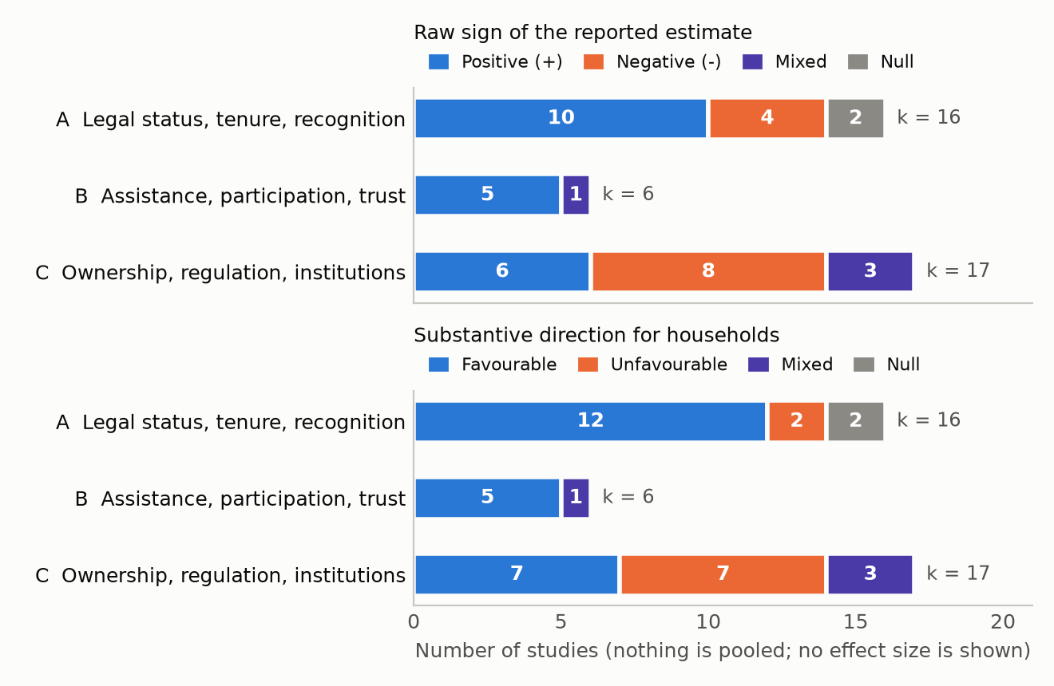
Figure 1. Direction of association in the three structured syntheses, read two ways.
- Family A (recognition and status). Where a legal status, tenure right or formal recognition is the exposure, the association with access is favourable in 75% of studies. Two point the other way (S104, a tenure study in which owners had more service interruptions, and S1020, a watershed programme after which collection time rose; the second is among the flagged studies) and two are null.
- Family B (assistance, participation, trust). Five studies are favourable and one is mixed (S294, a cluster trial with null health outcomes). The six study different mechanisms, and four of them are flagged (see below), so this should not be read as a pattern.
- Family C (ownership, regulation, structure). Raw signs split 6 positive, 8 negative and 3 mixed; substantive directions split 7, 7 and 3. The exposures are too different (private versus public ownership, the level of regulation, new local governments, contract enforcement, cost-recovery policy, governance quality) to expect agreement.
- Two readings, deliberately. Raw sign and substantive direction come apart for 11 of the 39 studies, so each is reported separately.
- Verification status. 29 of the 39 studies have a human-verified inclusion decision and 20 also have both direction codings confirmed by the author. The other 10 were flagged on a narrow-scope check (an exposure that is community management, participation, programme delivery, an attitude or macro-governance, or an outcome that is not household access) and are not counted as confirmed. The effect estimates were extracted and checked against the full texts by the AI, not by a human.

5. How robust are the counts?
Scenario | Family A: k; fav./unfav./null | Family B: k; fav./mixed | Family C: k; fav./unfav./mixed | Pre-stated tests
Baseline | 16; 12/2/2 (75%) | 6; 5/1 | 17; 7/7/3 | all hold
Drop S404, the one Family A coding judgment call | 15; 11/2/2 (73%) | 6; 5/1 | 17; 7/7/3 | all hold
Drop the two kept studies with no household-access outcome | 16; 12/2/2 (75%) | 5; 4/1 | 16; 6/7/3 | all hold
Recode S471 as null (fully adjusted estimate) | 16; 12/2/2 (75%) | 6; 5/1 | 17; 6/7/3 | all hold
Recode S879 as null (household water access alone) | 16; 12/2/2 (75%) | 6; 5/1 | 17; 7/7/2 | all hold
All of the above, plus the data-quality drops, applied together | 15; 11/2/2 (73%) | 5; 4/1 | 16; 5/7/2 | all hold
Keep only studies where raw sign and direction agree | 10; 8/0/2 (80%) | 6; 5/1 | 12; 4/5/3 | all hold
Illustrative: all ten flagged studies excluded (the ruling is the author's) | 12; 9/1/2 (75%) | 2; 2/0 | 15; 6/6/3 | all hold

The pre-stated conclusions were: more than half of Family A favourable; no Family B study unfavourable or null; no single direction holding a majority in Family C. They were fixed before the numbers were computed. The scenarios do not test the direction coding itself, studies that were never extracted, or overlap between reports that were not flagged as linked. The illustrative row shows the cost of the open scope question: Family B would shrink to 2 studies, though its direction would not change.

6. How far to trust this
The author's tentative characterisation is low to very low confidence for any causal or comparative claim (no GRADE judgment has been made). The main reasons:
- Screening is incomplete. 1,382 of 3,659 candidate records were never assessed at full text, and they are older on average, so earlier literature is under-represented. 151 of the 1,199 excludes were never judged on content because the text was inaccessible.
- Most decisions are the AI's. 1,810 of 2,277 full-text decisions have no human check (301 includes and 166 excludes do). A blind re-read of 70 exclusions by two other AI models, adjudicated by the author, found 3 false exclusions among the 62 randomly sampled (4.8%, 95% interval 1.7 to 13.3%), roughly 50 studies across the 1,040 content-based exclusions (interval 17 to 138).
- Eligibility was narrowed after the fact. After seeing the models' disagreement the author adopted a narrow reading of the second criterion (a legal or administrative access rule or mechanism, not programme delivery, participation or macro-governance). Together with the four inclusions the models questioned, that moved 86 included reports to the exclusions, and it is also why ten core studies are flagged. The protocol was fixed before searching but registered on OSF retrospectively.
- Extraction and appraisal are unchecked. There is no second extractor, 10 studies were extracted from abstracts only (a floor), and appraisal ratings are rule-based. 51 of 129 JBI ratings are "High concern", which here means sparse extraction rather than a poor study.
- The families are thematic groupings, not homogeneous pairs. Vote counting weights every study equally, ignores size and precision, and is not certainty-graded.

7. Decisions and next steps
# | Item | What it needs
1 | Rule on the 10 flagged core studies (open item A28) | Include or exclude, with a reason code. Family B is most affected (4 of 6), then A (4 of 16) and C (2 of 17). The sheet is 02_screening/full_text/A28_SWIM_FLAGGED_CK_SHEET_2026-10-14.csv.
2 | Finish the human check of screening (A6, tiers 2 and 3) | 152 further rows (102 excludes, 50 includes) would bound the risk of wrongly excluded or included studies.
3 | Second-extract the prepared sample | 60 studies from S001 to S200, checked against the source papers, to estimate extraction error. A second sample from later studies is needed before any corpus-wide claim.
4 | Reduce the retrieval bias | Prioritise the older, unassessed records, and consider targeted searches for Dutch and Canadian evidence if the comparative frame is to be tested.
5 | Register and freeze | Upload the preregistration draft to OSF (A7) and push the release tag v0.2.0-interim from your own clone.
6 | Revise the manuscript draft by hand | The draft in 07_manuscript/draft/ is generated from the same figures and is marked as not reviewed by a human author.

Provenance. Every figure is computed by code/analysis/build_executive_summary.py from the project databases (00_admin/CURRENT_FIGURES.md, 05_analysis/sensitivity/SENSITIVITY_ANALYSIS_2026-09-28.md, 05_analysis/effect_sizes/SWIM_DIRECTION_CODING_2026-10-14.csv and SWIM_CK_CHECKS_2026-10-14.csv). The full report is 06_outputs/PRELIMINARY_RESULTS_REPORT_2026-09-29.docx; AI use is described in AI_USE_STATEMENT.md.

