

**LEGACY APPLICATION ASSESSMENT**

**BUSINESS REQUIREMENT DOCUMENT**

**(BRD)**

Content

1. CHANGE LOG 4

2. DEFINITION/GLOSSARY 5

3. BUSINESS CONTEXT 6

3.1. Project Overview 6

4. SYSTEM OVERVIEW 7

4.1 System Purpose and Objectives 7

4.2 Key Features and Functionality 7

4.3 Target Audience/Users 7

4.4 System Integration 7

4.5 Technology Stack 7

4.6. Sitemap 8

4.7. Use Case 9

5. BUSINESS PROCESS 10

BP01. Admin Renew ticket(s) 11

BP02. Admin Redeem ticket(s) when Redeemer=Pawner 14

BP03. Admin Redeem ticket(s) when Redeemer≠Pawner 16

BP03.1. Admin Create New Customer 18

BP04. Admin Enquiry Pawner (by ID) 20

BP05. Admin Enquiry Ticket (by MMYY) 22

BP06. Admin Enquiry Ticket (by Expired Date) 24

BP07. Admin Enquiry Ticket (by Pledge Code) 26

BP08. Admin Enquiry Ticket (by Ticket No.) 28

BP09. Admin Report single lost pledge 30

BP10. Admin Report multiple lost pledge 32

BP11. Admin Reprint Lost Letter 34

BP12. Admin Combine Redemption and Renewal at the same time (Redeemer=all Pawner) 36

BP13. Admin Combine Redemption and Renewal at the same time (Redeemer ≠ Pawner) 38

BP14. Admin View Credit Rating 40

6.1. List of functions 42

6.2. Detail of functions 42

FUNC-01. Renew Ticket(s) 42

FUNC-02. Redeem Ticket(s) 51

FUNC-03. Enquiry 69

FUNC-04. Report Lost pledge 76

FUNC-05. Reprint Lost Letter 85

FUNC-06. Combine Redemption and Renewal 90

FUNC-07. View Credit Rating 105

7. APPENDIX 112

7.1. Output files 112

7.1.1. Receipt 112

7.1.2. Contract 112

7.1.3. Lost Letter 112

7.2. Workflow Diagram 112

# 1. CHANGE LOG

|  |  |  |  |
| --- | --- | --- | --- |
| **Change Date** | **Version** | **Description** | **Creator** |
| 16/05/2025 | 1.0 | Initial creation | Nhung Ngo (Nacy) |
|  |  |  |  |
|  |  |  |  |

# 2. DEFINITION/GLOSSARY

|  |  |
| --- | --- |
| **Terms, abbreviations and acronyms** | **Meaning** |
| **Vampire Frontend** | used by pawn shop outlet staff for **day-to-day operations**. This includes activity such as:   * Processing renewals and redemptions * Enquiry pawners and tickets * Report lost pledge |
| **Status ‘U’** | * When a **ticket (grant)** is newly created, a record is stored in the database with status **'U'** * When a **ticket is renewed**, a new record associated with the renewed ticket is also stored in the database with status **'U'**. |
| **Status ‘O’** | When a **ticket that was previously seized by the police** is returned, its status is updated to **'O'** |
| **Status ‘R’** | When a **ticket is either renewed or redeemed**, its status is updated to **'R'** |

# 3. BUSINESS CONTEXT

## 3.1. Project Overview

ValueMax aims to revamp its legacy **Desktop Application** into a **Web Application**. As part of the initial phase, this project focuses on assessing and documenting the **current system** to establish a clear understanding before proposing future improvements.

# 4. SYSTEM OVERVIEW

## 4.1 System Purpose and Objectives

* Briefly explain why the system is being developed and what business problem it will solve.
* Outline the goals and objectives of the system.
* State how the system will benefit the organization (e.g., improve efficiency, reduce costs, enhance customer experience).

## 4.2 Key Features and Functionality

* Provide an overview of the core features and functionalities of the system.
* Highlight the key capabilities it will provide to the users (e.g., data entry, reporting, integrations, analytics).
* Mention any significant technical components or systems it will interact with (e.g., databases, third-party APIs).

## 4.3 Target Audience/Users

* Identify the primary users or groups who will interact with the system (e.g., end-users, Outlet Staffistrators, managers).
* Describe their roles and how they will use the system.

## 4.4 System Integration

* Mention any external systems or technologies the system will interface with (e.g., legacy systems, third-party applications).
* Provide details about integration points or dependencies with other systems.

## 4.5 Technology Stack

* Provide a high-level overview of the technologies and tools used in the system (e.g., programming languages, databases, cloud platforms, frameworks).

## 4.6. Sitemap

Ảnh có chứa văn bản, ảnh chụp màn hình, Phông chữ, thiết kế

Nội dung do AI tạo ra có thể không chính xác.

## 4.7. Use Case

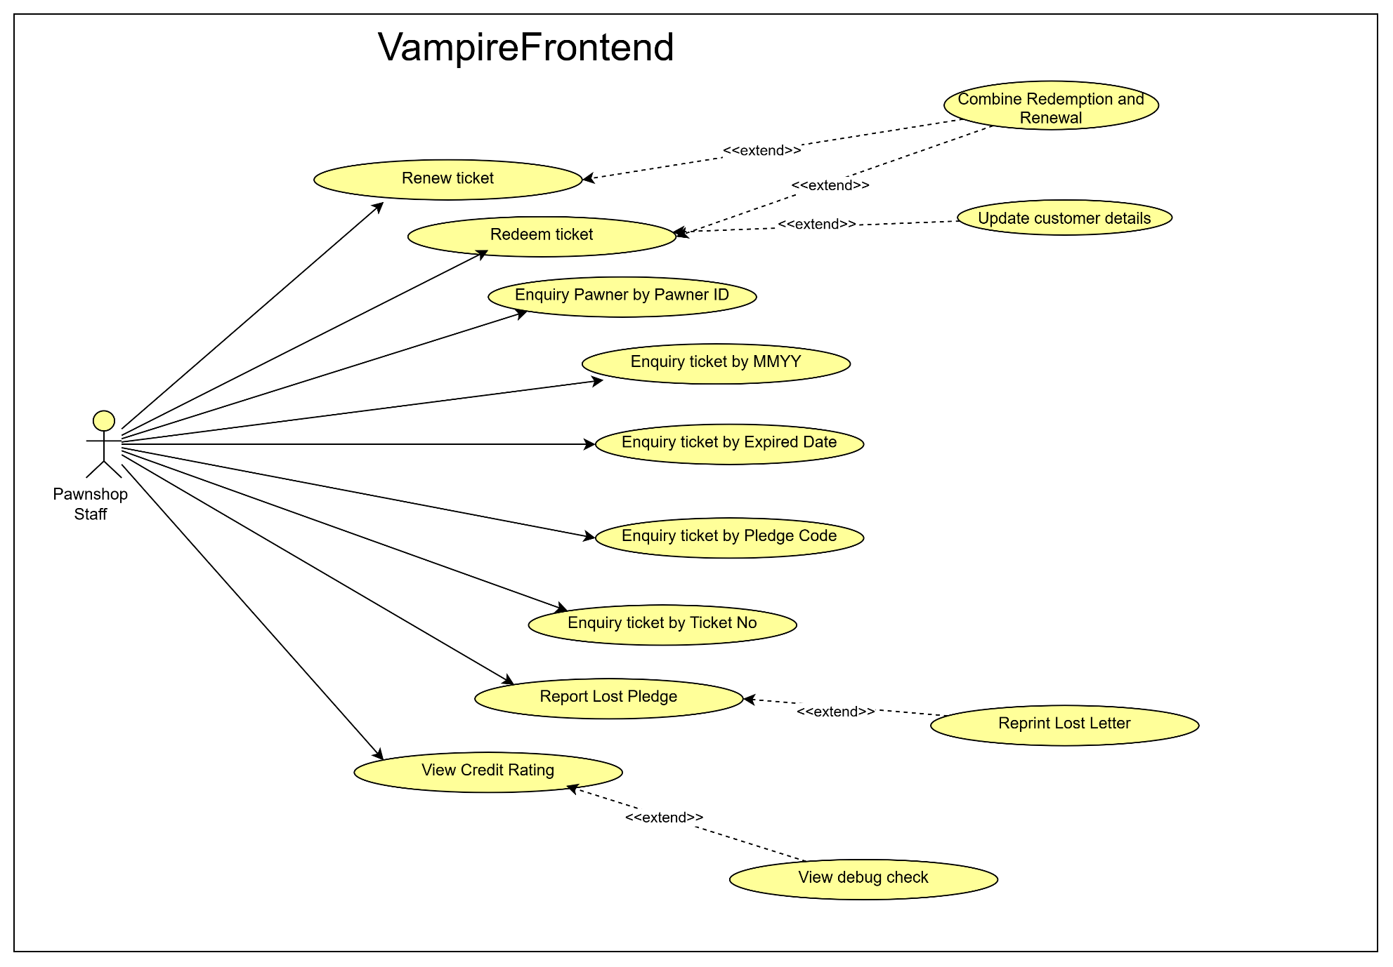

# 5. BUSINESS PROCESS

|  |  |  |  |
| --- | --- | --- | --- |
| **Business Process No.** | **Actor(s)**  **(Role Involved)** | **Description** | **Associated Function No.** |
| BP01 | Outlet Staff | Renew ticket(s) | FUNC-01 |
| BP02.1 | Outlet Staff | Redeem ticket(s) (Redeemer=Pawner) | FUNC-02 |
| BP02.2 | Outlet Staff | Redeem ticket(s) (Redeemer≠Pawner) | FUNC-02 |
| BP02.2.1 | Outlet Staff | Update Customer Details | FUNC-02.1 |
| BP03.1 | Outlet Staff | Enquiry Pawner (by ID) | FUNC-03 |
| BP03.2 | Outlet Staff | Enquiry Ticket (by MMYY) | FUNC-03 |
| BP03.3 | Outlet Staff | Enquiry Ticket (by Expired Date) | FUNC-03 |
| BP03.4 | Outlet Staff | Enquiry Ticket (by Pledge Code) | FUNC-03 |
| BP03.5 | Outlet Staff | Enquiry Ticket (by Ticket No.) | FUNC-03 |
| BP04.1 | Outlet Staff | Report single lost pledge | FUNC-04 |
| BP04.2 | Outlet Staff | Report multiple lost pledge | FUNC-04 |
| BP05 | Outlet Staff | Reprint Lost Letter | FUNC-05 |
| BP06.1 | Outlet Staff | Combine Redemption and Renewal at the same time (Redeemer=all Pawner) | FUNC-06 |
| BP06.2 | Outlet Staff | Combine Redemption and Renewal at the same time (Redeemer ≠ Pawner) | FUNC-06 |
| BP07 | Outlet Staff | View Credit Rating | FUNC-07 |

## BP01. Outlet Staff Renew ticket(s)

|  |  |  |
| --- | --- | --- |
| **AS A [type of user]** | **I WANT TO [do some task]** | **SO THAT I CAN [get some result]** |
| Outlet Staff | Renew single or multiple tickets | extend the validity of pawned items |

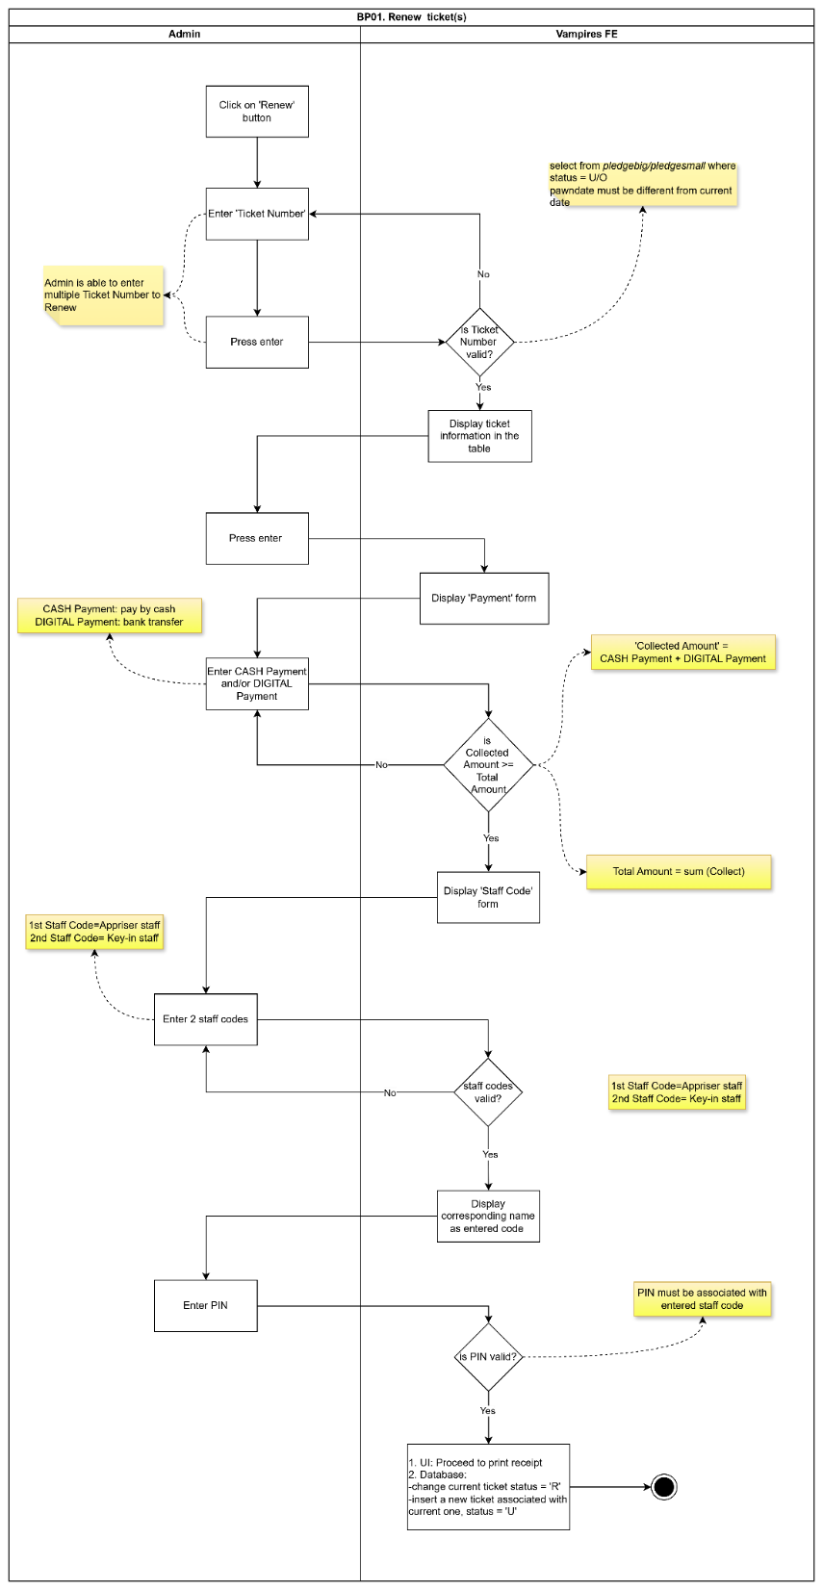

## BP02. Outlet Staff Redeem ticket

## BP02.1 Outlet Staff Redeem ticket(s) when Redeemer=Pawner

|  |  |  |
| --- | --- | --- |
| **AS A [type of user]** | **I WANT TO [do some task]** | **SO THAT I CAN [get some result]** |
| Outlet Staff | Redeem single or multiple | Terminate the pawning flow |

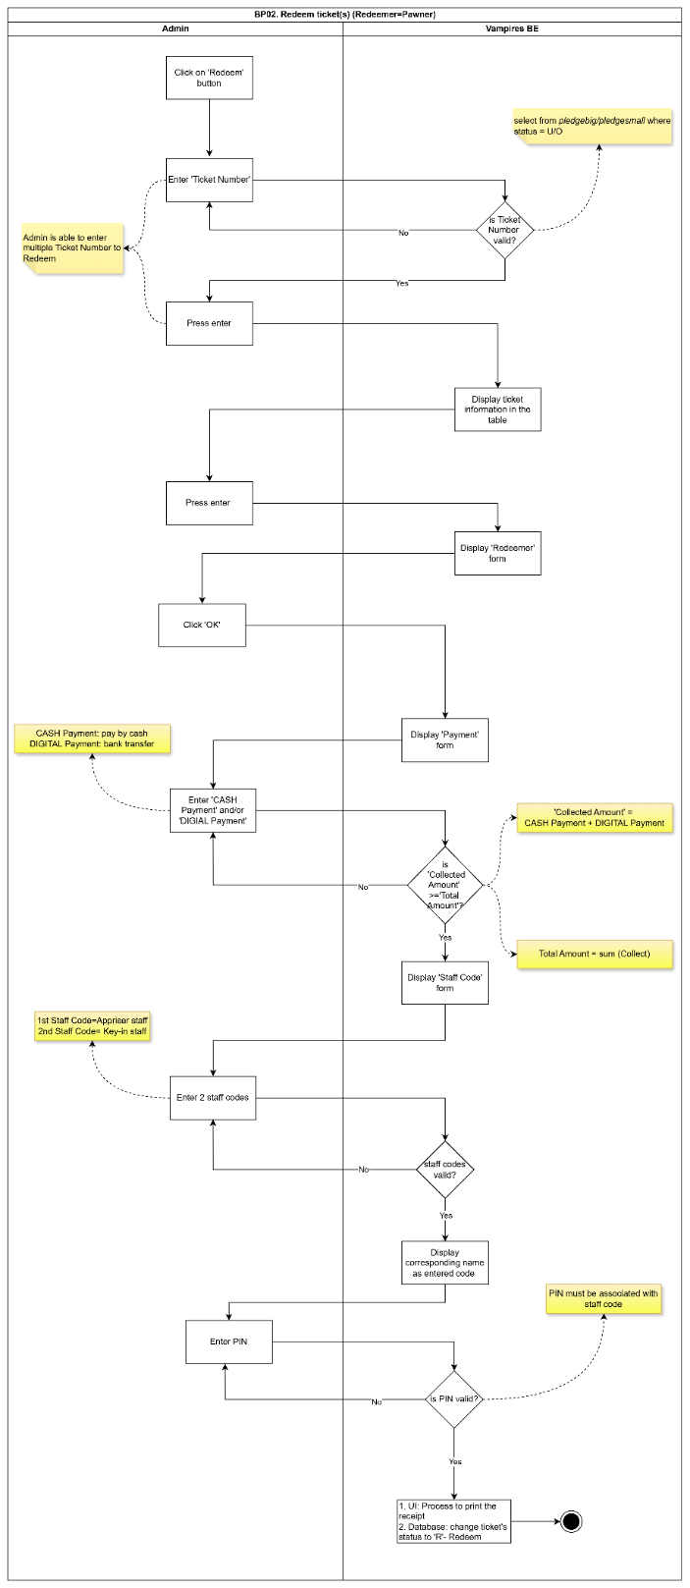

## BP02.2. Outlet Staff Redeem ticket(s) when Redeemer≠Pawner

|  |  |  |
| --- | --- | --- |
| **AS A [type of user]** | **I WANT TO [do some task]** | **SO THAT I CAN [get some result]** |
| Outlet Staff | Redeem ticket when Redeemer ≠ Pawner | Terminate the pawning flow |

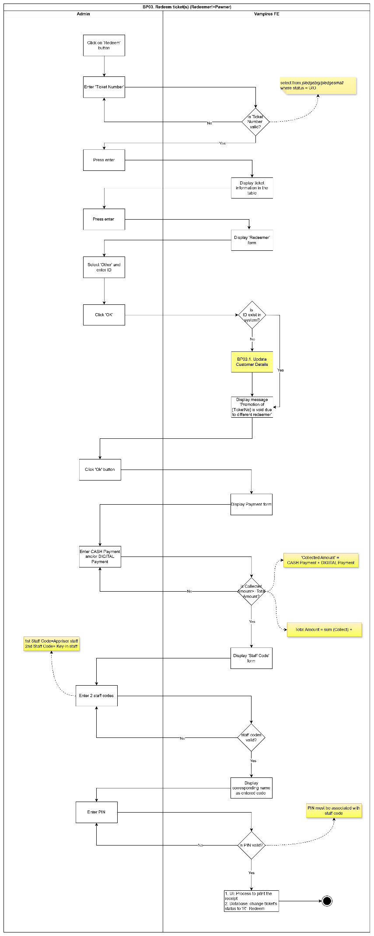

### BP02.2.1. Outlet Staff Create New Customer

|  |  |  |
| --- | --- | --- |
| **AS A [type of user]** | **I WANT TO [do some task]** | **SO THAT I CAN [get some result]** |
| Outlet Staff | Create new customer | register new customers and associate them with pawn transactions. |

Ảnh có chứa văn bản, ảnh chụp màn hình, Phông chữ, thiết kế

Nội dung do AI tạo ra có thể không chính xác.

## BP03. Enquiry

### BP03.1. Outlet Staff Enquiry Pawner (by ID)

|  |  |  |
| --- | --- | --- |
| **AS A [type of user]** | **I WANT TO [do some task]** | **SO THAT I CAN [get some result]** |
| Outlet Staff | Enquiry Pawner by ID | View all associated pawner information |

Ảnh có chứa văn bản, ảnh chụp màn hình, Phông chữ, Hình chữ nhật

Nội dung do AI tạo ra có thể không chính xác.

### BP03.2. Outlet Staff Enquiry Ticket (by MMYY)

|  |  |  |
| --- | --- | --- |
| **AS A [type of user]** | **I WANT TO [do some task]** | **SO THAT I CAN [get some result]** |
| Outlet Staff | Enquiry Ticket by MMYY | View all associated ticket information. |

Ảnh có chứa văn bản, ảnh chụp màn hình, Phông chữ, thiết kế

Nội dung do AI tạo ra có thể không chính xác.

### BP03.3. Outlet Staff Enquiry Ticket (by Expired Date)

|  |  |  |
| --- | --- | --- |
| **AS A [type of user]** | **I WANT TO [do some task]** | **SO THAT I CAN [get some result]** |
| Outlet Staff | Enquiry ticket by Expired Date | View all associated ticket information. |

Ảnh có chứa văn bản, ảnh chụp màn hình, Phông chữ, thiết kế

Nội dung do AI tạo ra có thể không chính xác.

### BP03.4. Outlet Staff Enquiry Ticket (by Pledge Code)

|  |  |  |
| --- | --- | --- |
| **AS A [type of user]** | **I WANT TO [do some task]** | **SO THAT I CAN [get some result]** |
| Outlet Staff | Enquiry Ticket by Pledge Code | View all associated ticket information. |

Ảnh có chứa văn bản, ảnh chụp màn hình, biểu đồ, Phông chữ

Nội dung do AI tạo ra có thể không chính xác.

### BP03.5. Outlet Staff Enquiry Ticket (by Ticket No.)

|  |  |  |
| --- | --- | --- |
| **AS A [type of user]** | **I WANT TO [do some task]** | **SO THAT I CAN [get some result]** |
| Outlet Staff | Enquiry Ticket by Ticket No | View all associated ticket information. |

Ảnh có chứa văn bản, ảnh chụp màn hình, Phông chữ, thiết kế

Nội dung do AI tạo ra có thể không chính xác.

## BP04. Outlet Staff Report Lost Pledge

### BP04.1. Outlet Staff Report Lost single lost pledge

|  |  |  |
| --- | --- | --- |
| **AS A [type of user]** | **I WANT TO [do some task]** | **SO THAT I CAN [get some result]** |
| Outlet Staff | Report a lost pledge | Reprint the lost letter |

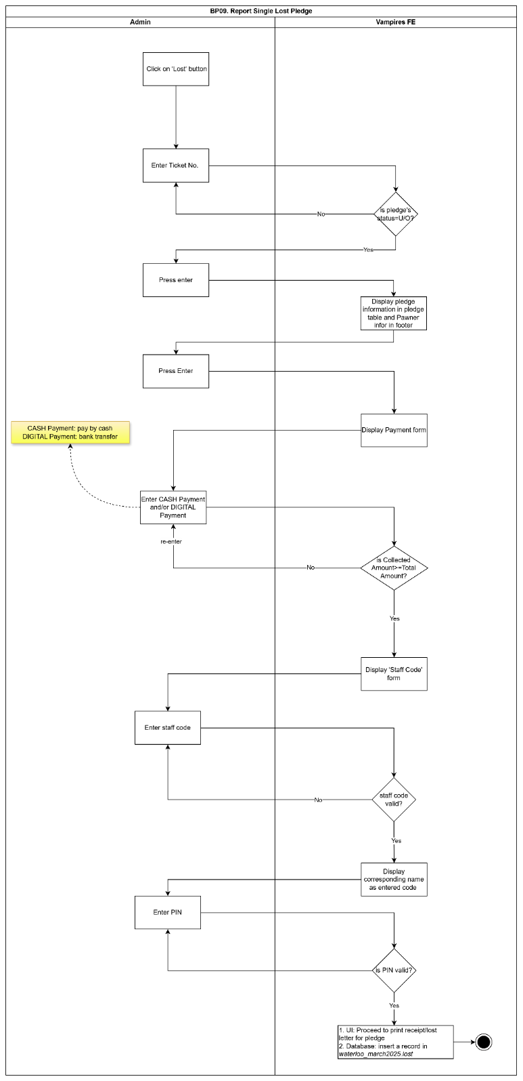

### BP4.2. Outlet Staff Report multiple lost pledge

|  |  |  |
| --- | --- | --- |
| **AS A [type of user]** | **I WANT TO [do some task]** | **SO THAT I CAN [get some result]** |
| Outlet Staff | Report multiple lost pledge | Reprint the lost letters |

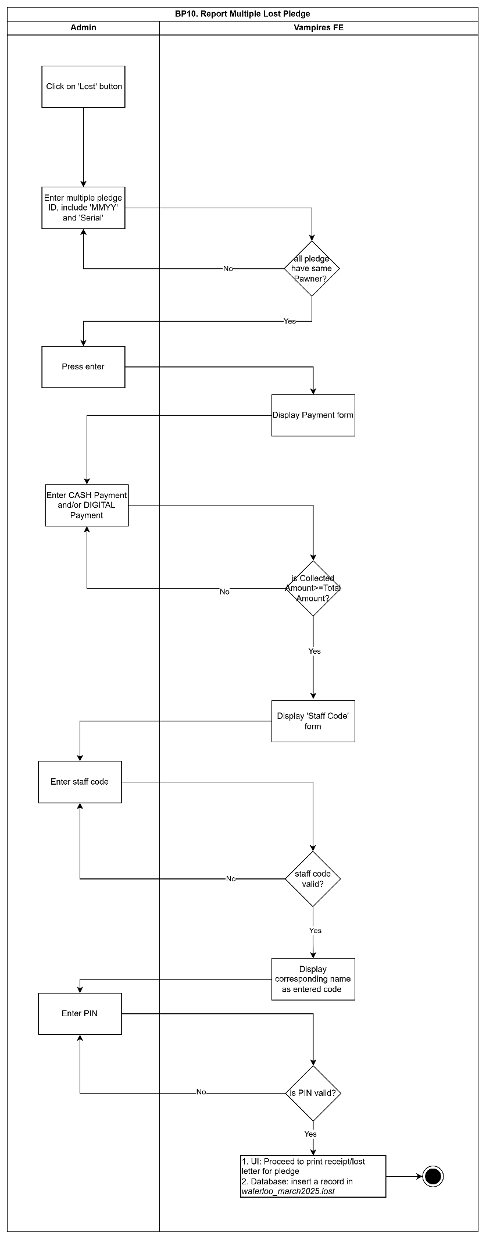

## BP05. Outlet Staff Reprint Lost Letter

|  |  |  |
| --- | --- | --- |
| **AS A [type of user]** | **I WANT TO [do some task]** | **SO THAT I CAN [get some result]** |
| Outlet Staff | Reprint lost letter | Give it to customer for later user |

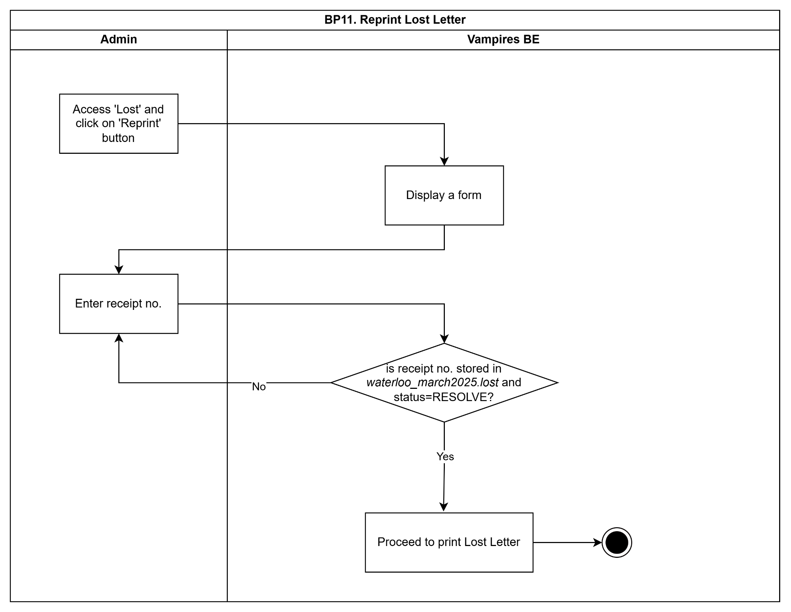

## BP06. Outlet Staff Combine Redemption and Renewal at the same time

### BP06.1. Outlet Staff Combine Redemption and Renewal at the same time (Redeemer=all Pawner)

|  |  |  |
| --- | --- | --- |
| **AS A [type of user]** | **I WANT TO [do some task]** | **SO THAT I CAN [get some result]** |
| Outlet Staff | Redeem and Renew ticket at the same time | extend the validity of pawned items and terminate the pawning flow |

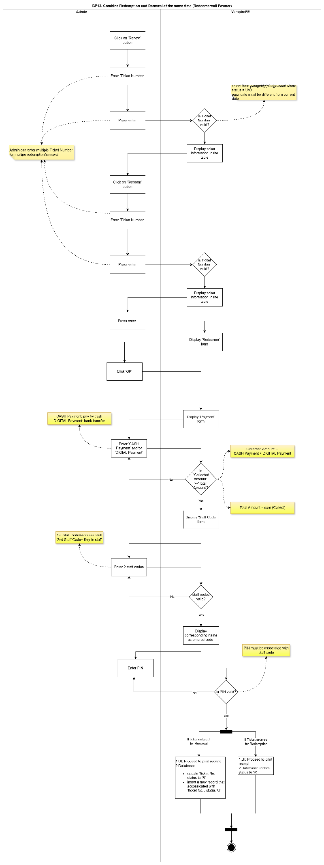

### BP06.2. Outlet Staff Combine Redemption and Renewal at the same time (Redeemer ≠ Pawner)

|  |  |  |
| --- | --- | --- |
| **AS A [type of user]** | **I WANT TO [do some task]** | **SO THAT I CAN [get some result]** |
| Outlet Staff | Redeem and Renew ticket at the same time | extend the validity of pawned items and terminate the pawning flow |

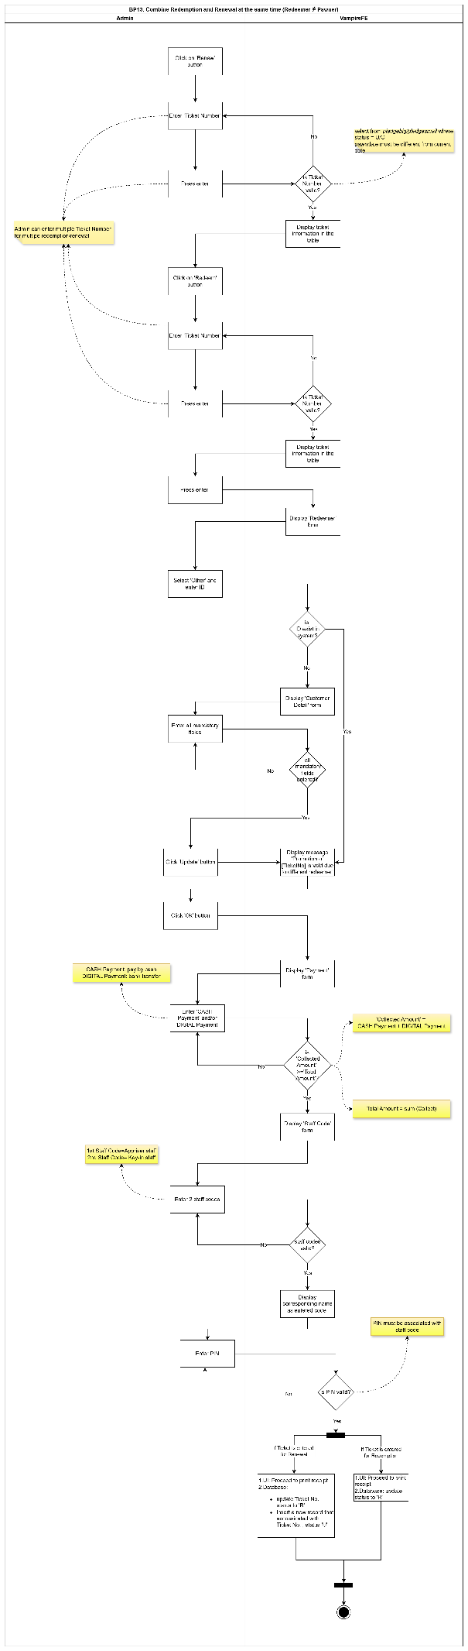

## BP07. Outlet Staff View Credit Rating

|  |  |  |
| --- | --- | --- |
| **AS A [type of user]** | **I WANT TO [do some task]** | **SO THAT I CAN [get some result]** |
| Outlet Staff | View credit rating | Assess the risk associated with a customer |

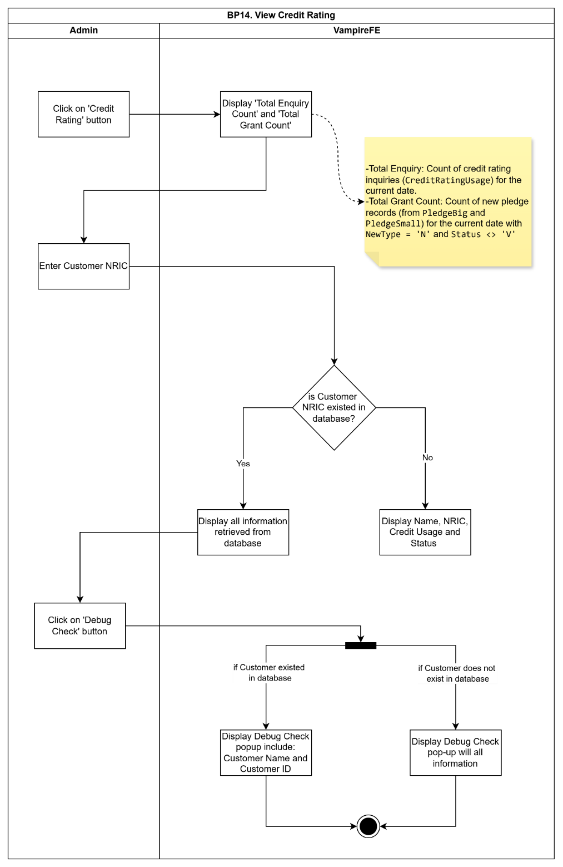6. FUNCTION SPECIFICATION

## 6.1. List of functions

|  |  |
| --- | --- |
| **FUNC. ID** | **Title** |
| FUNC-01 | Renew Ticket(s) |
| FUNC-02 | Redeem Ticket(s) |
| FUNC-02.1 | Update Customer Details |
| FUNC-03 | Enquiry |
| FUNC-04 | Report Lost pledge |
| FUNC-05 | Reprint Lost Letter |
| FUNC-06 | Combine Redemption and Renewal |
| FUNC-07 | View Credit Rating |

## 6.2. Detail of functions

### FUNC-01. Renew Ticket(s)

Figure FUNC-01 – a. Renew Form

|  |  |  |  |  |  |  |  |  |
| --- | --- | --- | --- | --- | --- | --- | --- | --- |
| Section | Field Name | Control Type | Values (**Default**) | Is Required Field? | Format | Is Visible? | Is Enabled? | Remark |
| Pledge table | Pledge No. | Display |  |  |  | TRUE | FALSE |  |
| Lost | Display |  |  |  | TRUE | FALSE |  |
| Weight | Display |  |  |  | TRUE | FALSE |  |
| Scrambled No. | Display |  |  |  | TRUE | FALSE |  |
| Principal | Display |  |  |  | TRUE | FALSE |  |
| Months | Display |  |  |  | TRUE | FALSE |  |
| Interest | Display |  |  |  | TRUE | FALSE |  |
| Collect | Display |  |  |  | TRUE | FALSE |  |
| ST. Code | Display |  |  |  | TRUE | FALSE |  |
| P.Code | Display |  |  |  | TRUE | FALSE |  |
| New Amt | Display |  |  |  | TRUE | FALSE |  |
|  | Ticket Number | TextBox |  |  |  | TRUE | TRUE |  |
| Total Renew | Display |  |  |  | TRUE | FALSE |  |
| Total Redeem | Display |  |  |  | TRUE | FALSE |  |
| Grand Total | Display | =Total Renew+Total Redeem |  |  | TRUE | FALSE |  |
| Name | Display |  |  |  | TRUE | FALSE |  |
| Contract No. | Display |  |  |  | TRUE | FALSE |  |
| Notes | Display |  |  |  | TRUE | FALSE |  |
| Float | Display |  |  |  | TRUE | FALSE |  |
| Auction | Display |  |  |  | TRUE | FALSE |  |
| Outstandings | Display |  |  |  | TRUE | FALSE |  |

-Fill in Ticket Number

-Press ‘Enter’

Figure FUNC-01 – b. Payment form

|  |  |  |  |  |  |  |  |  |
| --- | --- | --- | --- | --- | --- | --- | --- | --- |
| Section | Field Name | Control Type | Values (**Default**) | Is Required Field? | Format | Is Visible? | Is Enabled? | Remark |
| Payment form | Total Amount | Display |  |  |  | TRUE | FALSE |  |
| CASH Payment | TextBox |  |  |  | TRUE | TRUE |  |
| DIGITAL Payment | TextBox |  |  |  | TRUE | TRUE |  |
| Ref NO. | Display |  |  |  | TRUE | FALSE |  |
| Collected Amount | Display |  |  |  | TRUE | FALSE |  |

-Fill in CASH Payment and/or DIGITAL Payment

-Click ‘Ok’ button

Figure FUNC-01 – c. Staff Code

|  |  |  |  |  |  |  |  |  |
| --- | --- | --- | --- | --- | --- | --- | --- | --- |
| Section | Field Name | Control Type | Values (**Default**) | Is Required Field? | Format | Is Visible? | Is Enabled? | Remark |
| Staff Code | Staff Code | TextBox |  |  |  | TRUE | TRUE |  |
| PIN | TextBox |  |  |  | TRUE | TRUE |  |
| Appraiser | Display | Will be displayed once valid Staff Code is entered |  |  | TRUE | FALSE |  |
| Key-In Name | Display | Will be displayed once valid Staff Code is entered |  |  | TRUE | FALSE |  |

-Fill in Staff Code and PIN

-Press Enter

|  |  |  |  |  |  |  |  |  |  |  |  |  |  |  |  |  |  |  |  |  |  |  |  |  |
| --- | --- | --- | --- | --- | --- | --- | --- | --- | --- | --- | --- | --- | --- | --- | --- | --- | --- | --- | --- | --- | --- | --- | --- | --- |
| **Action Logic: Renew ticket(s)**  **Trigger:**   * User fills in Ticket No and press Enter   **1. Pre Checks:**   * Ticket Number must be entered * Ticket Number must exist in database * Ticket status must be U/O * PawnDate must be **different** from the current date * PIN must be associated with the entered staff code     **2. Action Logic:**   |  |  |  | | --- | --- | --- | | **Condition** | **System Action** | **State Change** | | Ticket number is valid | Display ticket information in the table | State = "Data Shown" | | Ticket number is invalid | Display error message | State unchanged | | User presses Enter (after info is shown) | Display Payment form | Awaiting Payment | | Collected Amount < Total Amount | Show error: "Collected Amount must be equal or greater than Total Amount" | State unchanged | | Collected Amount ≥ Total Amount | Proceed to PIN confirmation | Awaiting PIN Confirmation | | Valid staffcode and PIN | Proceed to finalize renewal, print receipt [7.1.1] and contract [7.1.2], update ticket records | Status = Renewed | | Invalid staffcode or PIN | Show error message | State unchanged |         **3. Post Flow:**   * **UI:** Proceeds to print receipt * **Database:** * Change current ticket status to 'R' (Renewed) * Insert a new ticket associated with the current one, with a status of 'U' |

### FUNC-02. Redeem Ticket(s)

Figure FUNC-02 – a. Redeem form

|  |  |  |  |  |  |  |  |  |
| --- | --- | --- | --- | --- | --- | --- | --- | --- |
| Section | Field Name | Control Type | Values (**Default**) | Is Required Field? | Format | Is Visible? | Is Enabled? | Remark |
| Pledge table | Pledge No. | Display |  |  |  | TRUE | FALSE |  |
| Lost | Display |  |  |  | TRUE | FALSE |  |
| Weight | Display |  |  |  | TRUE | FALSE |  |
| Scrambled No. | Display |  |  |  | TRUE | FALSE |  |
| Principal | Display |  |  |  | TRUE | FALSE |  |
| Months | Display |  |  |  | TRUE | FALSE |  |
| Interest | Display |  |  |  | TRUE | FALSE |  |
| Collect | Display |  |  |  | TRUE | FALSE |  |
| ST. Code | Display |  |  |  | TRUE | FALSE |  |
| P.Code | Display |  |  |  | TRUE | FALSE |  |
| New Amt | Display |  |  |  | TRUE | FALSE |  |
|  | Ticket Number | TextBox |  |  |  | TRUE | TRUE |  |
| Total Renew | Display |  |  |  | TRUE | FALSE |  |
| Total Redeem | Display |  |  |  | TRUE | FALSE |  |
| Grand Total | Display | =Total Renew+Total Redeem |  |  | TRUE | FALSE |  |
| Name | Display |  |  |  | TRUE | FALSE |  |
| Contract No. | Display |  |  |  | TRUE | FALSE |  |
| Notes | Display |  |  |  | TRUE | FALSE |  |
| Float | Display |  |  |  | TRUE | FALSE |  |
| Auction | Display |  |  |  | TRUE | FALSE |  |
| Outstandings | Display |  |  |  | TRUE | FALSE |  |

-Fill in Ticket Number

-Press ‘Enter’

Figure FUNC-02 – b. Redeemer form

|  |  |  |  |  |  |  |  |  |
| --- | --- | --- | --- | --- | --- | --- | --- | --- |
| Section | Field Name | Control Type | Values (**Default**) | Is Required Field? | Format | Is Visible? | Is Enabled? | Remark |
| Redeemer form | Pawner | TextBox |  |  |  | TRUE | FALSE |  |
| Guarantor | TextBox |  |  |  | FALSE | FALSE |  |
| Other | TextBox |  |  |  | TRUE | FALSE |  |

-Select Pawner/Other

-Fill in ID

Figure FUNC-02 – c. Payment form

|  |  |  |  |  |  |  |  |  |
| --- | --- | --- | --- | --- | --- | --- | --- | --- |
| Section | Field Name | Control Type | Values (**Default**) | Is Required Field? | Format | Is Visible? | Is Enabled? | Remark |
| Payment form | Total Amount | Display |  |  |  | TRUE | FALSE |  |
| CASH Payment | TextBox |  |  |  | TRUE | TRUE |  |
| DIGITAL Payment | TextBox |  |  |  | TRUE | TRUE |  |
| Ref NO. | Display |  |  |  | TRUE | FALSE |  |
| Collected Amount | Display |  |  |  | TRUE | FALSE |  |

-Fill in CASH Payment and/or DIGITAL Payment

-Click ‘Ok’ button

Figure FUNC-02 – d. Staff Code

|  |  |  |  |  |  |  |  |  |
| --- | --- | --- | --- | --- | --- | --- | --- | --- |
| Section | Field Name | Control Type | Values (**Default**) | Is Required Field? | Format | Is Visible? | Is Enabled? | Remark |
| Staff Code | Staff Code | TextBox |  |  |  | TRUE | TRUE |  |
| PIN | TextBox |  |  |  | TRUE | TRUE |  |
| Appraiser | Display | Will be displayed once valid Staff Code is entered |  |  | TRUE | FALSE |  |
| Key-In Name | Display | Will be displayed once valid Staff Code is entered |  |  | TRUE | FALSE |  |

-Fill in Staff Code and PIN

-Press Enter

|  |  |  |  |  |  |  |  |  |  |  |  |  |  |  |  |  |  |  |  |  |  |  |  |  |  |  |  |  |  |  |  |  |  |  |  |  |  |  |  |  |  |  |  |  |  |  |  |  |  |  |  |  |  |  |  |  |  |  |  |  |  |  |  |  |  |  |  |  |  |
| --- | --- | --- | --- | --- | --- | --- | --- | --- | --- | --- | --- | --- | --- | --- | --- | --- | --- | --- | --- | --- | --- | --- | --- | --- | --- | --- | --- | --- | --- | --- | --- | --- | --- | --- | --- | --- | --- | --- | --- | --- | --- | --- | --- | --- | --- | --- | --- | --- | --- | --- | --- | --- | --- | --- | --- | --- | --- | --- | --- | --- | --- | --- | --- | --- | --- | --- | --- | --- | --- |
| **Action Logic: Redeem Ticket (Pawner=Redeemer)**  **Trigger:**   * Outlet Staff fills in Ticket No and press Enter   **1. Pre Checks:**   * Ticket number must be entered and valid. * Pledge status must be U or O. * Collected Amount must be equal to or greater than the Total Amount. * Valid Staff Code and PIN must be entered. * Redeemer must be the Pawner   **2. Action Logic:**   |  |  |  | | --- | --- | --- | | **Condition** | **System Action** | **State Change** | | Ticket number is valid | Display pledge and pawner info | State = "Pledge Info Shown" | | Ticket number is invalid | Display error message | State unchanged | | Invalid collected amount | Prompt for re-entry | State unchanged | | Valid collected amount (≥ total) | Display Staff Code form | Awaiting Staff Code Entry | | Invalid staff code | Show validation error | State unchanged | | Valid staff code | Display staff name | Awaiting PIN Entry | | Invalid PIN | Show validation error | State unchanged | | Valid PIN | Proceed to print receipt |  |         **3. Post Flow:**   * **UI:** Proceeds to print receipt. * **Database:** Updates ticket status to 'R' in the database.   **Action Logic: Redeem Ticket (Pawner**≠**Redeemer)**  **Trigger:**   * User fills in Ticket No and press Enter   **1. Pre Checks:**   * Ticket number must be entered. * Ticket must exist in pledgebig, pledgesmall tables. * Ticket status must be U or O. * Pawner ≠ Redeemer. * Redeemer's ID must be entered and checked:   + If exists → retrieve details.   + If not → manual entry required. * All mandatory fields for redeemer must be completed. * Payment must be fully collected. * Two valid staff codes and PINs must be entered:   + **1st Staff**: Appraiser staff.   + **2nd Staff**: Key-in staff.   **2. Action Logic:**   |  |  |  | | --- | --- | --- | | **Condition** | **System Action** | **State Change** | | Valid ticket | Display ticket information | State = "Data Shown" | | Invalid ticket | Show error message | State unchanged | | ID exists in system | Proceed to next step |  | | ID not in system | Display Customer Detail form | Awaiting New Entry | | Required fields not filled | Show validation errors | State unchanged | | All required fields filled | Show message: “Promotion of Ticket(s) is void due to different redeemer” | Proceed | | User clicks "OK" | Display Payment form | Awaiting Payment | | Collected Amount < Total Amount | Show error and re-enter payment | State unchanged | | Collected Amount ≥ Total Amount | Display Staff Code form | Awaiting Staff Code Entry | | Invalid staff codes | Show validation error | State unchanged | | Valid staff codes | Display corresponding names | Awaiting PIN Entry | | Invalid PINs | Show validation error | State unchanged | | Valid PINs | Proceed to print receipt |  |         **3. Post Flow:**   * **UI:** Proceeds to print receipt. * **Database:** Updates ticket status to 'R' in the database. |

#### FUNC-02.1. Create New Customer

Figure FUNC-021.1 – a. Customer Details

Ảnh có chứa văn bản, ảnh chụp màn hình, màn hình, phần mềm

Nội dung do AI tạo ra có thể không chính xác.

|  |  |  |  |  |  |  |  |  |
| --- | --- | --- | --- | --- | --- | --- | --- | --- |
| Section | Field Name | Control Type | Values (**Default**) | Is Required Field? | Format | Is Visible? | Is Enabled? | Remark |
| Customer form | NRIC NO. | TextBox |  | TRUE |  | TRUE | TRUE |  |
| DOB | TextBox | DDMMYY | TRUE |  | TRUE | TRUE |  |
| CAT | TextBox |  |  |  | TRUE | TRUE |  |
| POSTAL | TextBox |  |  |  | TRUE | TRUE |  |
| REMIND | CheckBox | X/space |  |  | TRUE | TRUE |  |
| CONTACT | TextBox |  |  |  | TRUE | TRUE |  |
| ADDRESS | TextBox |  | TRUE |  |  |  |  |
| NAME | TextBox |  | TRUE |  | TRUE | TRUE |  |
| Race | TextBox | C/M/I/E/F/B/O | TRUE |  | TRUE | TRUE | Chinese, Malay, Indian, Eurasian, Filipino, Bumiputera (Sabah/Sarawak), Others |
| Sex | TextBox | M/F | TRUE |  | TRUE | TRUE | Male, Female |
| Nationality | TextBox | S/M/I/C/F/V/Y/P/T/B/N/A/O | TRUE |  | TRUE | TRUE | Singaporean, Malaysian. Indonesia, China, Philippines, Vietnam, Myanmar, Pakistan, Thailand, Bangladesh, India, Cambodia, Others |
| UNIT | TextBox | Number |  |  | TRUE | TRUE |  |
| NOTE | TextBox |  |  |  | TRUE | TRUE |  |
| OWNER | CheckBox | **Y/**N |  |  | TRUE | TRUE |  |
| B. LIST | Button |  |  |  | TRUE | FALSE |  |
| Guarantor form | NRIC NO. | TextBox |  | TRUE |  | TRUE | TRUE |  |
| DOB | TextBox | DDMMYY | TRUE |  | TRUE | TRUE |  |
| CAT | TextBox |  |  |  | TRUE | TRUE |  |
| POSTAL | TextBox |  |  |  | TRUE | TRUE |  |
| REMIND | CheckBox | X/space |  |  | TRUE | TRUE |  |
| CONTACT | TextBox |  |  |  | TRUE | TRUE |  |
| ADDRESS | TextBox |  | TRUE |  |  |  |  |
| NAME | TextBox |  | TRUE |  | TRUE | TRUE |  |
| Race | TextBox | C/M/I/E/F/B/O | TRUE |  | TRUE | TRUE | Chinese, Malay, Indian, Eurasian, Filipino, Bumiputera (Sabah/Sarawak), Others |
| Sex | TextBox | M/F | TRUE |  | TRUE | TRUE | Male, Female |
| Nationality | TextBox | S/M/I/C/F/V/Y/P/T/B/N/A/O | TRUE |  | TRUE | TRUE | Singaporean, Malaysian. Indonesia, China, Philippines, Vietnam, Myanmar, Pakistan, Thailand, Bangladesh, India, Cambodia, Others |
| UNIT | TextBox | Number |  |  | TRUE | TRUE |  |
| NOTE | TextBox |  |  |  | TRUE | TRUE |  |
| OWNER | CheckBox | **Y/**N |  |  | TRUE | TRUE |  |
| B. LIST | Button |  |  |  | TRUE | FALSE |  |

-Fill in all mandatory fields

-Click on ‘Update’ button

|  |  |  |  |  |  |  |  |  |  |  |  |  |  |  |  |  |  |  |  |  |  |  |  |  |
| --- | --- | --- | --- | --- | --- | --- | --- | --- | --- | --- | --- | --- | --- | --- | --- | --- | --- | --- | --- | --- | --- | --- | --- | --- |
| **Action Logic: Create New Customer**  **Trigger:**   * User selects “Other” at the Redeemer form and enters a customer ID that does **not** exist in the system.   **1. Pre Checks:**   * Entered ID must not exist in the customer database. * Customer and Guarantor information must be collected according to form validation rules.     **2. Action Logic:**   |  |  |  | | --- | --- | --- | | **Condition** | **System Action** | **State Change** | | ID does not exist in database | Display Customer Details form | State = "Form Displayed" | | Fill all mandatory fields in Customer section | Validate inputs in Customer section | State = "Customer Validating" | | Errors in Customer section | Show error message | State unchanged | | Customer has Guarantor = Yes | Display Guarantor section | State = "Guarantor Entry" | | Fill all mandatory fields in Guarantor section | Validate inputs in Guarantor section | State = "Guarantor Validating" | | Errors in Guarantor section | Show error message | State unchanged | | Click "Update" button with valid Customer/Guarantor data | Save new customer to waterloo_march2025.pawner | State = "Customer Saved" |         **3. Post Flow:**   * **UI:**   + Display success message   + Redirect back to Redeemer form. * **Database:** Insert new record into *waterloo_march2025.pawner*. |

### FUNC-03. Enquiry

Figure FUNC-03 – a. Enquiry form

|  |  |  |  |  |  |  |  |  |
| --- | --- | --- | --- | --- | --- | --- | --- | --- |
| Section | Field Name | Control Type | Values **(Default)** | Is Required Field? | Format | Is Visible? | Is Enabled? | Remark |
| ENQUIRY | NAME / ID / TICKET / MMYY/ EXPIRY DAY (DD) / PLEDGE CODE | TextBox |  | TRUE |  | TRUE | TRUE |  |
| DESCRIPTION | TextBox |  | FALSE |  | TRUE | TRUE |  |
| START DATE | DatePicker | A year ago compares with current date | FALSE | DD/MM/YYYY | TRUE | TRUE |  |
| END DATE | DatePicker | Current Date | FALSE | DD/MM/YYYY | TRUE | TRUE |  |
| INFORMATION | Display Area |  |  |  | TRUE | FALSE | Read-only display |

-Fill in NAME / ID / TICKET / MMYY/ EXPIRY DAY (DD) / PLEDGE CODE

- Press Enter

|  |  |  |  |  |  |  |  |  |  |  |  |  |  |  |  |  |  |  |  |  |  |  |  |  |  |  |  |  |  |  |  |  |  |  |  |  |  |  |  |  |  |  |  |  |  |  |  |  |  |  |  |  |  |  |
| --- | --- | --- | --- | --- | --- | --- | --- | --- | --- | --- | --- | --- | --- | --- | --- | --- | --- | --- | --- | --- | --- | --- | --- | --- | --- | --- | --- | --- | --- | --- | --- | --- | --- | --- | --- | --- | --- | --- | --- | --- | --- | --- | --- | --- | --- | --- | --- | --- | --- | --- | --- | --- | --- | --- |
| **Action Logic: Enquiry Pawner (by Name)**  **Trigger:**   * User fills in Pawner Name and press “Enter"   **1. Pre Checks:**   * The name must exist in the *waterloo_march2025.pawner* table   **2. Action Logic:**   |  |  |  | | --- | --- | --- | | **Condition** | **System Action** | **State Change** | | Name is valid (exists) | - Display pawner information in the result table |  | | Name not found | - Show error message: “No Record is Found” |  |   **3. Post Flow:**   * **UI**: Display pawner information below the enquiry form * **Database**: No update; read-only operation from *waterloo_march2025.pawner*   **Action Logic: Enquiry Pawner (by ID)**  **Trigger:**   * User fills in Pawner ID and press “Enter”   **1. Pre Checks:**   * The ID must exist in the *waterloo_march2025.pawner* table   **2. Action Logic:**   |  |  |  | | --- | --- | --- | | **Condition** | **System Action** | **State Change** | | Pawner ID is valid | - Display pawner information in the result table |  | | Pawner ID not found | - Show error: "No Record is found" |  |   **3. Post Flow:**   * **UI**: Display pawner information below the enquiry form * **Database**: No update; read-only operation from *waterloo_march2025.pawner*   **Action Logic: Enquiry Ticket (by MMYY)**  **Trigger:**   * User fills in MMYY and press “Enter”   **1. Pre Checks:**   * N/A   **2. Action Logic:**   |  |  |  | | --- | --- | --- | | **Condition** | **System Action** | **State Change** | | **Press Enter** | - Display associated ticket records in table below the form |  | | **No items found** | - Display error message: "No record found.” |  |   **3. Post Flow:**   * **UI**: Show ticket information in a results table based on MMYY input * **Database**: Read-only action querying pledgebig, pledgesmall, and pledgetcash in *waterloo_march2025*   **Action Logic: Enquiry Ticket (by Expired Date)**  **Trigger:**   * User fills in DD and press “Enter”   **1. Pre Checks:**   * Expired Date (DD) is entered and valid   **2. Action Logic:**   |  |  |  | | --- | --- | --- | | **Condition** | **System Action** | **State Change** | | **Record(s) found with Expiry Day = DD** | - Query from pledgebig, pledgesmall, tables in **waterloo_march2025**  - Display matching records in result table | State = Display | | **No matching record found** | - Display error message: “No records found” | State unchanged |   **3. Post Flow:**   * **UI**: Display all tickets with Expiry Day = DD in result table * **Database**: Read-only operation on pledgebig, pledgesmall from *waterloo_march2025*   **Action Logic: Enquiry Ticket (by Pledge Code)**  **Trigger:**   * User fills in Pledge Code and press “Enter”   **1. Pre Checks:**   * Pledge Code must exist in database * Pledge Code must be 5 characters including both numbers and letters.   **2. Action Logic:**   |  |  |  | | --- | --- | --- | | **Condition** | **System Action** | **State Change** | | Pledge Code is valid | - Query waterloo_march2025.pledgenowithpledgecode  - Display ticket details | State = "Display" | | Pledge Code. is invalid | - Display error message: “Invalid Pledge Code.” | State unchanged |   **3. Post Flow:**   * **UI**: Display ticket detail view populated with corresponding pledge record * **Database**: Read-only query on *waterloo_march2025.pledgenowithpledgecode*   **Action Logic: Enquiry Ticket (by Ticket No.)**  **Trigger:**   * User fills in Ticket No. and press “Enter”   **1. Pre Checks:**   * Ticket No. must be entered in the format: **A/MMYY/XXXX** * A = pledge size: B, S, or T * MMYY = month and year * XXXX = 4-digit auto-increment number   **2. Action Logic:**   |  |  |  | | --- | --- | --- | | **Condition** | **System Action** | **State Change** | | **Ticket No. is valid** | - Validate Ticket No. against waterloo_march2025.pledgenowithpledgecode  - Display ticket details | State = "Data Shown" | | **Ticket No. is invalid** | - Display error message: “Invalid Pledge No. or Pawner ID” | State unchanged |   **3. Post Flow:**   * **UI**: Display detailed ticket information in enquiry form * **Database**: Read-only lookup in *waterloo_march2025.pledgenowithpledgecode* |

### FUNC-04. Report Lost pledge

Figure FUNC-04 – a. Lost form

|  |  |  |  |  |  |  |  |  |
| --- | --- | --- | --- | --- | --- | --- | --- | --- |
| Section | Field Name | Control Type | Values (**Default**) | Is Required Field? | Format | Is Visible? | Is Enabled? | Remark |
| Pledge table | Pledge No. | Display |  |  |  | TRUE | FALSE |  |
| Lost | Display |  |  |  | TRUE | FALSE |  |
| Weight | Display |  |  |  | TRUE | FALSE |  |
| Scrambled No. | Display |  |  |  | TRUE | FALSE |  |
| Principal | Display |  |  |  | TRUE | FALSE |  |
| Months | Display |  |  |  | TRUE | FALSE |  |
| Interest | Display |  |  |  | TRUE | FALSE |  |
| Collect | Display |  |  |  | TRUE | FALSE |  |
| ST. Code | Display |  |  |  | TRUE | FALSE |  |
| P.Code | Display |  |  |  | TRUE | FALSE |  |
|  | Ticket Number | TextBox |  |  |  | TRUE | TRUE |  |
| Pawner Infor | Pawner Name | Display |  |  |  | If Ticket Number is entered | FALSE |  |
| Pawner ID | Display |  |  |  | If Ticket Number is entered | FALSE |  |
| Multi Lost Letter | Reprint | Button |  |  |  | If Ticket Number is not entered | FALSE |  |

Figure FUNC-04 – b. Payment form

|  |  |  |  |  |  |  |  |  |
| --- | --- | --- | --- | --- | --- | --- | --- | --- |
| Section | Field Name | Control Type | Values (**Default**) | Is Required Field? | Format | Is Visible? | Is Enabled? | Remark |
| Payment form | Total Amount | Display |  |  |  | TRUE | FALSE |  |
| CASH Payment | TextBox |  |  |  | TRUE | TRUE |  |
| DIGITAL Payment | TextBox |  |  |  | TRUE | TRUE |  |
| Ref NO. | Display |  |  |  | TRUE | FALSE |  |
| Collected Amount | Display |  |  |  | TRUE | FALSE |  |

-Fill in CASH Payment and/or DIGITAL Payment

-Click ‘Ok’ button

Figure FUNC-4 – c. Staff Code

|  |  |  |  |  |  |  |  |  |
| --- | --- | --- | --- | --- | --- | --- | --- | --- |
| Section | Field Name | Control Type | Values (**Default**) | Is Required Field? | Format | Is Visible? | Is Enabled? | Remark |
| Staff Code | Staff Code | TextBox |  |  |  | TRUE | TRUE |  |
| PIN | TextBox |  |  |  | TRUE | TRUE |  |
| Key-In Name | Display | Will be displayed once valid Staff Code is entered |  |  | TRUE | FALSE |  |

-Fill in Staff Code and PIN

-Press Enter

|  |  |  |  |  |  |  |  |  |  |  |  |  |  |  |  |  |  |  |  |  |  |  |  |  |  |  |  |  |  |  |  |  |  |  |  |  |  |  |  |  |  |  |  |  |  |  |  |  |  |  |  |  |  |  |
| --- | --- | --- | --- | --- | --- | --- | --- | --- | --- | --- | --- | --- | --- | --- | --- | --- | --- | --- | --- | --- | --- | --- | --- | --- | --- | --- | --- | --- | --- | --- | --- | --- | --- | --- | --- | --- | --- | --- | --- | --- | --- | --- | --- | --- | --- | --- | --- | --- | --- | --- | --- | --- | --- | --- |
| **Action Logic: Report Single Lost pledge**  **Trigger:**   * Outlet Staff clicks on **“Lost”** button.   **1. Pre Checks:**   * Ticket number must be entered and valid. * Pledge status must be U or O. * Collected Amount must be equal to or greater than the Total Amount. * Valid Staff Code and PIN must be entered.   **2. Action Logic:**   |  |  |  | | --- | --- | --- | | **Condition** | **System Action** | **State Change** | | Ticket number is valid | Display pledge and pawner info | State = "Pledge Info Shown" | | Ticket number is invalid | Display error message | State unchanged | | Invalid collected amount | Prompt for re-entry | State unchanged | | Valid collected amount (≥ total) | Display Staff Code form | Awaiting Staff Code Entry | | Invalid staff code | Show validation error | State unchanged | | Valid staff code | Display staff name | Awaiting PIN Entry | | Invalid PIN | Show validation error | State unchanged | | Valid PIN | UI: Print receipt and lost letter [7.1.3]  Database: Insert lost record into *waterloo_march2025.lost* |  |         **3. Post Flow:**   * **UI:** Proceeds to print receipt and lost letter for the pledge. * **Database:** Inserts a record into *waterloo_march2025.lost.*   **Action Logic: Report Multiple Lost pledge**  **Trigger:**   * Outlet Staff clicks on **“Lost”** button.   **1. Pre Checks:**   * Multiple pledge IDs must be entered, each including **MMYY** and **Serial**. * All pledges must = U/O. * All pledges must belong to the **same pawner**. * Collected Amount must be **greater than or equal to** Total Amount. * Staff Code and PIN must be entered.   **2. Action Logic:**   |  |  |  | | --- | --- | --- | | **Condition** | **System Action** | **State Change** | | All pledge IDs valid and belong to the same pawner | Display payment form | State = "Awaiting Payment" | | Pledge IDs invalid or not same pawner | Show error message | State unchanged | | Collected Amount < Total Amount | Show validation error, prompt for re-entry | State unchanged | | Collected Amount ≥ Total Amount | Display Staff Code form | Awaiting Staff Code Entry | | Invalid Staff Code | Show validation error | State unchanged | | Valid Staff Code | Display corresponding name | Awaiting PIN Entry | | Invalid PIN | Show validation error | State unchanged | | Valid PIN | UI: Print receipt and lost letter  Database: Insert lost record per pledge ID into *waterloo_march2025.lost* |  |         **3. Post Flow:**   * **UI:** Proceeds to print receipt and lost letter for the pledge. * **Database:** Inserts a record into *waterloo_march2025.lost*. |

### FUNC-05. Reprint Lost Letter

Figure FUNC-05 – a. Lost Letter

Ảnh có chứa văn bản, ảnh chụp màn hình, phần mềm, màn hình

Nội dung do AI tạo ra có thể không chính xác.

|  |  |  |  |  |  |  |  |  |
| --- | --- | --- | --- | --- | --- | --- | --- | --- |
| Section | Field Name | Control Type | Values (**Default**) | Is Required Field? | Format | Is Visible? | Is Enabled? | Remark |
| Multi Lost Letter | Reprint | Button |  |  |  | If Ticket Number is not entered | FALSE |  |

-Click on ‘Reprint’ button

Figure FUNC-05 -b. Receipt No.

Ảnh có chứa văn bản, ảnh chụp màn hình, Phông chữ, thiết kế

Nội dung do AI tạo ra có thể không chính xác.

-Fill in Receipt No.

-Press ‘Enter’/Click on ‘Ok’ button

|  |  |  |  |  |  |  |  |  |  |  |  |  |
| --- | --- | --- | --- | --- | --- | --- | --- | --- | --- | --- | --- | --- |
| **Action Logic: Reprint Lost Letter**  **Trigger:**   * User accesses the “Lost” and clicks on “Reprint” button   **1. Pre Checks:**   * User must input a valid lost receipt number   **2. Action Logic:**   |  |  |  | | --- | --- | --- | | **Condition** | **System Action** | **State Change** | | Receipt not found or status ≠ 'RESOLVE' in waterloo_march2025.lost | - Show error: “Lost Pledge Not Exist” | State unchanged | | Receipt found and status = 'RESOLVE' | - Allow user to proceed with lost letter reprint | Ready to Reprint | | User confirms | - System prints Lost Letter | Document Reprinted |   **3. Post Flow:**   * **UI**: Lost Letter document is printed * **Database**: No updates performed; the system only reads data for validation |

### FUNC-06. Combine Redemption and Renewal

Figure FUNC-06 – a. Ticket Number input form

Ảnh có chứa văn bản, đồ điện tử, ảnh chụp màn hình, màn hình

Nội dung do AI tạo ra có thể không chính xác.

Ảnh có chứa văn bản, đồ điện tử, ảnh chụp màn hình, màn hình

Nội dung do AI tạo ra có thể không chính xác.

|  |  |  |  |  |  |  |  |  |
| --- | --- | --- | --- | --- | --- | --- | --- | --- |
| Section | Field Name | Control Type | Values (**Default**) | Is Required Field? | Format | Is Visible? | Is Enabled? | Remark |
| Pledge table | Pledge No. | Display |  |  |  | TRUE | FALSE |  |
| Lost | Display |  |  |  | TRUE | FALSE |  |
| Weight | Display |  |  |  | TRUE | FALSE |  |
| Scrambled No. | Display |  |  |  | TRUE | FALSE |  |
| Principal | Display |  |  |  | TRUE | FALSE |  |
| Months | Display |  |  |  | TRUE | FALSE |  |
| Interest | Display |  |  |  | TRUE | FALSE |  |
| Collect | Display |  |  |  | TRUE | FALSE |  |
| ST. Code | Display |  |  |  | TRUE | FALSE |  |
| P.Code | Display |  |  |  | TRUE | FALSE |  |
| New Amt | Display |  |  |  | TRUE | FALSE |  |
|  | Ticket Number | TextBox |  |  |  | TRUE | TRUE |  |
| Total Renew | Display |  |  |  | TRUE | FALSE |  |
| Total Redeem | Display |  |  |  | TRUE | FALSE |  |
| Grand Total | Display | =Total Renew+Total Redeem |  |  | TRUE | FALSE |  |
| Name | Display |  |  |  | TRUE | FALSE |  |
| Contract No. | Display |  |  |  | TRUE | FALSE |  |
| Notes | Display |  |  |  | TRUE | FALSE |  |
| Float | Display |  |  |  | TRUE | FALSE |  |
| Auction | Display |  |  |  | TRUE | FALSE |  |
| Outstandings | Display |  |  |  | TRUE | FALSE |  |

-Fill in valid Ticket Number

-Press ‘Enter’

Figure FUNC-06 – b. Redeemer form

Ảnh có chứa văn bản, đồ điện tử, ảnh chụp màn hình, màn hình

Nội dung do AI tạo ra có thể không chính xác.

|  |  |  |  |  |  |  |  |  |
| --- | --- | --- | --- | --- | --- | --- | --- | --- |
| Section | Field Name | Control Type | Values (**Default**) | Is Required Field? | Format | Is Visible? | Is Enabled? | Remark |
| Redeemer form | Pawner | TextBox |  |  |  | TRUE | FALSE |  |
| Guarantor | TextBox |  |  |  | FALSE | FALSE |  |
| Other | TextBox |  |  |  | TRUE | FALSE |  |

-Select Pawner/Other

-Fill in ID

Figure FUNC-06 – c. Payment form

Ảnh có chứa văn bản, đồ điện tử, ảnh chụp màn hình, màn hình

Nội dung do AI tạo ra có thể không chính xác.

|  |  |  |  |  |  |  |  |  |
| --- | --- | --- | --- | --- | --- | --- | --- | --- |
| Section | Field Name | Control Type | Values (**Default**) | Is Required Field? | Format | Is Visible? | Is Enabled? | Remark |
| Payment form | Total Amount | Display |  |  |  | TRUE | FALSE |  |
| CASH Payment | TextBox |  |  |  | TRUE | TRUE |  |
| DIGITAL Payment | TextBox |  |  |  | TRUE | TRUE |  |
| Ref NO. | Display |  |  |  | TRUE | FALSE |  |
| Collected Amount | Display |  |  |  | TRUE | FALSE |  |

-Fill in CASH Payment and/or DIGITAL Payment

-Click ‘Ok’ button

Figure FUNC-06 – d. Staff Code

Ảnh có chứa văn bản, đồ điện tử, ảnh chụp màn hình, màn hình

Nội dung do AI tạo ra có thể không chính xác.

|  |  |  |  |  |  |  |  |  |
| --- | --- | --- | --- | --- | --- | --- | --- | --- |
| Section | Field Name | Control Type | Values (**Default**) | Is Required Field? | Format | Is Visible? | Is Enabled? | Remark |
| Staff Code | Staff Code | TextBox |  |  |  | TRUE | TRUE |  |
| PIN | TextBox |  |  |  | TRUE | TRUE |  |
| Appraiser | Display | Will be displayed once valid Staff Code is entered |  |  | TRUE | FALSE |  |
| Key-In Name | Display | Will be displayed once valid Staff Code is entered |  |  | TRUE | FALSE |  |

-Fill in Staff Code and PIN

-Press Enter

|  |  |  |  |  |  |  |  |  |  |  |  |  |  |  |  |  |  |  |  |  |  |  |  |  |  |  |  |  |  |  |  |  |  |  |  |  |  |  |  |  |  |  |  |  |  |  |  |  |  |  |  |  |  |  |  |  |  |  |  |  |  |  |  |  |  |  |  |  |  |  |  |  |  |  |  |  |  |  |  |  |  |
| --- | --- | --- | --- | --- | --- | --- | --- | --- | --- | --- | --- | --- | --- | --- | --- | --- | --- | --- | --- | --- | --- | --- | --- | --- | --- | --- | --- | --- | --- | --- | --- | --- | --- | --- | --- | --- | --- | --- | --- | --- | --- | --- | --- | --- | --- | --- | --- | --- | --- | --- | --- | --- | --- | --- | --- | --- | --- | --- | --- | --- | --- | --- | --- | --- | --- | --- | --- | --- | --- | --- | --- | --- | --- | --- | --- | --- | --- | --- | --- | --- | --- |
| **Action Logic: Combine Redemption and Renewal at the Same Time (Redeemer = all Pawners)**  **Trigger:**   * User fills in Ticket No and press Enter   **1. Pre Checks:**   * Multiple tickets can be entered for both **Renewal** and **Redemption**. * All tickets must:   + Exist in pledgebig / pledgesmall   + Have status = U or O. * Redeemer must match all Pawners. * Two staff codes and associated PINs must be entered:   + 1st Staff = Appraiser.   + 2nd Staff = Key-in.     **2. Action Logic:**   |  |  |  | | --- | --- | --- | | **Condition** | **System Action** | **State Change** | | Ticket number is invalid | Show error message | State unchanged | | Ticket number is valid | Display ticket information | State = "Data Shown" | | Click 'Redeem' after renewal tickets input | Proceed to Redemption input process | Awaiting Additional Input | | All tickets valid and matched | Display full ticket data with Redeemer form | Proceed | | Click ‘OK’ | Display Payment form | Awaiting Payment | | Collected Amount < Total Amount | Prompt for full payment | State unchanged | | Collected Amount ≥ Total Amount | Proceed to staff code validation | Awaiting Staff Code Entry | | Invalid staff codes | Show validation error | State unchanged | | Valid staff codes | Display corresponding names | Awaiting PIN Entry | | Invalid PIN | Show validation error | State unchanged | | Valid PIN | Print receipt and update database |  |         **3. Post Flow:**   * **UI:** Proceeds to print receipt. * **Database:**   + For Redemption Tickets:     - Update ticket status to 'R'   + For Renewal Tickets:     - Update old ticket status to 'R'     - Insert a new associated ticket with status 'U'   **Action Logic: Combine Redemption and Renewal at the Same Time (Redeemer ≠ Pawner)**  **Trigger:**   * User fills in Ticket No and press Enter   **1. Pre Checks:**   * At least one **valid Ticket Number** must be entered for both Redemption and Renewal. * All Ticket Numbers: * Must exist in pledgebig / pledgesmall * Must have status = U/O. * Redeemer must be verified via ID:   + If not in system, Outlet Staff must fill in **Customer Detail**. * Collected Amount must equal or greater than the **Total Amount**. * Two staff codes must be entered:   + 1st = Appraiser staff.   + 2nd = Key-in staff. * PIN must be associated with the entered staff code.     **2. Action Logic:**   |  |  |  | | --- | --- | --- | | **Condition** | **System Action** | **State Change** | | Ticket number is invalid | Display error message | State unchanged | | Valid ticket number | Display ticket information in table | State = "Data Shown" | | Outlet Staff clicks on 'Redeem' | Proceed to Redeemer entry | Awaiting Redeemer Info | | ID not in system | Display 'Customer Detail' form | Awaiting Redeemer Data Entry | | Not all mandatory fields are entered | Display validation error | State unchanged | | All mandatory fields entered | Proceed to update Redeemer info | Proceed | | Tickets are eligible for promotion but Redeemer ≠ Pawner | Show message: “Promotion of [TicketNo] is void due to different redeemer” | State unchanged | | Click ‘OK’ | Display Payment form | Awaiting Payment | | Collected Amount < Total Amount | Prompt for full payment | State unchanged | | Collected Amount ≥ Total Amount | Proceed to staff code entry | Awaiting Staff Code Entry | | Invalid staff codes | Show validation error | State unchanged | | Valid staff codes | Display corresponding staff names | Awaiting PIN Entry | | Invalid PIN | Show validation error | State unchanged | | Valid PIN | Proceed to receipt and update database |  |         **3. Post Flow:**   * **UI:** Proceeds to print receipt. * **Database:**   + For Redemption Tickets:     - Update ticket status to 'R'   + For Renewal Tickets:     - Update old ticket status to 'R'     - Insert new ticket associated with old one, status = 'U' |

### FUNC-07. View Credit Rating

Figure FUNC-07 – Credit Rating

Ảnh có chứa văn bản, ảnh chụp màn hình, màn hình, phần mềm

Nội dung do AI tạo ra có thể không chính xác.

|  |  |  |  |  |  |  |  |  |
| --- | --- | --- | --- | --- | --- | --- | --- | --- |
| Section | Field Name | Control Type | Values (**Default**) | Is Required Field? | Format | Is Visible? | Is Enabled? | Remark |
| Pledge table | NAME | Display |  |  |  | If CUSTOMER NRIC is entered | FALSE |  |
| NRIC | Display |  |  |  | If CUSTOMER NRIC is entered | FALSE |  |
| TODAY ENQUIRY COUNT | Display |  |  |  | TRUE | FALSE |  |
| TODAY GRANT COUNT | Display |  |  |  | TRUE | FALSE |  |
| CREDIT USAGE | Display |  |  |  | If CUSTOMER NRIC is entered | FALSE |  |
| STATUS | Display | Excellent/ Good/ Average/ New/ Limit |  |  | If CUSTOMER NRIC is entered | FALSE |  |
| ASSESSMENT LIMIT | Display |  |  |  | If entered CUSTOMER NRIC existed | FALSE |  |
| TOTAL OUTSTANDING AMOUNT | Display |  |  |  | TRUE | FALSE |  |
| OUTSTANDING LIMIT | Display |  |  |  | If entered CUSTOMER NRIC existed | FALSE |  |
| CUSTOMER NRIC | Textbox |  |  |  | TRUE | TRUE |  |
| Debug Check | Button |  |  |  | TRUE | FALSE |  |

-Enter ‘CUSTOMER NRIC’

-Display corresponding data

Figure FUNC-07 – b. Debug Check (existed Customer)

Ảnh có chứa văn bản, ảnh chụp màn hình, màn hình, phần mềm

Nội dung do AI tạo ra có thể không chính xác.

|  |  |  |  |  |  |  |  |  |
| --- | --- | --- | --- | --- | --- | --- | --- | --- |
| Section | Field Name | Control Type | Values (**Default**) | Is Required Field? | Format | Is Visible? | Is Enabled? | Remark |
| Pledge table | Customer ID | Display |  |  |  | TRUE | FALSE |  |
| Customer Name | Display |  |  |  | TRUE | FALSE |  |
| TInterest | Display | Sum of interest from related redeem records |  |  | TRUE | FALSE |  |
| TDefault | Display | Sum of pawned amounts where Status in ('A', 'D') |  |  | TRUE | FALSE |  |
| TPawnAmount | Display | Sum of pawned amounts where NewType = 'N' |  |  | TRUE | FALSE |  |
| TCount | Display | Number of pawned items where NewType = 'N' |  |  | TRUE | FALSE |  |

Figure FUNC-07 – c. Debug Check (new Customer)

Ảnh có chứa văn bản, ảnh chụp màn hình, màn hình, phần mềm

Nội dung do AI tạo ra có thể không chính xác.

|  |  |  |  |  |  |  |  |  |
| --- | --- | --- | --- | --- | --- | --- | --- | --- |
| Section | Field Name | Control Type | Values (**Default**) | Is Required Field? | Format | Is Visible? | Is Enabled? | Remark |
| Pledge table | Customer ID | Display |  |  |  | TRUE | FALSE |  |
| Customer Name | Display | [CUSTOMER NAME] |  |  | TRUE | FALSE |  |

-Click on ‘Debug Check’ button

|  |  |  |  |  |  |  |  |  |  |  |  |  |  |  |  |  |  |  |  |  |  |
| --- | --- | --- | --- | --- | --- | --- | --- | --- | --- | --- | --- | --- | --- | --- | --- | --- | --- | --- | --- | --- | --- |
| **Action Logic: View Credit Rate**  **Trigger:**   * Outlet Staff clicks on the **‘Credit Rating’** button. * Outlet Staff enters Customer NRIC   **1. Pre Checks:**   * System retrieves:   + **Total Enquiry Count** from CreditRatingUsage (for the current date)   + **Total Grant Count** from PledgeBig and PledgeSmall where NewType = 'N' and Status <> 'V' (for the current date) * NRIC must be entered.     **2. Action Logic:**   |  |  |  | | --- | --- | --- | | **Condition** | **System Action** | **State Change** | | User enters Customer NRIC | Display 'Total Enquiry Count' and 'Total Grant Count' | State = "Count Displayed" | | NRIC exists in database | Display all customer information retrieved from database | State = "Data Retrieved" | | NRIC not in database | Display Name, NRIC, Credit Usage, and Status only | State = "Basic Info Shown" | | User clicks ‘Debug Check’ | Show Debug Check pop-up | State = "Debug Check" | | If customer exists | Show Debug Check with **Customer Name** and **Customer ID** | State = "Debug Info" | | If customer does **not** exist | Show Debug Check with all available information | State = "Debug Info" |         **3. Post Flow:**   * **UI:**   + Show summary details and debug info as per customer existence status.   + Maintain current screen or allow return to main form. |

# 7. APPENDIX

## 7.1. Output files

### 7.1.1. Receipt

[Receipt Sample.pdf](https://bnksolution.sharepoint.com/:b:/s/BnK-Allmembers-SharedFolder/ESIGVkGCjY1CoowcxtG1pKgByCF4dUIbYzjVDDxxefyzAw?e=wjgWWf)

### 7.1.2. Contract

[Contract Sample.pdf](https://bnksolution.sharepoint.com/:b:/s/BnK-Allmembers-SharedFolder/EYW-rn4Pr49Bv58saFhqyQkBiho8Lphbkra1CF4-gdscQA?e=OBBQWx)

### 7.1.3. Lost Letter

[Lost Letter.pdf](https://bnksolution.sharepoint.com/:b:/s/BnK-Allmembers-SharedFolder/EcLDUmwEKEFJpdCZziUnJLUBNTcgfSv-b3lUKtGojlk_IQ?e=n245vb)

## 7.2. Workflow Diagram