

**LEGACY APPLICATION ASSESSMENT**

**BUSINESS REQUIREMENT DOCUMENT**

**(BRD)**

Table of Content

1. CHANGE LOG 3

2. DEFINITION/GLOSSARY 3

3. BUSINESS CONTEXT 4

3.1. Project Overview 4

4. SYSTEM OVERVIEW 4

4.1 System Purpose and Objectives 4

4.2 Key Features and Functionality 4

4.3 Target Audience/Users 5

4.4 System Integration 5

4.5 Technology Stack 5

4.6. Sitemap 6

5. FUNCTION SPECIFICATION 7

[Catalogue Report] FUNC-01. Reminder 7

[Catalogue Report] FUNC-02. Auction 10

[Catalogue Report] FUNC-03. Redemption 13

[Catalogue Report] FUNC-04. Valuation 16

[Catalogue Report] FUNC-05. Form3 19

[Catalogue Report] FUNC-06. Disposal Book 22

[Catalogue Report] FUNC-07. Bid Back 25

[Catalogue Report] FUNC-08. Pledge Book 28

[Monthly Report] FUNC-09. Cashflow 31

[Monthly Report] FUNC-10. Stocksum 35

[Monthly Report] FUNC-11. Operation 39

[Monthly Report] FUNC-12. Business 43

[Monthly Report] FUNC-13. Remote Renew 53

[Monthly Report] FUNC-14. NTUC Voucher (Scratch Transaction) 60

[Monthly Report] FUNC-15. Lost 63

[Monthly Report] FUNC-16. Receipt Transaction 66

[Other Report] FUNC-17. T-Cash 70

[Other Report] FUNC-18. Jadual-N 73

[Other Report] FUNC-19. Monthly Return ROP 76

[Other Report] FUNC-20. Pledge to Retail List 80

# 1. CHANGE LOG

|  |  |  |  |
| --- | --- | --- | --- |
| **Change Date** | **Version** | **Description** | **Creator** |
| 20/05/2025 | 1.0 | Initial creation | Nhung Ngo (Nacy) |

# 2. DEFINITION/GLOSSARY

|  |  |
| --- | --- |
| **Terms, abbreviations and acronyms** | **Meaning** |
| **Vampire HQ (Headquarter)** | *VampireHQ* is a **centralized system** used by head office (HQ) personnel to remotely **access outlet systems** for the purpose of:   * Report generation and printing |

# 3. BUSINESS CONTEXT

## 3.1. Project Overview

ValueMax aims to revamp its legacy **Desktop Application** into a **Web Application**. As part of the initial phase, this project focuses on assessing and documenting the **current system** to establish a clear understanding before proposing future improvements.

# 4. SYSTEM OVERVIEW

## 4.1 System Purpose and Objectives

* Streamline the generation of monthly financial and operational reports.
* Provide tools for accurate data validation using Excel integration.
* Facilitate report printing for distribution and archival purposes.

## 4.2 Key Features and Functionality

* Monthly Cash Flow
* Monthly Business SG 2015
* T-CASH Report
* Monthly Return ROP
* Pledge to Retail List

## 4.3 Target Audience/Users

* Finance Department staffs

## 4.4 System Integration

* Printer-print report
* Excel-validate the accuracy of reports

## 4.5 Technology Stack

## 4.6. Sitemap

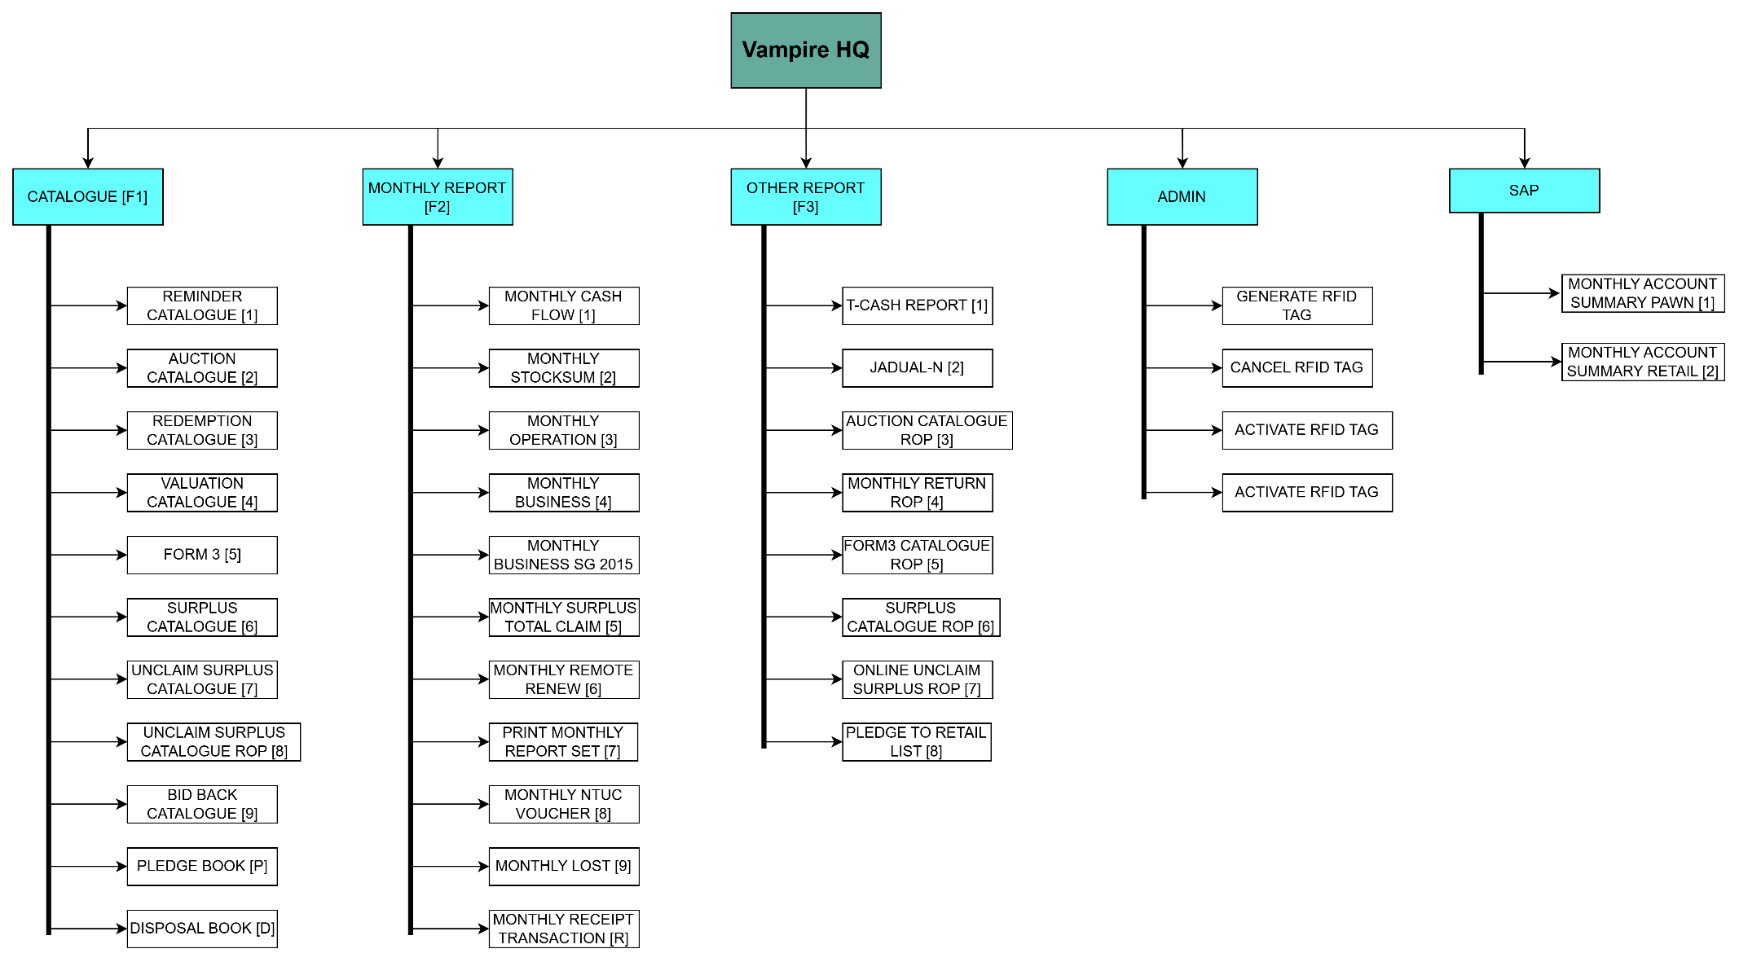

# 5. FUNCTION SPECIFICATION

### [Catalogue Report] FUNC-01. Reminder

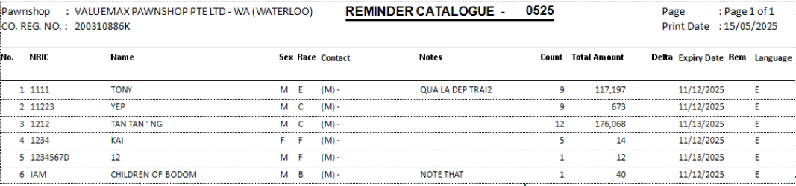

|  |  |  |  |  |  |  |  |  |  |  |  |  |  |  |  |  |  |  |  |  |  |  |  |  |
| --- | --- | --- | --- | --- | --- | --- | --- | --- | --- | --- | --- | --- | --- | --- | --- | --- | --- | --- | --- | --- | --- | --- | --- | --- |
| **Action Logic: View/Print Reminder report**  **Purpose**  To generate a **summary report of all active pawners** with open pledges during a specific month, showing:   * Contact information * Number of pledges * Total value * Minimum expiry date * Custom notification preference * A calculated **delta** (potential gain/loss compared to current gold price)   **Main Filters Applied**   * Only considers pledges where:   + Mmyy = '$Creation MonthYear'   + Status = 'Open' * Focuses **only on gold pledges**, **excluding**:   + JEWELLERY, SILVER, WATCH, DIAMOND, OTHER, and G-MIX   **Key Fields in Output**   | **Field** | **Meaning** | | --- | --- | | RowNo | Auto-incremented row number for display. | | NRIC | Pawner ID. | | Name, Sex, Race | Personal details of pawner. | | MobileContact, HomeContact, OtherContact | Labeled contact info (e.g., “(M) 91234567”). | | Notes, PagerNote | Additional custom fields from the database. | | PledgeCount | Number of open pledges. | | TotalValue | Total pawned amount. | | MinExpiry | Earliest expiry date among active pledges. | | Delta | **Potential net difference**: estimated resale value minus loan + interest. | | Reminder | Whether reminders are enabled. | | Language | Reminder language preferences: E (English), C (Chinese), M (Malay). |   **Delta Calculation Logic**  (Estimated resale value – (Loan + 10.5% interest))  Breakdown:   * Estimate gold value: * ((purity% / 24) * Weight * @GOLDPRICE * 0.85)   + Purity% derived from gold category label (like G22K, 22K, etc.)   + Current GoldPrice is fetched dynamically (most recent entry). * Compare to pawn amount + 10.5% interest: * PawnAmt * 1.105   This gives insight into whether each pledge is **in profit (positive delta)** or **loss (negative delta)** if resold today.  **Use Cases**   * **Customer risk analysis**: Helps understand over/under-valued pledges. * **Reminder targeting**: Shows whom to notify (and in which language). * **Customer service**: Facilitates proactive outreach based on expiry or contact info gaps. * **Operational strategy**: Focus marketing/renewal offers on high-delta customers. |

### [Catalogue Report] FUNC-02. Auction

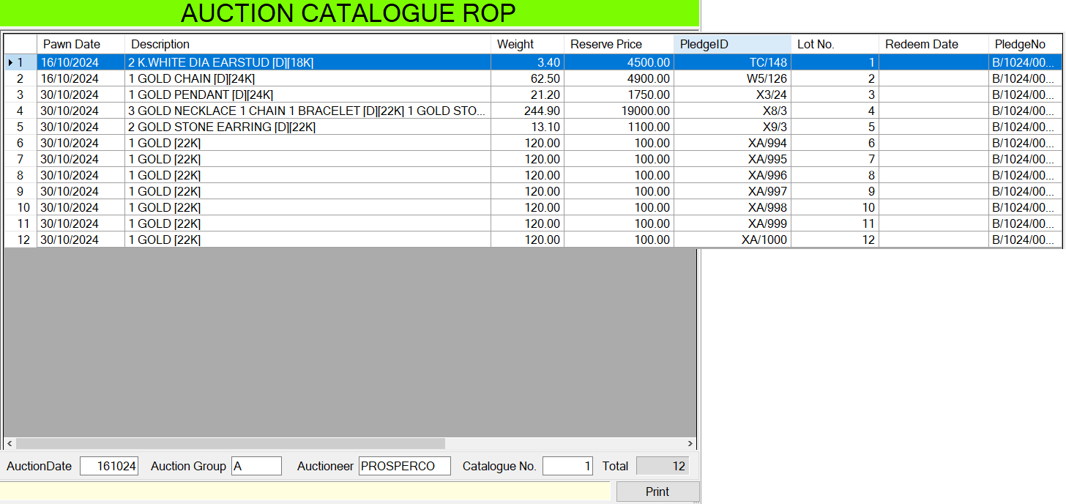

|  |  |  |  |  |  |  |  |  |  |  |  |  |  |  |  |  |  |  |
| --- | --- | --- | --- | --- | --- | --- | --- | --- | --- | --- | --- | --- | --- | --- | --- | --- | --- | --- |
| **Action Logic: View/Print Auction report**  **Business Logic** Auction Description Listing (with Gold Tagging) for PledgeBig/PledgeSmall Items  **Objective**  To prepare a **detailed, cleaned, gold-tagged list of auction items** for review, verification, or catalog generation — specifically for large-sized pledges in a specified auction month.  **Key Output Columns Explained:**   | **Field** | **Description** | | --- | --- | | PawnDate | Date item was pawned (format converted from ddmmyyyy string to YYYY-MM-DD). | | Description | Combined Entry1–Entry4 with logic to append [22K] if gold type is detected, and no karat label exists. Replaces [916] with [22K]. | | ReservePrice | Currently **equal to PawnAmt**, since markup multiplier is 0. Adjust as needed (e.g., use * 1.12 for 12% markup). | | Weight | Truncated (not rounded) gross weight (e.g., 12.98 → 12.9). | | PledgeID | A composite ID in format: Size/MMYY/ID (e.g., B/1024/0023). | | PledgeNo | Alias of the PledgeID, kept for compatibility or alternate referencing. | | LotNo | Auction lot number assigned to the pledge item. | | RedeemDate | Formatted redeem date (or null if not redeemed). |   **Business Usage Context**  **Audience:** Auction coordinators, catalog builders, appraisers.  **Use Cases:**  To validate gold content tagging ([22K]).  For inclusion in auction catalogs or internal review sheets.  To match pledges with corresponding redeem data for tracking outcomes.  As a base layer to apply further reserve price calculations or premium logic.  **Key Logic Highlights**  **Gold Labeling ([22K]) Logic:** Appends [22K] to EntryX **only if:**  Category starts with 'G'  Not marked as 'BAR'  No existing karat label via regex  Value is non-empty (<> '')  **Karat Replacement:** [916] is normalized to [22K].  **Reserve Price Logic:** Currently, uses PawnAmt only (multiplied by 1, since * (Interest / 100) * 0 = 0). ➤ To apply 8-month interest: change multiplier to * 8.00.  **Filtering:** Includes items with:  Non-empty LotNo  Auction statuses in: 'DEFAULTED', 'AUCTION', ‘OPEN, 'REOPEN', 'REDEEMED', ‘LOST'  **Sorting:** Numeric sort by LotNo (not string sort), e.g., 1, 2, 10 instead of 1, 10, 2. |

### [Catalogue Report] FUNC-03. Redemption

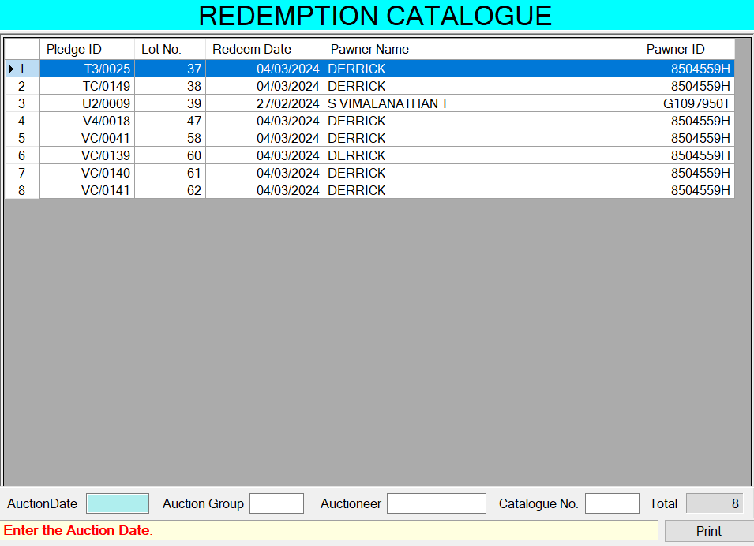

|  |  |  |  |  |  |  |  |  |  |  |  |  |  |  |  |  |  |  |  |  |  |  |  |  |
| --- | --- | --- | --- | --- | --- | --- | --- | --- | --- | --- | --- | --- | --- | --- | --- | --- | --- | --- | --- | --- | --- | --- | --- | --- |
| **Action Logic: View/Print Redemption report**  **Purpose**  To generate a **report of redeemed pledges** within a specific **auction batch ($Creation MonthYear)**, showing key pledge, customer, and redemption details.  **Business Objective**   * **Which pledges were redeemed** during a specific auction cycle. * **By whom**, and * **For how much**, along with **gross weight** of pledged items.   **Filters Applied**   | **Condition** | **Business Meaning** | | --- | --- | | PledgeTable.AuctionMmyy = '$Creation MonthYear' | Only include pledges from a specific auction batch (month/year). | | PledgeTable.LotNo <> '' | Only include pledges that were assigned a lot number. | | PledgeTable.Status = 'Redeemed' | Only include pledges that have been redeemed. |   **Fields Returned**   | **Field** | **Description** | | --- | --- | | PledgeID | Unique identifier for the pledge (e.g., MMYY/0001). | | LotNo | Auction lot number. | | RedeemDate | Formatted date of redemption (YYYY-MM-DD). | | PawnerName | Name of the customer who redeemed the pledge. | | PawnerID | ID/NRIC of the customer. | | PawnAmount | Original amount the customer pawned. | | Weight | Gross weight of the item(s) pledged. |   **Use Cases**   * **Internal audit** of redeemed items from auction batches. * **Customer service** inquiries (who redeemed what and when). * **Redemption trend analysis** based on weight and value. * **Financial reconciliation** of pawn amounts vs. redemption activity. |

### [Catalogue Report] FUNC-04. Valuation

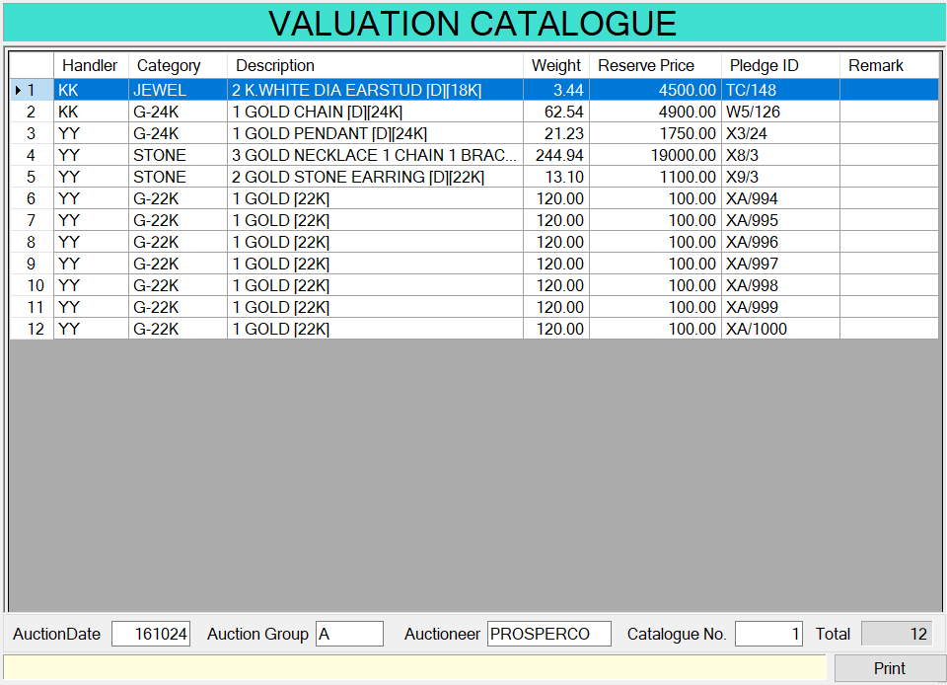

|  |  |  |  |  |  |  |  |  |  |  |  |  |  |  |  |  |  |  |  |  |
| --- | --- | --- | --- | --- | --- | --- | --- | --- | --- | --- | --- | --- | --- | --- | --- | --- | --- | --- | --- | --- |
| **Action Logic: View/Print** **Valuation report**  **Purpose**  To produce a **valuation sheet** for pawned items being considered for auction or review within a specified auction month ($Created MonthYear). To generate a **detailed itemized list of pledged items** (both Big and Small pledges) that are part of an **upcoming auction or valuation cycle** for internal review. A **valuation report generator for pledged items** due for review or auction in a given month. It's used by **pawnshop staff**, **auction teams**, or **back-office analysts** to make decisions on asset recovery and auction readiness  **Filters Records**   * Only records with a **non-empty LotNo** are included. * Status must be **in**:   + 'Defaulted', 'Auction', 'Reopen', 'Open', 'Redeemed', 'Lost' * This includes pledges that are:   + Up for auction   + Recently defaulted or still active   + Already redeemed (for tracking purposes)   **Generates Key Valuation Fields**   | **Field** | **Meaning** | | --- | --- | | SheetName | Categorizes entry as BigGold, SmallJewellery, etc. Useful for separate sheets or tabs. | | Handler | Staff member who handled the pledge. | | Category | Gold, Jewellery, etc. | | Description | Combines non-empty Entry fields for item description. | | Weight | Total weight of the item (raw). | | Reserveprice | Calculated as: PawnAmt + 8 months’ interest, where interest is based on pledge rate. | | PledgeID | Internal pledge identifier (StorageCodeYM/StorageCodeID). | | PawnAmount, RedeemAmount | Original loan and actual amount redeemed (if applicable). | | StoneValuation, FineWeight, Remark | Blank placeholders, likely for manual input post-query. |   **Use Cases**  **For Auction Planning**   * **Auction Houses** or pawn shops can use this for:   + **Pre-auction item validation**   + Creating reserve prices   + Evaluating whether items should be re-pledged, auctioned, or written off   **For Internal Auditing**   * Ensure all pledges marked for auction have:   + Clear descriptions   + Accurate weights and valuations   + Status properly set   **Reserve Price Formula**  PawnAmt + (PawnAmt * (Interest / 100) * 8)   * Assumes 8 months' interest * Reflects typical grace or holding period before auction |

### [Catalogue Report] FUNC-05. Form3

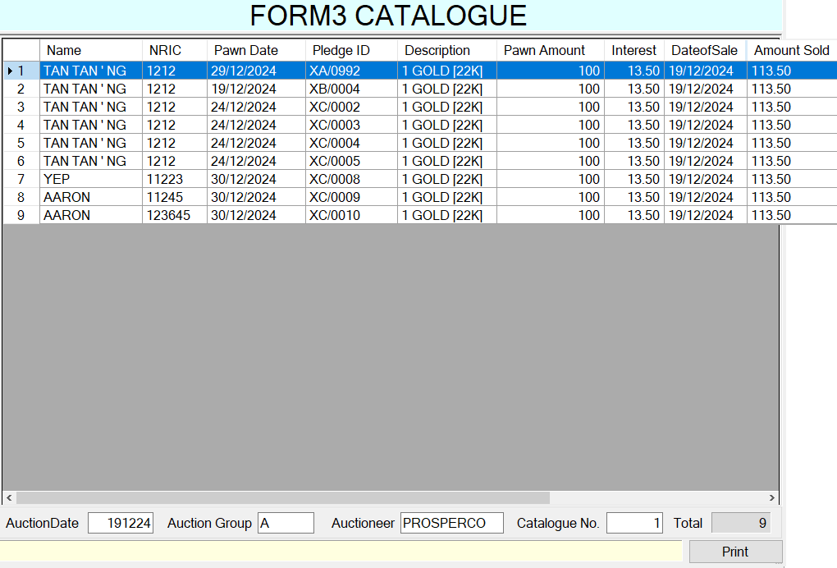

|  |  |  |  |  |  |  |  |  |  |  |  |  |  |  |  |  |  |  |  |  |  |  |  |  |
| --- | --- | --- | --- | --- | --- | --- | --- | --- | --- | --- | --- | --- | --- | --- | --- | --- | --- | --- | --- | --- | --- | --- | --- | --- |
| **Action Logic: View/Print Form 3 Auctions report**  **Business logic** Generate a **Form 3 Auction Report** or **auction financial summary** for each pawned item.  **Purpose**  To retrieve **detailed financial and identity info** for each **auctioned or defaulted pledge**, including:   * Customer name & NRIC * Pawned item details * Auction sale date & price * Computed or actual interest   **Pledge Information & Financials**   | Field | Description | | --- | --- | | PawnDate | Formatted date of pawning (from ddmmyyyy to yyyy-mm-dd). | | PledgeID | Unique pledge reference in format YYMM/ID (e.g., 0524/0012). | | Description | Concatenated item description (Entry1 to Entry4). | | PawnAmount | The original loan amount (from PledgeTable.PawnAmt). | | Interest | If Auction.Interest is recorded → use it. Otherwise → calculate: PawnAmt * InterestRate * 9 months / 100. | | DateofSale | If Auction.DateofSale exists → use it (format to yyyy-mm-dd). Else → fallback to AuctionInfo.AuctionDate for that month. | | AmountSold | If recorded in auction → use Auction.AmtSold. Else → use fallback: PawnAmt + Interest. |   **Filters Applied**  Only include items where:   * AuctionMMYY matches the provided $Auction MonthYear * Status is 'Auction' or 'Defaulted' * This limits the report to **only items eligible or sent for auction** in the selected month.   **Use Case Summary**   | Target Audience | Purpose | | --- | --- | | **Finance/Admin** | Validate amount recovered vs loaned + interest. | | **Compliance/Regulatory** | Generate Form 3 for records or external audits. | | **Management** | Analyze recovery efficiency, interest earnings, or discrepancies. | |

### [Catalogue Report] FUNC-06. Disposal Book

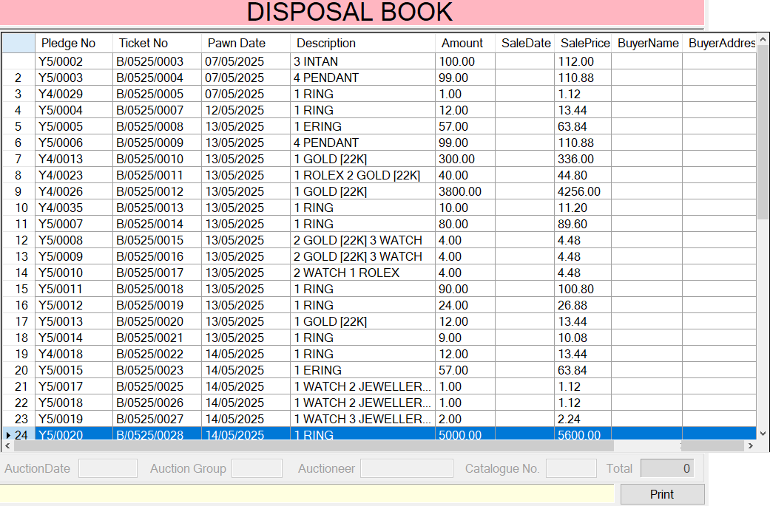

|  |  |  |  |  |  |  |  |  |  |  |  |  |  |  |  |  |
| --- | --- | --- | --- | --- | --- | --- | --- | --- | --- | --- | --- | --- | --- | --- | --- | --- |
| **Action Logic: View/Print Disposal Book report**  B**usiness logic G**enerate a **catalog or listing of pledges** that are likely prepared for **auction in a given month**, with a focus on display and sale preparation.  **Purpose**  To extract and format **pledge item data for auction preparation or cataloging**, including gold classification, ticket details, and sale pricing for the month '$MMYY'.  Filters only pledges created in the given month (creationMMYY = '$MMYY')  Excludes voided pledges: Status <> 'Void'  Includes all pledge metadata and generates a formatted **PledgeNo** like S/0524/0001  **Fields Generated**   | **Field** | **Logic** | | --- | --- | | PledgeNo / TicketNo | Standard pledge ticket number: YYMM/XXXX padded to 4 digits. | | PawnDate | Pulled directly from PledgeTable. Expected to be already in DATE format. | | Description | **Smart enhancement** of item names: - If the category starts with 'G' (for **Gold**) and doesn't already specify karat info (like [22K] or [916]) → it appends [22K]. - If it says [916] already → it replaces it with [22K]. This logic is applied to all 4 item entry fields: Entry1 to Entry4. | | Amount | This is the **pawn amount**, i.e., original loan. | | SaleDate | Pulled from AuctionInfo based on creationMMYY = '$MMYY'. It represents the **scheduled auction date**. | | SalePrice | Automatically calculated at **12% markup** over the pawned amount. This likely reflects expected reserve or floor price. | | BuyerName, BuyerAddress | Left empty for now — placeholders for post-sale updates. |   **Use Case: Auction Catalog Preparation**  **generation of auction catalogs** or internal listings, typically used for:   * Displaying items for **preview to potential buyers** * Setting **expected prices** * Assigning **auction sale dates** |

### [Catalogue Report] FUNC-07. Bid Back

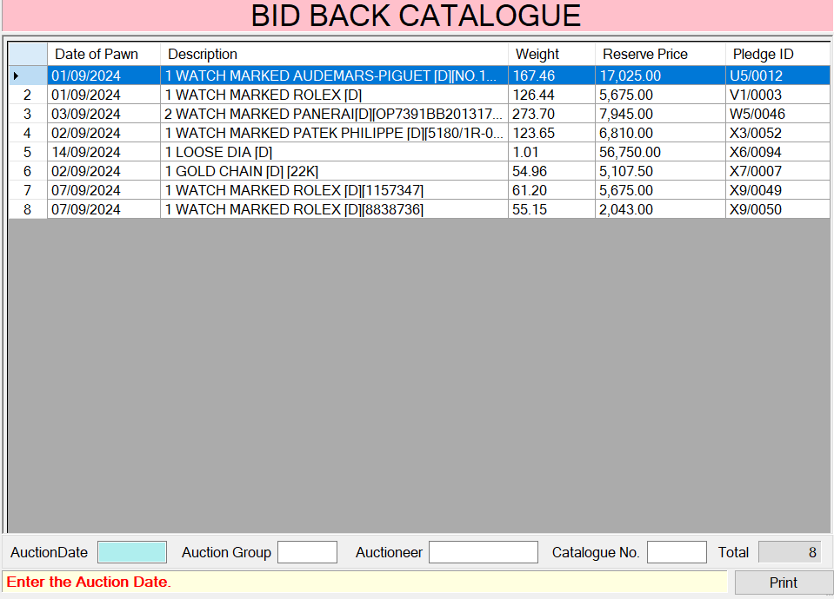

|  |  |  |  |  |  |  |  |  |  |  |  |  |  |  |  |  |  |  |
| --- | --- | --- | --- | --- | --- | --- | --- | --- | --- | --- | --- | --- | --- | --- | --- | --- | --- | --- |
| **Action Logic: View/Print Bid Back report**  **Purpose**  Generates a **pre-auction item listing** for items marked as **“Auction”** in the PledgeBig table and **tagged as “Bid = 'in'”** in the Auction table for a specific month ($Creation MonthYear). To produce a **list of pledged items ready to be auctioned**, complete with relevant information for valuation, documentation, or bidding sheets.  **Filtering**   * **Only PledgeBig entries with Status = 'Auction'** are considered. * These are matched to Auction table entries with Bid = 'in' — indicating they are **still in the auction inventory**.   **Key Output Columns**   | **Column** | **Description** | | --- | --- | | DateofPawn | When the item was initially pledged | | Description | Concatenation of Entry1–Entry4 describing the item | | PawnAmount | Amount loaned against the item | | Weight | Weight of the pledged item | | ReservePrice | Computed reserve price (Principal + 9% Interest) | | PledgeID | Internal pledge ID for inventory tracking | | LotNo | Auction lot number | | RedeemDate | Blank – likely filled post-auction |   **Reserve Price Formula**  ReservePrice = PawnAmt + (PawnAmt * Interest * 0.09)   * Assumes a multiplier of **9 months' interest** to set the reserve price (commonly used in pawn business logic).   **Use Cases**  **Auction Preparation**   * Helps auction managers **generate a catalog** of auctionable items.   **Internal Reporting**   * Used by valuation officers or finance to **assess potential return** on auction lots. |

### [Catalogue Report] FUNC-08. Pledge Book

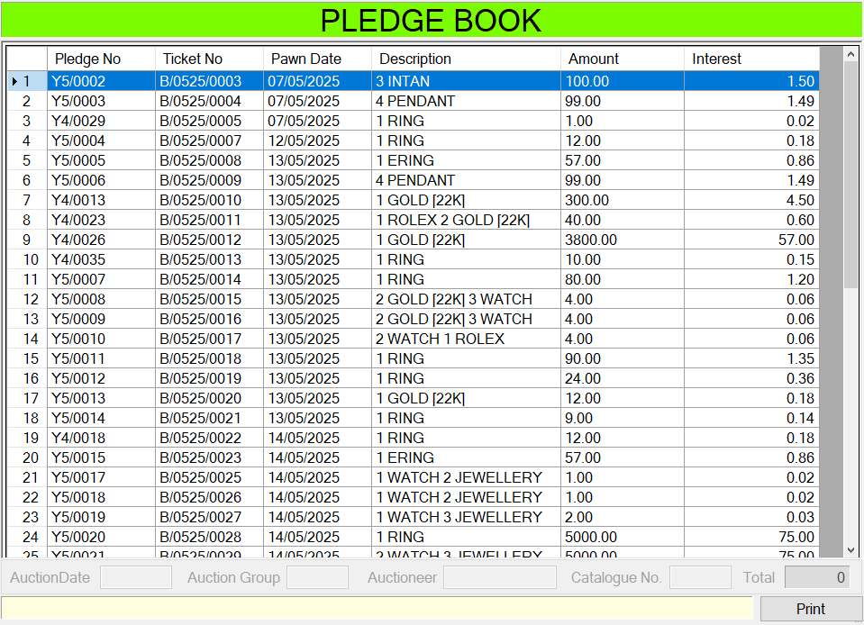

|  |  |  |  |  |  |  |  |  |  |  |  |  |  |  |  |  |  |  |  |  |
| --- | --- | --- | --- | --- | --- | --- | --- | --- | --- | --- | --- | --- | --- | --- | --- | --- | --- | --- | --- | --- |
| **Action Logic: View/Print NTUC Voucher (Scratch Transaction Report)**  **Purpose**  To **list all valid (non-void) pledges** from a specific branch/size/month, showing:   * Identification info, * Description of pledged items (with quality tagging), * Pawn amount, * Interest accrued.   **Business Objective**  This report supports:   * **Operational review** of pledge records. * **Auction preparation** or **pledge status audits**. * **Interest calculation** for financial tracking or reporting.   **Fields Selected**   | **Field Name** | **Business Meaning** | | --- | --- | | PledgeNo | Static pledge reference ID (MMYY/ID). | | TicketNo | Dynamically generated pledge reference (format: Size/MMYY/ID). | | PawnDate | Date of pledging. | | Description | Concatenated description of up to 4 item entries. Each gold item is tagged with [22K] if it doesn't already have a purity marker. | | Amount | Original pawn amount. | | Interest | Interest calculated based on rate from the pledge record (PawnAmt * Interest%). |   **Gold Item Labeling Logic**  Each item (Entry1 to Entry4) is checked:   * If **Category starts with 'G'** (i.e., it's a gold item), * And **not labeled as BAR**, * And **doesn’t already include a [xxK] or [xxx] label**, → Then the label [22K] is **added**.   Additionally, [916] is always **replaced** with [22K] to standardize gold notation.  **Filters Applied**   | **Filter** | **Purpose** | | --- | --- | | Status <> 'Void' | Only show active or valid pledges. | | Mmyy = '$Creation MonthYear' | Limit results to a specific month and year batch. |   **Use Case Summary**   * **Auction preparation**: Identify eligible and categorized pledges. * **Customer/branch reporting**: Breakdown of pledge details for internal reports. * **Interest monitoring**: Help calculate accrued interest for reporting or statements. |

### [Monthly Report] FUNC-09. Cashflow

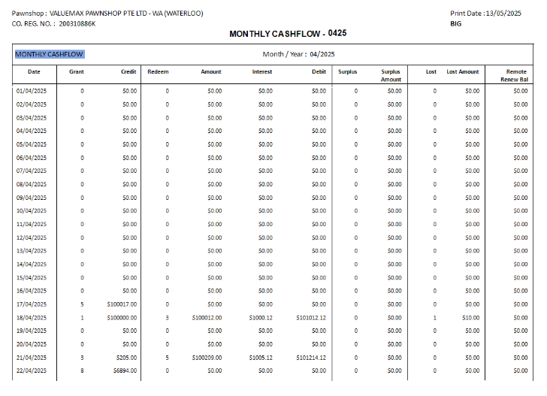

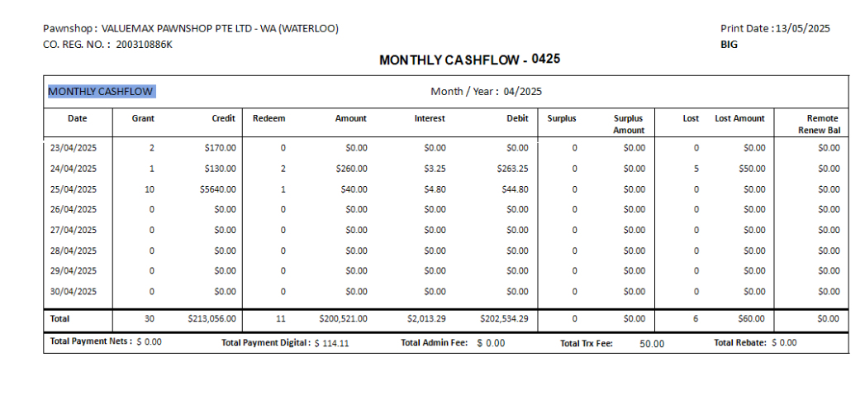

|  |  |  |  |  |  |  |  |  |  |  |  |  |  |  |  |  |  |  |  |  |  |  |  |  |  |  |  |  |  |  |  |  |  |  |
| --- | --- | --- | --- | --- | --- | --- | --- | --- | --- | --- | --- | --- | --- | --- | --- | --- | --- | --- | --- | --- | --- | --- | --- | --- | --- | --- | --- | --- | --- | --- | --- | --- | --- | --- |
| **Action Logic: View/Print Monthly Cashflow report**  Compiles a **daily financial activity report** for a specific **month and branch**, integrating data from various operational sources such as:   * Grants (new pawns) * Redemptions * Lost items * Surpluses from auctions * Special rebates * Fees (admin, transaction) * Payment channels (Nets, digital) * Remote renewals   **Query Purpose**  To **summarize all key financial transactions** by date for a given month, branch, and pledge table (big or small), including:   * Pawn activity (grants) * Redemption activity * Revenue (payments, fees) * Exceptions (rebates, lost items, surpluses) * Net financial movements (e.g., remote renew balances)   **Output Columns Overview**   | **Column** | **Description** | | --- | --- | | Dateofpawn | Report date (from calendar) | | TotalGrant, TotalGrantAmount | Number and total of new pawns | | TotalRedeem, TotalRedeemAmount | Number and total of redemptions | | TotalAmount | Redemption minus interest (net proceeds) | | TotalInterest | Interest portion from redemptions | | TotalSurplus, TotalSurplusAmount | Surplus items from auction (Big pledges only) | | TotalLost, TotalLostAmount | Lost receipts' summary (EntryCode 10) | | RemoteRenewBalance | Net balance from remote renewals (interest and pawn delta) | | TotalPaymentNets, TotalPaymentDigital | Payments received by channel | | TotalSpecialRebate | Rebates applied (as negative value) | | TotalAdminFee, TotalTrxFeeAmount | Admin and transaction fees collected |   **Practical Uses**   | **Use Case** | **How It Helps** | | --- | --- | | **Branch financial summary** | Compare pawns, redemptions, fees collected per day | | **Management insights** | Track revenue trends, rebates, and customer behavior | | **Audit trails** | Daily reconciliation of receipts and item status | | **Performance reporting** | Surplus recovery and lost item cost tracking | |

### [Monthly Report] FUNC-10. Stocksum

Ảnh có chứa văn bản, ảnh chụp màn hình, số, màn hình

Nội dung do AI tạo ra có thể không chính xác.

|  |
| --- |
| **Action Logic: View/Print Monthly Stocksum**  **Purpose**  To provide a **comprehensive monthly stock summary of pawn transactions**, broken down into components like grants, redemptions, losses, and police-seized items. It includes both **historical summaries** for each month in a range and a catch-all "OTHERS" section for older or uncategorized records.  To generate a **monthly report** that helps track:   * New pawn tickets (grants) * Redeemed items * Lost items * Police-seized items (and their statuses: returned, settled) * Grouped by month, plus a separate "OTHERS" bucket for residual data   **Key Business Metrics Computed**  For each MMYY (month-year in MMYY format):  1. **Grant Data**   * TotalGrant: Number of items pawned. * TotalGrantAmount: Total value pawned.   2. **Redeem Data**   * TotalRedeem: Number of items redeemed. * TotalRedeemAmount: Principal redeemed. * TotalInterest: Interest collected on redeemed items.   3. **Loss Data**   * TotalLoss: Number of lost items. * TotalLossAmount: Value of lost items.   4. Police Data   * TotalPoliceTaken: Items seized by police. * TotalPoliceTakenAmount: Value of items seized. * TotalPoliceReturn: Seized items returned to customer. * TotalPoliceReturnAmount: Value of returned items. * TotalPoliceSettle: Seized items marked as “settled” by police. * TotalPoliceSettleAmount: Value of settled items.   **First Main Section** — Monthly Summary Loop   * **Creates a list of months** by decrementing from $LASTDATE (the target date) backward by $STOCKHOLDDURATION months. * Joins grant, redeem, loss, and police data by MMYY:   + Ensures all calculations are only included **up to and including** $LASTDATE.   + Filters out voided or irrelevant statuses.   + Aggregates everything **per month**.   **Second Section ("OTHERS")** — Leftover/Older/Non-MonthGroup Police Data   * Catches **police-seized records** not included in the primary monthly loop (e.g., older data or mismatched months). * Groups them all under "OTHERS" as a single row. * Segregates data where the police status is unresolved or pending beyond the stock duration window.   **Stock Holding Period**   * $STOCKHOLDDURATION: Number of months to go back for tracking. * $MONTHGROUP: List of MMYY values representing months in that period.   **Key Conditions**   * Only **ACTIVE and non-Void** transactions are included. * **Date filtering** ensures relevance up to $LASTDATE and excludes prematurely resolved cases. * The OTHERS section ensures no important transaction is missed, even if it doesn’t fit neatly in the standard month loop.   **Final Output**  A **table** with each row representing:   * A specific month (or "OTHERS") * Key pawnshop operational KPIs for that month * A PrintDate timestamp for reporting consistency   **Use Cases**   * Track monthly stock movement and aging. * Monitor police-related inventory flow. * Help in compliance, auditing, and forecasting stock disposal or returns. * Identify unusual spikes in police or loss-related activities |

### [Monthly Report] FUNC-11. Operation

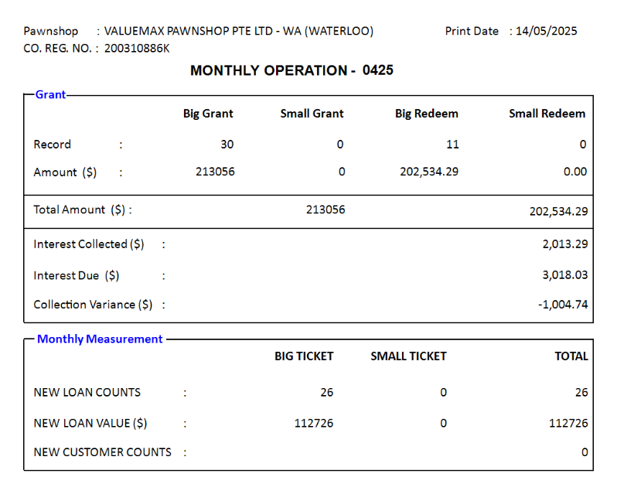

|  |
| --- |
| **Action Logic: Review/Print Monthly Operation report**  **Purpose** Aggregate **monthly pawnshop performance metrics** from multiple tables, giving a snapshot of grant (pawned), redemption, interest, and customer data for both **Big** and **Small** pledge categories for a specific month ($MMYY, $MMYYYY, $YYYYMM).  To generate a **summary report** for one month, tracking:   * New pledges and loans * Redemptions * Interest collected and interest due * Customer count * Loan volumes for "new" pledges   **Filters**   * Mmyy = $MMYY * Status NOT IN ('Void', 'Reopen')   **Small Grant Summary**  from PledgeSmall   * TotalSmallGrant: Number of small pledges. * TotalSmallGrantAmt: Total amount pledged.   **Big Redeem Summary**  from Redeem where size = 'Big'   * TotalBigRedeem: Number of big redemptions. * TotalBigRedeemAmt: Total amount redeemed (includes principal + interest).   **Small Redeem Summary**  from Redeem where size = 'Small'   * TotalSmallRedeem: Number of redemptions. * TotalSmallRedeemAmt: Total redeemed amount.   **Big Interest Summary**  Redeem INNER JOIN PledgeBig   * BigInterest: Actual interest collected. * BigInterestdue: Interest due, based on formula: NumMonths * Pawnamt * InterestRate * 0.01   **Small Interest Summary**  Redeem INNER JOIN PledgeSmall   * SmallInterest: Collected interest. * SmallInterestdue: Due interest calculated similarly.   **Customer Summary**  from Pawner   * CustomerNum: Number of distinct customers (by Id) who entered the system during the month.   **New Big Loan Summary**  from PledgeBig   * BigLoanNum: Number of "New" big pledge records. * BigLoanValue: Total value of new loans.   **New Small Loan Summary**  from PledgeSmall   * SmallLoanNum: Number of "New" small pledges. * SmallLoanValue: Total value of new small loans.   **Final Output**  A **single row** with the following business KPIs for the selected month:   * Grant and loan volumes (Big/Small) * Redemption performance * Interest actual vs. expected * Number of customers * New loans issued   **Use Cases**   * Monthly performance dashboard * Compare actual interest collected vs. projected * Assess loan issuance trends by size * Track customer engagement |

### [Monthly Report] FUNC-12. Business

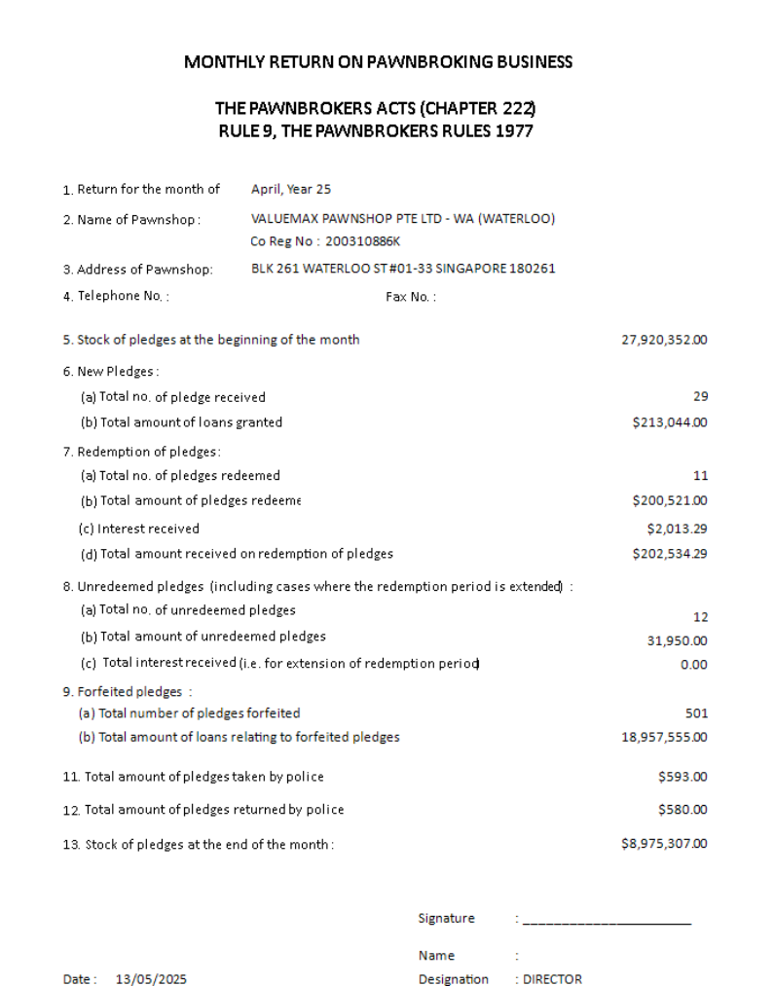  
Singapore template

|  |  |  |  |  |  |  |  |  |  |  |  |  |  |  |  |  |  |  |  |  |  |  |  |  |  |  |  |  |  |  |  |  |  |  |  |  |  |  |  |  |  |  |  |  |  |  |  |  |  |  |  |  |  |  |  |  |  |  |  |  |  |  |  |  |  |  |
| --- | --- | --- | --- | --- | --- | --- | --- | --- | --- | --- | --- | --- | --- | --- | --- | --- | --- | --- | --- | --- | --- | --- | --- | --- | --- | --- | --- | --- | --- | --- | --- | --- | --- | --- | --- | --- | --- | --- | --- | --- | --- | --- | --- | --- | --- | --- | --- | --- | --- | --- | --- | --- | --- | --- | --- | --- | --- | --- | --- | --- | --- | --- | --- | --- | --- | --- |
| **Action Logic: Review/Print Monthly Business report (Singapore template)**  **Business Logic** To generate a monthly financial summary for a pawnshop business. To present a detailed report around grants (pawnings), redemptions, interest, forfeits, unredeemed items, police seizures/returns, and stock**Pawning (Grant) Summary**   | **Metric** | **Table** | **Description** | | --- | --- | --- | | TotalBigGrant / TotalBigGrantAmt | PledgeBig | Number and total amount of **new big pawns** in the given month ($MMYY) | | TotalSmallGrant / TotalSmallGrantAmt | PledgeSmall | Same, for **small pawns** |   **Redemption Summary**   | **Metric** | **Table** | **Description** | | --- | --- | --- | | TotalBigRedeem / TotalBigRedeemAmt | Redeem | Number and total amount of **redeemed big pawns** in the given month | | TotalSmallRedeem / TotalSmallRedeemAmt | Redeem | Same, for **small pawns** |   **Interest Collected and Due**   | **Metric** | **Description** | | --- | --- | | BigInterest | Interest **actually collected** on redeemed big pawns | | BigInterestdue | Interest that **should have been collected** (based on pawn amt × months × rate) | | SmallInterest / SmallInterestdue | Same, for small pawns |   **Unredeemed Items**   | **Metric** | **Description** | | --- | --- | | TotalBigUnRedeem / TotalBigUnRedeemAmount | Items not redeemed, now considered **defaulted or auctioned** | | TotalBigUnRedeemRealised | Value realized from auction + reserve price-based value for unsold | | Same structure for small pawns |  |   **Police Seizure and Return**   | **Metric** | **Description** | | --- | --- | | TotalPoliceTaken | Sum of items **seized by police** (both sizes) in the current month | | TotalPoliceReturn | Value of **items returned by police** | | PoliceAdjustAmount | Value of police items **settled outside auction** or after forfeiture |   **Stock Management**  The calculation:  TotalStockAmount =  AllBigGrantAmount + AllSmallGrantAmount  - AdjustmentStock  + OtherStock  - AllRedeemAmount  + PoliceTaken  - PoliceReturn  - PoliceAdjustAmount  This computes the **value of inventory on hand**.   | **Component** | **Meaning** | | --- | --- | | AllBigGrantAmount / AllSmallGrantAmount | Total pawn amounts (granted but not auctioned yet) | | AdjustmentStock | Stock redeemed but from a **previous forfeited batch** | | TotalOtherStock | Stock reopened after police return | | TotalAllRedeemAmount | Redeemed value (excluding interest) | | PoliceTaken, PoliceReturn, PoliceAdjustAmount | Stock impacted by police actions |   **Forfeiture Summary**   | **Metric** | **Description** | | --- | --- | | TotalBigForfeit / Amount | Items marked **defaulted** and transferred to auction | | Same for small items |  |   **SG2015 Special Unredeemed Summary**   | **Metric** | **Description** | | --- | --- | | TotalBigUnRedeemSG2015 / Amount | Unredeemed from batch SG2015 (specific rules for auction cutoff and redeems) | | Same for small items |  |   **Key Business insights**  From this report, a business user can answer:   * How much money was loaned (pawned) and redeemed this month? * How much interest did we earn vs how much was due? * How many items remain unredeemed or forfeited? * What was the effect of police seizures? * What is the real value of stock (inventory)? * Are any items from old batches (e.g., SG2015) still open? |

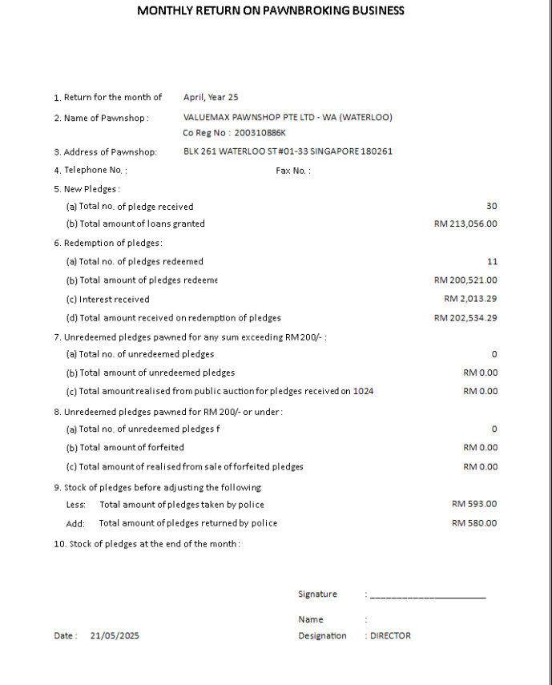  
Malaysia template

|  |
| --- |
| **Action Logic: Review/Print Monthly Business report (Malaysia template)**  **Purpose** To generate a **comprehensive financial and operational summary for a pawnbroking business**, for a given month and auction period. To provide a full month-end summary including grants (loans), redeems (repayments), interest, unredeemed items (defaults), police interactions (seizure/return), and net stock (inventory value).  **Big Pledges (Loans) Summary**   * TotalBigGrant: Number of big-sized pawn loans given in the month. * TotalBigGrantAmt: Total amount loaned for big pledges. * PrintDate: Reformatted pawn date for reporting.   **Business logic**: Tracks monthly disbursement of larger loans.    **Small Pledges (Loans) Summary**   * TotalSmallGrant, TotalSmallGrantAmt: Same as above, but for small-sized loans.   **Business logic**: Captures smaller loan issuance activity.  **Big Redeems**   * TotalBigRedeem, TotalBigRedeemAmt: Number and amount of big pledges redeemed (repaid) in the month.   **Small Redeems**   * TotalSmallRedeem, TotalSmallRedeemAmt: Same as above for small pledges.   **Business logic**: Redemption = when customer repays and retrieves pledged item.  **Big Interest Earned and Due**   * BigInterest: Actual interest collected from redeemed big pledges. * BigInterestdue: Expected interest based on number of months and loan amount.   **Business logic**: Compares earned vs expected interest on big loans.  **Small Interest Earned and Due**   * Same as above, for small pledges.   **Big Unredeemed Items**   * TotalBigUnRedeem, TotalBigUnRedeemAmount: Count and total amount of big loans not redeemed and moved to auction/default status.   **Big Unredeemed Realised**   * TotalBigUnRedeemRealised: Realised value from auction sales **or** estimate based on defaulted items if not auctioned yet.   **Business logic**: How much was recovered from defaulted big pledges (via auction or valuation).  **Small Unredeemed Summary**   * Same as Big, but also includes an estimate of realised value using assumed 9 months’ interest.   **Police Seizures**   * TotalPoliceTaken: Total value of items seized by police (linked to police cases).   **Police Returns**   * TotalPoliceReturn: Value of items returned by police during the month.   **Business logic**: Used to track movement of police-related assets (liability/risk tracking).  **Total Stock Calculation**  This part calculates the **net value of inventory** (pawned but not redeemed) using:  Components:   * TotalAllBigGrantAmount, TotalAllSmallGrantAmount: Value of all big/small loans not yet auctioned and still active. * TotalAllRedeemAmount: Total redemptions (adjusted for interest). * TotalPoliceTaken, TotalPoliceReturn: Adjustments for police-held or returned items.   **Final Formula:**  TotalStockAmount = (Big Grants + Small Grants - Redeems + Police Seized - Police Returned)  **Business logic**: This is the **net value of assets held in stock**, i.e., unredeemed items at risk, potentially auctionable or retrievable.  **Use Cases**   * **Monthly Board Reports** * **Branch-level Performance Metrics** * **Risk & Recovery Analysis** * **Inventory Valuation** * **Interest Revenue vs Due Monitoring** * **Police/Legal Seizure Tracking** * **Audit and Compliance Reporting** |

### [Monthly Report] FUNC-13. Remote Renew

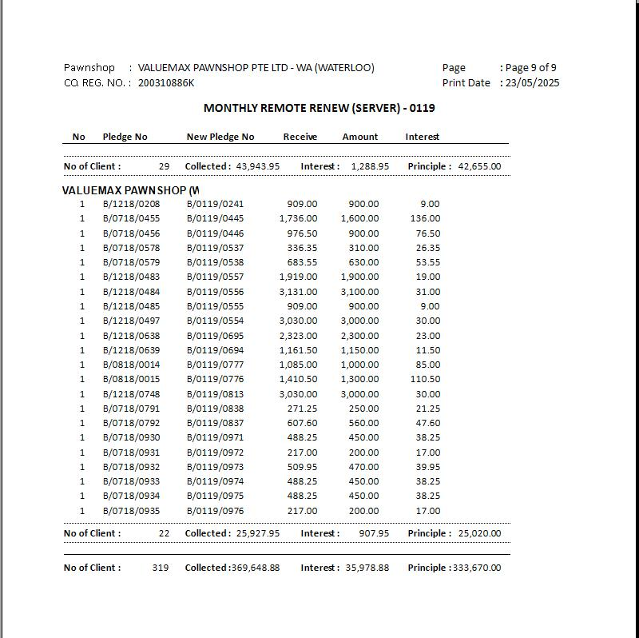

|  |
| --- |
| **Action Logic: Review/Print Monthly Renew report (server)**  **Purpose** To generate a **detailed list of pledges (pawn loans) that were renewed remotely and redeemed in a given month** by a specific branch.  To **report all remote pledge renewals** that were **redeemed** in a specific branch during a specific month. It tracks the renewal trail, showing new pledge numbers, amounts received, and interest collected.  **Branch**   * The name of the branch (looked up from the Branch table using the branch code from RemoteRenew).   **PledgeNo**   * A unique identifier for the **original pledge**, formatted as: Size/MMYY/ID (e.g., "Big/0525/0042").   **NewPledgeNo**   * The new pledge number assigned during renewal. * **Business meaning**: When a pledge is renewed, a new pledge number is assigned, and this field captures that.   **Receive**   * Total amount received at redemption time: PawnAmt + InterestCollect.   **Amount (PawnAmt)**   * The actual amount of the loan (principal).   **OldAmount (OldPawnAmt)**   * The loan amount before renewal. * **Used for auditing** how much the original pledge was before it got renewed.   **Interest (InterestCollect)**   * Interest collected at the time of redemption.   **RemoteBranch**   * The branch where the original pledge was issued. * **Important for tracking cross-branch renewals** (i.e., when a customer renews a pledge from a different location).   **RedeemDate**   * The date the pledge was finally redeemed (settled by the customer).   **PawnDate**   * Date when the pledge was originally made (before any renewals).   **BranchCode**   * Branch code repeated here (used internally for RowNo logic and possibly for display or filtering).   **Filter Conditions**   * Only include pledges that were redeemed in the specified month ($MMYY), * And originated from a specific branch ($BRANCHCODE).   **Use Case**s   * **Branch-level reconciliation** of renewed pledges. * **Remote renewal tracking**: shows which pledges were renewed at another location and later redeemed. * **Audit trails**: original and renewed pledge details side-by-side. * **Revenue insight**: how much interest was earned on renewed pledges. * **Performance tracking** for both lending and collections. |

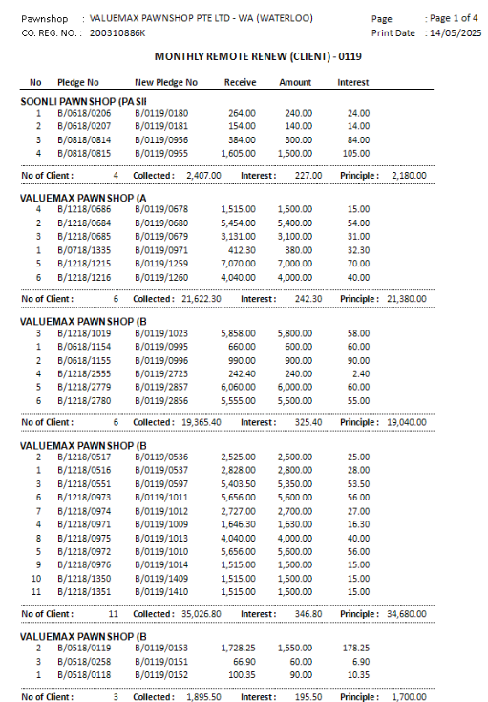

|  |  |  |  |  |  |  |  |  |  |  |  |  |  |  |  |  |  |  |  |  |  |  |  |  |  |  |
| --- | --- | --- | --- | --- | --- | --- | --- | --- | --- | --- | --- | --- | --- | --- | --- | --- | --- | --- | --- | --- | --- | --- | --- | --- | --- | --- |
| **Action Logic: Review/Print Monthly Renew report (client)**  **Purpose**  To provided a **transaction report** showing pledges that were:   * **Originally issued in another branch** (RemoteBranch), * **Renewed remotely** (i.e., continued at a different location), * And **redeemed (closed)** in the **current reporting branch and month**.   This helps in **tracking inter-branch pledge movements** and **financial reconciliations**.   | **Column** | **Business Meaning** | | --- | --- | | **RowNo** | Serial number per branch. Helps with clear display and counting. | | **Branch** | Name of the branch that renewed and redeemed the pledge. Pulled from the Branch table. | | **PledgeNo** | Original pledge number (formatted as Size/MMYY/ID) — identifies the pledge that was renewed. | | **NewPledgeNo** | The new pledge number (SonID) issued after renewal — shows the continuation of the original loan. | | **Receive** | Total money collected during redemption = Principal (PawnAmt) + Interest (InterestCollect). | | **Amount** | The principal loan amount of the renewed pledge. | | **OldAmount** | The principal loan amount of the original pledge before it was renewed. | | **Interest** | Interest collected at the time of redemption. | | **RemoteBranch** | The branch that originally issued the pledge. Useful for reconciliation between branches. | | **RedeemDate** | Date when the pledge was finally settled/redeemed. | | **PawnDate** | Date of original loan (before renewal). Shows loan lifecycle. | | **BranchCode** | Branch code of the current branch (used to update @Branch for row numbering). |   **Filter Logic**   * Only includes **pledges that were redeemed in the selected month** ($MMYY) * And **originated from a specific branch** ($BRANCHCODE)   **Use Cases**   1. **Branch Reconciliation** Helps ensure accurate credit for transactions between branches. 2. **Audit Trail of Renewals** Provides visibility into the chain of pledge renewals and redemptions. 3. **Performance Metrics** Identifies how many pledges from a given branch are being renewed and redeemed elsewhere. 4. **Interest Income Tracking** Understand how much interest was earned from remote renewals. |

### [Monthly Report] FUNC-14. NTUC Voucher (Scratch Transaction)

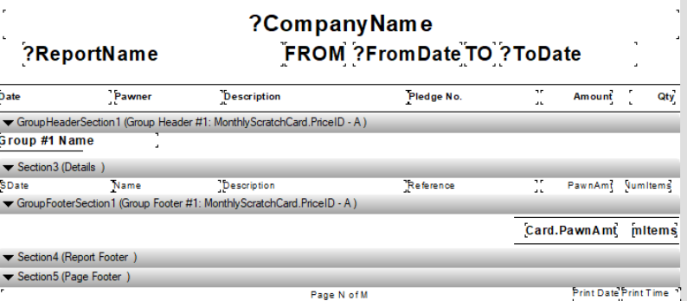

|  |  |  |  |  |  |  |  |  |  |  |  |  |  |  |  |  |  |  |  |  |  |  |  |  |  |  |
| --- | --- | --- | --- | --- | --- | --- | --- | --- | --- | --- | --- | --- | --- | --- | --- | --- | --- | --- | --- | --- | --- | --- | --- | --- | --- | --- |
| **Action Logic: Review/Print Monthly NTUC Voucher (Scratch Transaction) Report**  **Purpose**:  To retrieve all **scratch card transactions** for a given month ($MMYY) and display **details of the reward/prize** issued, along with the **linked pledge and customer (pawner)**.  **Key Filters and Logic:**   | **Clause** | **Business Logic** | | --- | --- | | ST.Reference = Concat(size, '/', mmyy, '/', id) | Matches scratch card to the corresponding pledge based on a **unique string ID** format like S/0524/0012. | | ST.CustomerID = Pawner.ID | Links the transaction to the **pawner (customer)** who made the pledge. | | ST.PrizeID = Prize.PrizeID | Connects the transaction to the **specific prize** awarded. | | WHERE CreationMMyy = '$MMYY' | Filters the report to only show scratch card redemptions for a specific month. |   **Fields Output:**   | **Field** | **Description** | | --- | --- | | Date | The **date** the scratch transaction was made (ST.SDate). | | Pawner | Name of the **customer** who received the prize. | | PriceID | The **ID** of the prize awarded. | | Description | Text description of the **prize** (e.g., "Gold Coin", "Cash Voucher"). | | Pledge_No | The **pledge number** associated with the transaction, confirming eligibility. | | Amount | The **pawn amount** of the item, possibly for value analysis or eligibility threshold. | | Qty | Always 1, assumes **one prize per transaction**. |   **Use Case: Scratch Card Reward Reporting**  This report is likely used for:   * Tracking how many **prizes were issued** via scratch promotions * Verifying **pawner eligibility** * Reconciling prizes with **pledge amounts** * Supporting monthly promotional campaign audits |

### [Monthly Report] FUNC-15. Lost

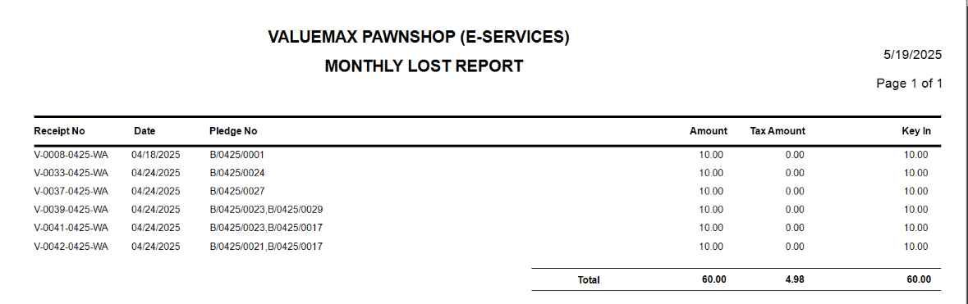

|  |  |  |  |  |  |  |  |  |  |  |  |  |  |  |  |  |  |  |  |  |  |  |
| --- | --- | --- | --- | --- | --- | --- | --- | --- | --- | --- | --- | --- | --- | --- | --- | --- | --- | --- | --- | --- | --- | --- |
| **Action Logic: View/Print Monthly Lost report**  P**urpose**:  To generate a **GST (tax) receipt report** for **entry code 10** transactions (likely renewals), filtering by a specific **month and year ($Creation MonthYear)**, and providing associated pledge numbers and amounts.  **Filters Applied**   | Filter | Business Logic | | --- | --- | | RT.Mmyy = '$Creation MonthYear' | Restricts to a specific month and year of creation. | | RDT.EntryCode = 10 | Limits to a specific transaction type – likely **pledge renewals**. | | Taxtype = 'GST' | Ensures only **GST-taxable** items are included. | | RT.Status = 'ACTIVE' | Excludes voided/inactive receipts. |   **Fields Returned**   | Field | Description | | --- | --- | | ReceiptNo | Full receipt number. | | Date | Date of the receipt (transaction date). | | PledgeNo | The pledge number the fee relates to – uses SonPledgeNo for RENEW or REMOTERENEW, otherwise PledgeNo. | | TaxAmount | The GST amount charged. | | Amount | The base amount (before tax) of the transaction. |   **Use Case**: Monthly GST Audit Report   * **GST reporting or reconciliation** * Auditing **pledge renewal charges** * Identifying **pledge activity and tax collected** |

### [Monthly Report] FUNC-16. Receipt Transaction

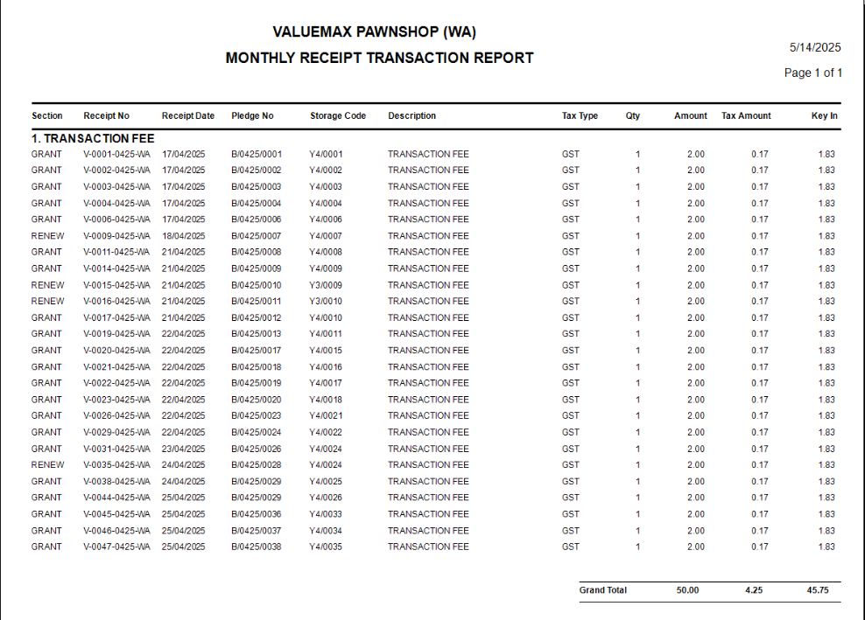

|  |  |  |  |  |  |  |  |  |  |  |  |  |  |  |  |  |  |  |  |  |  |  |  |  |  |  |  |  |
| --- | --- | --- | --- | --- | --- | --- | --- | --- | --- | --- | --- | --- | --- | --- | --- | --- | --- | --- | --- | --- | --- | --- | --- | --- | --- | --- | --- | --- |
| **Action Logic: Review/Print Monthly Receipt Transaction report**  **Purpose** Generate a **report of GST-taxed “Transaction Fee” entries** in receipts for a specific **month and branch**, focusing on transactions like **renewals** and **remote renewals.** This report provides **detailed financial information** on **transaction fees that include GST**, specifically for:   * **Active transactions** * Involving **pledge renewals or remote renewals** * For a **specific month** ($MMYY) * Useful for **GST reporting, auditing, and compliance**  | **Column** | **Business Meaning** | | --- | --- | | **RemoteBranch** | Extracted from GroupHeading, shows which branch originated the transaction if it’s a remote renewal (e.g., [01] becomes 01). Empty if not remote. | | **ReceiptNo** | Unique identifier for the receipt. Helps trace the transaction. | | **ReceiptMode** | Indicates the type or format of the receipt (e.g., Cash, Card, etc.). | | **ReceiptDate** | The date the transaction was recorded. | | **PledgeNo** | If the transaction is a **renewal or remote renewal**, shows the **new pledge number** (SonPledgeNo); otherwise, shows the original PledgeNo. | | **StorageCodeNo** | Similar logic: returns the new or original storage code based on the transaction type. | | **Description** | The item or charge description – will always be 'TRANSACTION FEE' in this case. | | **TaxType** | Will be 'GST', indicating this line item is GST-applicable. | | **TaxAmount** | GST amount charged for the transaction fee. | | **Quantity** | Quantity of the charge (typically 1 for fees). | | **UnitPrice** | Fee amount before GST. | | **SubTotal** | Total before tax = Quantity * UnitPrice. | | **Section** | Transaction category (e.g., RENEW, REMOTERENEW, AUCTION, etc.). Helps classify the type of pledge operation. |   **Filtering Logic**  RT.Mmyy = $MMYY   * Only includes **receipts for a specific month**.   Taxtype = 'GST'   * Only includes **GST-taxable entries**.   Status = 'ACTIVE'   * Excludes voided, cancelled, or inactive transactions.   RDT.EntryCode != 10   * Likely filters out a specific system-generated or internal entry (code 10).   description = 'TRANSACTION FEE'   * Focuses the report **only on fees charged for processing a pledge**.   **Use Cases**   1. **GST Reporting & Compliance** Accurately tracks taxable transaction fee entries for proper tax filing. 2. **Branch-wise Revenue Attribution** When RemoteBranch is populated, helps understand which **branches originated** the fee revenue. 3. **Fee Income Audit** Verifies that the correct fees were charged, taxed, and recorded properly. 4. **Renewal Insights** Helps identify the volume and tax implications of **pledge renewals** and **remote renewals** specifically. |

### [Other Report] FUNC-17. T-Cash

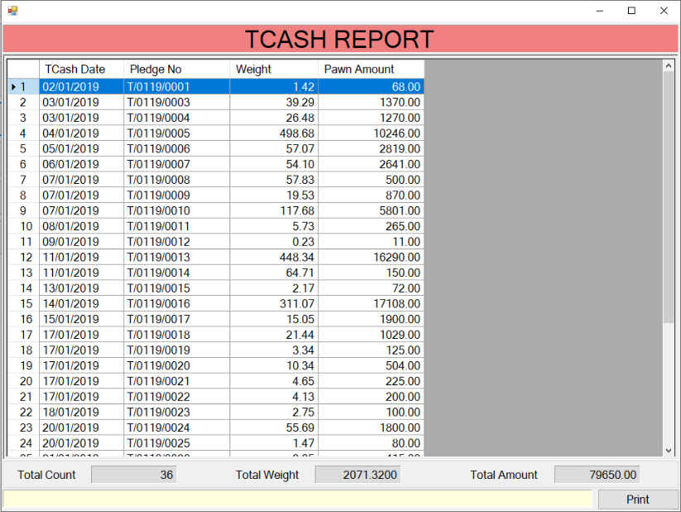

|  |  |  |  |  |  |  |  |  |  |  |
| --- | --- | --- | --- | --- | --- | --- | --- | --- | --- | --- |
| **Action Logic: Review/Print T-Cash report**  **Purpose**  To **list valid pledge cash transactions** (excluding voided ones) for the selected **month and year**, including:   * Date of transaction * Unique pledge number * Weight pledged * Amount issued  | **Column Name** | **Meaning in Business Terms** | | --- | --- | | **TCash_Date** | The actual **date the cash was pledged**, reconstructed from a non-standard dateofpawn field. Format is YYYY-MM-DD. | | **Pledge_No** | A **unique pledge number** in the format Size/MMYY/ID, used to identify individual pledge records. | | **Weight** | The weight of the item pledged, typically gold or other valuables, important for valuation. | | **Pawn_Amount** | The amount of cash given for the pledge. Key for financial tracking and daily cash reconciliation. |   **Filter**  mmyy = '$Creation MonthYear'   * Filters records for the selected **month/year**, e.g., 0325 for March 2025.   status <> 'Void'   * Excludes **voided transactions**, ensuring only active pledges are reported.   **Use Cases**   * A clean and accurate list of **non-voided pledges** * Exactly when they were pledged * The associated weights and loan amounts * Fully auditable pledge identifiers |

### [Other Report] FUNC-18. Jadual-N

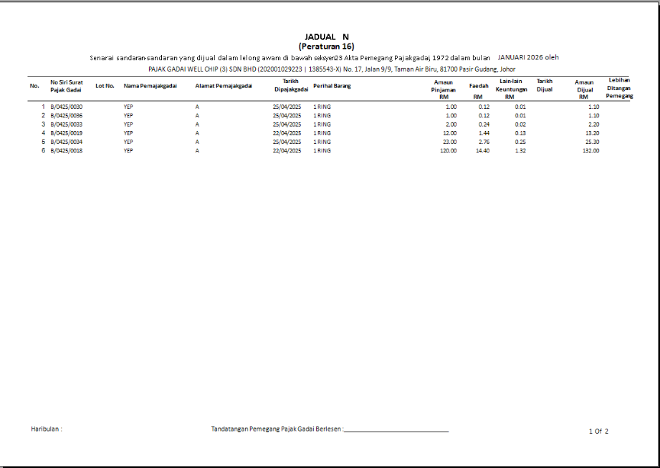

|  |  |  |  |  |  |  |  |  |  |  |  |  |  |  |  |  |  |  |  |  |  |  |
| --- | --- | --- | --- | --- | --- | --- | --- | --- | --- | --- | --- | --- | --- | --- | --- | --- | --- | --- | --- | --- | --- | --- |
| **Action Logic: Review/Print Jadual report**  **Purpose**  To list the **top 10 pledges** (by amount) are in auction-related statuses for a given **month/year**, providing key details like:   * Customer name and address * Pledge number and lot number * Pawn date and description * Pawn amount * Estimated interest and commission * Scheduled auction sale date  | **Column Name** | **Business Description** | | --- | --- | | **PledgeNo** | Unique pledge number (Size/MMYY/ID) used for internal tracking and auction documentation. | | **LotNo** | Lot number assigned to the item, important for grouping in auctions. | | **PawnerName** | Name of the customer who pawned the item. | | **PawnerAddress** | Address of the customer, useful for notifications or legal purposes. | | **PawnDate** | Actual date of pawn transaction, derived from a non-standard format. | | **Description** | Textual description of the pledged item, built from four descriptive fields. | | **Pawnamt** | Amount loaned against the item. | | **Interest** | Estimated total interest for 8 months (standard tenure used in calculation). | | **Commission** | 1-month commission, likely used for early auction cost projections. | | **DateofSale** | Scheduled auction sale date pulled from the AuctionInfo table for the same month/year. |   **WHERE Clause Business Logic**  PledgeTable.Mmyy = '$MMYY'   * Restricts results to the target **month and year** (e.g., 0325 for March 2025).   Status in ('Auction', 'Defaulted', 'Reopen', 'Open')   * Filters pledges that are either:   + Already in **auction**   + **Defaulted** (not repaid in time)   + **Reopened** (possibly after a prior auction/default)   + Still **Open**, potentially nearing default |

### [Other Report] FUNC-19. Monthly Return ROP

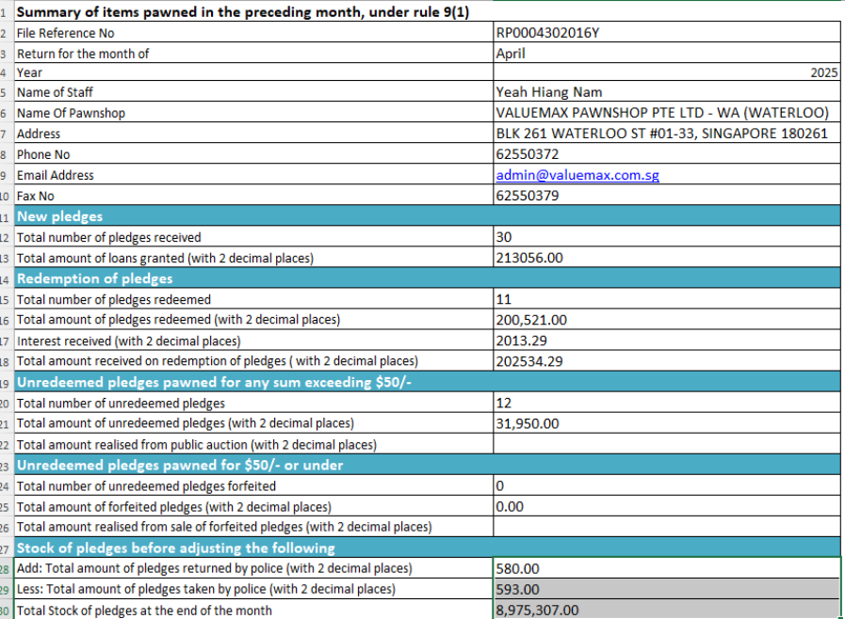

|  |  |  |  |  |  |  |  |  |  |  |  |  |  |  |
| --- | --- | --- | --- | --- | --- | --- | --- | --- | --- | --- | --- | --- | --- | --- |
| **Action Logic: Review/Print Monthly Return ROP report**  **Purpose**  This is typically used by **finance or operations managers** to:   * Assess **stock value** (pledged but not redeemed) * Understand the **flow of money**: new loans vs. redemptions * Track **police seizures** and returns * Monitor **auction recoveries** * Support **month-end financial reporting**   **New Loans Granted**   * **Big pledges** (PledgeBig) and **Small pledges** (PledgeSmall) * Count and total loan amount * Filtered by:   + Mmyy = $MMYY (month and year being reported)   + Status NOT IN ('Void', 'Reopen')   **Business meaning**: How many new loans were granted and their total value.  **Redemptions**   * From Redeem table * Divided by **Big** and **Small** * For the same $MMYYYY period * Also includes:   + **Actual interest collected**   + **Expected/due interest** (calculated as: NumMonths * PawnAmt * Interest %)   **Business meaning**: How many customers repaid loans, how much interest was expected vs collected.  **Unredeemed Items (Auction/Defaulted)**   * Filters pledges with Status = 'Auction' or 'Defaulted' and matching AuctionMmyy = $AUCTIONMMYY * Breaks down into:   + **Count and value of items** still not redeemed   + **Value realized via auction** (Auction table + a fallback calculation for defaulted)   **Business meaning**: Stock left unsold or recovered via auction.  **Police Seized and Returned Items**   * Combines PledgeBig, PledgeSmall, and Police tables * Tracks:   + **Seized amount** this month (Dateofseize)   + **Returned amount** this month (Dateofreturn)   + Differentiates between **Big** and **PoliceSettled**   **Business meaning**: Inventory impact due to legal actions or police seizures.  **Stock Valuation (Total Stock Amount)**  Formula:  TotalStock =  (All Big + All Small Grants)  - All Redeems  + Police Taken  - Police Returns   * Ensures **accurate end-of-month valuation** of all pledged items still on hand * Filters based on comparison between:   + AuctionMmyy and $AUCTIONYYMM (for items not sold yet)   + Mmyy <= $YYMM (current or earlier pledges)   + Dateofredeem <= $YYYYMM (for realized redemptions)   **Business meaning**: Provides a single value of what’s still in stock (not auctioned, not redeemed, not returned to police).   | **Metric Category** | **Sample Output Columns** | | --- | --- | | Loan Metrics | TotalBigGrant, TotalSmallGrant, TotalBigGrantAmt | | Redemption Metrics | TotalBigRedeem, BigInterest, BigInterestdue | | Auction Metrics | TotalBigUnRedeem, TotalBigUnRedeemRealised | | Police Activity | TotalPoliceTaken, TotalPoliceReturn | | Stock Summary | TotalStockAmount | | Reporting Date | AuctionDate (as char) |   **Use Cases**   * Monthly **management report** * **Board presentations** on performance * Feeding into **BI dashboards** * Comparing **grants vs redeems** to analyze cash flow * Estimating **auction exposure** and **default risk** |

### [Other Report] FUNC-20. Pledge to Retail List

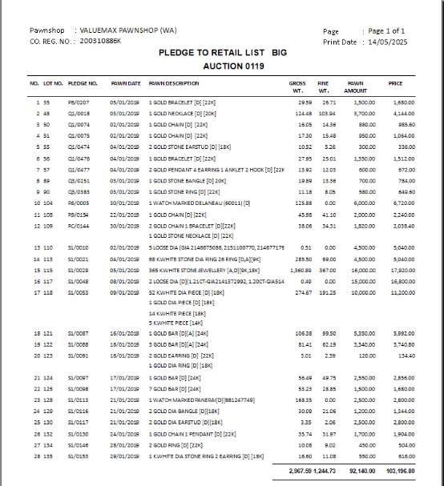

|  |  |  |  |  |  |  |  |  |  |  |  |  |  |  |  |  |  |  |
| --- | --- | --- | --- | --- | --- | --- | --- | --- | --- | --- | --- | --- | --- | --- | --- | --- | --- | --- |
| **Action Logic: Review/Print Pledge to Retail List report**  **Purpose**  To generate an **auction lot list** for items that:   * Were **defaulted** (i.e., not redeemed in time) * Are **scheduled** for auction in a given month * Have been assigned a **Lot Number**  | **Column** | **Description** | | --- | --- | | Lot_No | Identifier used for auction cataloguing; must not be empty | | Pledge_No | Unique pledge number (formatted as MMYY/ID) | | Pawn_Date | Date when the item was originally pledged | | Gross_WT | Total (gross) weight of the pledged item | | entry1 to entry4 | Descriptive fields (e.g., item type, karat, design) | | Fine_WT | Fine weight (pure gold content, usually 24K equivalent) | | Pawn_Amount | Loan amount originally granted for the pledge | | Price | Valuation for auction (calculated as Pawn_Amount * 1.12), often includes interest and markup |   **Filters and Conditions**   * **status = 'Defaulted'**: Only includes pledges that were not redeemed and have moved into auction status. * **auctionmmyy = '$MMYY'**: Only includes pledges marked for auction in the specified month and year. * **lotno <> ''**: Ensures only those items that have been formally assigned a lot number (ready for auction) are included.   **Use Cases**  This report would typically be used for:  **Operational Use**   * **Auction Catalog Preparation**: Staff can create printed/online catalogues with lot info, weights, descriptions, and prices. * **Valuation Audits**: Managers or appraisers can verify if the 12% markup is being applied properly.   **Financial Insight**   * Provides an estimate of the **total potential value** recoverable from auction (Price column). * Helps calculate **expected loss or gain** based on pledged vs. auction price. |