<Document type> | 1999-07-12
Prepared  Anders Edenbrandt | Document number | Rev
Approved | Reference

WIP memory allocation system
This document describes a memory allocation system designed specifically for use in the WAP client under OSE. The system design goal has been to minimise the fragmentation and the allocation overhead, in an environment where memory resources are scarce. In addition, the code has been tuned for speed.

User interface
There are two main routines, wip_malloc and wip_free, that serve as drop-in replacements for malloc and free, respectively. These functions have the following prototypes:
void *wip_malloc (UINT32 size);
This function takes an argument that indicates the requested size of the memory area to be allocated. It returns a pointer to an area of at least this size, aligned on a 4-byte boundary. If allocation fails, because there is no free area of sufficient size, wip_malloc returns 0.
void wip_free (void *p);
The argument to wip_free is a pointer to the memory area to be freed. This must be a value previously obtained from wip_malloc; otherwise, the results are unpredictable. Calling wip_free with 0 as parameter has no effect.
Before either of the two functions above are used, the system must be initialised:
INT16 wip_initmalloc (void *mem, UINT32 memsize);
This routine takes a pointer to a memory area and the size of that area as parameters. All allocations using wip_malloc will be made from this area. The supplied memory area must be aligned on a 4-byte boundary. This routine returns 0 on success, and -1 otherwise. Possible errors are that the size of the supplied memory area is too small (less than 24 bytes) or too large (greater than 128k).

Batch reclamation of memory
In addition to wip_malloc mentioned above, there is also a function called wip_gcmalloc. This routine has the same semantics as wip_malloc, and the same prototype. However, memory allocated with wip_gcmalloc can be freed in one batch operation using wip_gc.
void wip_gc (void);
By calling wip_gc, all memory areas previously allocated with wip_gcmalloc are freed. But memory blocks allocated with wip_malloc are left undisturbed. Just as with regular wip_free, trying to access memory after it has been freed may lead to unpredictable behaviour.

System design
This memory allocation system works by partitioning the entire memory area into "chunks" of different sizes. Each chunk has a header of two 16-bit fields that hold the size of the chunk (including the header) and the size of the previous, adjacent chunk. This way, given a pointer to an arbitrary chunk, it is possible to find both the next adjacent chunk and the previous one.
A chunk is either free or in use, i.e., presently allocated to the user. Adjacent free chunks are always merged into one. Hence, the entire memory area will look like this, where shaded chunks are those "in use":
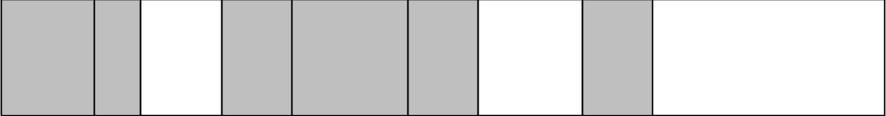
Figure 1. Memory divided into chunks

Besides size information, the rightmost bit in the size field marks whether the chunk is presently allocated or not. In a similar fashion, the rightmost bit in the "previous chunk size" field indicates whether this chunk can be reclaimed by wip_gc. This only leaves 15 bits for size information, but since all sizes are a multiple of 4 bytes we do not need to store the last two bits (they are always zero). Hence, we still have enough bits to handle chunk sizes of up to 128k.
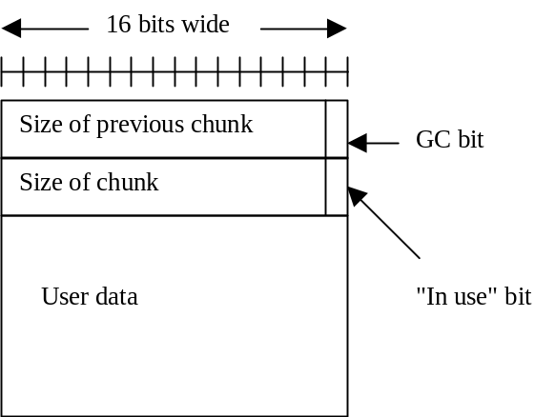
Figure 2. Allocated chunk

Chunks that are not presently allocated, i.e., "free" chunks, are kept on a doubly linked list. The pointers for this list are stored in two 16-bit fields immediately following the chunk header. This way, no space for these pointers is needed in an allocated chunk.
To save space, we do not store real pointer values in the pointer fields. Instead, we use offsets from the base of the memory area. In addition, since all chunks are aligned on 4-byte boundaries the last two bits of the offsets will always be zero. Hence, we do not need store these bits, and can thus handle offsets of up to 256k.
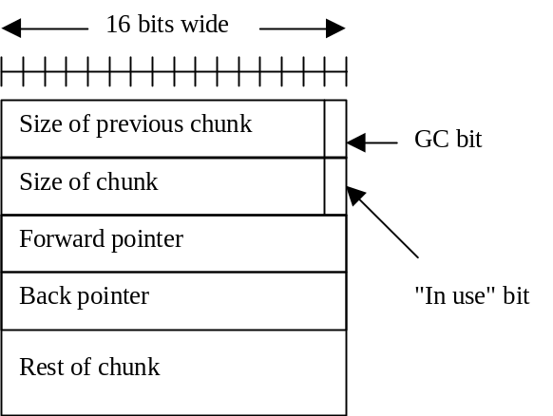
Figure 3. Free chunk

The total overhead is then limited to 4 bytes per chunk (for the size fields) plus what we get when we round the requested size to the next larger multiple of 4.

Algorithms
The algorithm used for allocation is best-fit with segregated free lists. This means that there are multiple free lists, each one holding some interval of chunk sizes. Currently there are 10 different lists. Allocation of a memory block of size n starts with the first list where sizes are larger than or equal to n. If the list is empty, the next list is examined, until a non-empty list is found. All elements in the list are then examined, and the chunk whose size is closest to the requested size is chosen. In case of ties, the chunk closest to the head of the list is chosen.
When freeing a chunk of memory, the algorithm checks whether either or both of the adjacent chunks are free. If so, they are merged into one bigger chunk that is then added to the appropriate added free list. This way, there are never two adjacent chunks that are both free.
Freeing can be done in constant time, whereas allocation will take time proportional to the length of the appropriate free list. However, using multiple free lists does tend to reduce the length of each list, thereby reducing allocation time.

Performance
When evaluating the performance of a memory allocation system there are several different factors that have to be taken into account. Besides the average running time of the allocation and deallocation routines themselves, there is the question of efficient memory usage, and also how well the allocation scheme caters to the requirements of the processor's caching strategy. Because there are so many factors that interact in complex ways, the preferred method of evaluation is to take several "typical" programs and measure the total running time of each one, using different allocation strategies. This way, the performance of the memory allocation system as a whole can be measured, but it might be harder to see what the effects are of varying independent details in the allocation strategy, and also how efficient the memory usage is.
A first version of this allocator used first-fit as allocation strategy. Results from usage in its intended target environment pointed to problems with excessive fragmentation. That is, there would be plenty of free memory areas, but none large enough to satisfy the next allocation request. After the change to best-fit with segregated free lists, no further performance problems have been reported.

Integration
The implementation of the memory allocation library is in two files, wip_mem.c and wip_mem.h. Presently, these files can be found in Source Safe under Components/Common/implementation/base/optional/memory. To use the system, one needs to add these files and define the symbol USE_WIP_MALLOC. Without this flag set, no code from the system will be included.
There is also another flag, DEBUG_WIP_MALLOC. With this flag set, some statistical data is collected during usage, and also consistency checks are made each time an allocation or deallocation is invoked. These checks tend to catch errors where for example a memory block is freed twice, or where an allocated memory area is overwritten beyond its allocated size. The debugging checks use the assert macro, hence execution will be halted by this macro if a test fails.

