<Document type> | 1999-07-12
Prepared  Anders Edenbrandt | Document number | Rev
Approved | Reference

WIP memory allocation system
This document describes a memory allocation system designed specifically for use in the WAP client under OSE. The system design goal has been to minimise the allocation overhead, in an environment where memory resources are scarce. In addition, the code has been tuned for speed.

User interface
There are two main routines, wip_malloc and wip_free, that serve as drop-in replacements for malloc and free, respectively. These functions have the following prototypes:
void *wip_malloc (UINT32 size);
This function takes an argument that indicates the requested size of the memory area to be allocated. It returns a pointer to an area of at least this size, aligned on a 4-byte boundary. If allocation fails, because there is no free area of sufficient size, wip_malloc returns 0.
void wip_free (void *p);
The argument to wip_free is a pointer to the memory area to be freed. This must be a value previously obtained from wip_malloc; otherwise, the results are unpredictable. Calling wip_free with 0 as parameter has no effect.
Before either of the two functions above are used, the system must be initialised:
INT16 wip_initmalloc (void *mem, UINT32 memsize);
This routine takes a pointer to a memory area and the size of that area as parameters. All allocations using wip_malloc will be made from this area. The supplied memory area must be aligned on a 4-byte boundary. This routine returns 0 on success, and -1 otherwise. Possible errors are that the size of the supplied memory area is too small (less than 24 bytes) or too large (greater than 128k).

Batch reclamation of memory
In addition to wip_malloc mentioned above, there is also a function called wip_gcmalloc. This routine has the same semantics as wip_malloc, and the same prototype. However, memory allocated with wip_gcmalloc can be freed in one batch operation using wip_gc.
void wip_gc (void);
By calling wip_gc, all memory areas previously allocated with wip_gcmalloc are freed. But memory blocks allocated with wip_malloc are left undisturbed. Just as with regular wip_free, trying to access memory after it has been freed may lead to unpredictable behaviour.

System design
This memory allocation system works by partitioning the entire memory area into "chunks" of different sizes. Each chunk has a header of two 16-bit fields that hold the size of the chunk (including the header) and the size of the previous, adjacent chunk. This way, given a pointer to an arbitrary chunk, it is possible to find both the next adjacent chunk and the previous one.
A chunk is either free or in use, i.e., presently allocated to the user. Adjacent, free chunks are always merged into one. Hence, the entire memory area will look like this, where shaded chunks are those "in use":
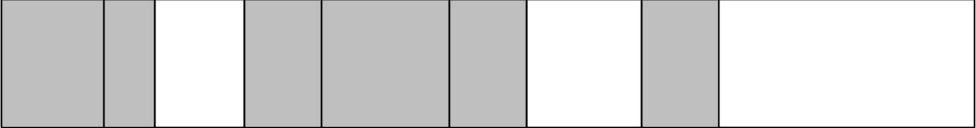
Figure 1. Memory divided into chunks

Besides size information, the rightmost bit in the size field marks whether the chunk is presently allocated or not. In a similar fashion, the rightmost bit in the "previous chunk size" field indicates whether this chunk can be reclaimed by wip_gc. This only leaves 15 bits for size information, but since all sizes are a multiple of 4 bytes we do not need to store the last two bits (they are always zero). Hence, we still have enough bits to handle chunk sizes of up to 128k.
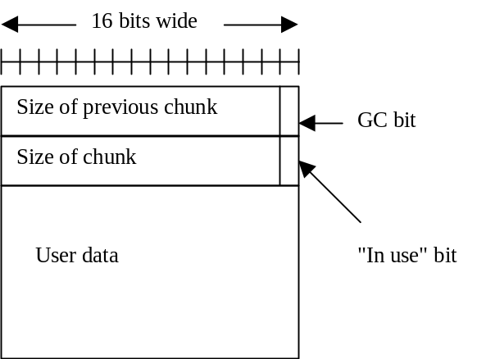
Figure 2. Allocated chunk

Chunks that are not presently allocated, i.e., "free" chunks, are kept on a doubly linked list. The pointers for this list are stored in two 16-bit fields immediately following the chunk header. This way, no space for these pointers is needed in an allocated chunk.
To save space, we do not store real pointer values in the pointer fields. Instead, we use offsets from the base of the memory area. In addition, since all chunks are aligned on 4-byte boundaries the last two bits of the offsets will always be zero. Hence, we do not need store these bits, and can thus handle offsets of up to 256k.
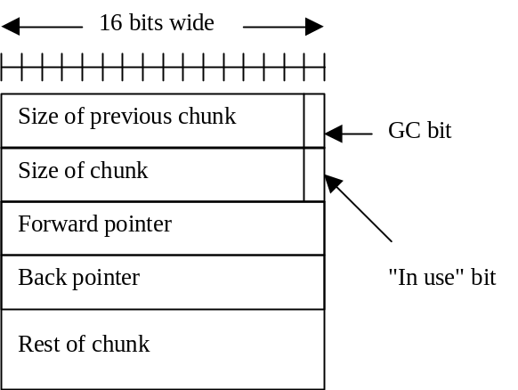
Figure 3. Free chunk

The total overhead is then limited to 4 bytes per chunk (for the size fields) plus what we get when we round the requested size to the next larger multiple of 4.

Algorithms
The algorithm for allocation is simple: upon receiving a memory allocation request, a chunk size is calculated (taking into account the 4 byte chunk header and rounding up to a multiple of 4; also, a chunk must never be smaller than 8 bytes). Then, the free list is scanned until a chunk of sufficient size is found. If the located chunk is larger than what was requested it is split in two, and the newly formed chunk is inserted into the free list. This is a straight first-fit algorithm.
When freeing a chunk of memory, the algorithm checks whether either or both of the adjacent chunks are free. If so, they are merged into one bigger chunk that is added to the free list. This way, there are never two adjacent chunks that are both free.
Freeing can be done in constant time, whereas allocation might take time proportional to the length of the free list. Experiments run so far seems to indicate that even if the length of the free list grows, the number of chunks on the list that have to be checked is still small (between 1 and 2).

Performance
When evaluating the performance of a memory allocation system there are several different factors that have to be taken into account. Besides the average running time of the allocation and deallocation routines themselves, there is the question of efficient memory usage, and also how well the allocation scheme caters to the requirements of the processor's caching strategy. Because there are so many factors that interact in complex ways, the preferred method of evaluation is to take several "typical" programs and measure the total running time of each one, using different allocation strategies. This way, the performance of the memory allocation system as a whole can be measured, but it might be harder to see what the effects are of varying independent details in the allocation strategy, and also how efficient the memory usage is.
The only measurements made on this system so far, has been to run the test system found in TestComponents/WinNT. The system was built and executed on a Windows NT machine, using Visual Quantify to measure the performance. Besides running it without the new memory allocation system, a number of trial runs were also made with the new system, trying different strategies for managing the free list.
There are two points in the code where the free list is manipulated; the first is during allocation, when a split is required. Here, two strategies were tested: to leave the new chunk in the same position in the list as before, or to insert the new chunk first in the list. The first strategy is largely motivated by efficiency concerns, it requires fewer instructions to let the new chunk take the old one's place. The motivation behind the second strategy is localisation: sequential allocations have a good chance of being placed next to each other in memory. This might improve performance due to a higher hit rate in the memory cache.
The second point that affects the free list is during deallocation. The freed chunk, possibly merged with other chunks, can be placed either at the front of the free list or at its tail, or, in the case when it is merged with a previous chunk, it can be left in its place.
The outcome of the trials seemed to be that strategies that favoured the fastest allocation and deallocation routines also gave the lowest total running times. The recorded results varied between 489 and 498 microseconds. The fastest time was achieved by the variant where chunks were left in place in the free list as often as possible. Running the system without the new allocation routines took 520 microseconds.
There is a multitude of other possibilities that could be explored. For example, one could use "exact fit" rather than just first fit. This means that the entire free list is scanned, and if there is a chunk of exactly the requested size it is chosen; otherwise a first fit strategy is used. This is an attempt to reduce the number of splits performed. In order to speed this scheme up, one can use a number of free lists, one for each chunk size (below some fixed limit). We did try exact fit, and also the idea with several free lists, but without any positive effects on running time.
Besides measuring running time, we have also collected statistics on the memory usage during execution of the same program as above. Here are some of the results:
Total number of allocations | 197
Total number of deallocations | 180
Total number of bytes requested | 9247
Total number of bytes allocated | 10160
Overhead | 10%
High watermark of number of allocated bytes | 5500
Max length of free list | 16
Average number of chunks checked in free list on an allocation | 1.45

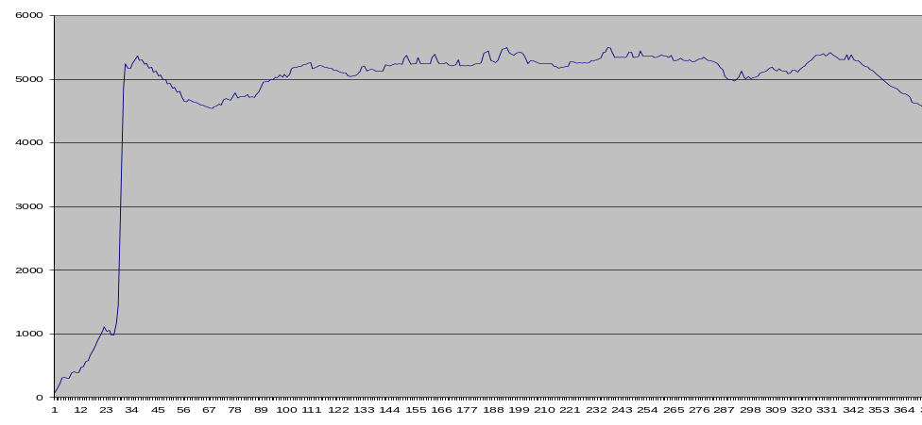
Figure 4. Memory usage over time of the test program

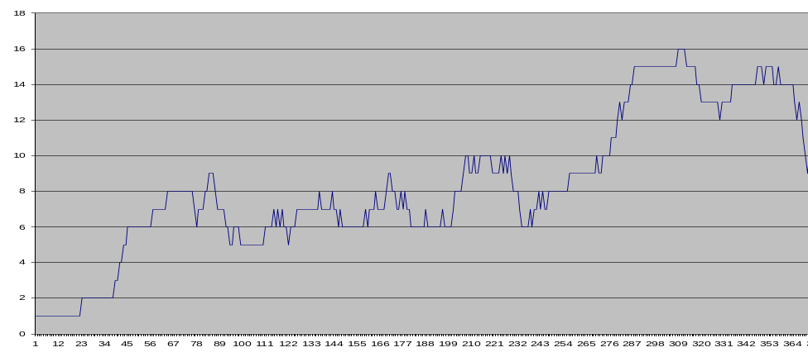
Figure 5. Length of free list over time

In conclusion, the performance of the system so far seems to be quite satisfactory. However, the tests that we have been able to run are much too limited in scope to be able to draw conclusions with any certainty. Further testing and evaluation is needed, especially on the intended target platform, OSE-IAR.

Integration
The implementation of the memory allocation library is in two files, wip_mem.c and wip_mem.h. Presently, these files can be found in Source Safe under Components/Environment/Implementation/cconnect. To use the system, one needs to add these files and define the symbol USE_WIP_MALLOC. Without this flag set, no code from the system will be included.
There is also another flag, DEBUG_WIP_MALLOC. With this flag set, you get access to debugging information and statistics. See wip_mem.h for a brief description of what is available.

