Jonathan Lopez 11/15/2020
CS 2301 HW 3 Bingo

Sequence Diagram:

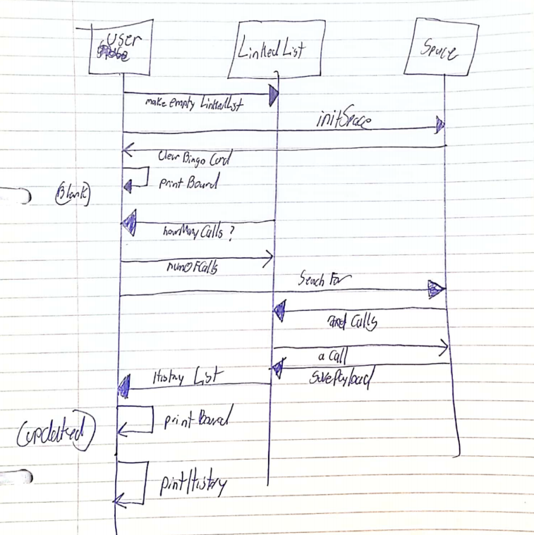

Test 1 Figure 1
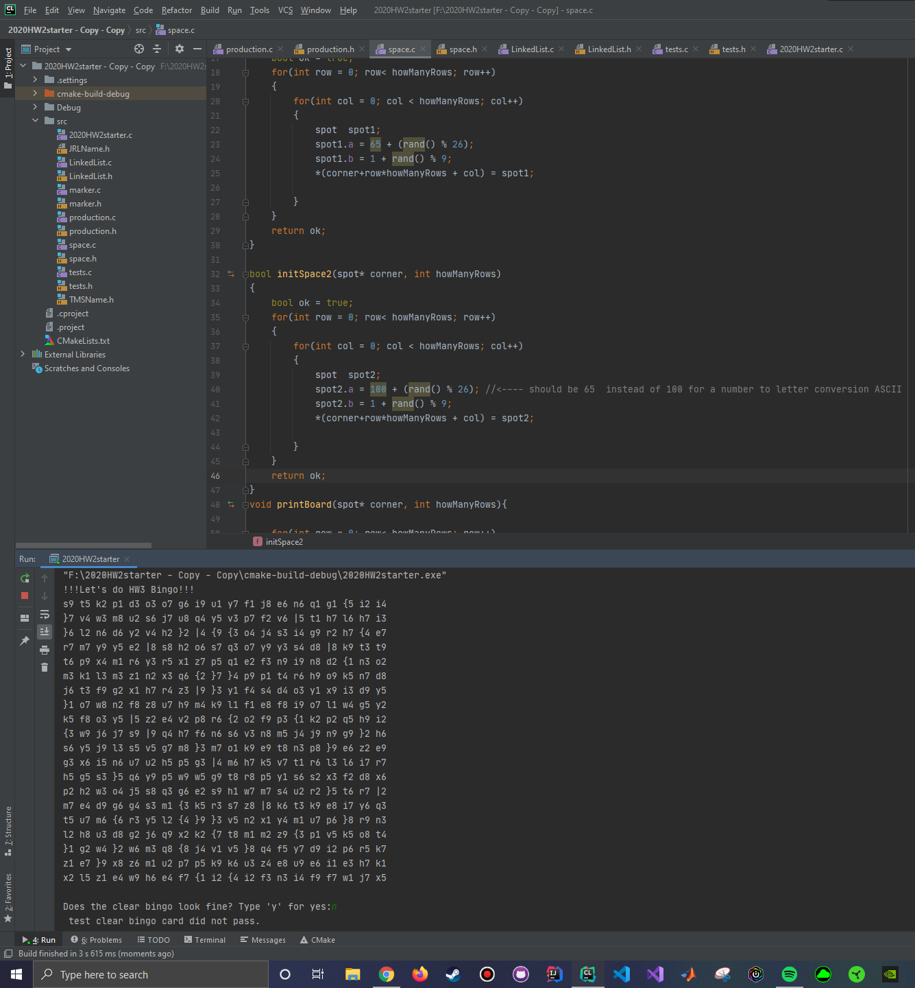

Test 1 Figure 2
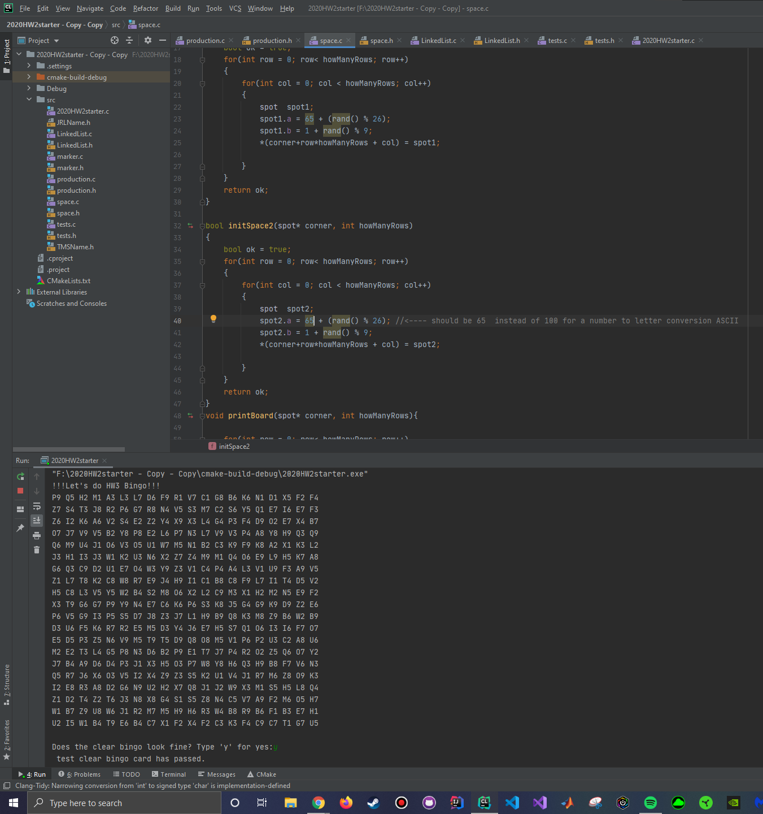

Test 2 Figure 1
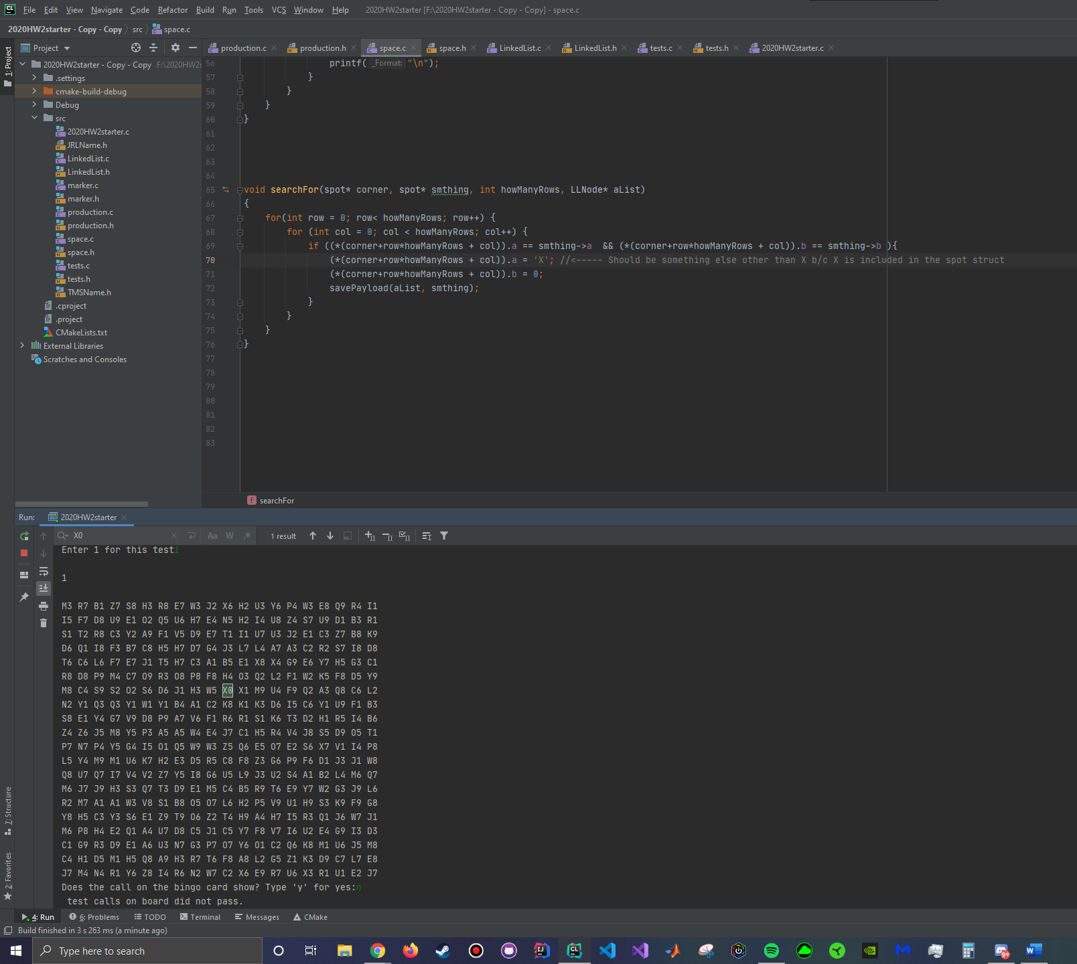

Test 2 Figure 2
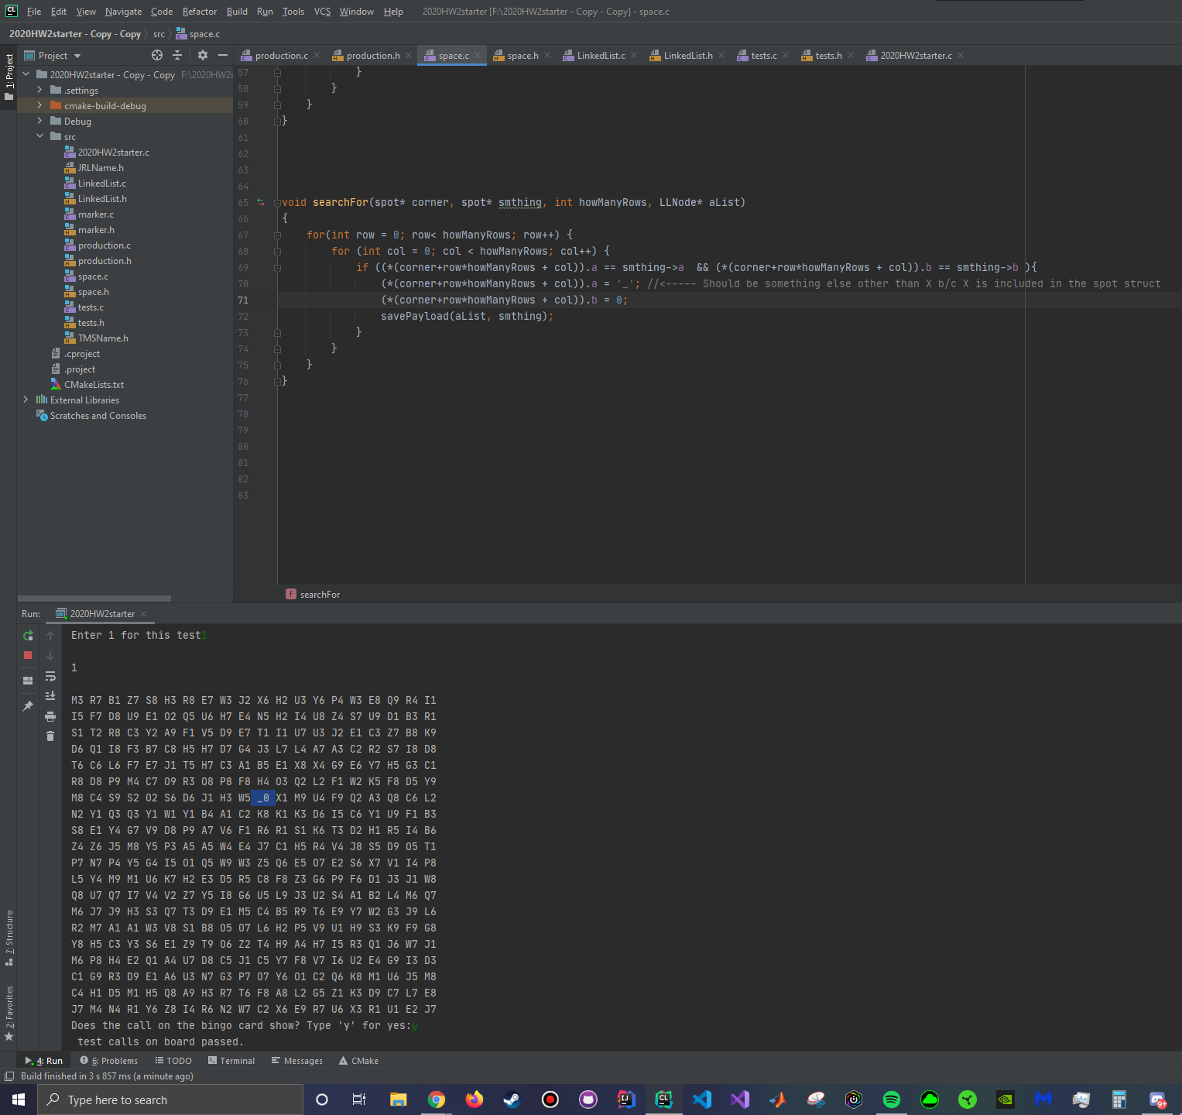

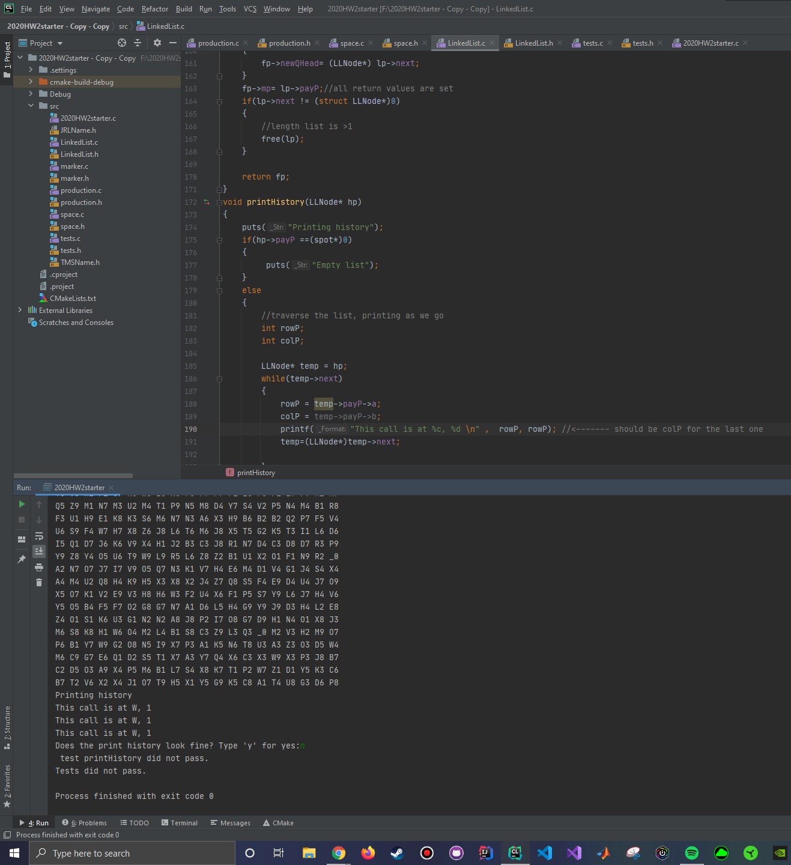
Test 3 Figure 1

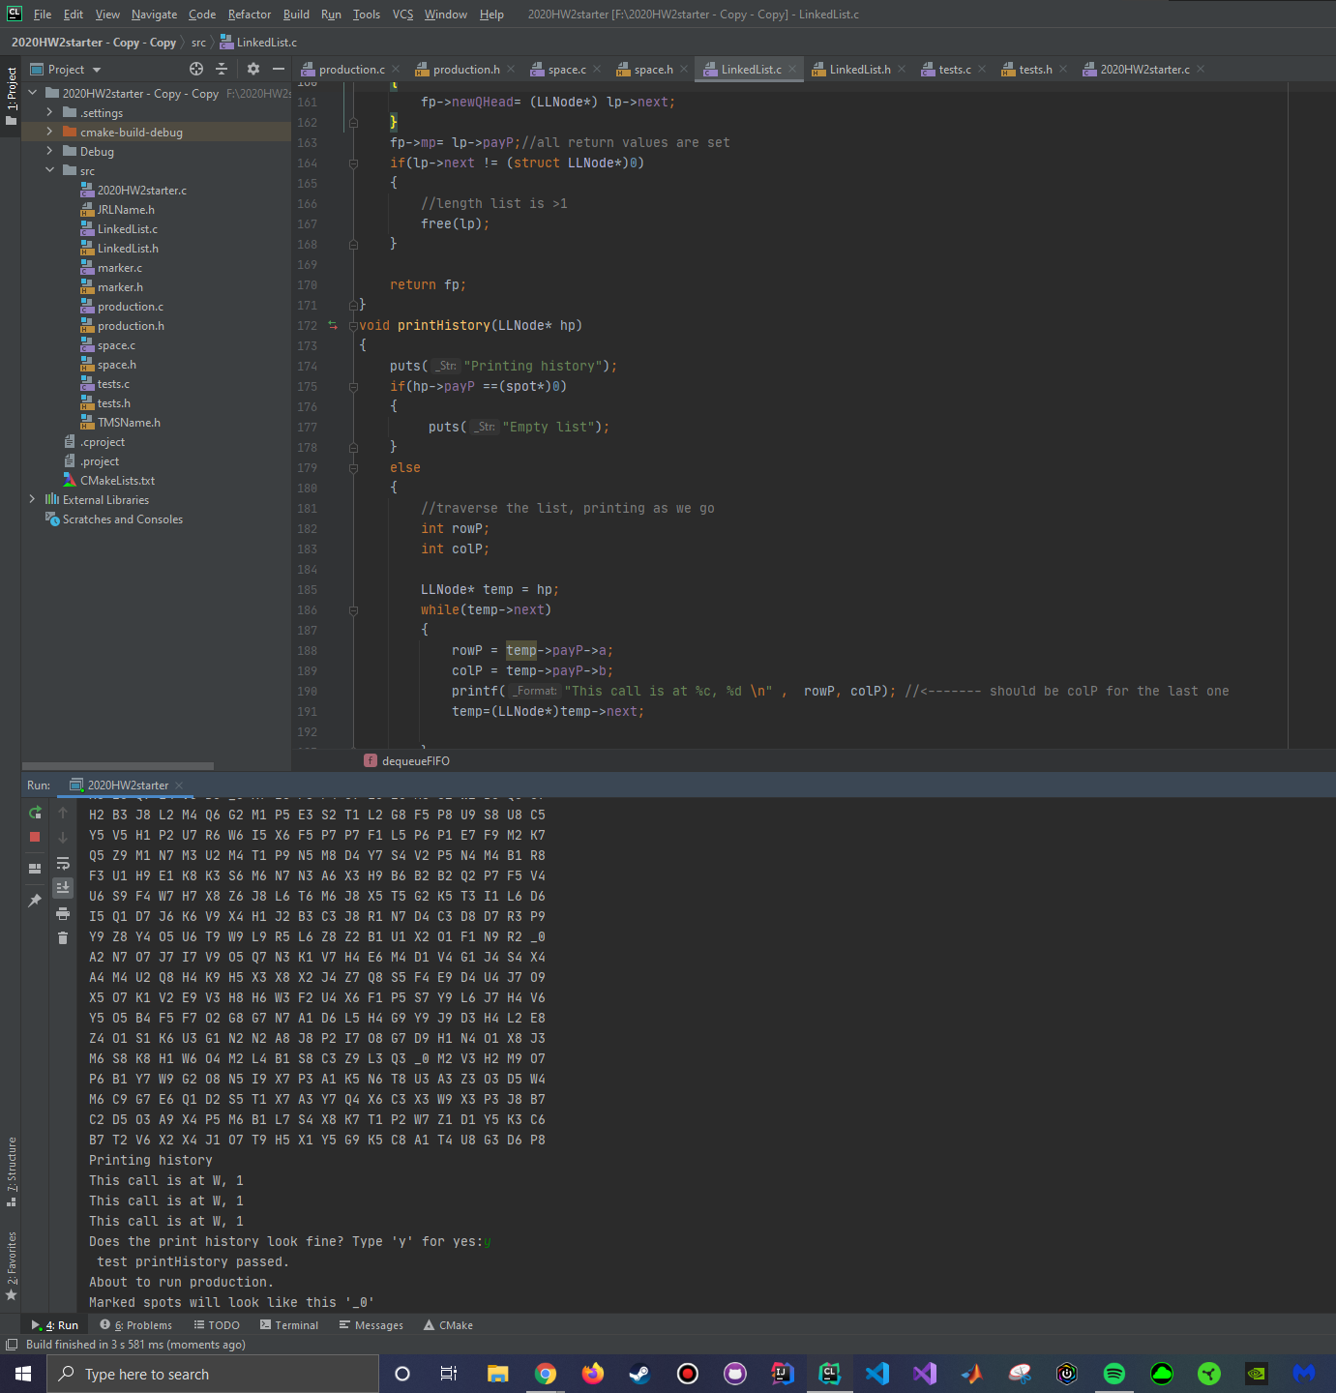
Test 3 Figure 2

