Worcester Polytechnic Institute ⎯ Department of Electrical and Computer Engineering

ECE2311 ⎯ Continuous-Time Signal and System Analysis ⎯ Term B’07

Exam 1: Thursday, 8 November 2007

- Closed book, notes provided, calculators permitted for simple computation only (no stored formulae or text).
- Show all of your work. Use written English, where applicable. Always write neatly.
- A solution requiring physical units is incorrect if the units are omitted from the result.
- Underline, circle or box each result.

1a) (5 pts) Sketch and label: 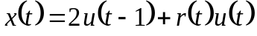, where 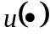 is the unit step function and 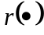 is the unit ramp function. Show x/y intercepts whenever applicable.
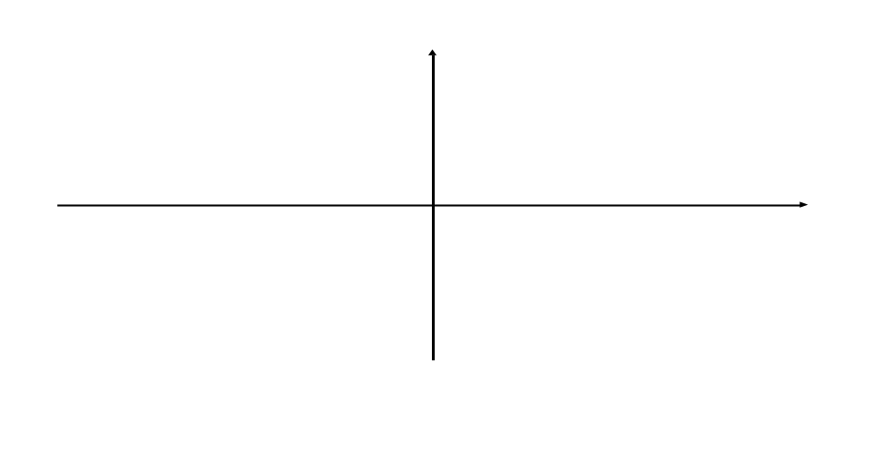
1b) (5 pts) Sketch and label: 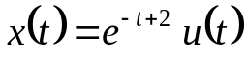. Show x/y intercepts whenever applicable.

2a) (5 pts) Let 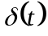 be the impulse function. Simplify the expression: 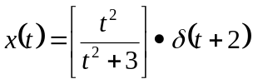.

2b) (5 pts) Let be the impulse function. Evaluate the expression: 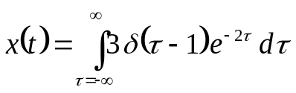.

3a) (5 pts) Let y(t) be the system output and x(t) be the system input. Determine if the system described below is (i) static or dynamic and (ii) causal or non-causal. State the reason for your decisions.
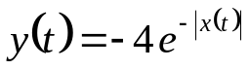

- Static or dynamic? Why?

ii) Causal or non-causal? Why?

3b) (10 pts) Determine and sketch the odd part of: 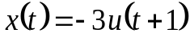, where is the step function.

4) (15 pts) Use the definition of time invariance to show if the following system is time-invariant or time-variant: 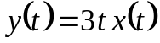.
5) (20 pts) Use the definition of a linear system to show if the following system is linear: 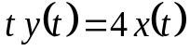.

6) (20 pts) Use the concept of graphical convolution (and any associated computation required) to convolve x₁(t) and x₂(t) shown below. Be sure to show a drawing for each region where a distinct integral range is required in the convolution. Sketch the result as well (showing applicable x/y intercepts) and provide the result via a mathematical expression. Additional space is provided on the next page (if needed).
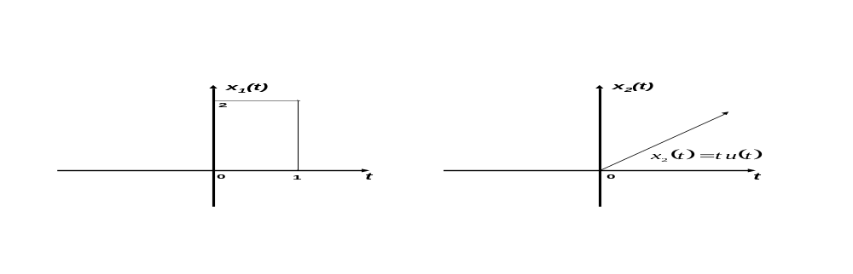

Additional space on next page, if needed.
Additional space for problem 6.
7) (10 pts) Given the interconnected LTI system below, write the overall system response y(t) as a function of the impulses responses [h_{i}(t)] of the individual systems and the input x(t).

