Worcester Polytechnic Institute ⎯ Department of Electrical and Computer Engineering

ECE2311 ⎯ Continuous-Time Signal and System Analysis ⎯ Term B’16

Exam 1: Thursday, 10 November 2016

- Closed book, notes provided, calculators permitted for computation only (no stored formulae or text).
- Show all of your work. Use written English, where applicable. Always write neatly.
- A solution requiring physical units is incorrect if the units are omitted from the result.
- Underline, circle or box each result.

1a) (5 pts) Sketch and label on the axis below: 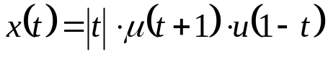, where 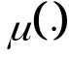 is the unit step function. Show axis intercepts, if applicable.
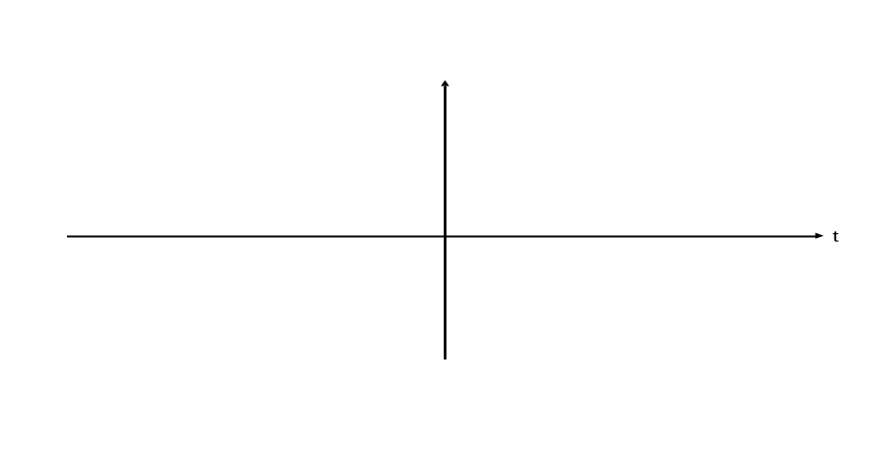
1b) (5 pts) Let 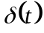 be the impulse function. Simplify the expression: 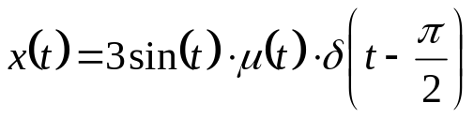 where is the unit step function.

1c) (5 pts) Let be the impulse function. Evaluate the expression: 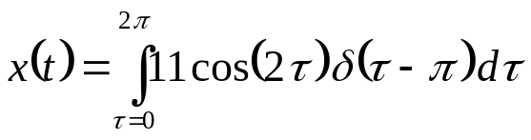.

2a) (5 pts) Let 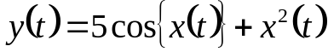, with x(t) the system input and y(t) the system output.
i) Is this system static or dynamic? WHY?

ii) Is this system causal or non-causal? WHY?

2b) (5 pts) Write and sketch the odd part of: 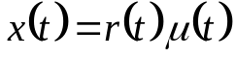, where 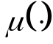 is the unit step function.

3) (15 pts) Use the definition of time invariance to show if the following system, with input x(t) and output y(t), is time-invariant or time-varying: 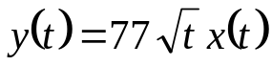. (Show your work to receive credit.)
4) (15 pts) Use the definition of a linear system to show if the following system, with input x(t) and output y(t), is linear: 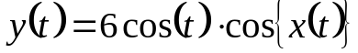. (Show your work.)

5) (25 pts) Use the concept of graphical convolution and the convolution integral to convolve x₁(t) and x₂(t) shown below. DO NOT USE THE COVOLUTION TABLES ON THE NOTESHEET. Be sure to show a drawing for each region where a distinct integral range is required in the convolution. Additional space is provided on the next page (if needed).

Sketch the result as well (showing applicable axis intercepts) and provide the result via a mathematical expression.
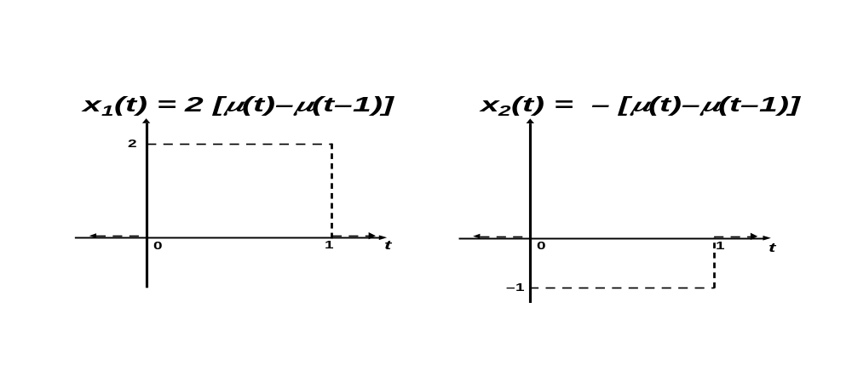

Additional space on next page, if needed.
Additional space for problem 5.

6) (10 pts) Use the convolution table from the course notesheet (and any appropriate convolution properties) to find the following convolution—you need NOT draw your result:

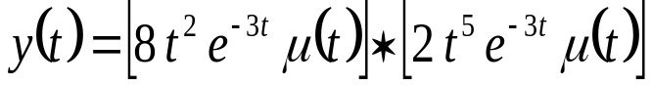
7) (10 pts) Given the interconnected LTI system below, write the overall system response y(t) as a function of the impulse responses [h_{i}(t)] of the individual systems and the input x(t).

