Worcester Polytechnic Institute ⎯ Department of Electrical and Computer Engineering
Solution

ECE2311 ⎯ Continuous-Time Signal and System Analysis ⎯ Term D’16

Exam 1: Thursday, 31 March 2016

- Closed book, notes provided, calculators permitted for computation only (no stored formulae or text).
- Show all of your work. Use written English, where applicable. Always write neatly.
- A solution requiring physical units is incorrect if the units are omitted from the result.
- Underline, circle or box each result.

1a) (5 pts) Sketch and label on the axis below: 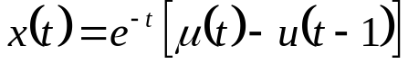, where 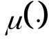 is the unit step function. Show axis intercepts, if applicable.
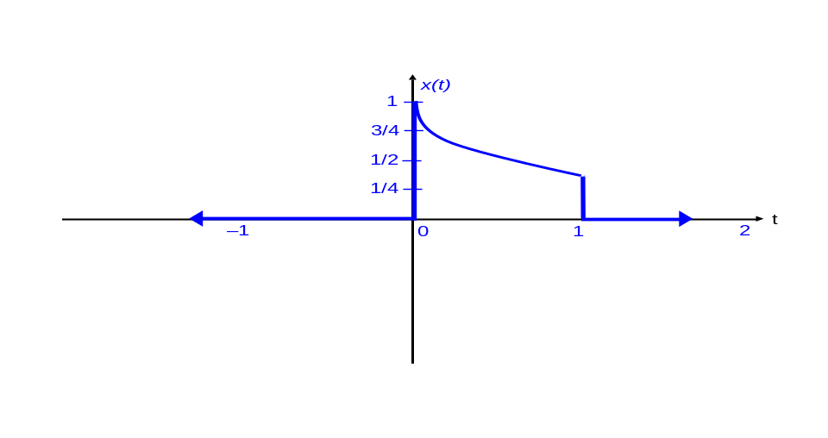
1b) (5 pts) Let 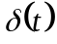 be the impulse function. Simplify the expression: 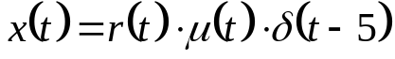 where 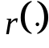 is the unit ramp function and is the unit step function.
Recall: 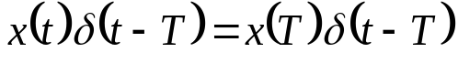
Here, the impulse function occurs at time location 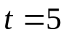:
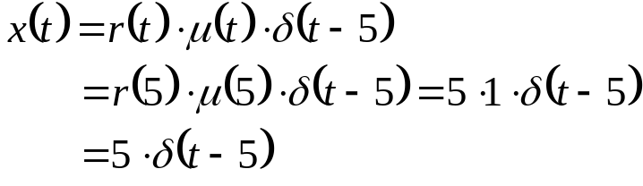

1c) (5 pts) Let be the impulse function. Evaluate the expression: 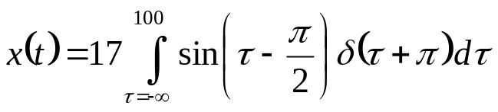.

Recall: 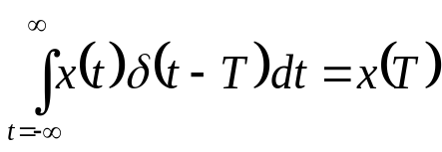
In this problem, the restriction of the limits of the definite integral (between –∞ and 100) does not alter the general concepts for evaluating the integral. The impulse occurs at 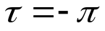, which is within the region of integration. The impulse function has a value of zero at all locations other than at the impulse location. Thus, integration over ranges outside of the impulse location results in zero area. So:

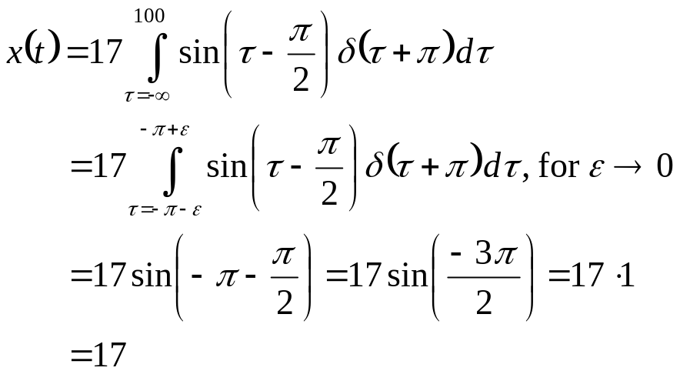.

2a) (5 pts) Let 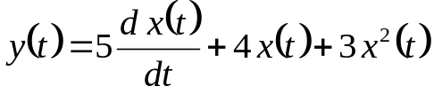, with x(t) the system input and y(t) the system output.
i) Is this system static or dynamic? WHY?
DYNAMIC. Via the derivative, the present output depends on present and past inputs.

ii) Is this system causal or non-causal? WHY?
CAUSAL. Present output depends on only present and past (via the derivative) times.

2b) (5 pts) Write and sketch the even part of: 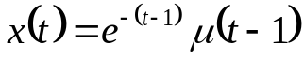, where 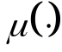 is the unit step function.
- By definition:
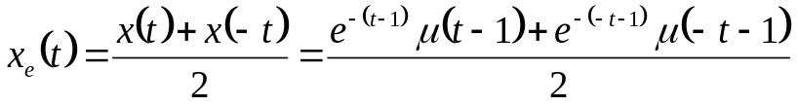.
Here, x(t) and x(–t) are drawn as:
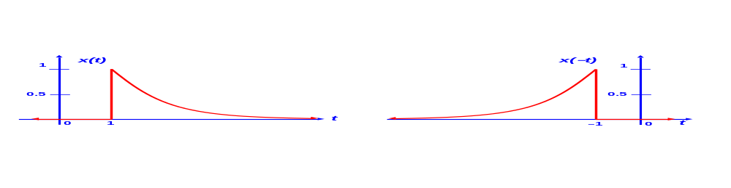
2) ADDING the two above plots and dividing by 2 gives the final solution:
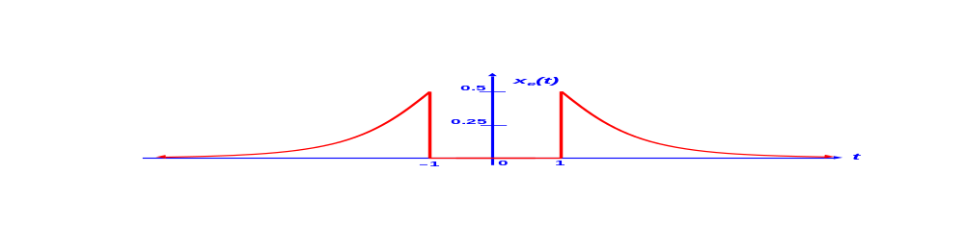

3) (15 pts) Use the definition of time invariance to show if the following system, with input x(t) and output y(t), is time-invariant or time-varying: 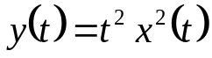. (Show your work to receive credit.)
1) Delay each input, then apply transform:
a) 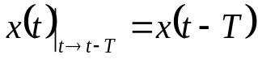

b) 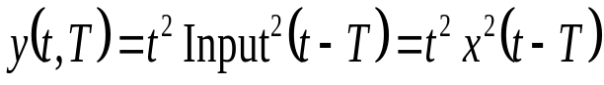

2) Delay output (substitute t–T for each occurrence of t):
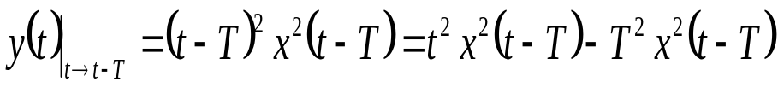

Since 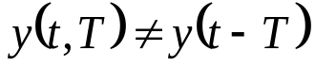 ➔➔➔ TIME VARYING
4) (15 pts) Use the definition of a linear system to show if the following system, with input x(t) and output y(t), is linear: 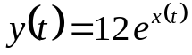. (Show your work.)

Linear ??: Substituting into the superposition definition:

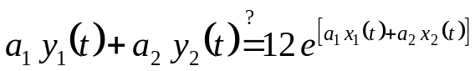
Or, substituting on the left-hand side:
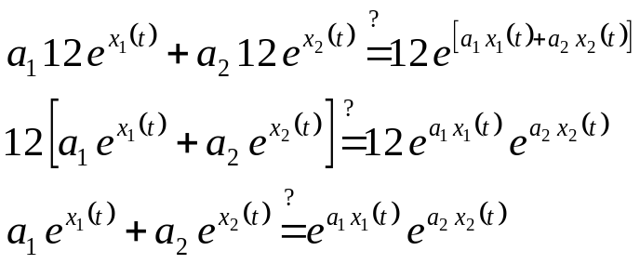.

Left side cannot equal the right side, in general ➔ ➔ ➔ NON-LINEAR
5) (25 pts) Use the concept of graphical convolution and the convolution integral to convolve x₁(t) and x₂(t) shown below. DO NOT USE THE COVOLUTION TABLES ON THE NOTESHEET. Be sure to show a drawing for each region where a distinct integral range is required in the convolution. Additional space is provided on the next page (if needed).

Sketch the result as well (showing applicable axis intercepts) and provide the result via a mathematical expression.
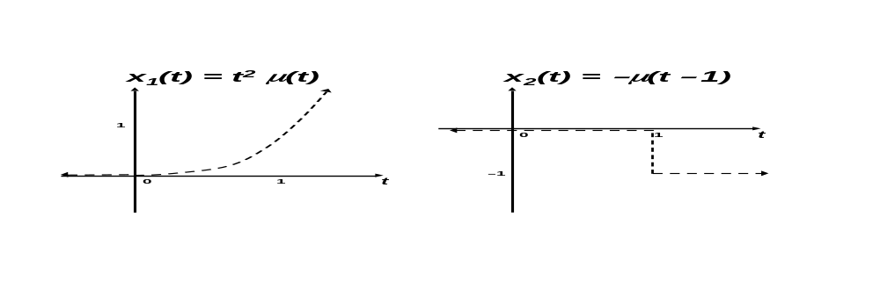
Note: Will choose to treat x₂(t) as the signal to “rotate” about the y-axis and “slide.”

t < 1: No overlap. Convolution equals zero in this range.
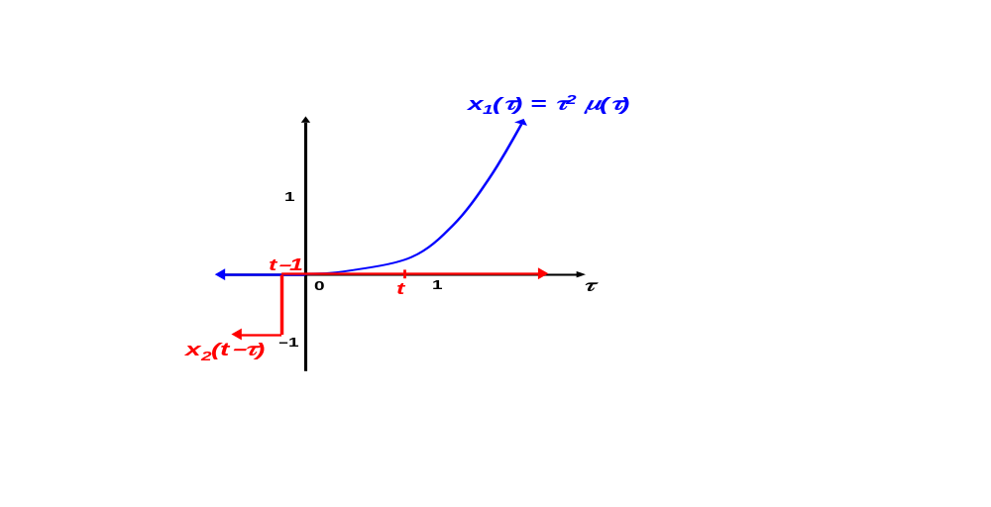

CONTINUED

Additional space on next page, if needed.
Additional space for problem 5.
t≥1: Overlap from left.
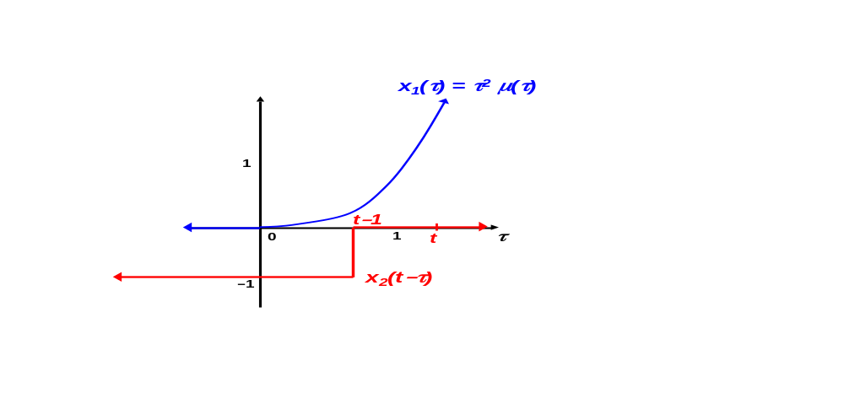
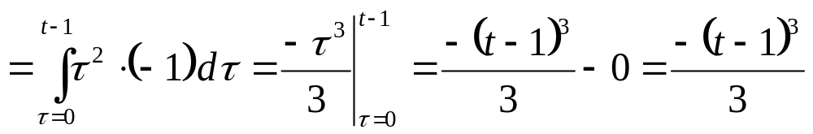

FULL SOLUTION:
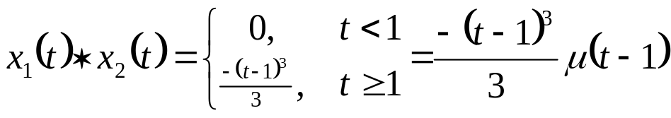

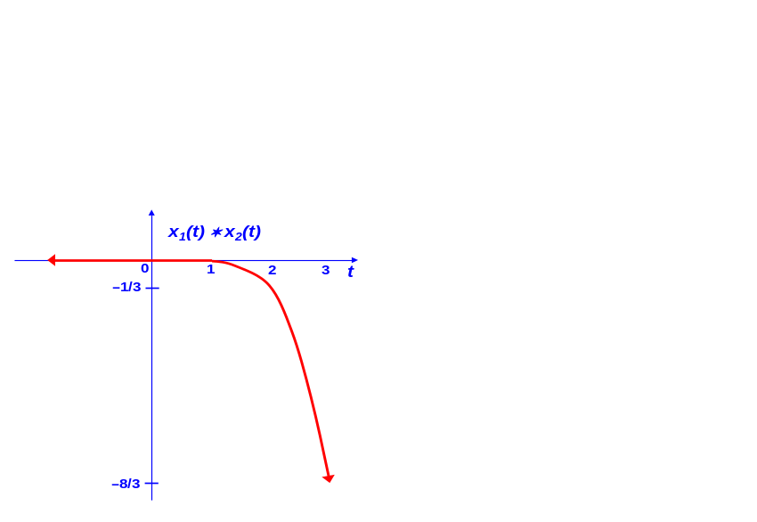

6) (10 pts) Use the convolution table from the course notesheet (and any appropriate convolution properties) to find the following convolution—you need NOT draw your result:

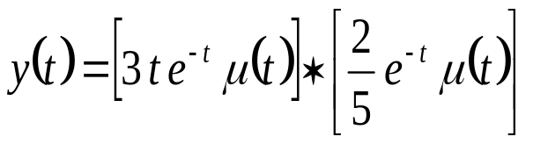
From the class notesheet:
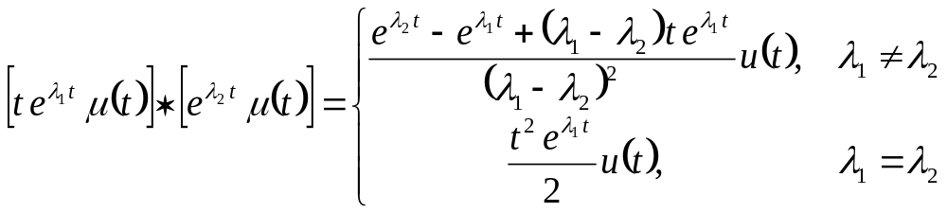.
We use the above formula, with λ₁ = λ₂, giving:
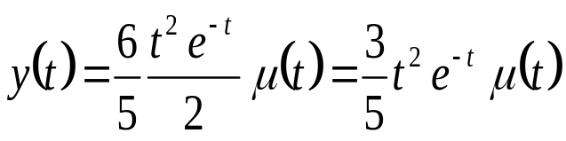.
7) (10 pts) Given the interconnected LTI system below, write the overall system response y(t) as a function of the impulse responses [h_{i}(t)] of the individual systems and the input x(t).

