+ Real
+j Imag
Complex Numbers
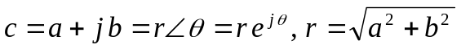
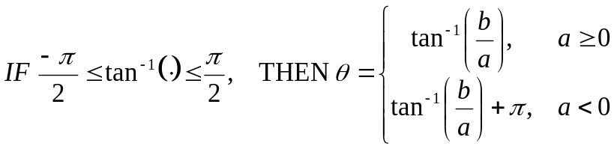
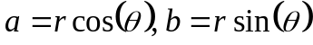
Euler’s Identity: 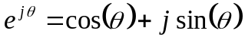
Trigonometric Identities

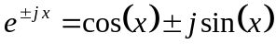
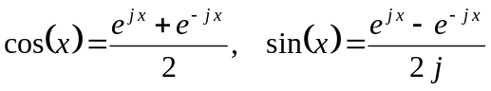
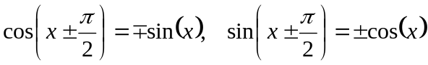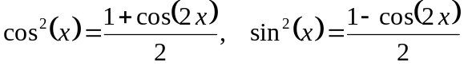

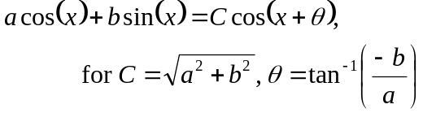
Elementary Signals
Energy: 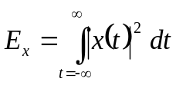
Power (general): 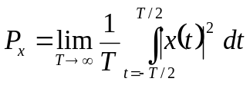
P_{x} (periodic signal): 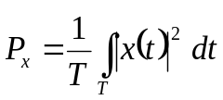
Unit Step: 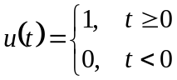
Unit Ramp: 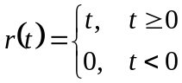
Impulse: 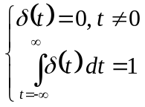
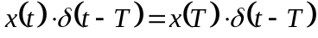
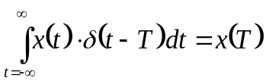
Even Signals: 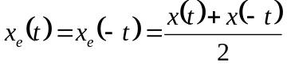
Odd Signals: 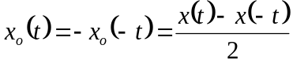
Convolution Table

x₁(t) | x₂(t) | x₁(t)*x₂(t)
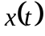 | 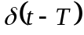 | 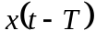
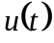 |  | 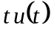
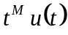 | 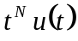 | 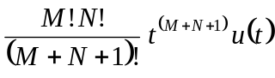
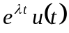 |  | 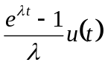
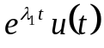 | 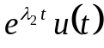 | 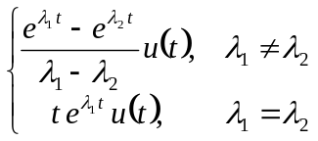
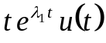 |  | 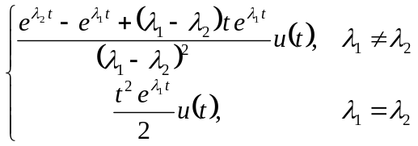
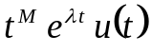 | 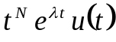 | 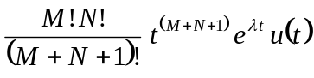

Convolution
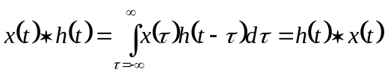; ;
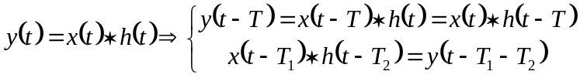; 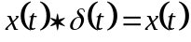; Unit step response 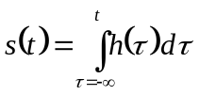
If causal, 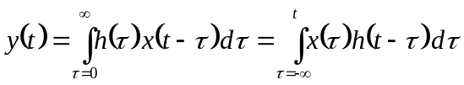; BIBO stable iff 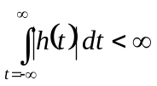

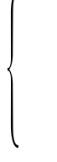

Transforms
Bilateral Laplace Transform:  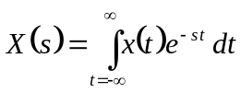  ROC Properties: | Unilateral Laplace Transform:  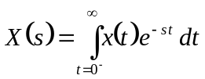  Frequency Conversion:  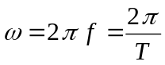 | Fourier Transform:  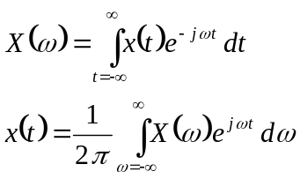  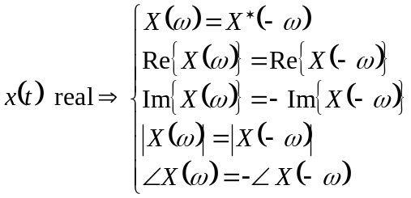  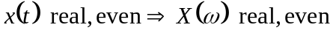
  If x(t) is … | … then ROC is …
  Finite-duration, integrable | Entire s-plane
  Right-sided | Re{s} > σ_{o}
  Left-sided | Re{s} < σ_{o}
  Two-sided | σ_{a} < Re{s} <σ_{b}

Rational Transforms
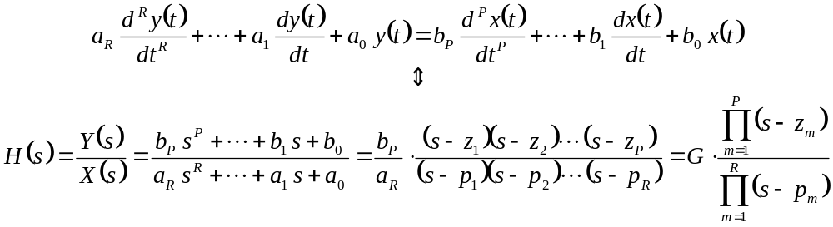
ROC: Bounded by poles, but not include any pole.
Stable: iff ROC include jω axis.

Graphical Frequency Response:
Zeros: 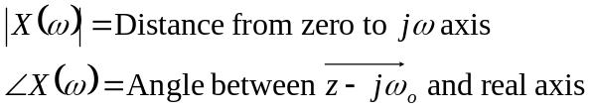

Poles: 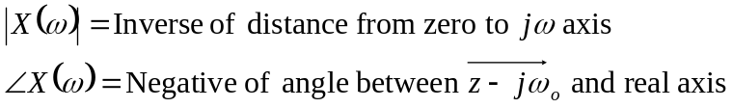
R, L, C Terminal Laws
Device | Bilateral  Laplace | Unilateral  Laplace
Resistor | 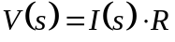 |  | 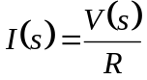
Inductor | 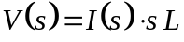 | 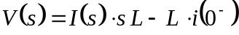 | 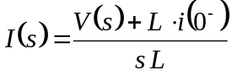
Capacitor | 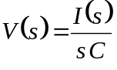 | 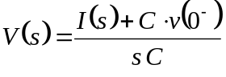 | 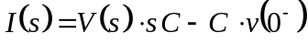

Frequently-Used Integrals

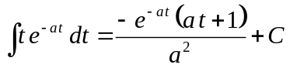
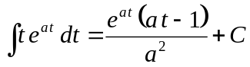
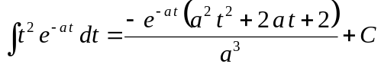

See also: http://www.integrals.com
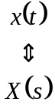
Modulation
- For signal m(t) and modulated signal s(t):

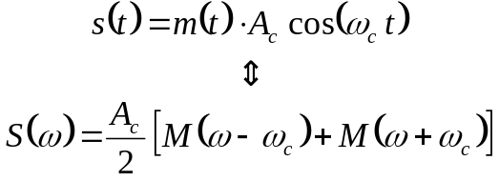
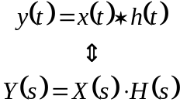
Fourier Series
Exponential Form:
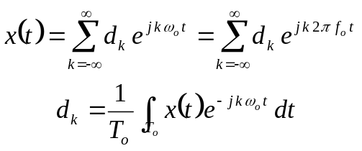
Trigonometric Form:
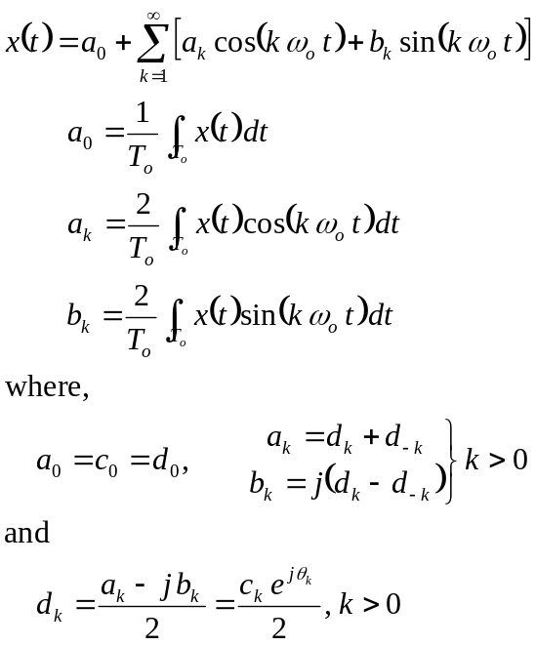

Compact Trigonometric Form;
x(t) MUST BE REAL_VALUED:
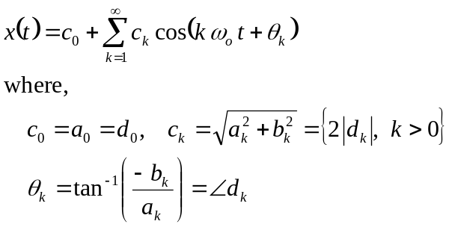
Fourier Transform of Periodic Signal

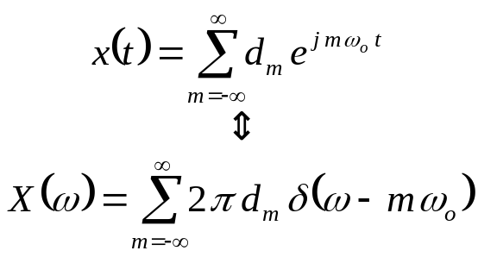
Transform Usage

Transform | Usage
Bilateral Laplace | Total system response (steady state plus transient), assuming null initial conditions
Unilateral Laplace | Total system response (steady state plus transient) for t≥0, with initial conditions known
Fourier Transform | Steady state sinusoidal response
Fourier Series | Steady state sinusoidal response when signal is periodic (sub-set of Fourier Transform)

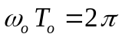
Linear Time-Invariant Systems
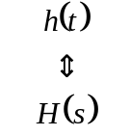
Transform Table
Signal | Bilateral Laplace, ROC | Unilateral Laplace | Fourier
1 | No ROC. | [Same as u(t)] | 2 π δ(ω)
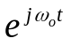 |  |  | 2 π δ(ω–ω_{o})
δ(t) | 1, All s | 1 | 1
δ(t-T_{o}) | 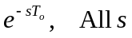
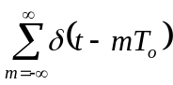 |  |  | 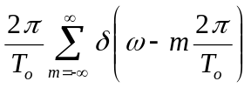
μ(t) | 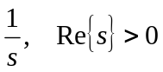 |  | 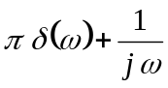
–μ(–t) | 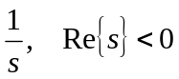 | 0
sign(t) |  | [Same as u(t)] | 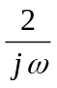
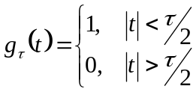 |  |  | 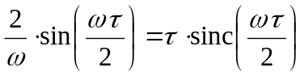
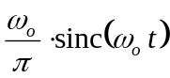 |  |  | 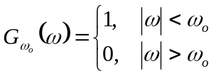
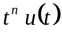 | 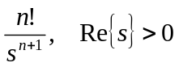 | 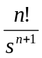
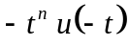 | 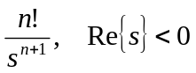 | 0
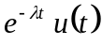 | 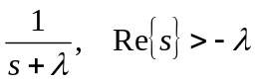 | 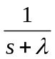 | 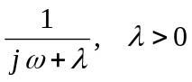
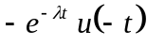 | 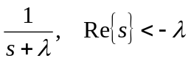 | 0 | 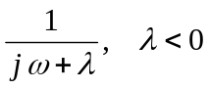
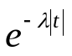 |  |  | 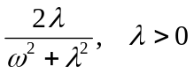
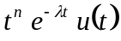 | 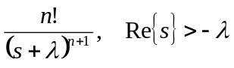 | 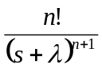 | 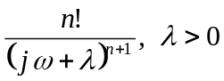
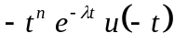 | 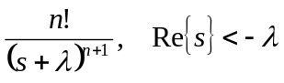 | 0
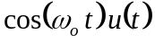 | 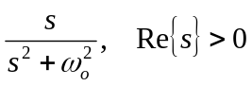 | 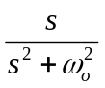 | 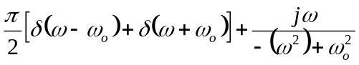
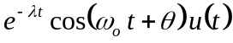 |  | 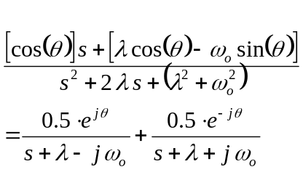
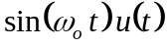 | 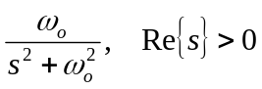 | 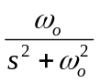 | 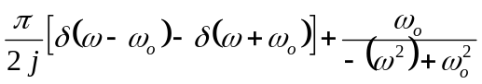
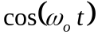 |  |  | 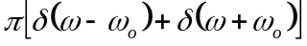
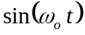 |  |  | 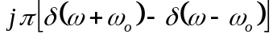
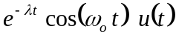 | 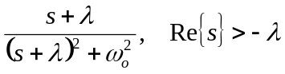 | 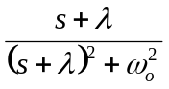 | 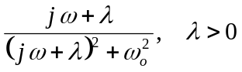
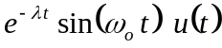 | 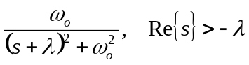 | 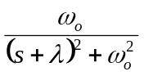 | 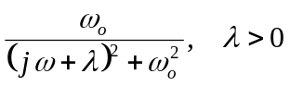

Properties Table
Property | Operation | Bi Laplace, ROC | Unilateral Laplace | Fourier
Linearity | 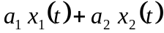 | 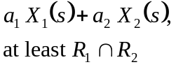 | 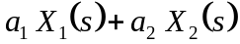 | 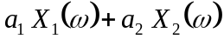
First derivative | 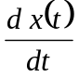 | 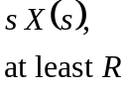 | 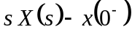 | 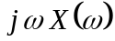
Second derivative | 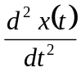 | 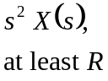 | 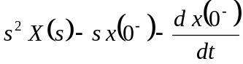
Higher derivatives | 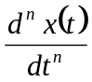 | 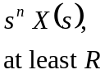 | 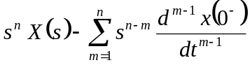
Time integration | 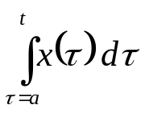 | 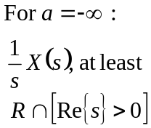 | 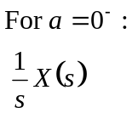 | 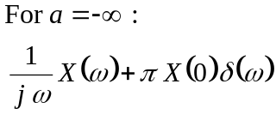
Conjugate | 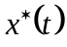 | 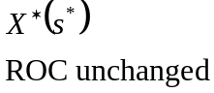 |  | 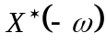
Time shifting | 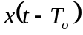 | 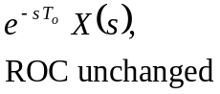 | 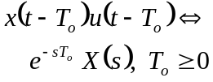 | 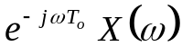
Time reversal | 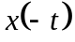 |  |  | 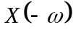
Time scaling | 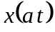 | 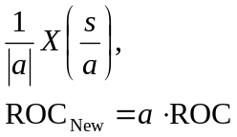 | 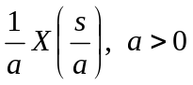 | 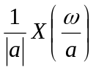
Time convolution | 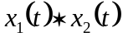 | 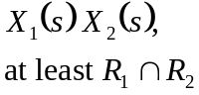 | 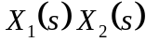 | 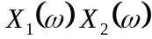
Frequency shifting | 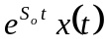 | 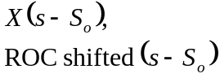 | 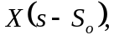 | 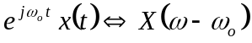
Frequency derivative | 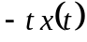 | 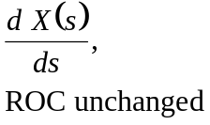 | 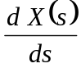 | 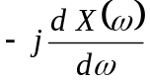
Frequency integration | 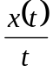 |  | 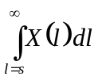
Frequency convolution | 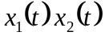 |  | 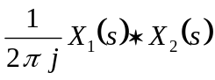 | 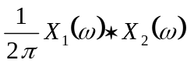
Initial value | 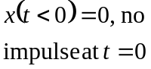 | 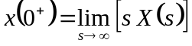
Final value | 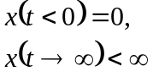 | 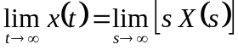
Parseval’s |  |  |  | 