Set-Up : _______________________________________________________ Date: ____________

Repair : _______________________________________________________ Date:____________
Change Point : _______________________________________________________ Date: ____________
(Including critical vision parameter changes)

Others : _______________________________________________________ Date:____________

Note: Attach the printed MBOI in the buy off form
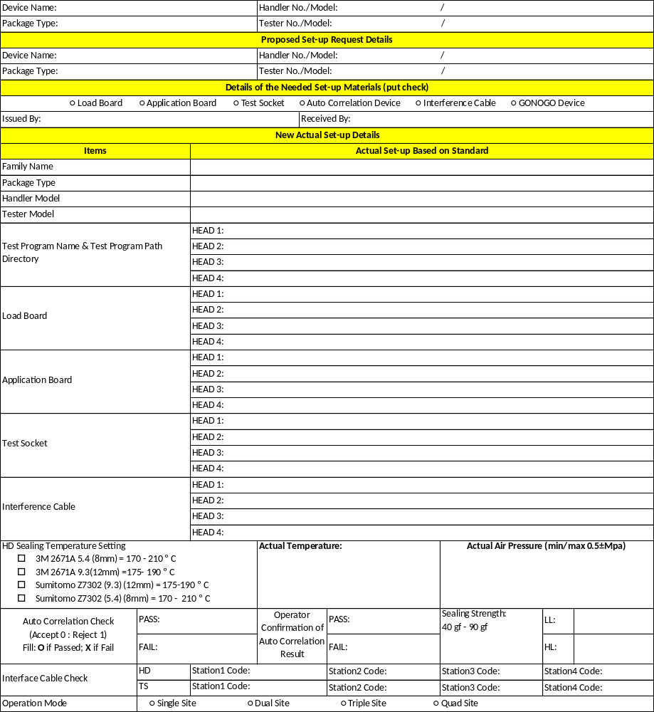

EAGLE 300 TESTER & UENO BIN Setting | BIN Setting | 0 | 1 | 2 | 3 | 4 | 5 | 6 | 7 | 8 | 9 | 10 | 11 | 12 | 13 | 14 | 15 | 16 | S
EAGLE 300 TESTER & UENO BIN Setting | Handler Bin | 14 | 1 | 4 | 5 | 14 | 14 | 8 | 14 | 7 | 14 | 14 | 14 | 14 | 14 | 14 | 14 | 14 | 1
EAGLE 300 TESTER & UENO BIN Setting | Actual Test BIN Site 1
EAGLE 300 TESTER & UENO BIN Setting | Actual Test BIN Site 2
EAGLE 300 TESTER & UENO BIN Setting | Actual Test BIN Site 3
EAGLE 300 TESTER & UENO BIN Setting | Actual Test BIN Site 4
EAGLE 88 TESTER & SRM BIN Setting | BIN Setting | 1 | 2 | 3 | 4 | 5 | 6 | 7 | 8 | 9 | 0 | No bin
EAGLE 88 TESTER & SRM BIN Setting | Handler Bin | 1 | 7 | 12 | 4 | 8 | 2 | 2 | 5 | 2 | 2 | 2
EAGLE 88 TESTER & SRM BIN Setting | Actual Test BIN Site 1
EAGLE 88 TESTER & SRM BIN Setting | Actual Test BIN Site 2
EAGLE 88 TESTER & SRM BIN Setting | Actual Test BIN Site 3
EAGLE 88 TESTER & SRM BIN Setting | Actual Test BIN Site 4
TMT TESTER & SRM BIN Setting | BIN Setting | 1 | 2 | 3 | 4 | 5 | 6 | 7 | 8 | 9 | 0 | No Bin
TMT TESTER & SRM BIN Setting | BIN (SITE 1 & 2) | 1 | 2 | 2 | 5 | 7 | 5 | 2 | 2 | 2 | 2 | 2
TMT TESTER & SRM BIN Setting | Actual Test BIN Site 1
TMT TESTER & SRM BIN Setting | Actual Test BIN Site 2
TMT TESTER & SRM BIN Setting | Actual Test BIN Site 3
TMT TESTER & SRM BIN Setting | Actual Test BIN Site 4
PTECH 6166 TESTER & UENO BIN Setting | BIN Setting (FT) | 0 | 1 | 2 | 3 | 4 | 5 | 6 | 7 | 8 | 9 | 10 | 11 | 12 | 13 | 14 | 15 | 16 | S
PTECH 6166 TESTER & UENO BIN Setting | Tester BIN (Site1) | 14 | 1 | 4 | 5 | 14 | 14 | 8 | 14 | 7 | 14 | 14 | 14 | 14 | 14 | 14 | 14 | 14 | 1
PTECH 6166 TESTER & UENO BIN Setting | Actual Test BIN Site 1
PTECH 6166 TESTER & UENO BIN Setting | BIN Setting (QA) | 0 | 1 | 2 | 3 | 4 | 5 | 6 | 7 | 8 | 9 | 10 | 11 | 12 | 13 | 14 | 15 | 16 | S
PTECH 6166 TESTER & UENO BIN Setting | Tester BIN (Site2) | 14 | 1 | 6 | 6 | 14 | 14 | 6 | 14 | 6 | 14 | 14 | 14 | 14 | 14 | 14 | 14 | 14 | 1
PTECH 6166 TESTER & UENO BIN Setting | Actual Test BIN Site 2
PTECH 6166 TESTER & UENO BIN Setting | Vision BIN |  |  |  |  |  |  |  | Mark | 5 Side
PTECH 6166 TESTER & UENO BIN Setting | Actual Vision BIN
PTECH 8100 TESTER & UENO BIN Setting | BIN Setting | 0 | 1 | 2 | 3 | 4 | 5 | 6 | 7 | 8 | 9 | 10 | 11 | 12 | 13 | 14 | 15 | 16 | S
PTECH 8100 TESTER & UENO BIN Setting | Tester BIN (Site 1 & 2) | 14 | 1 | 4 | 5 | 14 | 14 | 8 | 14 | 7 | 14 | 14 | 14 | 14 | 14 | 14 | 14 | 14 | 1
PTECH 8100 TESTER & UENO BIN Setting | Actual Test BIN Site 1
PTECH 8100 TESTER & UENO BIN Setting | Actual Test BIN Site 2
PTECH 8100 TESTER & UENO BIN Setting | Vision BIN |  |  |  |  |  |  |  | Mark | 5 Side
PTECH 8100 TESTER & UENO BIN Setting | Actual Vision BIN
PTECH 8100  TESTER & SRM BIN Setting | BIN Setting | 1 | 2 | 3 | 4 | 5 | 6 | 7 | 8 | 9 | 0 | No bin
PTECH 8100  TESTER & SRM BIN Setting | Handler BIN (Site1) | 1 | 7 | 12 | 2 | 2 | 4 | 2 | 5 | 2 | 2 | 2
PTECH 8100  TESTER & SRM BIN Setting | Actual Test BIN Site 1
PTECH 8100  TESTER & SRM BIN Setting | Actual Test BIN Site 2
PTECH 8100  TESTER & SRM BIN Setting | Actual Test BIN Site 3
PTECH 8100  TESTER & SRM BIN Setting | Actual Test BIN Site 4
PTECH 8100  TESTER & SRM BIN Setting | Vision BIN |  |  |  |  |  |  |  | Mark | 5 Side
PTECH 8100  TESTER & SRM BIN Setting | Actual Vision BIN
EAGLE 88 TESTER & UENO BIN Setting | BIN Setting | 0 | 1 | 2 | 3 | 4 | 5 | 6 | 7 | 8 | 9 | 10 | 11 | 12 | 13 | 14 | 15 | 16 | S
EAGLE 88 TESTER & UENO BIN Setting | Handler Bin | 14 | 1 | 4 | 5 | 6 | 7 | 14 | 14 | 8 | 14 | 14 | 14 | 14 | 14 | 14 | 14 | 14 | 1
EAGLE 88 TESTER & UENO BIN Setting | Actual Test BIN Site 1
EAGLE 88 TESTER & UENO BIN Setting | Actual Test BIN Site 2
EAGLE 88 TESTER & UENO BIN Setting | Actual Test BIN Site 3
EAGLE 88 TESTER & UENO BIN Setting | Actual Test BIN Site 4

EAGLE 300 TESTER & SRM BIN Setting | BIN Setting | 1 | 2 | 3 | 4 | 5 | 6 | 7 | 8 | 9 | 0 | No Bin
EAGLE 300 TESTER & SRM BIN Setting | Handler Bin | 1 | 7 | 12 | 2 | 2 | 4 | 2 | 5 | 2 | 2 | 2
EAGLE 300 TESTER & SRM BIN Setting | Actual Test BIN Site 1
EAGLE 300 TESTER & SRM BIN Setting | Actual Test BIN Site 2
EAGLE 300 TESTER & SRM BIN Setting | Actual Test BIN Site 3
EAGLE 300 TESTER & SRM BIN Setting | Actual Test BIN Site 4
EAGLE 300 TESTER & SRM BIN Setting | Vision BIN |  |  |  |  |  |  |  | Mark | 5 Side
EAGLE 300 TESTER & SRM BIN Setting | Actual Vision BIN

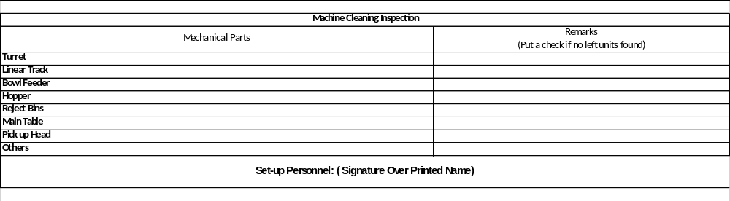

Conduct Open Socket Check
NOTE: Perform only during change Load Board and Change Cable

Open Socket Test | Test Result (Pass/ Fail)
Site 1
Site 2
Site 3
Site 4

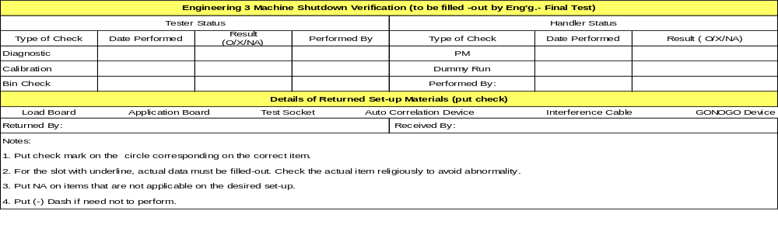

QA SAMPLING INSPECTION |  |  |  |  |  | LSG SETUP BUY-OFF
 | Defect |  | Taping Direction |  | Judgment | ITEMS | Actual / Value | Judgment (O/X) |  | LSG CHECKING
10 Sample Devices |  |  |  |  | OK  /  NG | Handler Program Name |  |  |  | Actual Unit Tape Orientation |  | Judgement
 |  |  |  |  |  | Tester Program Name (FT) |  |  |  |  |  | OK / NG
 |  |  |  |  |  | Tester Program Name (QA) |  |  |  |  |  | OK / NG
 |  |  |  |  |  | Actual Sealing Temp. / Actual Cover Tape Code |  |  |  |  |  | OK / NG
Performed by: |  |  |  |  |  | Performed by: |  |  |  |  |  | OK / NG
ONLINE INSPECTION REEL BUY-OFF (Every Start of the Shift/Change of Material/Repair/Set-up)
Tape Leader  (400mm-480mm) Tape Trailer  (160mm-240mm)  Reel |  | OK / NG |  | Every Start of the Shift/Change of Material/Repair/Set-up (SAMPLING INSPECTION: A. First pass: 3 units marking check for date code & sampling inspection of 200 units (beginning, middle and end of reel). B. Second pass 100% Sealing and carrier tape. C. Check the Trailer & Leader of reel. Trailer - 160mm to 240mm & Leader- 400mm to 480mm )  (Lot Number / Device Number) |  |  | Actual Marking and Unit Orientation on Tape  (Online Inspn) |  | Online Inspn  Buy-Off Result
 |  |  |  |  |  |  | Actual Orientation | Judgment:  OK / NG | ____________  Performed By |  | Judgment:  OK / NG
 |  |  |  | Qty / Reel: ________ pcs
QA GATE SAMPLING INSPECTION REEL BUY-OFF (Every Start of the Shift/Change of Material/Repair/Set-up )
Actual Marking and Unit Orientation on Tape  (QA GATE) |  |  |  | Reel Buy-Off Every Start of the Shift/Change of Material/Repair/Set-up (50 units beginning, middle and end) |  |  | Completeness of Form
Actual Orientation |  | Judgment:  OK / NG |  | QA GATE Buy-Off Result  Lot no. / Device no._____________________________  Reel S.N. _____________________________________  _____________ Judgment:  Performed By OK / NG |  |  | Completely Filled Up | OK / NG | With MBOI attached |  | OK / NG

Note: Judgment will be based on attached printed MBOI vs Shop Order vs Actual
Approved By:  _______________  Setup In-Charge  (FT – Equipment) | Date/Time: | Checked By:  _____________  Shift In-Charge (FT-Mfg) | Date/Time: | Approved By:  __________________  Shift In-Charge (FT- QA) |  | Date/Time: | Approved & Checked By:  _____________________  Shift In-Charge (FT-Process) | Date/Time:
Overall Judgment: OK / NG |  |  |  |  | Approved By:  _________________________________________________  Shift In-Charge (FT- QA) |  |  | Date/Time:

REVISION HISTORY
Revision | Change  Originator | Description and Reason of Change | Change Analyst | Effective Date
E | A.Beñan | Revise BIN Settings/Checking at page 2 of 5  Change QA Sampling Inspection from 20 sample to 10 sample at page 3 of 5  Revised template from Rev. B to Rev. C.  Changed process owner to QFN.  Reason for change: ICAR Action Item  As per ECO-NBOI-197962 | G. Macauyam | 26 Jan 2019
F | B. BRIONES | - Add Test Program Path Directory check item on new actual setup details  - Revise Test Program item in LSG buy off to include FT & QA Test Program buy off  Reason for change: ICAR Action Item  As per ECO-NBOI-202475 | S. Asuncion | 06 Mar 2019
G | A.BEÑAN | - Add LSG Checking on actual unit tape orientation under LSG SETUP BUY OFF at page 3 of 5  Reason for change: EQUALITY Action Item  - As per ECO-NBOI-203552 | S. Asuncion | 15 Mar 2019
H | R. Esguerra | Revised the Bin setting of EAGLE 88 TESTER & SRM BIN Setting on page 2.  Reason for change: E-Quality action item  As per ECO-Non BOI-206719 | S. Asuncion | 15 Apr 2019
J | E. Villanueva | Add Checking of open socket test every change Load Board and Cable at page 3 of 5  Reason for Change: ICAR corrective action Y20190300774  ECO-NBOI-209801 | S. Asuncion | 10 May 2019
K | K. Ducusin | Added Including critical vision parameter changes on page 1.  Added table for PTECH 8100  TESTER & SRM BIN Setting and EAGLE 88 TESTER & UENO BIN Setting on page 2.  Change the Bin setting in TMT TESTER & SRM BIN Setting on page 2  Check the alignment in all pages.  For E-Quality/ICAR CAPA closure and process improvement.  As per ECO-NBOI-215492 | S. Asuncion | 03 Jul 2019
L | K. Ducusin | Revised the bin setting for PTECH 6166 Tester & UENO on page 2.  Removed the other table for PTECH 6166 Tester & UENO Bin setting on page 2.  Added table for EAGLE 300 TESTER & SRM BIN Setting on page 3.  Check the alignment on all pages.  For process improvement.  As per ECO-NBOI-218506 | S. Asuncion | 06 Aug 2019
M | K. Ducusin | Revised the binning of TMT tester and SRM handler combination on page 2.  Change the tester binning of bin8 of PTECH6166 tester and UENO handler combination from 10 to 7 on page 2.  Transfer the document to new template TEM001458 Revision D.  For process improvement  As per ECO-NBOI-224076. | S. Asuncion | 30 Sep 2019
N | K. Ducusin | Revised the bin setting of EAGLE 300 TESTER & UENO BIN on page 2.  For Process Improvement.  As per ECO-NBOI-225889. | S. Asuncion | 15 Oct 2019
P | K. Ducusin | Revised the bin setting of PTECH 8100 Tester & UENO combination on page 2.  Revised the bin setting of PTECH 8100 Tester & SRM combination on page 2.  Revised the bin setting of EAGLE 300 Tester & SRM combination on page 3.  Change the table into editable copy on page 1.  Change the sealing strength from 35-70 to 40-90 on page 1.  Added parameter for Sumitomo on HD Sealing Temperature Setting on page 1.  For process improvement.  As per ECO-NBOI-232258. | S. Asuncion | 02 Dec 2019

