California Polytechnic State University, Pomona

CS480 Section 1

Software Engineering

Jacob Lepere

ID: 012839151

02/19/2018

**High Level Use Case**

1. User accesses the system via a web browser
2. User views product catalog
3. User selects product and adds to cart
4. Repeat step 2 until all products are added to cart
5. User selects checkout
6. User presented with all items in shopping cart and total cost
7. User enters credit card, name and address information
8. User submits information
9. System processes information and verifies for correctness (credit card sufficient funds, address is valid, etc.)
10. System presents user with verification screen
11. Employees of Medical Supplies alerted of purchase and organizes products
12. Employees ship products
13. User receives products
14. Later, user contacts Medical Supplies and asks for order history
15. Medical Supplies provides order history

**Risk Matrix**

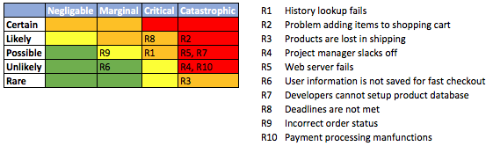

**Activity Diagram**

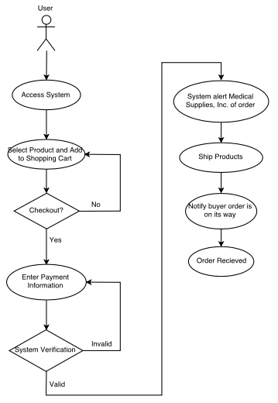

**Domain Object Model**

