California State Polytechnic State University, Pomona

CS555 Image Processing

Assignment 1

Jacob Lepere

012839151

**Method:** Nearest Neighbor

**Zoom:** 512 to 32 to 512

**Gray level resolution:** 7

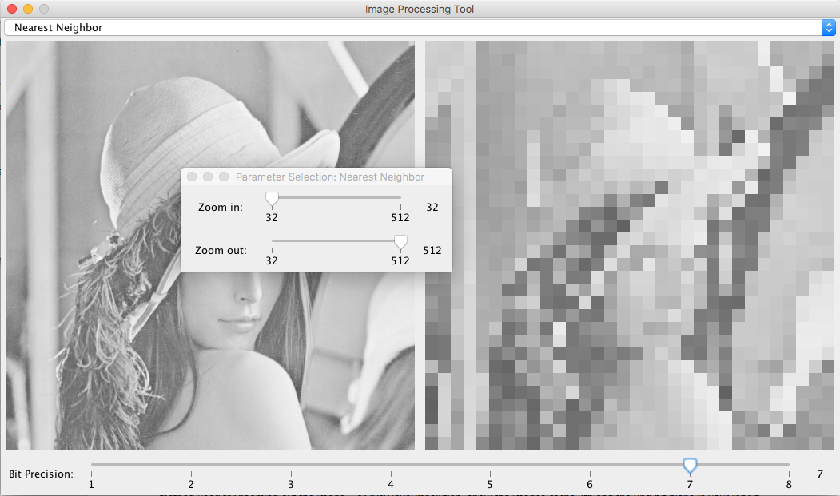

**Method:** Nearest Neighbor

**Zoom:** 512 to 32 to 512

**Gray level resolution:** 2

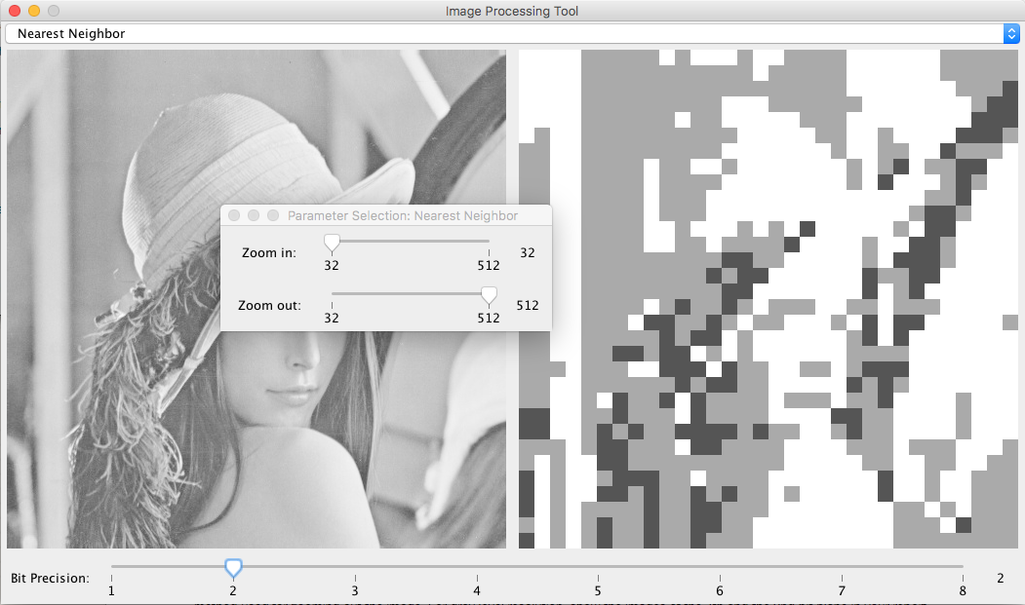

**Method:** Linear Interpolation X

**Zoom:** 512 to 32 to 512

**Gray level resolution:** 7

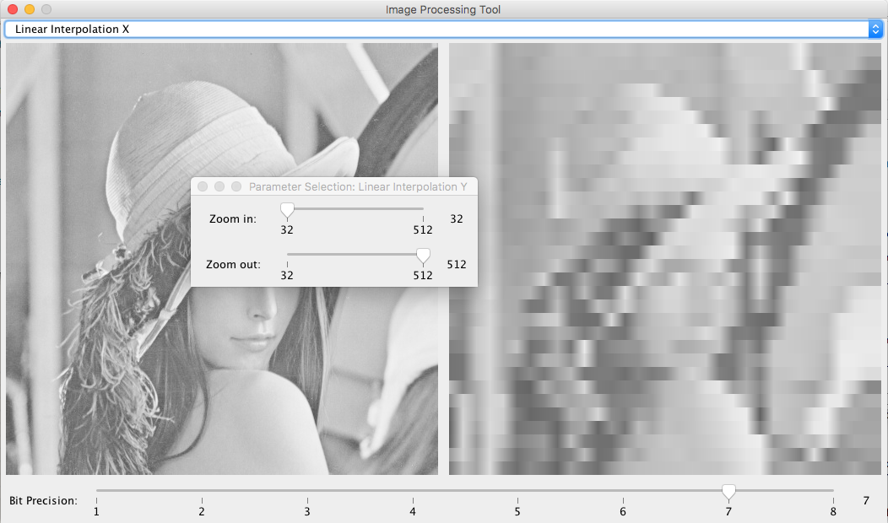

**Method:** Linear Interpolation X

**Zoom:** 512 to 32 to 512

**Gray level resolution:** 2

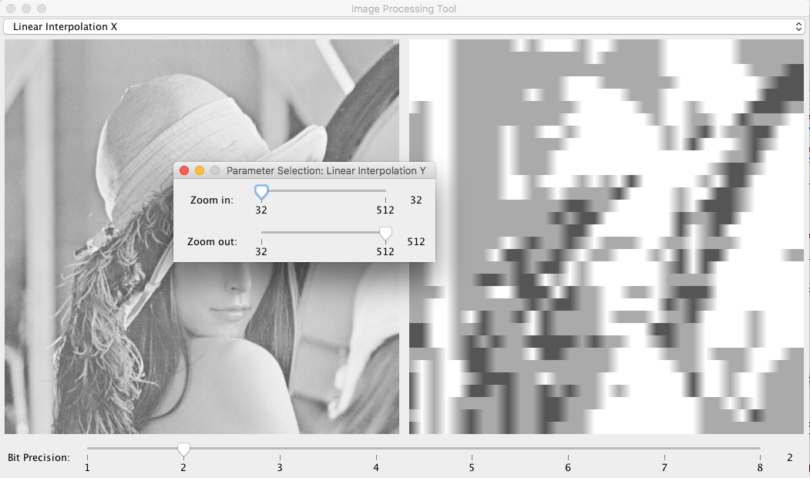

**Method:** Linear Interpolation Y

**Zoom:** 512 to 32 to 512

**Gray level resolution:** 7

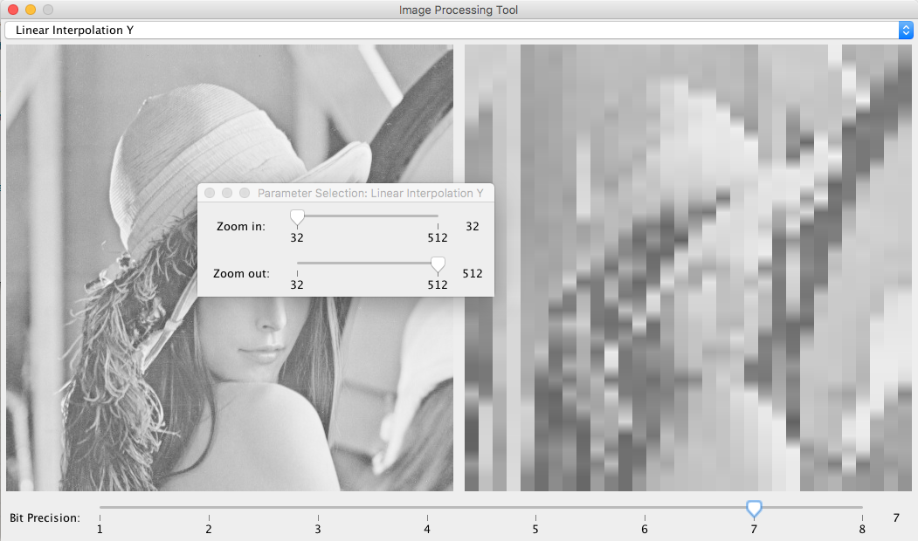

**Method:** Linear Interpolation Y

**Zoom:** 512 to 32 to 512

**Gray level resolution:** 2

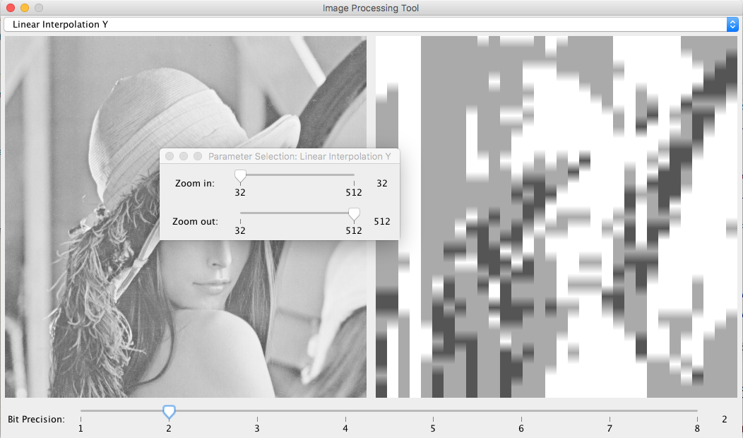

**Method:** BiLinear Interpolation

**Zoom:** 512 to 32 to 512

**Gray level resolution:** 7

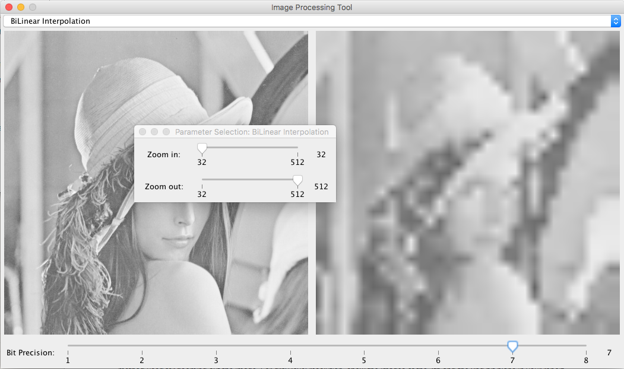

**Method:** BiLinear Interpolation

**Zoom:** 512 to 32 to 512

**Gray level resolution:** 2

