**RBL BioChemical Corporation Consulation**

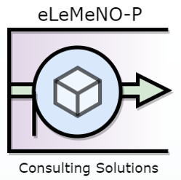

Captain Matthew Davis

1Lt William Sevier

2Lt Jacob Lindell

**Abstract:**

eLeMeNO-P Consulting was hired by RBL Biochem in order to determine if they should hire EEMRC for their more accurate initial demand projections. According to our analysis, RBL Biochem should hire EEMRC, and once they do, they should choose strategy 1 (no partnership, no expansion) if EEMRC gives them a low or base initial demand projection, and strategy 3 (Joint Venture) if the initial demand projection is high.

1. **Introduction**
   1. **Background**

RBL Biochem is looking to release a new product, Dulcis, a new synthetic biocatalyst that causes Riesling grapes to become highly susceptible to the botrytis mold, causing more valuable wine. They have six uncertainties with their new product, along with three alternative numbers for each uncertainty, shown in Table 1.

**1.2 Problem Statement**

The data we were given was general information in order for us to have all of the necessary material to fill in the blanks. These including the demand uncertainties, revenue uncertainty, production uncertainties, and then the general numbers necessary to complete the analysis. The uncertainties are shown in Table 1.

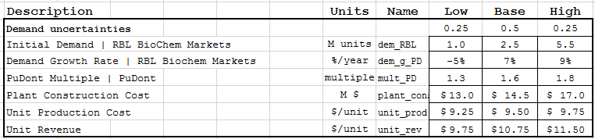

Table 1. Table of uncertainties given in problem

RBL Biochem is having trouble with their initial demand estimates and would like help on whether or not they should hire an outside source, EEMRC, to hopefully give them a better initial demand projection, and ultimately get them a better Net Present Value.

**1.3 Organization**

The organization of this paper is going to step into the framing of the problem, then the evaluation of the problem, followed by the appraisal and ultimately the final decision on whether or not EEMRC should be hired by RBL Biochem with help predicting the initial demand for the upcoming Dulcis product.

**2. Frame the Decision**

**2.1 Issue Sorting**

Approaching RBL’s decision at hand, the firm is faced with several strategies. eLeMeNO-P Consulting Solutions has sorted these strategies into four overarching alternatives.

Table 2. Table of Strategic Alternatives

Table 2 outlines these strategies. In Strategy 1, RBL rejects the offer for PuDont in any form of partnership agreement. RBL will receive all the profit but will be responsible for any and all production and marketing of the Dulcis product. In Strategy 2, RBL will still be the sole producer of the product, but may choose to expand their current production capacity, an expense they will also undertake alone. In Strategy 3, RBL may choose to partner with PuDont, but as a joint venture enterprise. PuDont will market Dulcis, fund the expansion project, but will receive compensation in the form of 60% of the profit. In the final Strategy, RBL will consume Dulcis, licensed as their own product, but will pay 3% royalties to RBL for developing the product. In addition, RBL may choose to purchase market research survey to determine initial demand of Dulcis for $250,000. All strategies have their own merits and compromises and it is eLeMeNO-P’s responsibility to recommend the most beneficial course of action.

**2.2 Decision Hierarchy**

Several factors of this produce launch have been decided before eLeMeNO-P Consulting was brought on-board to advise in the decision making process. These decisions can be prioritized in the order of time frame.

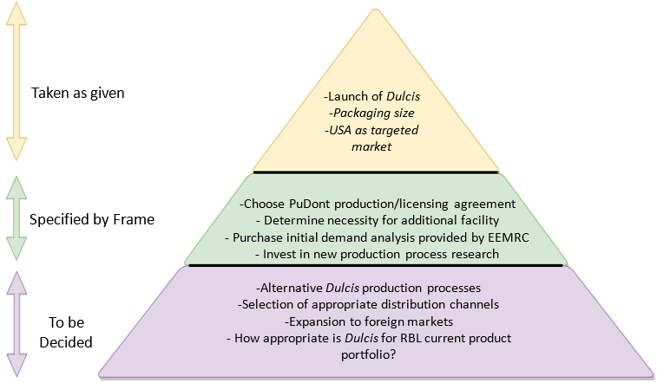

Figure 1. Decision Hierarchy for RBL Dulcis Launch

In Figure 1, it can be noticed that some aspects of the Dulcis launch have been decided. These factors are “taken as given” and include the packaging size, and the targeted market for the launch. The next tier includes all decisions within our scope or “Specified by Frame”. These decisions are the ones our firm is responsible for taking into account when advising RBL. It includes which partnership agreement, if any, should be pursued with PuDont, expansion necessity, EEMRC market analysis advantages, and the potential investment in the development of a new production process. The final tier are decisions that will be tackled later, and although eLeMeNO-P may be able to give some insight and recommend a way forward, these decisions remain outside the current scope. This includes, alternative production processes, market expansion overseas, alternative distribution channels, and determining where Dulcis fits in RBL’s current product portfolio.

**2.3 Influence Diagram**

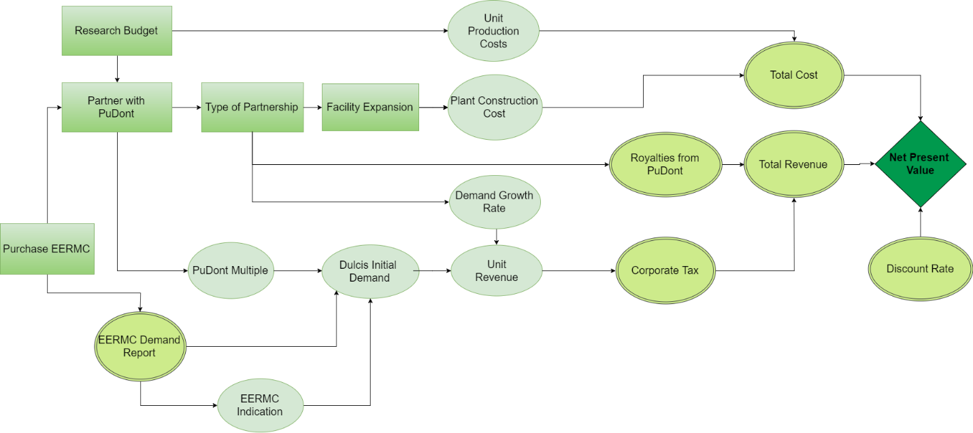

Figure 2. Influence Diagram for RBL production of Dulcis

Figure 2 outlines the order of decisions, deterministic and probabilistic factors, and how they influence each other, and ultimately the net present value of each strategy. We can see that there exist decision nodes that RBL can control, like the type of partnership with PuDont, the choice to expand their facility, and the choice to purchase the market report from EEMRC. Some of these decisions can influence other decisions (for example, the decision to purchase EEMRC can determine whether a partnership with PuDont is prudent), while others influence factors that have probabilistic outcomes. For example, the decision to partner with PuDont would affect how much revenue RBL receives from the Dulcis product (Unit Revenue), and there exists an unknown probability that demand can be high or low, also influencing the unit revenue from Dulcis. Some factors remain more deterministic. For example, the amount of corporate tax, total cost, total revenue, and discount rate are aspects of the decision that will be known once previous decisions and unknowns that influence them play out.

**3. Evaluation**

**2.1 Deterministic Analysis**

The first thing done with this data was to determine factors that are generally used by industry in order to determine the Net Present Value (NPV) of a company or given product. The factors used were projected ten years into the future in order to better determine the Net Present Value of the Dulcis Product. The factors used were; sales, production/plant costs, joint venture/royalty payments, as well as taxes and their effect on the Net Present Value, base NPVs shown in Table 1.

Figure 3. Net Present Values for each base case scenario (all uncertainties set equal to base)

Figure 3 portrays that without any clairvoyance and using the Equal Areas Method for the probabilities of low-base-high, Strategy 1 has the best Net Present Value. So if we were to not hire EEMRC and chose Strategy 1, we would expect a Certain Equivalent of approximately $14.04 million.

Tornado diagrams allow eLeMeNO-P Consulting to visually depict the variance of present equivalent values (amount in 2017 $M that can be gained) for each factor in the decision that is subject to uncertainty (potential for high and low). This provides insight as to which factors are most important to a decision and contribute the most to the risk of choosing that strategy.



Figure 4a. Tornado Diagram of Present Equivalents of Uncertain Decision Factors for Strategy 1



Figure 4b. Tornado Diagram of Present Equivalents of Uncertain Decision Factors for Strategy 2



Figure 4c. Tornado Diagram of Present Equivalents of Uncertain Decision Factors for Strategy 3



Figure 4d. Tornado Diagram of Present Equivalents of Uncertain Decision Factors for Strategy 4

There are many inferences we can draw from these Tornado Diagrams. The factors with the highest variances are sorted above those with lower. This shows which factor will have the greatest difference between present equivalent values (present day profit to be made) if that factor is high or low. The first glaring observation of these charts is from Strategy 2 (Figure 5b), RBL would pursue no partnership and would invest in expansion of the new facility. The cost of this venture gives the potential for a negative present equivalent value (potential for loss) if initial demand *or* unit revenue is low. In this case, the expense of expanding the facility has the potential to consume all profits if either initial demand or unit revenue is low. This presents RBL with significant risk if Strategy 2 is to be the course of action chosen. Strategy 2 also, however, has the potential for the most profit if initial demand and unit revenue are high. Contrast this with Strategy 1, where not only is the downside risk not in the red (no potential losses), but there still exists significant potential gains if unit revenue is high. Strategy 3 and 4 present less risky alternatives, as the variance of these factors (especially in the downside) don’t stray far from the base value. Unfortunately, this doesn’t leave as much room for the potential for significant profit in the event of probability of high initial demand or unit revenue. Notice that although Strategy 4 appears to have a great amount of potential gain if initial demand is high, its scale is downsized from that of Strategy 1 and 2, so its highest potential is around $17M, where Strategy 2 is over $30M and Strategy 1 over $20M.

**2.2 Probabilistic Analysis**

Decision Trees become useful when there are multiple decisions and/or uncertainties that affect a strategy. Since all of the strategies different in a few key components, they each have a different decision tree, all shown in Figure 5.

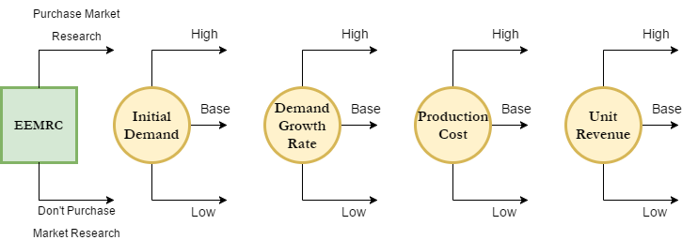

Figure 5a. Decision Tree for Strategy 1

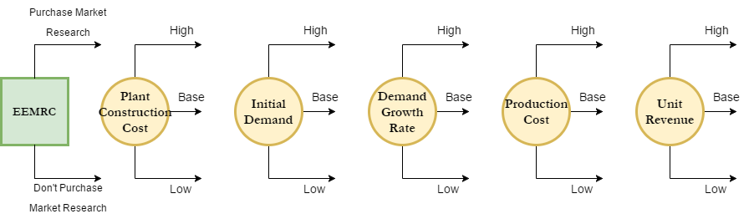

Figure 5b. Decision Tree for Strategy 2

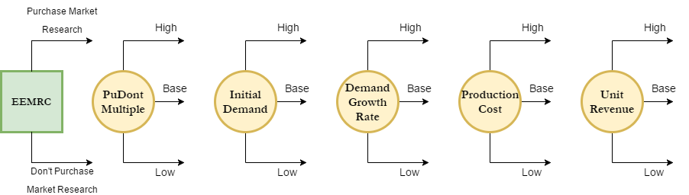

Figure 5c. Decision Tree for Strategy 3

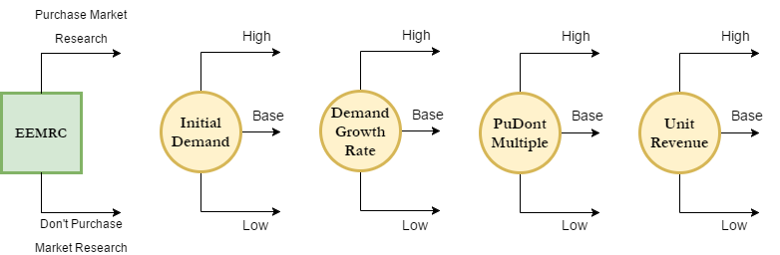

Figure 5d. Decision Tree for Strategy 4

These Decision Trees allow us to determine what changing uncertainties and decisions lead to the Net Present Value received once all of the data is analyzed.

The Cumulative Density Function (CDF) chart shows the probability that x will take a value equal to or less than X, or in terms of this project, the probability that the Net Present Value will be less than or equal to the given Net Present Value (shown along the x-axis). Using the Visual Basic for Applications (VBA) extension, the uncertainties were cycled through the low-base-high probabilities using the Equal Areas Method for every scenario in order to determine the Present Equivalent, and ultimately the Certain Equivalents with EEMRC and Cumulative Distribution functions for each strategy. The CDF for all four strategies can be found in Figure 6.

Figure 6. Cumulative Density Function for each strategy showing the probability of the Net Present Value being less than the given Net Present Value along the x-axis

The CDF of the four strategies shows that the strategies have varying rates of improvement. For example, strategy 4 has a much more truncated answer region (1.4 to 22) than the other strategies, and reaches the maximum value of 1 more rapidly, but does not have the highest Certain Equivalent, as shown in Table 1/Figure 3. Strategy 2, the strategy that has RBL Biochem expanded on its own, is the only strategy that has CDF values below zero. If strategy 2 were to be chosen, there is approximately a probability of 0.4 (40%) that the Net Present Value would be less than zero. This is something to consider because although the Certain Equivalent for strategy 3 is not the lowest, there is a large probability that RBL Biochem ends up with a negative NPV.

High-Base-Low charts take the decisions and uncertainties and provide a splash picture of how each Strategy compares to one another is all uncertain factors are at their highest value, their lowest value, or their base value. Figure 7 depicts the High-Base-Low chart for the Dulcis production decision, and Table 3 shows the values corresponding.

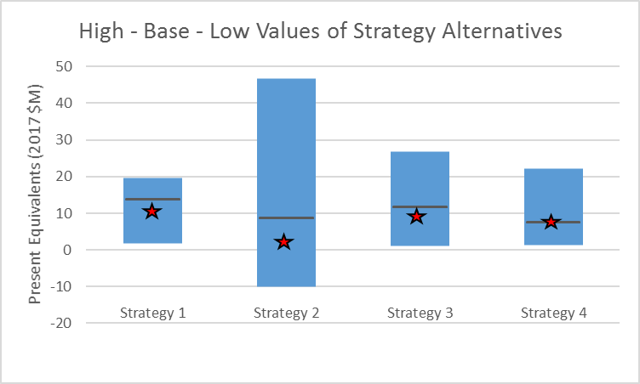Figure 7. High-Base-Low Chart for Strategy Alternatives in terms of Present Equivalents

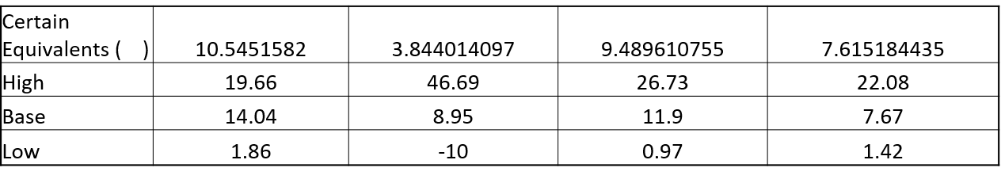

Table 3. Values corresponding to High-Base-Low chart

Figure 7 gives a good indication of potential profit for best case and worst case scenarios, although doesn’t provide as much fidelity as the tornado diagrams. However, some insight can be gained from a quick glance at Figure 7. Strategy 2, where there is no partnership but the expansion project is undertaken by RBL, presents an appealing amount of potential profit if all uncertain factors are at their high. The downside being that there is a potential for *significant* loss if all uncertainties play out to be at their lows. This is in turn dragging the certain equivalent of Strategy 2 well down below its base, and certain equivalents of the other Strategies, making it far less appealing, and a riskier option. Strategy 1 has a lower spread from low to high, with the highest certain equivalent of all alternatives, making it the most valuable deal. However, it has less potential for producing gains than the other Strategies, but the highest potential for low values of all strategies as well, making it a safer bet.

The Certain Equivalent gives the information on how valuable something would be to a decision maker, or more generally, how much money the individual would have to be given in order to be indifferent between the amount of money and the asset. The Certain Equivalent Values for the four different strategies are shown in Table 4.

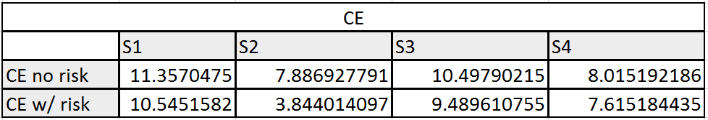

Table 4. Equivalent values for each strategy for both the inclusion of risk and not including the risk tolerance

Table 4 shows the different Certain Equivalent values for each strategy factoring in both the risk tolerance and without using the risk tolerance. This shows that in order for the decision makers to be indifferent on taking strategy 1 or an amount of money, that amount of money would have to be $14.04 million. Table 4 is shown graphically in Figure 8 below.

Figure 8.Certain Equivalent Values both without factoring in the risk tolerance of $30 Million and with the risk tolerance.

Figure 8 shows that without clairvoyance, strategy 1 is the best option both without incorporating RBL Biochem’s risk tolerance of $30 million (CE value of 11.36) and with incorporating that risk tolerance (CE value of 10.54). This information gives us the framework necessary in order to determine whether or not RBL Biochem should hire EEMRC for $250,000.

**4. Appraisal**

**4.1 Sensitivity Analysis**

Additional sensitivity analysis was done in order to better understand the data we were dealing with. Figure 10 shows the change in the Net Present Value based on the change in the real discount rate. The real discount rate of 8% is based on RBL Biochem’s management’s recommendation, because they would like to pursue other investment opportunities. Since this number can be changed by an increase or decrease in the total money spent on investments, it is the easiest number to change and manipulate.

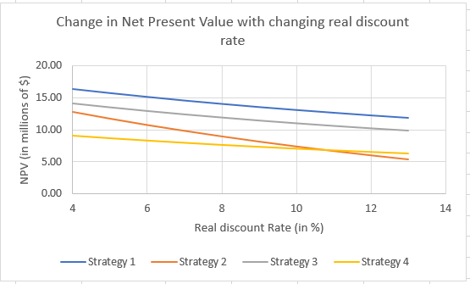

Figure 10. How the Net Present Value changes for each strategy based on the real discount rate

No matter the discount rate, strategy 1 is always better, but if it is possible to lower the real discount rate from 8% to at least 7%, the NPV goes up by one million dollars. At approximately 10.5%, strategy 4 surpasses strategy 2, and would decrease at a lesser rate than the rest if the real discount rate were to continue to increase.

**4.2 Value of Information**

Now that we have all of the basic information, it is possible to move onto whether or not RBL Biochem should hire EEMRC. Table 5 below shows the probabilities found when using EEMRC’s insight, which will then be factored into the calculations for Net Present Value with EEMRC’s insight.

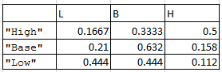

Table 5. Probabilities found when flipping the tree of the likelihoods of EEMRC giving correct insight.

With these values, the NPV can be calculated for the insight provided by EEMRC.

Calculating the Net Present values for each scenario, giving a total of twelve values, yielded the following Certain Equivalents.

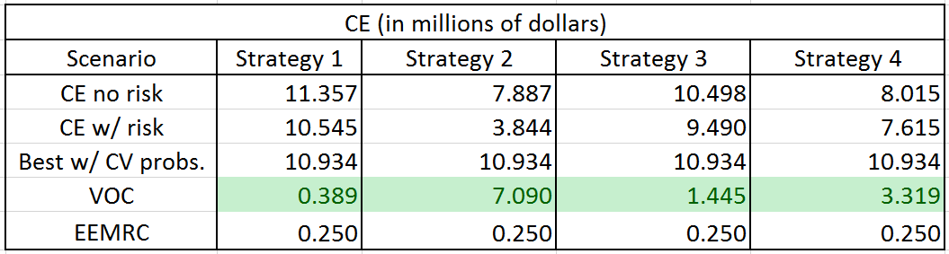

Table 6. Best Certain Equivalence with Clairvoyance, and how much Clairvoyance is worth for each strategy.

As shown in Table 6, the Value of Clairvoyance for each strategy is higher than the cost of Clairvoyance ($250,000). This is shown graphically in Figure 11.

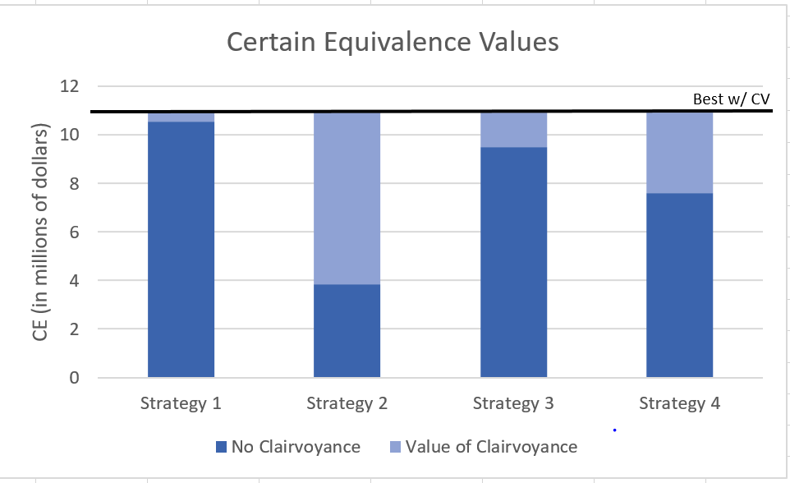

Figure 11. Certain Equivalent Values with Value of Clairvoyance

Now that the value of clairvoyance is known, the original problem was modified to factor in the $250,000 to hire EEMRC in order to determine the Certain Equivalent for the deal. The values for each of the strategies, with the low base and high probabilities shown in Table 5, is shown below in Table 7.

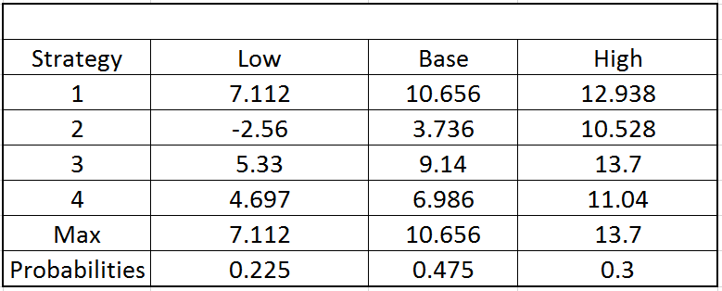

Table 7. Certain Equivalent for each strategy based on whether the low, base, or high probabilities were used.

Table 7 shows that if EEMRC were to tell RBL Biochem that their research shows the initial demand will be low, Strategy 1 is best. Strategy 1 is also best for the base case. If EEMRC tells RBL Biochem that the research shows the initial demand will be high, then it is best to use strategy 3 and do the joint venture with PuDont for 60% share of the net profits before tax. The final Certain Equivalent for the deal with EEMRC is $10.77 (in millions of dollars).

**5. Decision**

**5.1 Recommended Alternative**

It is recommended that RBL Biochem invests the $250,000 with EEMRC in order to improve the insight into the initial demand. The best Certain Equivalent without EEMRC insight is $10.54 million, while the best Certain Equivalent with EEMRC is $10.77 million, including the cost of EEMRC in the first year NPV calculations. Once RBL Biochem invests in EEMRC and they provide the company with their initial demand estimate, the company should choose their strategy as shown in Table 8.

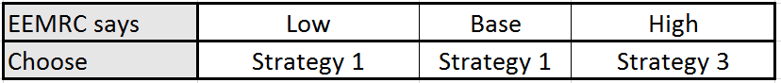

Table 8. This table shows what RBL Biochem should do based on the insight from EEMRC.

If RBL Biochem picks the strategy based on EEMRC’s insight, their Certain Equivalent will be $10.77 million. If RBL Biochem cannot choose the strategy after the EEMRC initial demand projections, they should choose Strategy 1 with the Certain Equivalent of $10.54 million. Although this Certain Equivalent is the same with or without clairvoyance, it is better to not only have the possibility of picking strategy after EEMRC’s projections, but if not more information is more helpful, and RBL Biochem will not lose anything by paying EEMRC either way.

**5.2 Trade space discussion**

Although eLeMeNO-P consulting is confident in our recommendation, all strategies have their own merits and downsides. Therefore, there are tradeoffs that are made choosing Strategy 1 over Strategy 3. Strategy 1 has the highest certain equivalent, and the highest minimum potential profit, decreasing the risk of that strategy. The tradeoff is that Strategy 3 has a higher maximum potential value, at $13.7M NPV, but lower base. In addition, although eLeMeNO-P recommends that Strategy 3 be implemented in the case that EEMRC reports high numbers, RBL may wish to implement Strategy 1 anyways, as a high report only has a 50% chance of actually being high, in which Strategy 3 would be advantageous, and a 50% chance of being low or base, in which Strategy 1 would be advantageous. Fortunately, the difference between base and low potential NPV for the two strategies are within $3 M of each other, which may not be a concern to RBL and worst the marginal risk of pressing forward with Strategy 3 if EEMRC reports high. Overall, Our primary recommendation and alternate course of actions have very similar profiles, with initial demand contributing more to potential profitability of Strategy 3, and unit revenue contributing more to the potential profitability of Strategy 1 (See Figure 5a. and 5c. Tornado Diagrams), making Strategy 3 more sensitive to the accuracy of the EEMRC market research report. In short, Strategy 3 presents a slightly riskier alternative with higher potential payout and more faith put in the EEMRC report than Strategy 1, making Strategy 1 a safer, but still most attractive option.

**5.3 Additional Sensitivity Analysis**

Additional sensitivity analysis was conducted in order to better understand the data given along with give insight into what would be RBL Biochem’s best route of improvement. As shown in Figure 4, if RBL Biochem can decrease the real discount rate by 1%, they can improve the Net Present Value by approximately $1 million. This is something that RBL Biochem can weigh against their other investment opportunities and see which of them yields the highest percent yield.

In order for RBL Biochem to be able to go back to PuDont and negotiate for better terms, it was necessary to look at how much the royalty and joint venture share of profits would need to change in order for RBL Biochem to consider partnering with PuDont. Figure 11 shows how much the royalty would need to change in order for Strategy 4 to surpass Strategy 1 for the best Certain Equivalent.

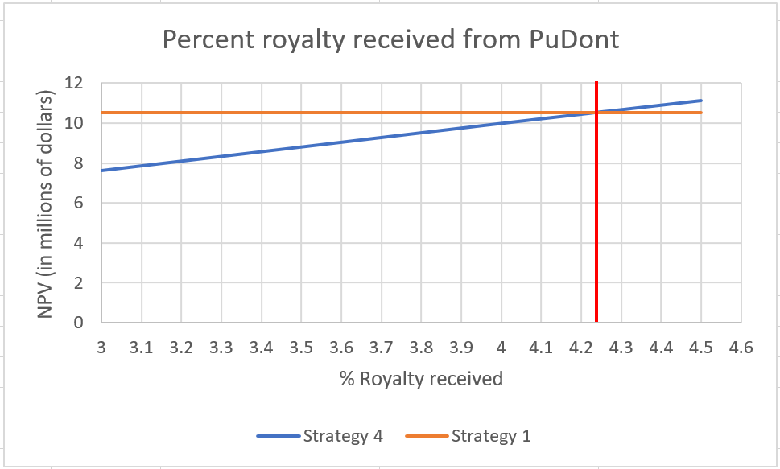

Figure 12. Percent royalty received from PuDont would need to be in order for the NPV of strategy 4 to surpass strategy 1.

Based on Figure 12, the percent royalty where strategies 4 and 1 breakeven is at approximately 4.24%. If RBL Biochem were to go back to PuDont with this information and say they would take the deal if PuDont would give RBL Biochem a 4.5% royalty, they may be able to have a higher NPV than expected.

Another scenario is RBL Biochem going back to PuDont and negotiating a new share of the net profits before tax in order to create a better deal. Figure 13 shows the breakeven point for this scenario.

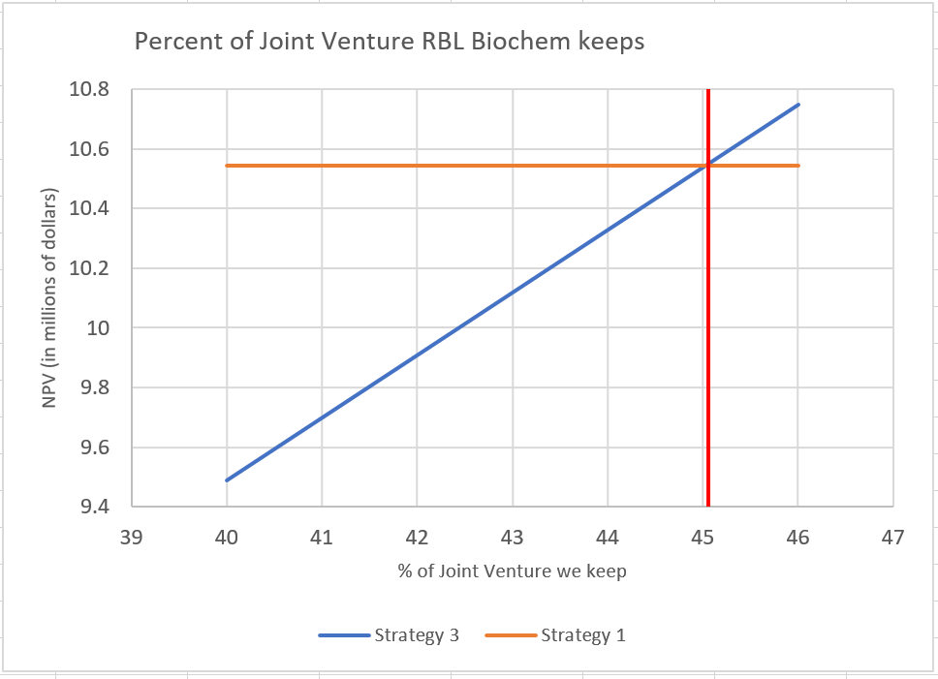

Figure 13. Percent of net profits before tax RBL Biochem would have to keep in order for RBL Biochem to want to take the deal.

Figure 13 shows that at about 45% strategy 3 passes strategy 1 and RBL Biochem would be inclined to take this deal. RBL Biochem could take this information and ask PuDont for 46% of the net profits before tax (versus the original 40%) and work down from there in order to complete the deal.