For Glue to work, you must install two R packages “MASS” and “xlsReadWrite” for R. These two packages are used in the GLUE program and they must be installed. First, start R and click the menu of “Packages” in the menu of R Console.

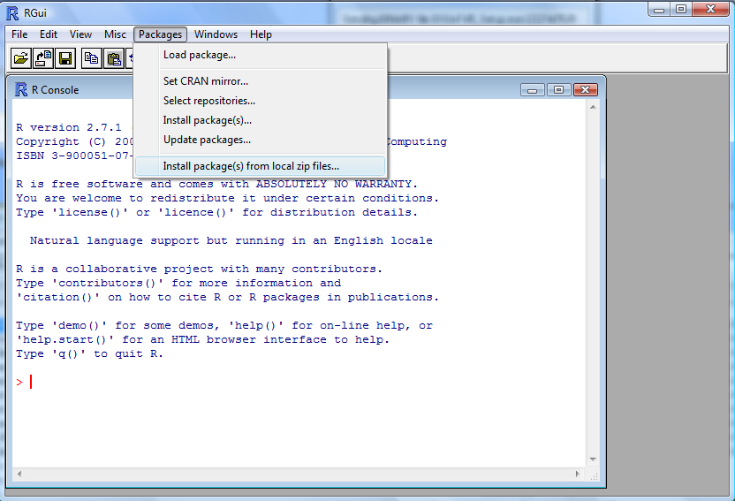

Two packages required, ZIP files, in the directory c:\dssat45\tools\glue\install.  Install both.

