Installing R packages for GLUE on VISTA or 7 OS
- Run R with Administrator privileges in sessions where you want to install packages. (Do so by right-clicking on the R shortcut and selecting 'Run as Administrator'.
- Using the File pull-down menu on R, Select “change dir…” and browse to the DSSAT45/Tools/GLUE/Install directory. Hit “OK” to close the window. 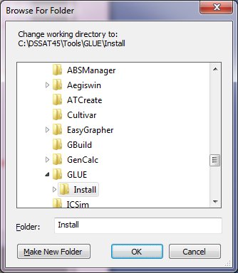
- Using the File pull-down menu on R, Select “source R code…” and select GLUE_setup.R
