ITF22519 - Innføring i Operativsystemer

Lab 5

Exercise 1.

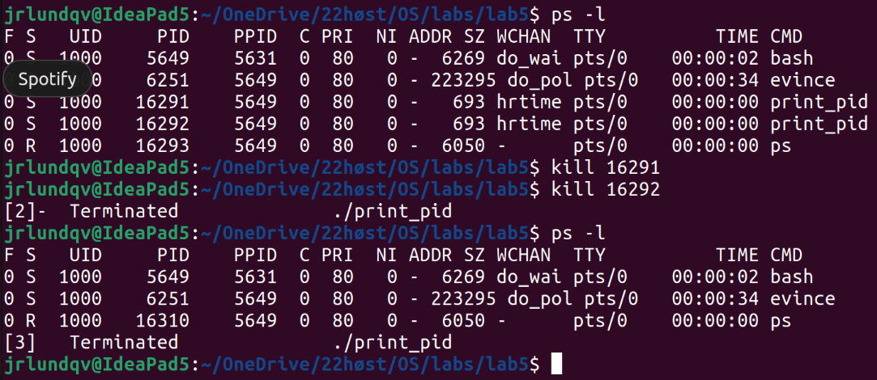Figure 1: Running two instances of print_pid, then killing them.

Process name = CMD
Process state = S
Process ID = PID
Process ID of parent = PPID

The process which spawned my print_pid processes is the bash process with PID = 5649. We can see this by looking at the PPID column of the print_pid processes.

When we kill the print_pid processes they stop running and are no longer listed in the process table.

I have used ps -l instead of ps -el to avoid printing irrelevant lines.

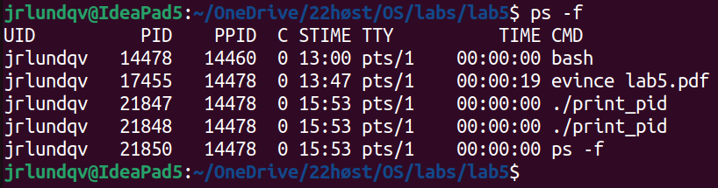Figure 2: ps -f to get STIME

Time being created = STIME
Exercise 2.
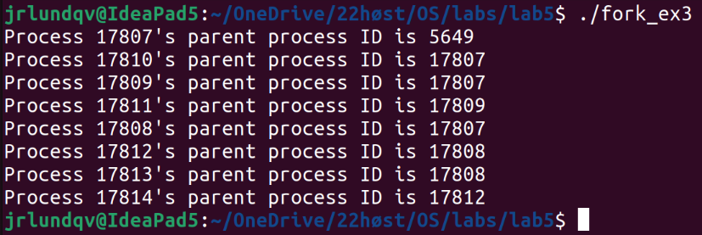Figure 3: Running fork_ex3

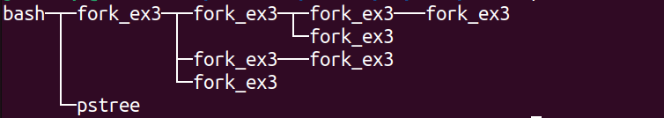Figure 4: Showing the process tree by the "pstree" command

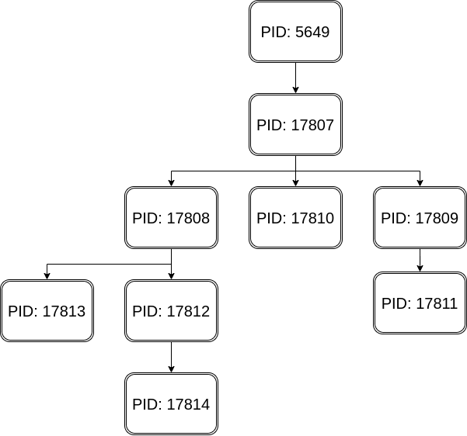Figure 5: Process tree

PID 5649 is the bash shell, PIDs 17807-17814 are instances of the fork_ex3 program.
Calling fork() n amounts of times will result in 2^{n} processes. In the fork_ex3 example code we have called fork() three times resulting in 2³ = 8 processes. This is because after each call to fork(), a new process has been created which will also execute the next fork() call.

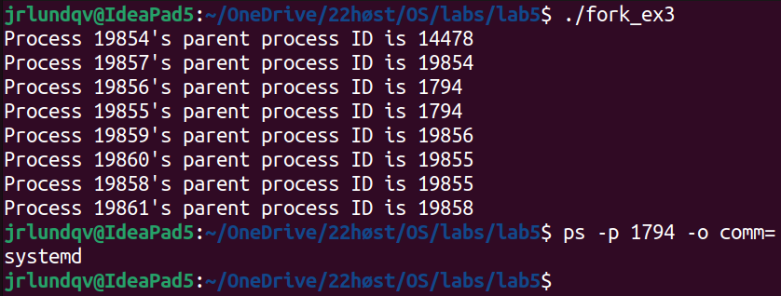Figure 6: Running fork_ex3 without call to sleep()

By removing the sleep() statement, some of the parent processes will finish before their child processes. When this happens the child processes will be assigned to a new parent process. In this case systemd with PID 1794 has become the parent of two fork_ex3 processes.
Exercise 3.

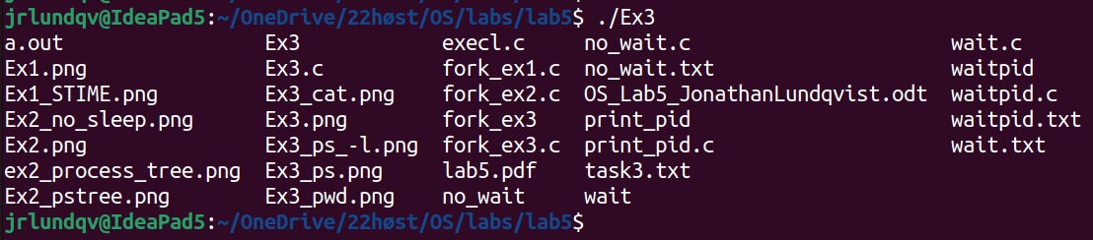Figure 7: execl("bin/ls", "ls", NULL);

Figure 8: execl("bin/pwd", "pwd", NULL);

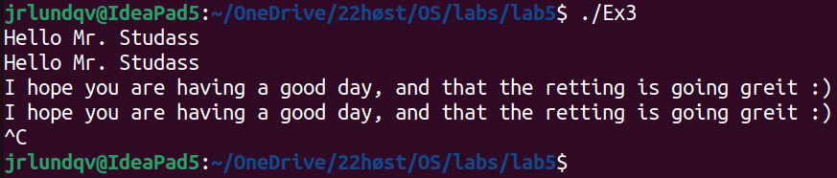Figure 9: execl("bin/cat", "cat", NULL);

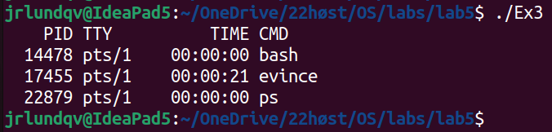Figure 10: execl("bin/ps", "ps", NULL);

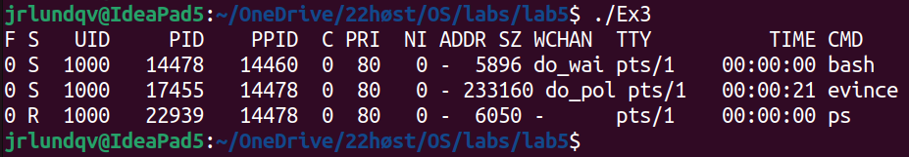Figure 11: execl("bin/ps", "ps", "-l", NULL);

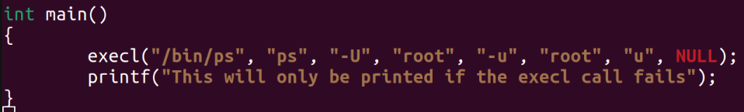

If the execl call is successful, the current process image will be replaced by what is passed as arguments into the execl function. That would result in the above program never reaching the printf() function.
If the execl call fails for some reason, the current process will continue executing, and our printf() function would be reached and called.

