bamazonCustomer:

the displayProducts() function is called when ‘node bamazonCustomer.js’ is entered in a terminal window:

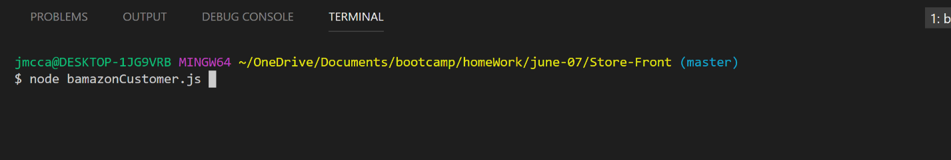

the displayProducts() function selects all the products from the products table and displays the data in the terminal window:

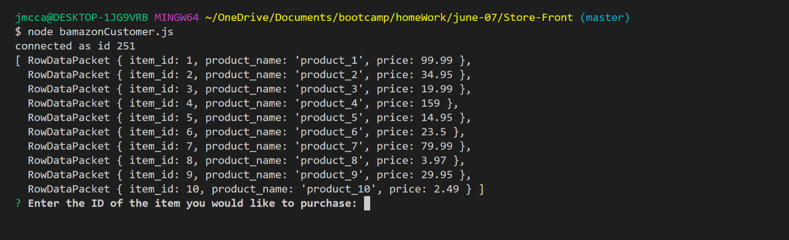

The displayProducts() function calls the promptCustomer() function after displaying product information

The promptCustomer() function uses inquirer to ask the customer 2 questions:

What product would like to purchase?

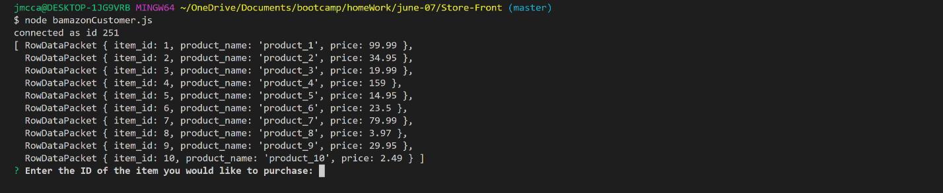

How many units do they want?

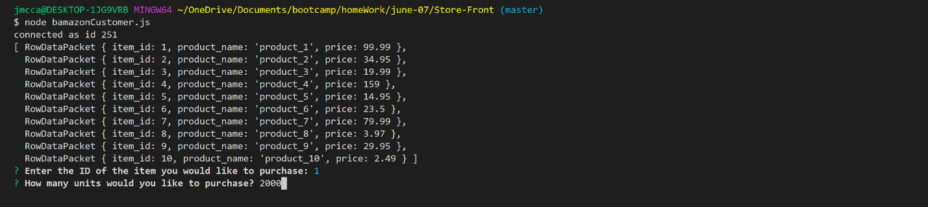

In the example above the customer wants to purchase 2000 units of product ID 1

The promptCustomer() function calls the determineStock() function after prompting the customer for information and passes the information gathered to the determineStock() function

The determineStock() function uses the item ID it receives from the promptCustomer() function to determine the amount of product in stock

As you can see below, there are only 1000 units of item ID 1 in stock, but the customer wants to purchase 2000 units

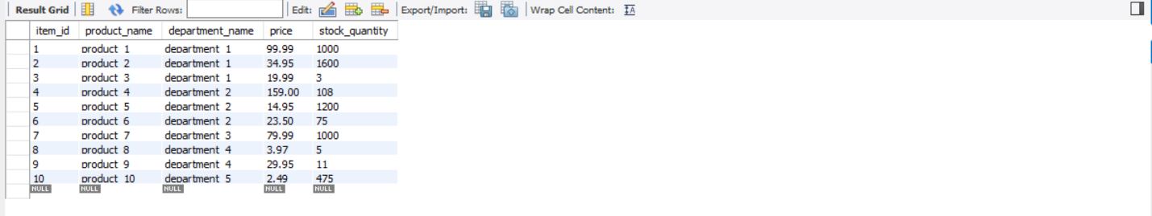

The determineStock() function calls the processOrder() function

The processOrder() function uses an if statement to determine if there is enough product in stock to fill the customer order.

If there is NOT enough stock to fill the order a message is displayed to the customer in the terminal window to explain the order can’t be filled

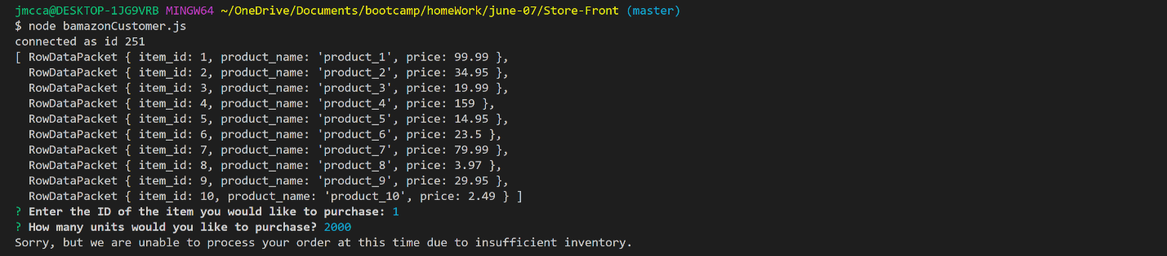

If there is enough stock to fill the order, the number of units purchased is subtracted from the number of units in stock, then the record for that product is updated to reflect the reduction in stock.

In this example, the customer wants to purchase 500 units of item ID 1:

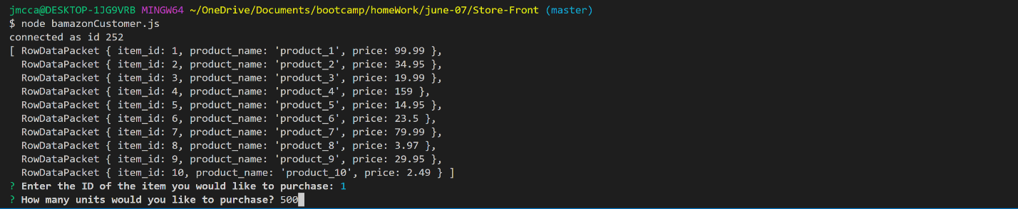

The order will be processed because there are 1000 units of item ID 1 in stock:



The customer receives a confirmation and the products table is updated to reflect the purchase:

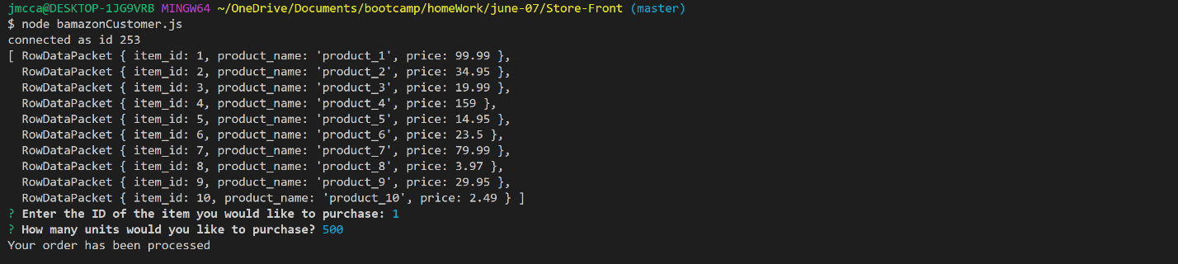

The stock_quantity is updated for item ID 1 to reflect the purchase:

