🎭 Drama Jokes 🎭
20 Curriculum-Linked Jokes
Each joke connects to a key learning point

Contents
1. Why did the actor break up with the stage? [The fourth wall in theatre]
2. What do you call a play about puns? [Wordplay and script writing]
3. Why did the light go to drama school? [Stage lighting: spotlights, floods, gels]
4. Why was the understudy always nervous? [Understudies and rehearsal process]
5. What did the director say to the set? [Set design and staging]
6. Why did the mime go to school? [Mime and physical theatre techniques]
7. Why did the play get arrested? [Play structure: acts and scenes]
8. What's an actor's favourite breakfast? [Over-acting and character restraint]
9. Why did the curtain blush? [Stage fright and performance confidence]
10. What do you get when you cross a vampire and a drama student? [Gothic theatre and genre]
11. Why did the costume designer bring a ladder? [Costume design in theatre production]
12. What did the stagehand say at the end of the show? [Striking the set after a production]
13. Why is improvisation so unpredictable? [Improvisation skills in drama]
14. What did the audience say to the monologue? [Monologues: solo character speeches]
15. Why are drama students bad at hiding? [Creating dramatic scenes]
16. What do actors drink on set? [Stage wings and backstage areas]
17. Why was the playwright always tired? [Plot development and story arcs]
18. What's a ghost's favourite stage direction? [Stage directions: exit, enter, aside]
19. Why did the audience throw vegetables at the Shakespearean actor? [Shakespeare and Elizabethan theatre]
20. What do you call a play with no conflict? [Dramatic tension and conflict]

Joke #1
📌 Curriculum Link: The fourth wall in theatre
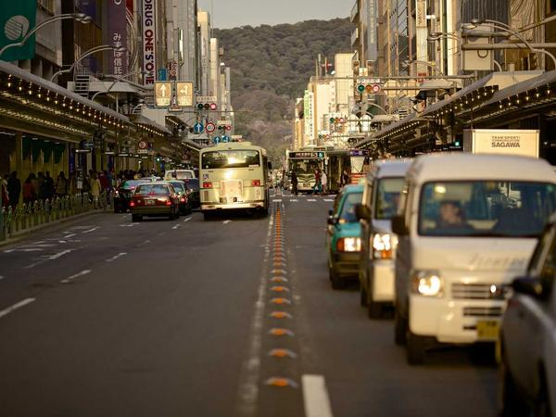
Q: Why did the actor break up with the stage?
A: They needed some space — the fourth wall kind!
💡 Discussion: Why is this joke funny? What does it tell us about "The fourth wall in theatre"? Can you explain the concept to a partner?

Joke #2
📌 Curriculum Link: Wordplay and script writing

Q: What do you call a play about puns?
A: A play on words!
💡 Discussion: Why is this joke funny? What does it tell us about "Wordplay and script writing"? Can you explain the concept to a partner?

Joke #3
📌 Curriculum Link: Stage lighting: spotlights, floods, gels
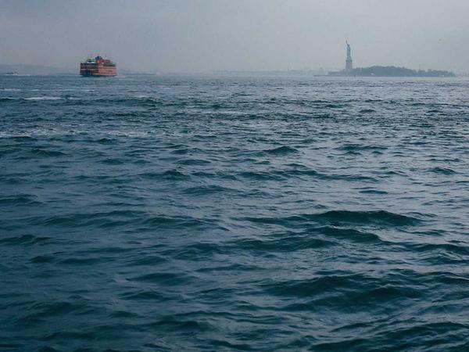
Q: Why did the light go to drama school?
A: To learn about spotlight and staging!
💡 Discussion: Why is this joke funny? What does it tell us about "Stage lighting: spotlights, floods, gels"? Can you explain the concept to a partner?

Joke #4
📌 Curriculum Link: Understudies and rehearsal process
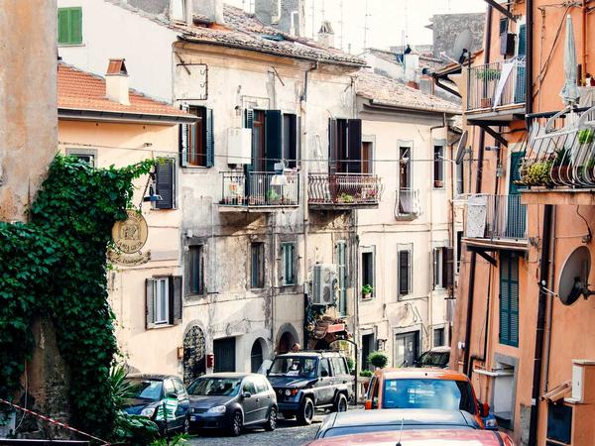
Q: Why was the understudy always nervous?
A: Because they were always in someone else's shadow!
💡 Discussion: Why is this joke funny? What does it tell us about "Understudies and rehearsal process"? Can you explain the concept to a partner?

Joke #5
📌 Curriculum Link: Set design and staging
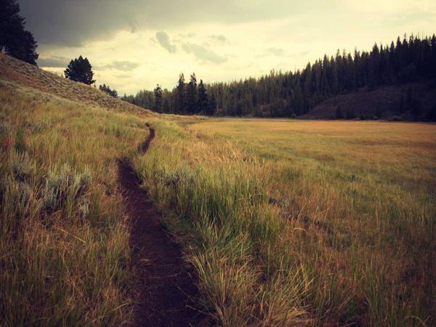
Q: What did the director say to the set?
A: You're setting the scene perfectly!
💡 Discussion: Why is this joke funny? What does it tell us about "Set design and staging"? Can you explain the concept to a partner?

Joke #6
📌 Curriculum Link: Mime and physical theatre techniques
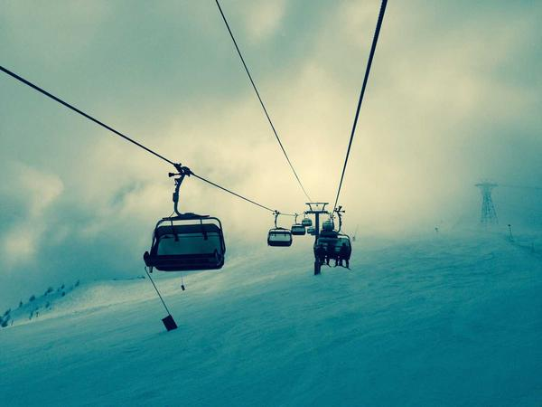
Q: Why did the mime go to school?
A: To learn the art of silence — and physical theatre!
💡 Discussion: Why is this joke funny? What does it tell us about "Mime and physical theatre techniques"? Can you explain the concept to a partner?

Joke #7
📌 Curriculum Link: Play structure: acts and scenes

Q: Why did the play get arrested?
A: For having too many acts of violence — Acts 1, 2, and 3!
💡 Discussion: Why is this joke funny? What does it tell us about "Play structure: acts and scenes"? Can you explain the concept to a partner?

Joke #8
📌 Curriculum Link: Over-acting and character restraint
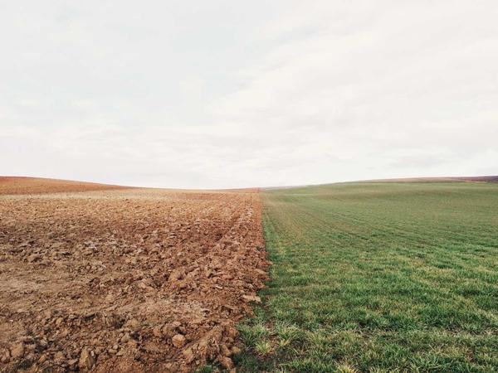
Q: What's an actor's favourite breakfast?
A: Ham and eggs — extra ham!
💡 Discussion: Why is this joke funny? What does it tell us about "Over-acting and character restraint"? Can you explain the concept to a partner?

Joke #9
📌 Curriculum Link: Stage fright and performance confidence

Q: Why did the curtain blush?
A: Because it saw the audience and stage fright kicked in!
💡 Discussion: Why is this joke funny? What does it tell us about "Stage fright and performance confidence"? Can you explain the concept to a partner?

Joke #10
📌 Curriculum Link: Gothic theatre and genre

Q: What do you get when you cross a vampire and a drama student?
A: A show that really bites — and explores Gothic drama!
💡 Discussion: Why is this joke funny? What does it tell us about "Gothic theatre and genre"? Can you explain the concept to a partner?

Joke #11
📌 Curriculum Link: Costume design in theatre production
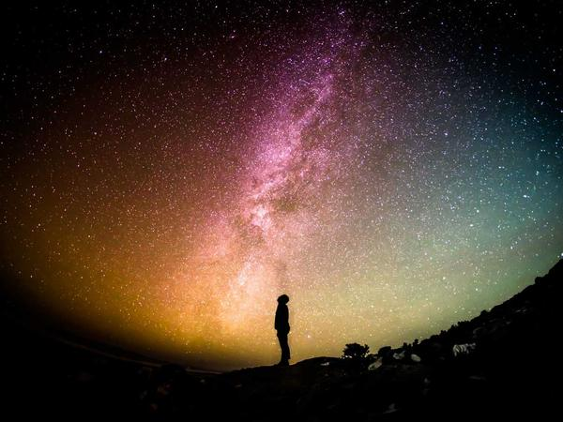
Q: Why did the costume designer bring a ladder?
A: To reach new heights in wardrobe!
💡 Discussion: Why is this joke funny? What does it tell us about "Costume design in theatre production"? Can you explain the concept to a partner?

Joke #12
📌 Curriculum Link: Striking the set after a production

Q: What did the stagehand say at the end of the show?
A: That's a wrap — or rather, strike the set!
💡 Discussion: Why is this joke funny? What does it tell us about "Striking the set after a production"? Can you explain the concept to a partner?

Joke #13
📌 Curriculum Link: Improvisation skills in drama
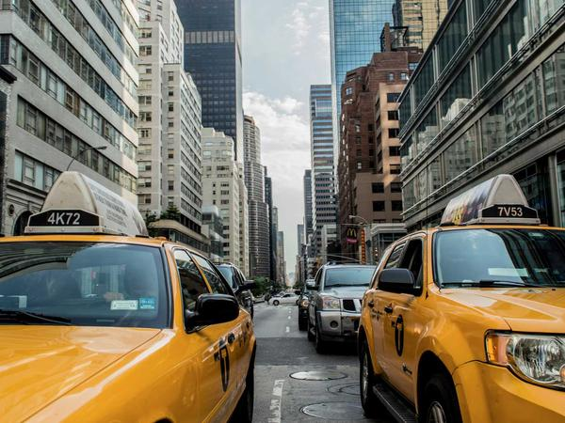
Q: Why is improvisation so unpredictable?
A: Because nobody knows what's going to happen — that's the point!
💡 Discussion: Why is this joke funny? What does it tell us about "Improvisation skills in drama"? Can you explain the concept to a partner?

Joke #14
📌 Curriculum Link: Monologues: solo character speeches
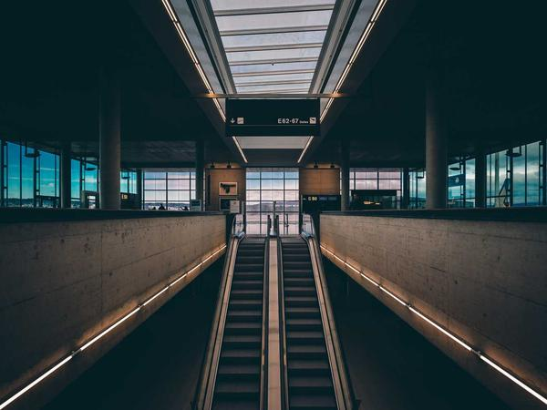
Q: What did the audience say to the monologue?
A: You really know how to hold a room!
💡 Discussion: Why is this joke funny? What does it tell us about "Monologues: solo character speeches"? Can you explain the concept to a partner?

Joke #15
📌 Curriculum Link: Creating dramatic scenes

Q: Why are drama students bad at hiding?
A: Because they always make a scene!
💡 Discussion: Why is this joke funny? What does it tell us about "Creating dramatic scenes"? Can you explain the concept to a partner?

Joke #16
📌 Curriculum Link: Stage wings and backstage areas

Q: What do actors drink on set?
A: Stage whiskers... I mean, water from the wings!
💡 Discussion: Why is this joke funny? What does it tell us about "Stage wings and backstage areas"? Can you explain the concept to a partner?

Joke #17
📌 Curriculum Link: Plot development and story arcs

Q: Why was the playwright always tired?
A: Because they were always working on their plot!
💡 Discussion: Why is this joke funny? What does it tell us about "Plot development and story arcs"? Can you explain the concept to a partner?

Joke #18
📌 Curriculum Link: Stage directions: exit, enter, aside

Q: What's a ghost's favourite stage direction?
A: Exit, stage fright!
💡 Discussion: Why is this joke funny? What does it tell us about "Stage directions: exit, enter, aside"? Can you explain the concept to a partner?

Joke #19
📌 Curriculum Link: Shakespeare and Elizabethan theatre
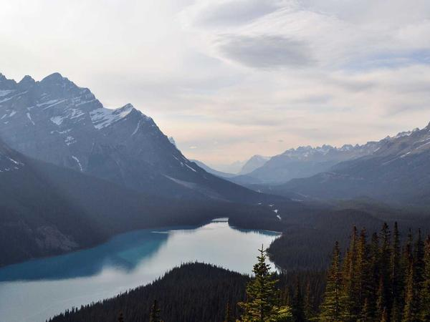
Q: Why did the audience throw vegetables at the Shakespearean actor?
A: Because the bard had set a bad precedent!
💡 Discussion: Why is this joke funny? What does it tell us about "Shakespeare and Elizabethan theatre"? Can you explain the concept to a partner?

Joke #20
📌 Curriculum Link: Dramatic tension and conflict
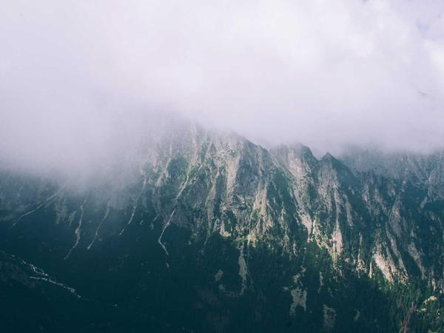
Q: What do you call a play with no conflict?
A: Boring — every good drama needs tension!
💡 Discussion: Why is this joke funny? What does it tell us about "Dramatic tension and conflict"? Can you explain the concept to a partner?

