🇫🇷 French Jokes 🇫🇷
20 Curriculum-Linked Jokes
Each joke connects to a key learning point

Contents
1. What do you call a French man in sandals? [French names and pronunciation]
2. Why did the baguette go to the doctor? [French food vocabulary: baguette, pain]
3. How do French cats say 'thank you'? [Merci = thank you; beaucoup = very much]
4. What do you call a lazy kangaroo in French? [Adjectives agree with nouns in French]
5. Why did the French student eat their homework? [Idiomatic expressions: piece of cake]
6. What's a French skeleton called? [Cognates: words similar in both languages]
7. Why did the croissant go to school? [Pour + infinitive = 'in order to']
8. How does a French dog say goodbye? [Au revoir = goodbye]
9. What's a French ghost's favourite meal? [French food vocabulary: crêpes]
10. Why did the Eiffel Tower fail the exam? [Famous French landmarks]
11. What do you say to a French person on their birthday? [Birthday greetings in French]
12. Why did the verb go to prison? [Verb conjugation in French]
13. What do French ducks say? [Animal sounds differ across languages]
14. What time is it when a French clock strikes 13? [Telling the time in French (24hr)]
15. Why is French so romantic? [Gendered nouns: masculine and feminine]
16. What did the French student say about reflexive verbs? [Reflexive verbs: se laver, s'appeler]
17. Why was the passé composé stressed? [Past participle agreement rules]
18. What do French people eat for breakfast in space? [Lune = moon; petit déjeuner vocabulary]
19. How do you make a French omelette laugh? [Food vocabulary: oeuf (egg)]
20. Why did the student bring a ladder to French class? [French accent marks and pronunciation]

Joke #1
📌 Curriculum Link: French names and pronunciation

Q: What do you call a French man in sandals?
A: Philippe Philoppe!
💡 Discussion: Why is this joke funny? What does it tell us about "French names and pronunciation"? Can you explain the concept to a partner?

Joke #2
📌 Curriculum Link: French food vocabulary: baguette, pain

Q: Why did the baguette go to the doctor?
A: Because it was feeling crumby!
💡 Discussion: Why is this joke funny? What does it tell us about "French food vocabulary: baguette, pain"? Can you explain the concept to a partner?

Joke #3
📌 Curriculum Link: Merci = thank you; beaucoup = very much

Q: How do French cats say 'thank you'?
A: Merci beau-paw!
💡 Discussion: Why is this joke funny? What does it tell us about "Merci = thank you; beaucoup = very much"? Can you explain the concept to a partner?

Joke #4
📌 Curriculum Link: Adjectives agree with nouns in French

Q: What do you call a lazy kangaroo in French?
A: Un kangourou paresseux!
💡 Discussion: Why is this joke funny? What does it tell us about "Adjectives agree with nouns in French"? Can you explain the concept to a partner?

Joke #5
📌 Curriculum Link: Idiomatic expressions: piece of cake

Q: Why did the French student eat their homework?
A: The teacher said it was un morceau de gâteau!
💡 Discussion: Why is this joke funny? What does it tell us about "Idiomatic expressions: piece of cake"? Can you explain the concept to a partner?

Joke #6
📌 Curriculum Link: Cognates: words similar in both languages

Q: What's a French skeleton called?
A: Un squelette — same word, different accent!
💡 Discussion: Why is this joke funny? What does it tell us about "Cognates: words similar in both languages"? Can you explain the concept to a partner?

Joke #7
📌 Curriculum Link: Pour + infinitive = 'in order to'

Q: Why did the croissant go to school?
A: Pour apprendre les bonnes manières!
💡 Discussion: Why is this joke funny? What does it tell us about "Pour + infinitive = 'in order to'"? Can you explain the concept to a partner?

Joke #8
📌 Curriculum Link: Au revoir = goodbye

Q: How does a French dog say goodbye?
A: Au re-voir-f!
💡 Discussion: Why is this joke funny? What does it tell us about "Au revoir = goodbye"? Can you explain the concept to a partner?

Joke #9
📌 Curriculum Link: French food vocabulary: crêpes

Q: What's a French ghost's favourite meal?
A: Crêpes — they love anything wrapped in a sheet!
💡 Discussion: Why is this joke funny? What does it tell us about "French food vocabulary: crêpes"? Can you explain the concept to a partner?

Joke #10
📌 Curriculum Link: Famous French landmarks

Q: Why did the Eiffel Tower fail the exam?
A: It was too high up to concentrate!
💡 Discussion: Why is this joke funny? What does it tell us about "Famous French landmarks"? Can you explain the concept to a partner?

Joke #11
📌 Curriculum Link: Birthday greetings in French
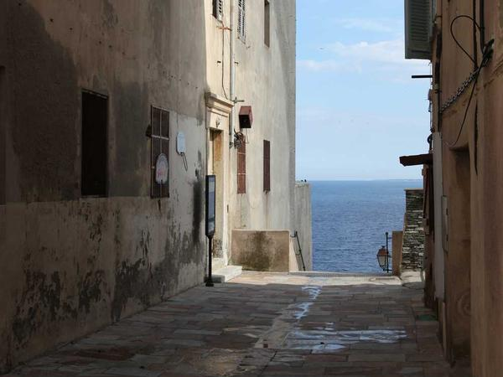
Q: What do you say to a French person on their birthday?
A: Bon anniversaire — and watch the spelling!
💡 Discussion: Why is this joke funny? What does it tell us about "Birthday greetings in French"? Can you explain the concept to a partner?

Joke #12
📌 Curriculum Link: Verb conjugation in French

Q: Why did the verb go to prison?
A: Because it broke the conjugation rules!
💡 Discussion: Why is this joke funny? What does it tell us about "Verb conjugation in French"? Can you explain the concept to a partner?

Joke #13
📌 Curriculum Link: Animal sounds differ across languages

Q: What do French ducks say?
A: Coin coin — not quack!
💡 Discussion: Why is this joke funny? What does it tell us about "Animal sounds differ across languages"? Can you explain the concept to a partner?

Joke #14
📌 Curriculum Link: Telling the time in French (24hr)

Q: What time is it when a French clock strikes 13?
A: Il est treize heures — they use 24-hour time!
💡 Discussion: Why is this joke funny? What does it tell us about "Telling the time in French (24hr)"? Can you explain the concept to a partner?

Joke #15
📌 Curriculum Link: Gendered nouns: masculine and feminine

Q: Why is French so romantic?
A: Because every noun has a gender — le and la!
💡 Discussion: Why is this joke funny? What does it tell us about "Gendered nouns: masculine and feminine"? Can you explain the concept to a partner?

Joke #16
📌 Curriculum Link: Reflexive verbs: se laver, s'appeler

Q: What did the French student say about reflexive verbs?
A: Je me confused!
💡 Discussion: Why is this joke funny? What does it tell us about "Reflexive verbs: se laver, s'appeler"? Can you explain the concept to a partner?

Joke #17
📌 Curriculum Link: Past participle agreement rules

Q: Why was the passé composé stressed?
A: It couldn't agree with the past participle!
💡 Discussion: Why is this joke funny? What does it tell us about "Past participle agreement rules"? Can you explain the concept to a partner?

Joke #18
📌 Curriculum Link: Lune = moon; petit déjeuner vocabulary

Q: What do French people eat for breakfast in space?
A: Des croissants de lune!
💡 Discussion: Why is this joke funny? What does it tell us about "Lune = moon; petit déjeuner vocabulary"? Can you explain the concept to a partner?

Joke #19
📌 Curriculum Link: Food vocabulary: oeuf (egg)

Q: How do you make a French omelette laugh?
A: Tell it an oeuf joke! (Oeuf = egg)
💡 Discussion: Why is this joke funny? What does it tell us about "Food vocabulary: oeuf (egg)"? Can you explain the concept to a partner?

Joke #20
📌 Curriculum Link: French accent marks and pronunciation

Q: Why did the student bring a ladder to French class?
A: To reach the higher level of accents: é, è, ê, ë!
💡 Discussion: Why is this joke funny? What does it tell us about "French accent marks and pronunciation"? Can you explain the concept to a partner?

