🌍 Geography Jokes 🌍
20 Curriculum-Linked Jokes
Each joke connects to a key learning point

Contents
1. What's the smartest mountain? [World's highest peak: Mount Everest]
2. Why did the tectonic plate break up with the other? [Tectonic plates and plate boundaries]
3. What do you call a sleeping volcano? [Volcano states: active, dormant, extinct]
4. Why do rivers never get lost? [River courses: upper, middle, lower]
5. What did the ocean say to the shore? [Coastal processes: waves and erosion]
6. Why is the desert so bad at telling jokes? [Arid climates and desert biomes]
7. What rock can float on water? [Volcanic rocks and their properties]
8. Why did the map go to school? [Map scales and their uses]
9. What did the compass say to the map? [Using compass bearings for navigation]
10. Why is the North Pole so cold? [Latitude and solar energy distribution]
11. What do you call a map's autobiography? [Map keys/legends explain symbols]
12. Why was the glacier so slow? [Glacial movement and erosion]
13. What did the earthquake say to the city? [Earthquake faults: normal, reverse, strike-slip]
14. Why are meanders so indecisive? [River meanders and lateral erosion]
15. What holds the sea up? [Tides caused by gravitational pull]
16. Why did the geographer bring a ruler to the beach? [Longshore drift moves sediment along coast]
17. What's a tornado's favourite game? [Extreme weather: tornados and storms]
18. Why did the oxbow lake feel left out? [Oxbow lake formation from meanders]
19. What sits in the middle of the world? [The Equator divides N and S hemispheres]
20. Why did the climate scientist go broke? [Climate change and net zero targets]

Joke #1
📌 Curriculum Link: World's highest peak: Mount Everest

Q: What's the smartest mountain?
A: Mount Cleverest! (Everest)
💡 Discussion: Why is this joke funny? What does it tell us about "World's highest peak: Mount Everest"? Can you explain the concept to a partner?

Joke #2
📌 Curriculum Link: Tectonic plates and plate boundaries

Q: Why did the tectonic plate break up with the other?
A: There was too much friction between them!
💡 Discussion: Why is this joke funny? What does it tell us about "Tectonic plates and plate boundaries"? Can you explain the concept to a partner?

Joke #3
📌 Curriculum Link: Volcano states: active, dormant, extinct
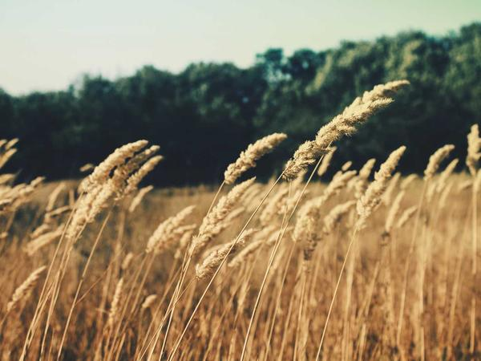
Q: What do you call a sleeping volcano?
A: A nap-olcano! But really — it's dormant.
💡 Discussion: Why is this joke funny? What does it tell us about "Volcano states: active, dormant, extinct"? Can you explain the concept to a partner?

Joke #4
📌 Curriculum Link: River courses: upper, middle, lower

Q: Why do rivers never get lost?
A: Because they always find their course!
💡 Discussion: Why is this joke funny? What does it tell us about "River courses: upper, middle, lower"? Can you explain the concept to a partner?

Joke #5
📌 Curriculum Link: Coastal processes: waves and erosion
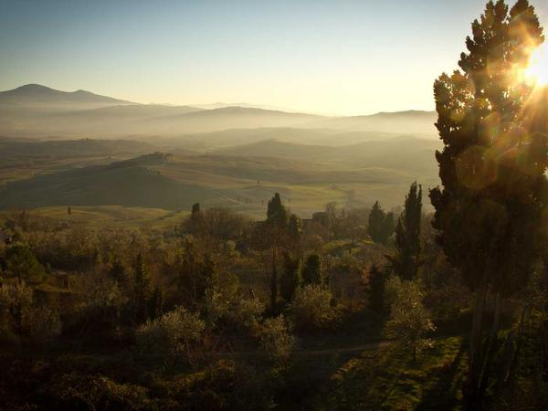
Q: What did the ocean say to the shore?
A: Nothing — it just waved!
💡 Discussion: Why is this joke funny? What does it tell us about "Coastal processes: waves and erosion"? Can you explain the concept to a partner?

Joke #6
📌 Curriculum Link: Arid climates and desert biomes
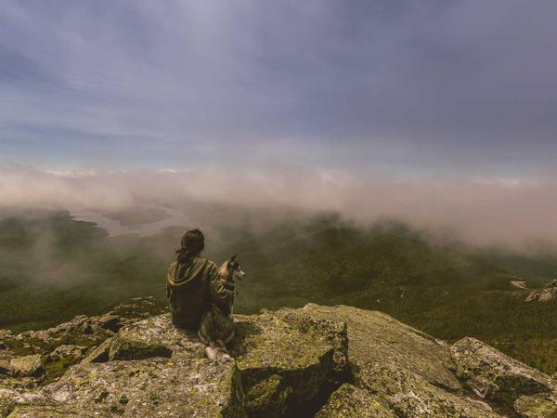
Q: Why is the desert so bad at telling jokes?
A: Because it's too dry!
💡 Discussion: Why is this joke funny? What does it tell us about "Arid climates and desert biomes"? Can you explain the concept to a partner?

Joke #7
📌 Curriculum Link: Volcanic rocks and their properties

Q: What rock can float on water?
A: Pumice — it's full of air holes from volcanic gas!
💡 Discussion: Why is this joke funny? What does it tell us about "Volcanic rocks and their properties"? Can you explain the concept to a partner?

Joke #8
📌 Curriculum Link: Map scales and their uses
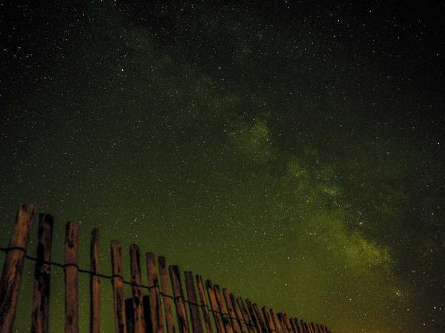
Q: Why did the map go to school?
A: To improve its scale!
💡 Discussion: Why is this joke funny? What does it tell us about "Map scales and their uses"? Can you explain the concept to a partner?

Joke #9
📌 Curriculum Link: Using compass bearings for navigation
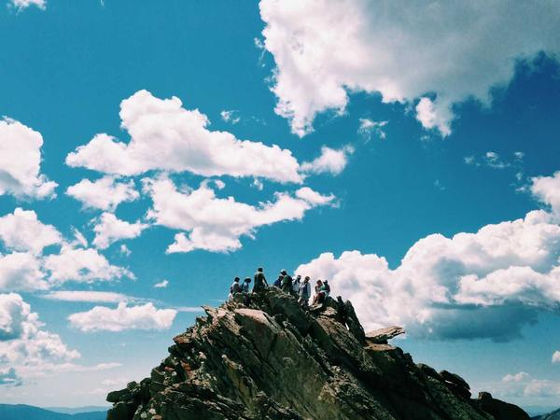
Q: What did the compass say to the map?
A: Without me, you'd be lost!
💡 Discussion: Why is this joke funny? What does it tell us about "Using compass bearings for navigation"? Can you explain the concept to a partner?

Joke #10
📌 Curriculum Link: Latitude and solar energy distribution
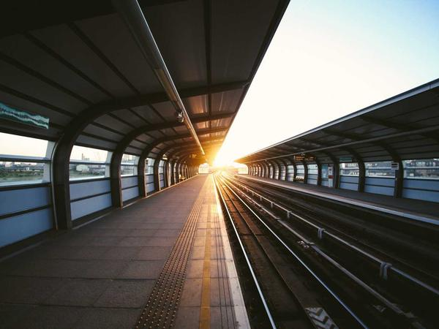
Q: Why is the North Pole so cold?
A: Because it gets very little direct sunlight!
💡 Discussion: Why is this joke funny? What does it tell us about "Latitude and solar energy distribution"? Can you explain the concept to a partner?

Joke #11
📌 Curriculum Link: Map keys/legends explain symbols

Q: What do you call a map's autobiography?
A: A legend!
💡 Discussion: Why is this joke funny? What does it tell us about "Map keys/legends explain symbols"? Can you explain the concept to a partner?

Joke #12
📌 Curriculum Link: Glacial movement and erosion

Q: Why was the glacier so slow?
A: Because it was taking its ice time!
💡 Discussion: Why is this joke funny? What does it tell us about "Glacial movement and erosion"? Can you explain the concept to a partner?

Joke #13
📌 Curriculum Link: Earthquake faults: normal, reverse, strike-slip
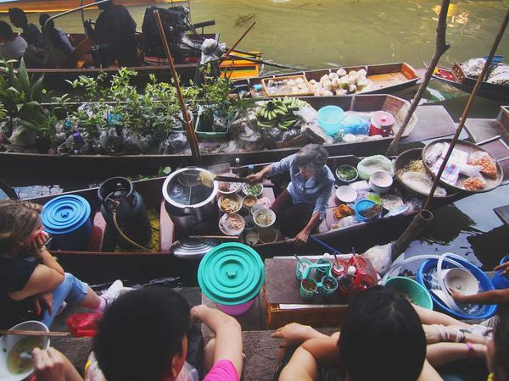
Q: What did the earthquake say to the city?
A: Sorry, my fault!
💡 Discussion: Why is this joke funny? What does it tell us about "Earthquake faults: normal, reverse, strike-slip"? Can you explain the concept to a partner?

Joke #14
📌 Curriculum Link: River meanders and lateral erosion
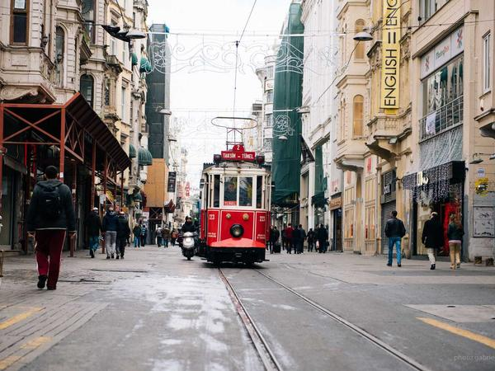
Q: Why are meanders so indecisive?
A: They keep going back and forth!
💡 Discussion: Why is this joke funny? What does it tell us about "River meanders and lateral erosion"? Can you explain the concept to a partner?

Joke #15
📌 Curriculum Link: Tides caused by gravitational pull
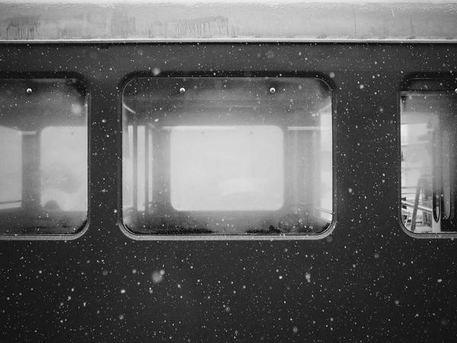
Q: What holds the sea up?
A: Spring tides and neap tides!
💡 Discussion: Why is this joke funny? What does it tell us about "Tides caused by gravitational pull"? Can you explain the concept to a partner?

Joke #16
📌 Curriculum Link: Longshore drift moves sediment along coast

Q: Why did the geographer bring a ruler to the beach?
A: To measure the longshore drift!
💡 Discussion: Why is this joke funny? What does it tell us about "Longshore drift moves sediment along coast"? Can you explain the concept to a partner?

Joke #17
📌 Curriculum Link: Extreme weather: tornados and storms
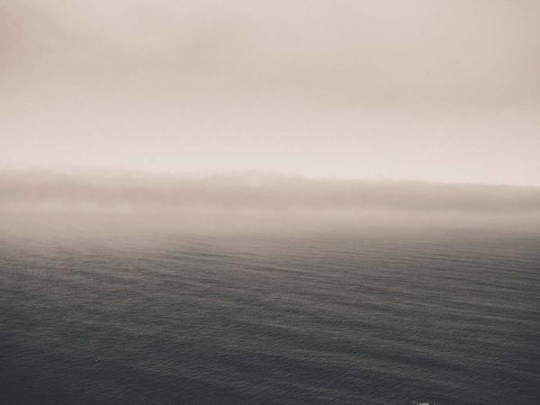
Q: What's a tornado's favourite game?
A: Twister!
💡 Discussion: Why is this joke funny? What does it tell us about "Extreme weather: tornados and storms"? Can you explain the concept to a partner?

Joke #18
📌 Curriculum Link: Oxbow lake formation from meanders
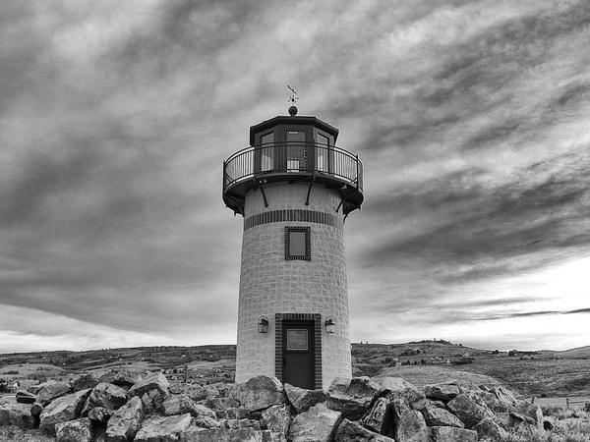
Q: Why did the oxbow lake feel left out?
A: Because it was cut off from the river!
💡 Discussion: Why is this joke funny? What does it tell us about "Oxbow lake formation from meanders"? Can you explain the concept to a partner?

Joke #19
📌 Curriculum Link: The Equator divides N and S hemispheres
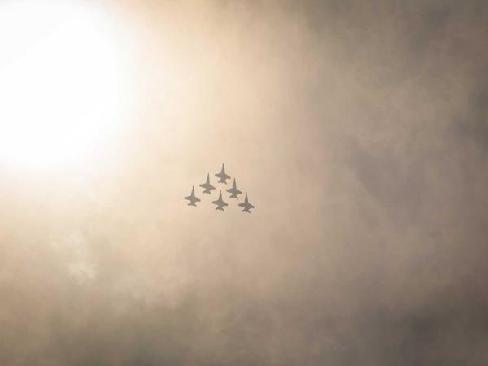
Q: What sits in the middle of the world?
A: The letter R — but also the Equator!
💡 Discussion: Why is this joke funny? What does it tell us about "The Equator divides N and S hemispheres"? Can you explain the concept to a partner?

Joke #20
📌 Curriculum Link: Climate change and net zero targets
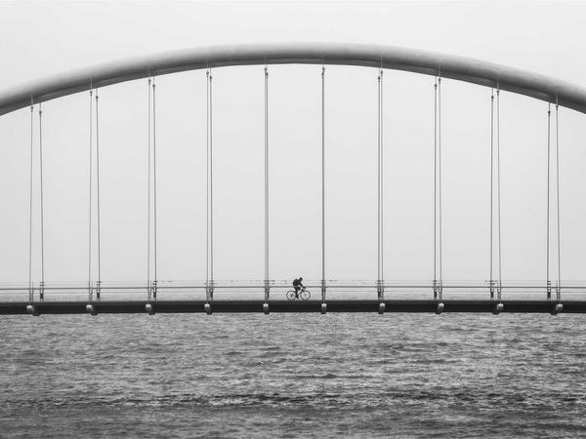
Q: Why did the climate scientist go broke?
A: Because their studies had zero net worth... I mean net zero!
💡 Discussion: Why is this joke funny? What does it tell us about "Climate change and net zero targets"? Can you explain the concept to a partner?

