🇩🇪 German Jokes 🇩🇪
20 Curriculum-Linked Jokes
Each joke connects to a key learning point

Contents
1. Why is German food so filling? [Food vocabulary: Wurst = sausage]
2. What do you call a German barber? [Herr = Mr; formal address in German]
3. Why did the German student struggle with articles? [Three genders: masculine, feminine, neuter]
4. What's a German ghost's favourite greeting? [Time-based greetings in German]
5. Why did the Dachshund sit in the shade? [Animal vocabulary: Hund = dog]
6. What did the accusative case say to the dative? [Accusative = direct object; dative = indirect]
7. Why are German compound words so long? [Compound nouns in German]
8. What do you call a German VW that's also a professor? [Formal titles and car culture]
9. Why is the German verb always at the end? [Word order in subordinate clauses]
10. How does a German cow greet you? [Greetings: Guten Tag = Good day]
11. Why was the umlaut so important? [Umlauts change meaning: ä, ö, ü]
12. What did the separable verb say? [Separable prefix verbs split in main clauses]
13. Why did the German student love Christmas? [Cultural vocabulary: Christmas markets]
14. What's a German's favourite element? [German for 'one' is 'ein']
15. Why was the modal verb so bossy? [Modal verbs: können, müssen, dürfen]
16. How do you fix a broken German sentence? [TMP rule for adverb order]
17. What's the German word for constipation? [Medical vocabulary and pronunciation]
18. Why did the student confuse the German classroom? [Homonyms: same word, different meanings]
19. Why don't German jokes work in English? [V2 word order and verb-final in subclauses]
20. What did the German say at the bakery? [Ordering food: ich möchte = I would like]

Joke #1
📌 Curriculum Link: Food vocabulary: Wurst = sausage

Q: Why is German food so filling?
A: Because the wurst is yet to come!
💡 Discussion: Why is this joke funny? What does it tell us about "Food vocabulary: Wurst = sausage"? Can you explain the concept to a partner?

Joke #2
📌 Curriculum Link: Herr = Mr; formal address in German

Q: What do you call a German barber?
A: Ein Herr Cutter!
💡 Discussion: Why is this joke funny? What does it tell us about "Herr = Mr; formal address in German"? Can you explain the concept to a partner?

Joke #3
📌 Curriculum Link: Three genders: masculine, feminine, neuter

Q: Why did the German student struggle with articles?
A: Because there are three: der, die, das!
💡 Discussion: Why is this joke funny? What does it tell us about "Three genders: masculine, feminine, neuter"? Can you explain the concept to a partner?

Joke #4
📌 Curriculum Link: Time-based greetings in German

Q: What's a German ghost's favourite greeting?
A: Guten Abend! (Good evening!)
💡 Discussion: Why is this joke funny? What does it tell us about "Time-based greetings in German"? Can you explain the concept to a partner?

Joke #5
📌 Curriculum Link: Animal vocabulary: Hund = dog

Q: Why did the Dachshund sit in the shade?
A: Because it was a hot dog!
💡 Discussion: Why is this joke funny? What does it tell us about "Animal vocabulary: Hund = dog"? Can you explain the concept to a partner?

Joke #6
📌 Curriculum Link: Accusative = direct object; dative = indirect

Q: What did the accusative case say to the dative?
A: I object! No, wait — I'm the object!
💡 Discussion: Why is this joke funny? What does it tell us about "Accusative = direct object; dative = indirect"? Can you explain the concept to a partner?

Joke #7
📌 Curriculum Link: Compound nouns in German

Q: Why are German compound words so long?
A: Donaudampfschifffahrt — they just keep adding!
💡 Discussion: Why is this joke funny? What does it tell us about "Compound nouns in German"? Can you explain the concept to a partner?

Joke #8
📌 Curriculum Link: Formal titles and car culture
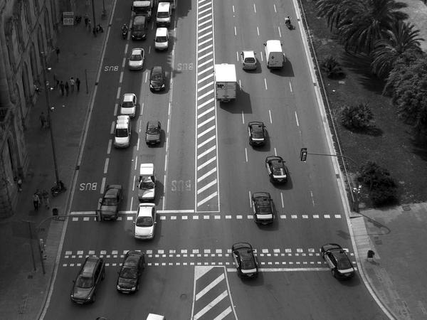
Q: What do you call a German VW that's also a professor?
A: A Herr Doktor Beetle!
💡 Discussion: Why is this joke funny? What does it tell us about "Formal titles and car culture"? Can you explain the concept to a partner?

Joke #9
📌 Curriculum Link: Word order in subordinate clauses

Q: Why is the German verb always at the end?
A: Weil es so sein muss! (Because it must be so!)
💡 Discussion: Why is this joke funny? What does it tell us about "Word order in subordinate clauses"? Can you explain the concept to a partner?

Joke #10
📌 Curriculum Link: Greetings: Guten Tag = Good day

Q: How does a German cow greet you?
A: Moo-in Tag! (Guten Tag!)
💡 Discussion: Why is this joke funny? What does it tell us about "Greetings: Guten Tag = Good day"? Can you explain the concept to a partner?

Joke #11
📌 Curriculum Link: Umlauts change meaning: ä, ö, ü

Q: Why was the umlaut so important?
A: Without it, schon (already) becomes schön (beautiful)!
💡 Discussion: Why is this joke funny? What does it tell us about "Umlauts change meaning: ä, ö, ü"? Can you explain the concept to a partner?

Joke #12
📌 Curriculum Link: Separable prefix verbs split in main clauses

Q: What did the separable verb say?
A: I'll meet you at the end of the sentence!
💡 Discussion: Why is this joke funny? What does it tell us about "Separable prefix verbs split in main clauses"? Can you explain the concept to a partner?

Joke #13
📌 Curriculum Link: Cultural vocabulary: Christmas markets

Q: Why did the German student love Christmas?
A: Because Weihnachtsmarkt is one word for everything!
💡 Discussion: Why is this joke funny? What does it tell us about "Cultural vocabulary: Christmas markets"? Can you explain the concept to a partner?

Joke #14
📌 Curriculum Link: German for 'one' is 'ein'

Q: What's a German's favourite element?
A: Ein-steinium!
💡 Discussion: Why is this joke funny? What does it tell us about "German for 'one' is 'ein'"? Can you explain the concept to a partner?

Joke #15
📌 Curriculum Link: Modal verbs: können, müssen, dürfen

Q: Why was the modal verb so bossy?
A: Because it always tells the infinitive what to do!
💡 Discussion: Why is this joke funny? What does it tell us about "Modal verbs: können, müssen, dürfen"? Can you explain the concept to a partner?

Joke #16
📌 Curriculum Link: TMP rule for adverb order

Q: How do you fix a broken German sentence?
A: Check the word order: Time, Manner, Place!
💡 Discussion: Why is this joke funny? What does it tell us about "TMP rule for adverb order"? Can you explain the concept to a partner?

Joke #17
📌 Curriculum Link: Medical vocabulary and pronunciation

Q: What's the German word for constipation?
A: Farfrompoopin! (Just a joke — it's Verstopfung!)
💡 Discussion: Why is this joke funny? What does it tell us about "Medical vocabulary and pronunciation"? Can you explain the concept to a partner?

Joke #18
📌 Curriculum Link: Homonyms: same word, different meanings

Q: Why did the student confuse the German classroom?
A: They mixed up Klasse (class) and Klasse (great)!
💡 Discussion: Why is this joke funny? What does it tell us about "Homonyms: same word, different meanings"? Can you explain the concept to a partner?

Joke #19
📌 Curriculum Link: V2 word order and verb-final in subclauses

Q: Why don't German jokes work in English?
A: Because the verb is always at the end coming!
💡 Discussion: Why is this joke funny? What does it tell us about "V2 word order and verb-final in subclauses"? Can you explain the concept to a partner?

Joke #20
📌 Curriculum Link: Ordering food: ich möchte = I would like

Q: What did the German say at the bakery?
A: Ich möchte ein Brötchen, bitte! Now that's polite!
💡 Discussion: Why is this joke funny? What does it tell us about "Ordering food: ich möchte = I would like"? Can you explain the concept to a partner?

