🔢 Maths Jokes 🔢
20 Curriculum-Linked Jokes
Each joke connects to a key learning point

Contents
1. Why was the equal sign so humble? [Inequality symbols: >, < and =]
2. Why did the student do multiplication on the floor? [Times tables and multiplication]
3. Why is 6 afraid of 7? [Number operations and sequences]
4. What do you call friends who love maths? [Introduction to algebra]
5. Why did the two 4s skip dinner? [Multiplication facts: 4×2=8]
6. What's a mathematician's favourite season? [Addition and summation]
7. Why was the fraction worried about marrying the decimal? [Converting fractions to decimals]
8. What do you call a number that can't keep still? [Roman numerals (I, V, X, L, C)]
9. Why did the angle go to the beach? [Right angles and degrees]
10. What did the triangle say to the circle? [Properties of 2D shapes]
11. Why is the obtuse angle always upset? [Types of angles: acute, right, obtuse]
12. Why did the student wear glasses in maths? [Division as a core operation]
13. How do you stay warm in a cold room? [Right angles in shapes]
14. Why was the maths book sad? [Mathematical problem-solving]
15. What did zero say to eight? [Digit recognition and number shapes]
16. Why did Pi get its driver's licence revoked? [Pi (π) as an irrational number]
17. What's the king of the pencil case? [Measurement with rulers]
18. Parallel lines have so much in common... [Parallel lines never intersect]
19. Why did the circle go to the gym? [Degrees in a full turn = 360°]
20. What did the acorn say when it grew up? [Introduction to geometry]

Joke #1
📌 Curriculum Link: Inequality symbols: >, < and =

Q: Why was the equal sign so humble?
A: Because it knew it wasn't greater than or less than anyone else.
💡 Discussion: Why is this joke funny? What does it tell us about "Inequality symbols: >, < and ="? Can you explain the concept to a partner?

Joke #2
📌 Curriculum Link: Times tables and multiplication

Q: Why did the student do multiplication on the floor?
A: The teacher told them not to use tables!
💡 Discussion: Why is this joke funny? What does it tell us about "Times tables and multiplication"? Can you explain the concept to a partner?

Joke #3
📌 Curriculum Link: Number operations and sequences

Q: Why is 6 afraid of 7?
A: Because 7 8 9!
💡 Discussion: Why is this joke funny? What does it tell us about "Number operations and sequences"? Can you explain the concept to a partner?

Joke #4
📌 Curriculum Link: Introduction to algebra
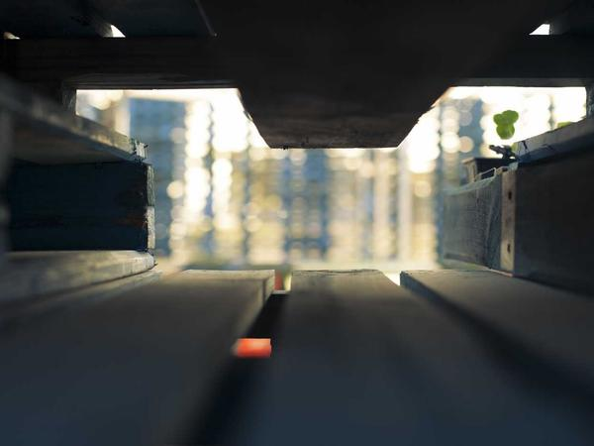
Q: What do you call friends who love maths?
A: Algebros!
💡 Discussion: Why is this joke funny? What does it tell us about "Introduction to algebra"? Can you explain the concept to a partner?

Joke #5
📌 Curriculum Link: Multiplication facts: 4×2=8

Q: Why did the two 4s skip dinner?
A: Because they already 8!
💡 Discussion: Why is this joke funny? What does it tell us about "Multiplication facts: 4×2=8"? Can you explain the concept to a partner?

Joke #6
📌 Curriculum Link: Addition and summation

Q: What's a mathematician's favourite season?
A: Sum-mer!
💡 Discussion: Why is this joke funny? What does it tell us about "Addition and summation"? Can you explain the concept to a partner?

Joke #7
📌 Curriculum Link: Converting fractions to decimals

Q: Why was the fraction worried about marrying the decimal?
A: Because they'd have to convert!
💡 Discussion: Why is this joke funny? What does it tell us about "Converting fractions to decimals"? Can you explain the concept to a partner?

Joke #8
📌 Curriculum Link: Roman numerals (I, V, X, L, C)

Q: What do you call a number that can't keep still?
A: A roamin' numeral!
💡 Discussion: Why is this joke funny? What does it tell us about "Roman numerals (I, V, X, L, C)"? Can you explain the concept to a partner?

Joke #9
📌 Curriculum Link: Right angles and degrees
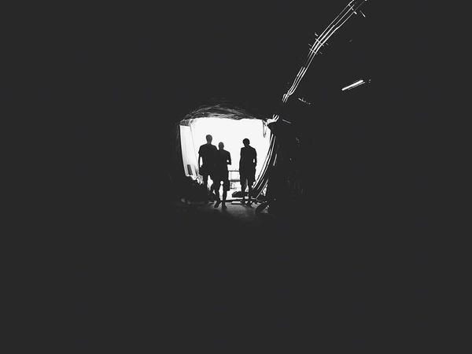
Q: Why did the angle go to the beach?
A: Because it was 90 degrees!
💡 Discussion: Why is this joke funny? What does it tell us about "Right angles and degrees"? Can you explain the concept to a partner?

Joke #10
📌 Curriculum Link: Properties of 2D shapes

Q: What did the triangle say to the circle?
A: You're pointless!
💡 Discussion: Why is this joke funny? What does it tell us about "Properties of 2D shapes"? Can you explain the concept to a partner?

Joke #11
📌 Curriculum Link: Types of angles: acute, right, obtuse

Q: Why is the obtuse angle always upset?
A: Because it's never right!
💡 Discussion: Why is this joke funny? What does it tell us about "Types of angles: acute, right, obtuse"? Can you explain the concept to a partner?

Joke #12
📌 Curriculum Link: Division as a core operation

Q: Why did the student wear glasses in maths?
A: To improve di-vision!
💡 Discussion: Why is this joke funny? What does it tell us about "Division as a core operation"? Can you explain the concept to a partner?

Joke #13
📌 Curriculum Link: Right angles in shapes

Q: How do you stay warm in a cold room?
A: Go to the corner — it's always 90 degrees!
💡 Discussion: Why is this joke funny? What does it tell us about "Right angles in shapes"? Can you explain the concept to a partner?

Joke #14
📌 Curriculum Link: Mathematical problem-solving

Q: Why was the maths book sad?
A: It had too many problems.
💡 Discussion: Why is this joke funny? What does it tell us about "Mathematical problem-solving"? Can you explain the concept to a partner?

Joke #15
📌 Curriculum Link: Digit recognition and number shapes

Q: What did zero say to eight?
A: Nice belt!
💡 Discussion: Why is this joke funny? What does it tell us about "Digit recognition and number shapes"? Can you explain the concept to a partner?

Joke #16
📌 Curriculum Link: Pi (π) as an irrational number

Q: Why did Pi get its driver's licence revoked?
A: Because it didn't know when to stop!
💡 Discussion: Why is this joke funny? What does it tell us about "Pi (π) as an irrational number"? Can you explain the concept to a partner?

Joke #17
📌 Curriculum Link: Measurement with rulers

Q: What's the king of the pencil case?
A: The ruler!
💡 Discussion: Why is this joke funny? What does it tell us about "Measurement with rulers"? Can you explain the concept to a partner?

Joke #18
📌 Curriculum Link: Parallel lines never intersect

Q: Parallel lines have so much in common...
A: It's a shame they'll never meet.
💡 Discussion: Why is this joke funny? What does it tell us about "Parallel lines never intersect"? Can you explain the concept to a partner?

Joke #19
📌 Curriculum Link: Degrees in a full turn = 360°

Q: Why did the circle go to the gym?
A: To get 360° of fitness!
💡 Discussion: Why is this joke funny? What does it tell us about "Degrees in a full turn = 360°"? Can you explain the concept to a partner?

Joke #20
📌 Curriculum Link: Introduction to geometry

Q: What did the acorn say when it grew up?
A: Ge-om-e-try! (Gee, I'm a tree!)
💡 Discussion: Why is this joke funny? What does it tell us about "Introduction to geometry"? Can you explain the concept to a partner?

