🎵 Music Jokes 🎵
20 Curriculum-Linked Jokes
Each joke connects to a key learning point

Contents
1. Why couldn't the string quartet find their composer? [Joseph Haydn: Classical era composer]
2. What do you call a cow that plays music? [Musical roles and terminology]
3. Why did the music teacher need a ladder? [Pitch: high and low notes]
4. What type of music are balloons scared of? [Musical genres and styles]
5. Why is a piano so hard to open? [Piano: keyboard instruments and keys]
6. What makes music on your head? [Musical bands and ensembles]
7. What do you get when you drop a piano down a mine shaft? [Flat notes and minor keys]
8. Why did the singer climb a ladder? [Vocal range and musical notes]
9. What's a skeleton's favourite instrument? [Brass instruments: trombone]
10. Why did the musician throw away their calendar? [Musical bars and time signatures]
11. What do you call a musical insect? [Musical notes: A, B, C, D, E, F, G]
12. Why was the guitar teacher arrested? [Guitar chords and finger placement]
13. What key do cows sing in? [Musical keys and notation]
14. How do you fix a broken tuba? [Brass instruments and orchestra sections]
15. Why did the quarter note fail the test? [Note values: crotchet = quarter note]
16. What's Beethoven's favourite fruit? [Beethoven's Symphony No. 5 motif]
17. Why did the rest get detention? [Rests in music: silence has value]
18. What tempo does a tortoise play at? [Tempo markings: largo, adagio, allegro]
19. How do you make a bandstand? [Musical ensembles and performance]
20. What do you call a fish that plays piano? [Tuning instruments to correct pitch]

Joke #1
📌 Curriculum Link: Joseph Haydn: Classical era composer

Q: Why couldn't the string quartet find their composer?
A: He was Haydn!
💡 Discussion: Why is this joke funny? What does it tell us about "Joseph Haydn: Classical era composer"? Can you explain the concept to a partner?

Joke #2
📌 Curriculum Link: Musical roles and terminology

Q: What do you call a cow that plays music?
A: A moo-sician!
💡 Discussion: Why is this joke funny? What does it tell us about "Musical roles and terminology"? Can you explain the concept to a partner?

Joke #3
📌 Curriculum Link: Pitch: high and low notes

Q: Why did the music teacher need a ladder?
A: To reach the high notes!
💡 Discussion: Why is this joke funny? What does it tell us about "Pitch: high and low notes"? Can you explain the concept to a partner?

Joke #4
📌 Curriculum Link: Musical genres and styles

Q: What type of music are balloons scared of?
A: Pop music!
💡 Discussion: Why is this joke funny? What does it tell us about "Musical genres and styles"? Can you explain the concept to a partner?

Joke #5
📌 Curriculum Link: Piano: keyboard instruments and keys
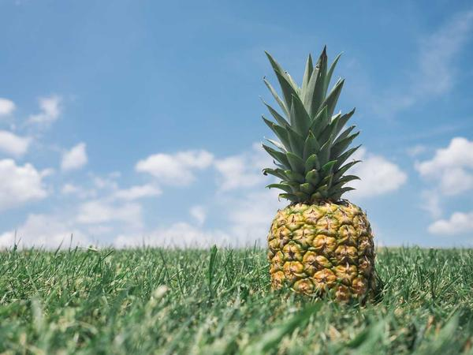
Q: Why is a piano so hard to open?
A: Because the keys are inside!
💡 Discussion: Why is this joke funny? What does it tell us about "Piano: keyboard instruments and keys"? Can you explain the concept to a partner?

Joke #6
📌 Curriculum Link: Musical bands and ensembles

Q: What makes music on your head?
A: A headband!
💡 Discussion: Why is this joke funny? What does it tell us about "Musical bands and ensembles"? Can you explain the concept to a partner?

Joke #7
📌 Curriculum Link: Flat notes and minor keys

Q: What do you get when you drop a piano down a mine shaft?
A: A flat miner! (minor)
💡 Discussion: Why is this joke funny? What does it tell us about "Flat notes and minor keys"? Can you explain the concept to a partner?

Joke #8
📌 Curriculum Link: Vocal range and musical notes

Q: Why did the singer climb a ladder?
A: To reach the high C!
💡 Discussion: Why is this joke funny? What does it tell us about "Vocal range and musical notes"? Can you explain the concept to a partner?

Joke #9
📌 Curriculum Link: Brass instruments: trombone

Q: What's a skeleton's favourite instrument?
A: The trom-bone!
💡 Discussion: Why is this joke funny? What does it tell us about "Brass instruments: trombone"? Can you explain the concept to a partner?

Joke #10
📌 Curriculum Link: Musical bars and time signatures

Q: Why did the musician throw away their calendar?
A: Because their days were numbered — like their bars!
💡 Discussion: Why is this joke funny? What does it tell us about "Musical bars and time signatures"? Can you explain the concept to a partner?

Joke #11
📌 Curriculum Link: Musical notes: A, B, C, D, E, F, G

Q: What do you call a musical insect?
A: A hum-bug — and it hums in B flat!
💡 Discussion: Why is this joke funny? What does it tell us about "Musical notes: A, B, C, D, E, F, G"? Can you explain the concept to a partner?

Joke #12
📌 Curriculum Link: Guitar chords and finger placement

Q: Why was the guitar teacher arrested?
A: For fingering A minor!
💡 Discussion: Why is this joke funny? What does it tell us about "Guitar chords and finger placement"? Can you explain the concept to a partner?

Joke #13
📌 Curriculum Link: Musical keys and notation

Q: What key do cows sing in?
A: Beef flat! (B flat)
💡 Discussion: Why is this joke funny? What does it tell us about "Musical keys and notation"? Can you explain the concept to a partner?

Joke #14
📌 Curriculum Link: Brass instruments and orchestra sections

Q: How do you fix a broken tuba?
A: With a tuba glue!
💡 Discussion: Why is this joke funny? What does it tell us about "Brass instruments and orchestra sections"? Can you explain the concept to a partner?

Joke #15
📌 Curriculum Link: Note values: crotchet = quarter note

Q: Why did the quarter note fail the test?
A: It only got a crotchet! (Same thing!)
💡 Discussion: Why is this joke funny? What does it tell us about "Note values: crotchet = quarter note"? Can you explain the concept to a partner?

Joke #16
📌 Curriculum Link: Beethoven's Symphony No. 5 motif

Q: What's Beethoven's favourite fruit?
A: Ba-na-na-naaa! (5th Symphony opening)
💡 Discussion: Why is this joke funny? What does it tell us about "Beethoven's Symphony No. 5 motif"? Can you explain the concept to a partner?

Joke #17
📌 Curriculum Link: Rests in music: silence has value

Q: Why did the rest get detention?
A: For doing nothing during the performance!
💡 Discussion: Why is this joke funny? What does it tell us about "Rests in music: silence has value"? Can you explain the concept to a partner?

Joke #18
📌 Curriculum Link: Tempo markings: largo, adagio, allegro

Q: What tempo does a tortoise play at?
A: Largo — very slow!
💡 Discussion: Why is this joke funny? What does it tell us about "Tempo markings: largo, adagio, allegro"? Can you explain the concept to a partner?

Joke #19
📌 Curriculum Link: Musical ensembles and performance

Q: How do you make a bandstand?
A: Take away their chairs!
💡 Discussion: Why is this joke funny? What does it tell us about "Musical ensembles and performance"? Can you explain the concept to a partner?

Joke #20
📌 Curriculum Link: Tuning instruments to correct pitch

Q: What do you call a fish that plays piano?
A: A piano tuna!
💡 Discussion: Why is this joke funny? What does it tell us about "Tuning instruments to correct pitch"? Can you explain the concept to a partner?

