🏃 PE Jokes 🏃
20 Curriculum-Linked Jokes
Each joke connects to a key learning point

Contents
1. Why did the football pitch get wet? [Football: dribbling techniques]
2. Why did the gymnast bring a pencil? [Gymnastics: balance and form]
3. Why don't sprinters eat before a race? [Athletics: sprinting and nutrition]
4. What's the hardest part about doing the long jump? [Athletics: long jump and measurement]
5. Why was the netball player excellent at exams? [Netball: goal setting and positions]
6. What do you call a boomerang that doesn't come back? [Projectile motion in sport science]
7. Why did the cricket player go to the bank? [Cricket: batting stance and balance]
8. Why do basketball players love cookies? [Basketball: shooting and dunking]
9. What's a runner's favourite subject? [Cross-country running and orienteering]
10. Why was the swimming pool so smart? [Swimming strokes: front crawl, backstroke]
11. Why don't tennis players ever get married? [Tennis scoring: love = zero]
12. Why did the PE teacher go to art class? [Body composition: muscle, fat, bone]
13. What exercise do lazy people do best? [Squats: lower body exercises]
14. Why was the relay team so good? [Relay races: baton technique]
15. Why did the yoga teacher go to the beach? [Flexibility and stretching in PE]
16. What do you call a fake noodle? [Nutrition: carbohydrate loading for athletes]
17. Why is badminton so loud? [Badminton: racquet sports techniques]
18. Why did the hockey player bring string? [Hockey: scoring and game rules]
19. What's a PE teacher's favourite type of music? [Warm-up routines before exercise]
20. Why was the gym so noisy? [Repetitions and sets in fitness training]

Joke #1
📌 Curriculum Link: Football: dribbling techniques

Q: Why did the football pitch get wet?
A: Because the players dribbled all over it!
💡 Discussion: Why is this joke funny? What does it tell us about "Football: dribbling techniques"? Can you explain the concept to a partner?

Joke #2
📌 Curriculum Link: Gymnastics: balance and form

Q: Why did the gymnast bring a pencil?
A: To draw a perfect circle... on the beam!
💡 Discussion: Why is this joke funny? What does it tell us about "Gymnastics: balance and form"? Can you explain the concept to a partner?

Joke #3
📌 Curriculum Link: Athletics: sprinting and nutrition

Q: Why don't sprinters eat before a race?
A: Because they fast!
💡 Discussion: Why is this joke funny? What does it tell us about "Athletics: sprinting and nutrition"? Can you explain the concept to a partner?

Joke #4
📌 Curriculum Link: Athletics: long jump and measurement
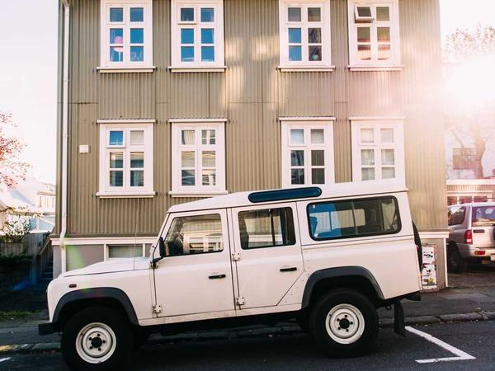
Q: What's the hardest part about doing the long jump?
A: The landing — and measuring the distance!
💡 Discussion: Why is this joke funny? What does it tell us about "Athletics: long jump and measurement"? Can you explain the concept to a partner?

Joke #5
📌 Curriculum Link: Netball: goal setting and positions

Q: Why was the netball player excellent at exams?
A: Because they were good at goal setting!
💡 Discussion: Why is this joke funny? What does it tell us about "Netball: goal setting and positions"? Can you explain the concept to a partner?

Joke #6
📌 Curriculum Link: Projectile motion in sport science
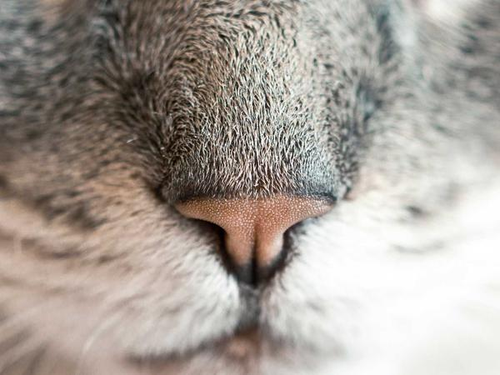
Q: What do you call a boomerang that doesn't come back?
A: A stick — but it teaches projectile motion!
💡 Discussion: Why is this joke funny? What does it tell us about "Projectile motion in sport science"? Can you explain the concept to a partner?

Joke #7
📌 Curriculum Link: Cricket: batting stance and balance

Q: Why did the cricket player go to the bank?
A: To check their balance at the crease!
💡 Discussion: Why is this joke funny? What does it tell us about "Cricket: batting stance and balance"? Can you explain the concept to a partner?

Joke #8
📌 Curriculum Link: Basketball: shooting and dunking

Q: Why do basketball players love cookies?
A: Because they can dunk them!
💡 Discussion: Why is this joke funny? What does it tell us about "Basketball: shooting and dunking"? Can you explain the concept to a partner?

Joke #9
📌 Curriculum Link: Cross-country running and orienteering
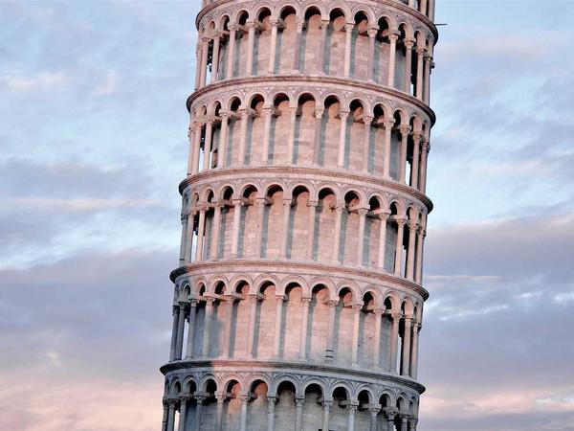
Q: What's a runner's favourite subject?
A: Jog-raphy! But really, cross-country navigation.
💡 Discussion: Why is this joke funny? What does it tell us about "Cross-country running and orienteering"? Can you explain the concept to a partner?

Joke #10
📌 Curriculum Link: Swimming strokes: front crawl, backstroke

Q: Why was the swimming pool so smart?
A: Because it was full of brainstrokes!
💡 Discussion: Why is this joke funny? What does it tell us about "Swimming strokes: front crawl, backstroke"? Can you explain the concept to a partner?

Joke #11
📌 Curriculum Link: Tennis scoring: love = zero

Q: Why don't tennis players ever get married?
A: Love means nothing to them!
💡 Discussion: Why is this joke funny? What does it tell us about "Tennis scoring: love = zero"? Can you explain the concept to a partner?

Joke #12
📌 Curriculum Link: Body composition: muscle, fat, bone
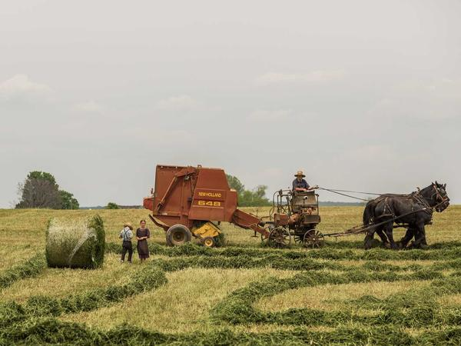
Q: Why did the PE teacher go to art class?
A: To learn about body composition!
💡 Discussion: Why is this joke funny? What does it tell us about "Body composition: muscle, fat, bone"? Can you explain the concept to a partner?

Joke #13
📌 Curriculum Link: Squats: lower body exercises
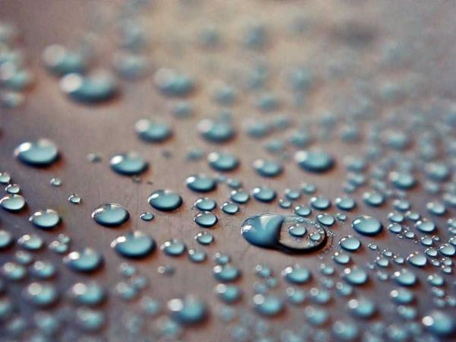
Q: What exercise do lazy people do best?
A: Diddly squats!
💡 Discussion: Why is this joke funny? What does it tell us about "Squats: lower body exercises"? Can you explain the concept to a partner?

Joke #14
📌 Curriculum Link: Relay races: baton technique

Q: Why was the relay team so good?
A: Because they never dropped the baton... or the ball!
💡 Discussion: Why is this joke funny? What does it tell us about "Relay races: baton technique"? Can you explain the concept to a partner?

Joke #15
📌 Curriculum Link: Flexibility and stretching in PE

Q: Why did the yoga teacher go to the beach?
A: To work on their flexibility and sun salutations!
💡 Discussion: Why is this joke funny? What does it tell us about "Flexibility and stretching in PE"? Can you explain the concept to a partner?

Joke #16
📌 Curriculum Link: Nutrition: carbohydrate loading for athletes

Q: What do you call a fake noodle?
A: An im-pasta — nothing to do with PE, but carb-loading is real!
💡 Discussion: Why is this joke funny? What does it tell us about "Nutrition: carbohydrate loading for athletes"? Can you explain the concept to a partner?

Joke #17
📌 Curriculum Link: Badminton: racquet sports techniques

Q: Why is badminton so loud?
A: Because each player raises a racquet!
💡 Discussion: Why is this joke funny? What does it tell us about "Badminton: racquet sports techniques"? Can you explain the concept to a partner?

Joke #18
📌 Curriculum Link: Hockey: scoring and game rules

Q: Why did the hockey player bring string?
A: To tie the score!
💡 Discussion: Why is this joke funny? What does it tell us about "Hockey: scoring and game rules"? Can you explain the concept to a partner?

Joke #19
📌 Curriculum Link: Warm-up routines before exercise

Q: What's a PE teacher's favourite type of music?
A: Hip-hop — great for warm-ups!
💡 Discussion: Why is this joke funny? What does it tell us about "Warm-up routines before exercise"? Can you explain the concept to a partner?

Joke #20
📌 Curriculum Link: Repetitions and sets in fitness training

Q: Why was the gym so noisy?
A: Because everyone was working on their reps!
💡 Discussion: Why is this joke funny? What does it tell us about "Repetitions and sets in fitness training"? Can you explain the concept to a partner?

