⚛️ Physics Jokes ⚛️
20 Curriculum-Linked Jokes
Each joke connects to a key learning point

Contents
1. Why can't you trust atoms? [Atoms are the building blocks of matter]
2. What did the thermometer say to the graduated cylinder? [Temperature measurement in degrees]
3. Why does a burger have less energy than a steak? [Energy levels and ground state]
4. What is a physicist's favourite food? [Nuclear fission — splitting atoms]
5. Why is electricity the ideal student? [Electrical conductivity]
6. What did one magnet say to the other? [Magnetic attraction and repulsion]
7. What did the photon say when asked about luggage? [Photons and the speed of light]
8. Why can you never trust stairs? [Potential and kinetic energy]
9. How does the moon cut its hair? [Solar and lunar eclipses]
10. Why did the sun go to school? [Luminosity and brightness of stars]
11. What did the nuclear physicist have for lunch? [Nuclear fission reactions]
12. Why did the light wave go to the doctor? [Wave phase and interference]
13. A neutron walks into a bar and asks the price. [Neutrons carry no electric charge]
14. What do you do with a dead battery? [Circuit components and batteries]
15. Why do physicists love airports? [Electrical terminals in circuits]
16. What's a nuclear physicist's favourite meal? [Nuclear fission releases energy]
17. Why was the physics teacher always calm? [Potential energy (stored energy)]
18. What did the scientist say when they found two isotopes of helium? [Isotopes — atoms with different neutrons]
19. Why does a photon never go to church? [Light as electromagnetic radiation]
20. How can you tell Saturn was married more than once? [Saturn's ring system]

Joke #1
📌 Curriculum Link: Atoms are the building blocks of matter

Q: Why can't you trust atoms?
A: They make up everything!
💡 Discussion: Why is this joke funny? What does it tell us about "Atoms are the building blocks of matter"? Can you explain the concept to a partner?

Joke #2
📌 Curriculum Link: Temperature measurement in degrees
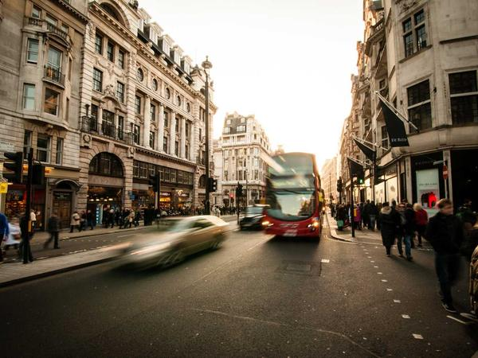
Q: What did the thermometer say to the graduated cylinder?
A: You may have graduated, but I've got many degrees!
💡 Discussion: Why is this joke funny? What does it tell us about "Temperature measurement in degrees"? Can you explain the concept to a partner?

Joke #3
📌 Curriculum Link: Energy levels and ground state

Q: Why does a burger have less energy than a steak?
A: Because it's in its ground state!
💡 Discussion: Why is this joke funny? What does it tell us about "Energy levels and ground state"? Can you explain the concept to a partner?

Joke #4
📌 Curriculum Link: Nuclear fission — splitting atoms

Q: What is a physicist's favourite food?
A: Fission chips!
💡 Discussion: Why is this joke funny? What does it tell us about "Nuclear fission — splitting atoms"? Can you explain the concept to a partner?

Joke #5
📌 Curriculum Link: Electrical conductivity

Q: Why is electricity the ideal student?
A: It conducts itself well!
💡 Discussion: Why is this joke funny? What does it tell us about "Electrical conductivity"? Can you explain the concept to a partner?

Joke #6
📌 Curriculum Link: Magnetic attraction and repulsion

Q: What did one magnet say to the other?
A: I find you very attractive!
💡 Discussion: Why is this joke funny? What does it tell us about "Magnetic attraction and repulsion"? Can you explain the concept to a partner?

Joke #7
📌 Curriculum Link: Photons and the speed of light

Q: What did the photon say when asked about luggage?
A: No thanks, I'm travelling light!
💡 Discussion: Why is this joke funny? What does it tell us about "Photons and the speed of light"? Can you explain the concept to a partner?

Joke #8
📌 Curriculum Link: Potential and kinetic energy

Q: Why can you never trust stairs?
A: They're always up to something!
💡 Discussion: Why is this joke funny? What does it tell us about "Potential and kinetic energy"? Can you explain the concept to a partner?

Joke #9
📌 Curriculum Link: Solar and lunar eclipses

Q: How does the moon cut its hair?
A: Eclipse it!
💡 Discussion: Why is this joke funny? What does it tell us about "Solar and lunar eclipses"? Can you explain the concept to a partner?

Joke #10
📌 Curriculum Link: Luminosity and brightness of stars

Q: Why did the sun go to school?
A: To get a bit brighter!
💡 Discussion: Why is this joke funny? What does it tell us about "Luminosity and brightness of stars"? Can you explain the concept to a partner?

Joke #11
📌 Curriculum Link: Nuclear fission reactions

Q: What did the nuclear physicist have for lunch?
A: Fission and chips!
💡 Discussion: Why is this joke funny? What does it tell us about "Nuclear fission reactions"? Can you explain the concept to a partner?

Joke #12
📌 Curriculum Link: Wave phase and interference

Q: Why did the light wave go to the doctor?
A: It was feeling out of phase!
💡 Discussion: Why is this joke funny? What does it tell us about "Wave phase and interference"? Can you explain the concept to a partner?

Joke #13
📌 Curriculum Link: Neutrons carry no electric charge

Q: A neutron walks into a bar and asks the price.
A: The bartender says: 'For you, no charge!'
💡 Discussion: Why is this joke funny? What does it tell us about "Neutrons carry no electric charge"? Can you explain the concept to a partner?

Joke #14
📌 Curriculum Link: Circuit components and batteries

Q: What do you do with a dead battery?
A: You barium! (Bury 'em)
💡 Discussion: Why is this joke funny? What does it tell us about "Circuit components and batteries"? Can you explain the concept to a partner?

Joke #15
📌 Curriculum Link: Electrical terminals in circuits
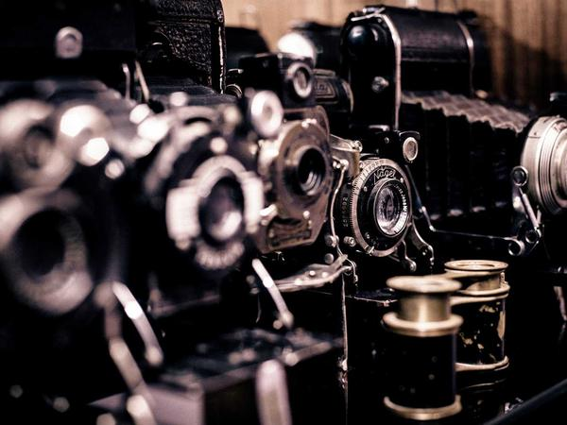
Q: Why do physicists love airports?
A: Because of all the terminals!
💡 Discussion: Why is this joke funny? What does it tell us about "Electrical terminals in circuits"? Can you explain the concept to a partner?

Joke #16
📌 Curriculum Link: Nuclear fission releases energy

Q: What's a nuclear physicist's favourite meal?
A: Fission and chips!
💡 Discussion: Why is this joke funny? What does it tell us about "Nuclear fission releases energy"? Can you explain the concept to a partner?

Joke #17
📌 Curriculum Link: Potential energy (stored energy)

Q: Why was the physics teacher always calm?
A: Because they had a lot of potential!
💡 Discussion: Why is this joke funny? What does it tell us about "Potential energy (stored energy)"? Can you explain the concept to a partner?

Joke #18
📌 Curriculum Link: Isotopes — atoms with different neutrons

Q: What did the scientist say when they found two isotopes of helium?
A: HeHe!
💡 Discussion: Why is this joke funny? What does it tell us about "Isotopes — atoms with different neutrons"? Can you explain the concept to a partner?

Joke #19
📌 Curriculum Link: Light as electromagnetic radiation

Q: Why does a photon never go to church?
A: Because it's already enlightened!
💡 Discussion: Why is this joke funny? What does it tell us about "Light as electromagnetic radiation"? Can you explain the concept to a partner?

Joke #20
📌 Curriculum Link: Saturn's ring system
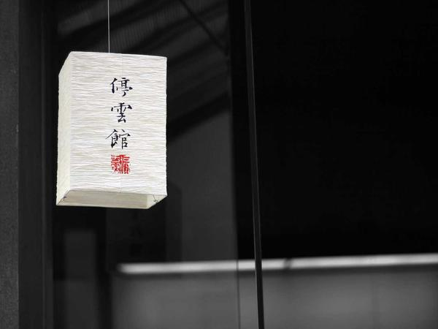
Q: How can you tell Saturn was married more than once?
A: It has a lot of rings!
💡 Discussion: Why is this joke funny? What does it tell us about "Saturn's ring system"? Can you explain the concept to a partner?

