🕊️ Religious Education Jokes 🕊️
20 Curriculum-Linked Jokes
Each joke connects to a key learning point

Contents
1. Why did Noah never go fishing? [Noah's Ark: pairs of animals]
2. Why didn't Jonah trust the ocean? [Jonah and the whale: faith and obedience]
3. What do you call a sleepwalking nun? [Roman Catholicism as a Christian denomination]
4. Why did Moses cross the Red Sea? [Exodus: Moses leading Israelites to freedom]
5. What do you call a prayer before a meal? [Prayer rituals across religions]
6. Why are churches so cold? [Places of worship and their design]
7. What do you call a philosophical sheep? [Buddhism: a non-theistic religion]
8. Why did the meditating monk refuse painkillers? [Meditation in Buddhist practice]
9. What lights a menorah best? [Hanukkah: Jewish festival of lights]
10. Why do pilgrims pack light? [Pilgrimage: Hajj, Lourdes, Varanasi]
11. What did the Sikh say at the langar? [Langar: Sikh communal kitchen for all]
12. Why did the philosopher cross the road? [Philosophical questions about existence]
13. What do you call a friendly mosque? [Ummah: the global Muslim community]
14. Why is the Golden Rule so popular? [The Golden Rule across world religions]
15. What do sacred texts have in common? [Sacred texts: Bible, Quran, Torah, Guru Granth Sahib]
16. Why did the student study ethics? [Ethics and moral decision-making]
17. What festival celebrates light over darkness? [Festivals of light across religions]
18. Why is charity important in Islam? [Five Pillars of Islam: Zakat (charity)]
19. What did the Dharma wheel say? [Dharma: teachings in Buddhism and Hinduism]
20. Why did the RE student smile during the exam? [Ultimate questions: meaning and purpose]

Joke #1
📌 Curriculum Link: Noah's Ark: pairs of animals

Q: Why did Noah never go fishing?
A: He only had two worms!
💡 Discussion: Why is this joke funny? What does it tell us about "Noah's Ark: pairs of animals"? Can you explain the concept to a partner?

Joke #2
📌 Curriculum Link: Jonah and the whale: faith and obedience

Q: Why didn't Jonah trust the ocean?
A: Because he knew there was something fishy about it!
💡 Discussion: Why is this joke funny? What does it tell us about "Jonah and the whale: faith and obedience"? Can you explain the concept to a partner?

Joke #3
📌 Curriculum Link: Roman Catholicism as a Christian denomination

Q: What do you call a sleepwalking nun?
A: A roamin' Catholic!
💡 Discussion: Why is this joke funny? What does it tell us about "Roman Catholicism as a Christian denomination"? Can you explain the concept to a partner?

Joke #4
📌 Curriculum Link: Exodus: Moses leading Israelites to freedom

Q: Why did Moses cross the Red Sea?
A: To avoid Egyptian traffic!
💡 Discussion: Why is this joke funny? What does it tell us about "Exodus: Moses leading Israelites to freedom"? Can you explain the concept to a partner?

Joke #5
📌 Curriculum Link: Prayer rituals across religions

Q: What do you call a prayer before a meal?
A: Grace — and it's practised across many faiths!
💡 Discussion: Why is this joke funny? What does it tell us about "Prayer rituals across religions"? Can you explain the concept to a partner?

Joke #6
📌 Curriculum Link: Places of worship and their design

Q: Why are churches so cold?
A: Because they're full of fans — and worship spaces matter!
💡 Discussion: Why is this joke funny? What does it tell us about "Places of worship and their design"? Can you explain the concept to a partner?

Joke #7
📌 Curriculum Link: Buddhism: a non-theistic religion

Q: What do you call a philosophical sheep?
A: Baaa-ddhist!
💡 Discussion: Why is this joke funny? What does it tell us about "Buddhism: a non-theistic religion"? Can you explain the concept to a partner?

Joke #8
📌 Curriculum Link: Meditation in Buddhist practice

Q: Why did the meditating monk refuse painkillers?
A: He wanted to transcend-dental medication!
💡 Discussion: Why is this joke funny? What does it tell us about "Meditation in Buddhist practice"? Can you explain the concept to a partner?

Joke #9
📌 Curriculum Link: Hanukkah: Jewish festival of lights

Q: What lights a menorah best?
A: The shamash — the helper candle lights the rest!
💡 Discussion: Why is this joke funny? What does it tell us about "Hanukkah: Jewish festival of lights"? Can you explain the concept to a partner?

Joke #10
📌 Curriculum Link: Pilgrimage: Hajj, Lourdes, Varanasi

Q: Why do pilgrims pack light?
A: Because the journey matters more than the luggage!
💡 Discussion: Why is this joke funny? What does it tell us about "Pilgrimage: Hajj, Lourdes, Varanasi"? Can you explain the concept to a partner?

Joke #11
📌 Curriculum Link: Langar: Sikh communal kitchen for all

Q: What did the Sikh say at the langar?
A: Everyone is welcome to eat — no exceptions!
💡 Discussion: Why is this joke funny? What does it tell us about "Langar: Sikh communal kitchen for all"? Can you explain the concept to a partner?

Joke #12
📌 Curriculum Link: Philosophical questions about existence
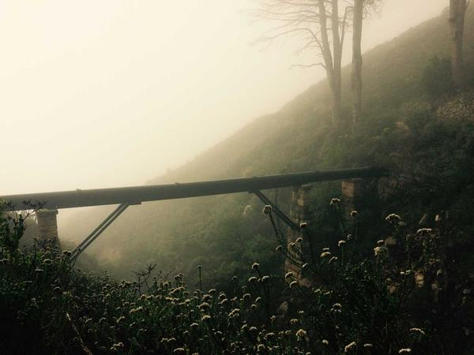
Q: Why did the philosopher cross the road?
A: To question why the road was there in the first place!
💡 Discussion: Why is this joke funny? What does it tell us about "Philosophical questions about existence"? Can you explain the concept to a partner?

Joke #13
📌 Curriculum Link: Ummah: the global Muslim community

Q: What do you call a friendly mosque?
A: A welcoming ummah!
💡 Discussion: Why is this joke funny? What does it tell us about "Ummah: the global Muslim community"? Can you explain the concept to a partner?

Joke #14
📌 Curriculum Link: The Golden Rule across world religions

Q: Why is the Golden Rule so popular?
A: Treat others as you want to be treated — every religion agrees!
💡 Discussion: Why is this joke funny? What does it tell us about "The Golden Rule across world religions"? Can you explain the concept to a partner?

Joke #15
📌 Curriculum Link: Sacred texts: Bible, Quran, Torah, Guru Granth Sahib

Q: What do sacred texts have in common?
A: They're all best-sellers with lasting impact!
💡 Discussion: Why is this joke funny? What does it tell us about "Sacred texts: Bible, Quran, Torah, Guru Granth Sahib"? Can you explain the concept to a partner?

Joke #16
📌 Curriculum Link: Ethics and moral decision-making

Q: Why did the student study ethics?
A: Because right and wrong aren't always black and white!
💡 Discussion: Why is this joke funny? What does it tell us about "Ethics and moral decision-making"? Can you explain the concept to a partner?

Joke #17
📌 Curriculum Link: Festivals of light across religions

Q: What festival celebrates light over darkness?
A: Diwali! But also Hanukkah and Christmas in their own way.
💡 Discussion: Why is this joke funny? What does it tell us about "Festivals of light across religions"? Can you explain the concept to a partner?

Joke #18
📌 Curriculum Link: Five Pillars of Islam: Zakat (charity)

Q: Why is charity important in Islam?
A: Because Zakat isn't optional — it's a pillar!
💡 Discussion: Why is this joke funny? What does it tell us about "Five Pillars of Islam: Zakat (charity)"? Can you explain the concept to a partner?

Joke #19
📌 Curriculum Link: Dharma: teachings in Buddhism and Hinduism

Q: What did the Dharma wheel say?
A: Keep turning — life is a cycle of learning!
💡 Discussion: Why is this joke funny? What does it tell us about "Dharma: teachings in Buddhism and Hinduism"? Can you explain the concept to a partner?

Joke #20
📌 Curriculum Link: Ultimate questions: meaning and purpose

Q: Why did the RE student smile during the exam?
A: Because they found the meaning of life... in the mark scheme!
💡 Discussion: Why is this joke funny? What does it tell us about "Ultimate questions: meaning and purpose"? Can you explain the concept to a partner?

