John Barker

Data Visualization – Final Project

Abstract

Antimicrobial resistance is a growing global challenge that requires a serious and concerted approach to manage. Genes encoding resistance to key drugs are spread throughout the environment by various forms of gene transfer and can significantly worsen infections that threaten public health. A variety of factors that may contribute to worsening this problem, including agricultural output, livestock holdings, and gross national income, are here considered and visualized to consider various correlations with antimicrobial resistance to particular bacterial strain resistances to particular compounds, as well as the total burden of AMR, in hopes of better identifying avenues for possible improvement.

Introduction

The use of antimicrobial agents in agriculture is a longstanding issue at the intersection of public health and human development. The keeping of livestock animals has always been associated with the spread of some diseases, and animal husbandry in the close quarters necessary for the most efficient and cost-reducing modes of modern industrial agriculture is particularly susceptible. However, the development of antimicrobial-resistant strains of human diseases represent a serious threat to public health, and the maintenance of tools to control dangerous infectious strains is of considerable public interest.

Background

Genes for antimicrobial resistance have been found around the world, spreading along with the use of antimicrobial agents. Gene sequences associated with microbial resistances have even been found in samples taken aboard the International Space Station (Urbaniak et al., 2018). Although Karkman et al. (2020) have suggested that socioeconomic factors and the quality of sewage infrastructure are major contributors to antibiotic resistance prevalence, whereas other studies like Manyi-Loh et al. (2018) focus primarily on the influence of broader antibiotic use on environmental factors. Fresia et al., (2019) and Su et al., (2017) provide additional information relating to the extraction and use of metagenomic data. Data from these studies provides additional insight into the practices of data collection and further sources of information that can be correlated with the factors being investigated.

Not all antibiotics are created equal, nor are they all used equally for agricultural and medical purposes. The US FDA records that a large majority of the antimicrobial agents used for agricultural purposes in the United States are tetracyclins and ionophores, used primarily in the husbandry of cattle and swine, and that medically important antimicrobials such as cephalosporins are much more commonly used in humans (FDA, 2018). Given this separation in usages, it is reasonable to hypothesize that elevated environmental antimicrobial resistance – in the form of measured genes that confer such resistance as captured at a sequencing facility, or culture data proving that a given bacterium is resistant to a given AM agent – would be more suggestive of an agricultural cause if the resistance were to tetracyclins, and more suggestive of a medical cause if the resistance were to cephalosporins. This is, unfortunately, not universally true – tetracyclins are used in some countries to treat tuberculosis, and the incidence of this disease varies substantially from region to region. However, there are some subregions of the planet in which TB incidence is low and with sufficiently similar levels of GDP per capita, water infrastructure, and medical coordination that some classes of antibiotics may be separated out by agricultural or medical application. We can then peruse available information looking for correlations

Approach

Due to the relative availability of data sets that are granular enough to be localized to specific latitude and longitude, for this project I sought to make comparisons at a higher level, attempting to co-visualize reported antimicrobial resistance events, national GDP, and national agriculture, then drill down into more detail on related information. To do this, I utilized pre-existing visualization generation tools linked to national and international databases whose datasets are not open to the public, and I also worked to generate some visualizations of my own from open access sources.

Results

An initial review of OneHealthTrust’s collected research data on global E. coli microbial isolates displaying resistance to Cephalosporins shows widespread resistance, with many countries showing that a majority of such detected human coliforms are resistant to the class of medication.

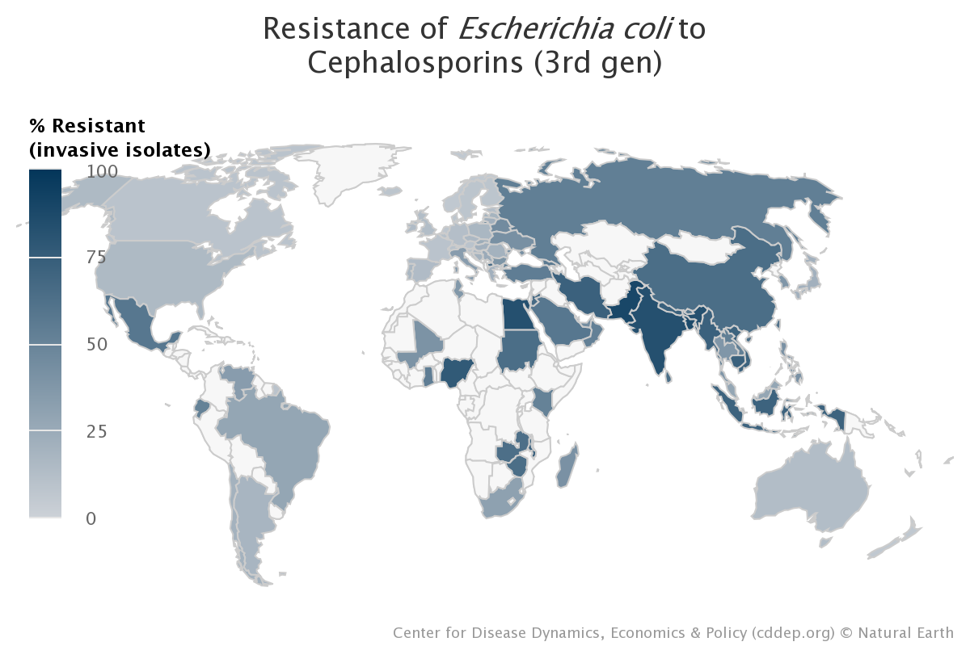

A superficial relationship between GNI per capita and percent resistance is already suggested from this initial visualization. The countries seen as lower income below in a World Bank visualization are also mor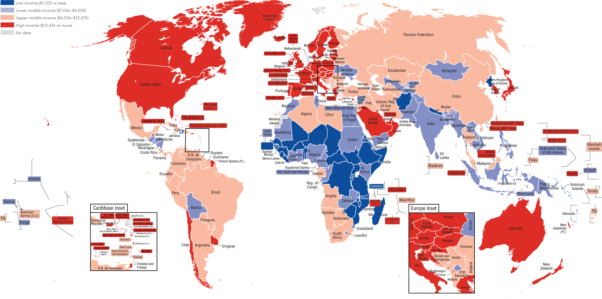e likely to be darkened above with higher percentages of resistant bacterial isolates.

While metrics of national income and economic health can capture any number of things, making this first pass approach merely suggestive, when maps recording livestock holdings per capita by are also considered, the relationship looks far less direct between farming and incidents of AMR. At first glance, it seems that economic factors are a better predictor of reports of antimicrobial resistance than mere agricultural output per capita.

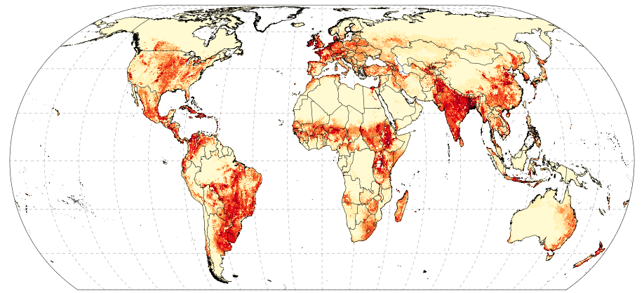

When overlaid with the original map of measured antimicrobial resistances, it is clear that in some places, like India, high prevalence of livestock is associated with antimicrobial resistance, but similarly high densities of livestock in Europe and the Americas is not predictive of similarly high antimicrobial resistance. This indicates that on some level, the global burden of antimicrobial resistance is predicted by other factors, and that GDP may be a more effective macro scale metric.

Intriguingly, there is more apparent correlation with nations experiencing a recent *increase* in agricultural productivity, but this is difficult to disentangle from lower income countries experiencing economic growth without requisite water infrastructure (and I must still, regrettably, rely on GDP as a surrogate metric for plumbing quality) Fuglie, Wang, and Ball (2012) capture a map that looks not dissi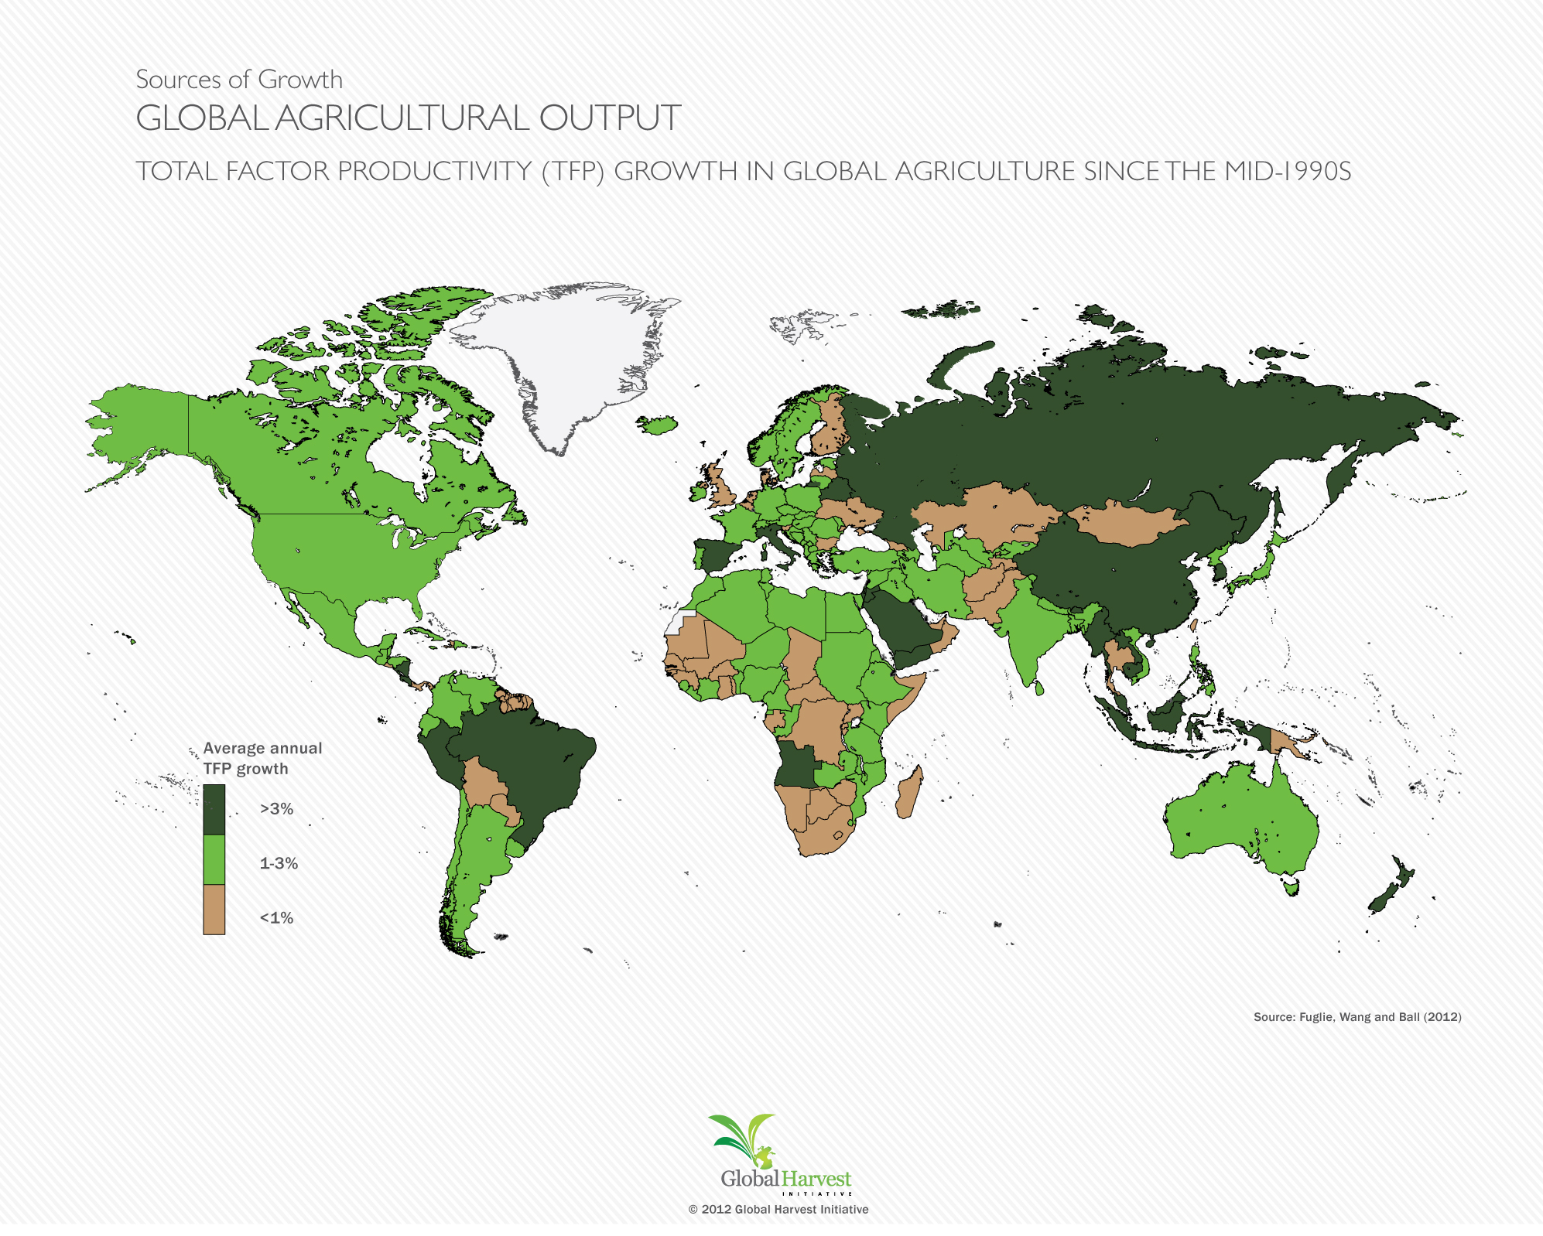milar to the GDP map in recording agricultural growth.

Although a global tendency may be observed by considering these figures generated from other datasets, it is useful to consider correlations between AMR and GDP or agricultural output within a smaller region, preferably one that is homogeneous enough to identify smaller yet meaningful trends that could be addressed at a national or regional level. The European Union’s Center for Disease Prevention and Control maintains a database of reported isolations of resistant bacteria of various species, broken down by nation and subcategorized by the type of antimicrobial to which they are resistant. The EU also records total livestock by head of cattle (or “bovine like animals,” technically), in the Eurostat data browser over the years 1974 to 2021 (Eurostat) – this dataset is used, as cows are associated with heavier antimicrobial use and a better predictor of agricultural use of antimicrobial agents that might contribute to regional AMR events more precisely than general agricultural output. The World Bank also records GDP in current US dollars for every country on Earth, and from this I gathered GDP as an imperfect surrogate measure for development and infrastructure quality. For the sake of easy visualization, and to avoid potential complications from the Covid-19 pandemic, I collected all of this information by nation for the year 2019, as a representative year of the recent past. I also gathered the latitude and longitude coordinates of these nations various capital cities, so as to have a reference dataset on hand to plot dots on a map if needed.

Within the context of EU nations alone, the data plotted with increasingly large markers over countries, plotted against GDP, the tendency of large markers to occur more frequently over low GDP nations is noticeable:

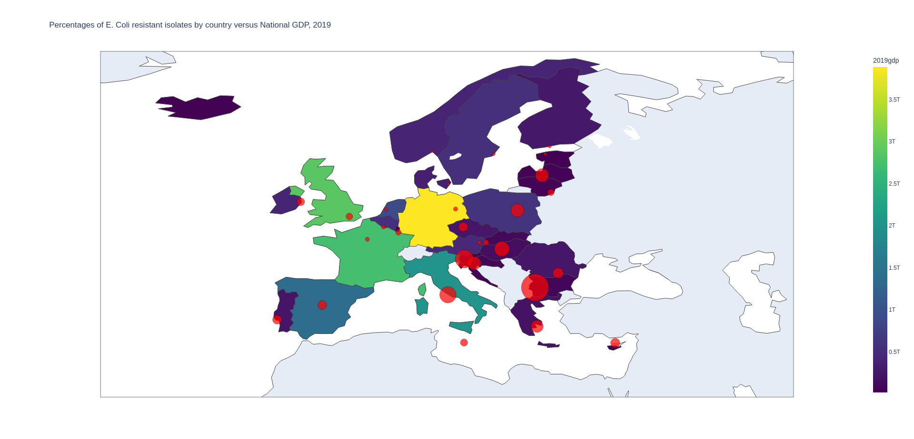

However, we also wish to investigate whether the presence of high numbers of livestock farms causes deviations from the trend associating GDP with antimicrobial resistance – in other words, we wish to see whether having lots of cows can make a country worse off for AMR events than it would otherwise be expected to be, given its GDP. Using a scatter plot where the size of the dots correlates with the number of cattle herds in a given nation, an interesting relationship can be observed.

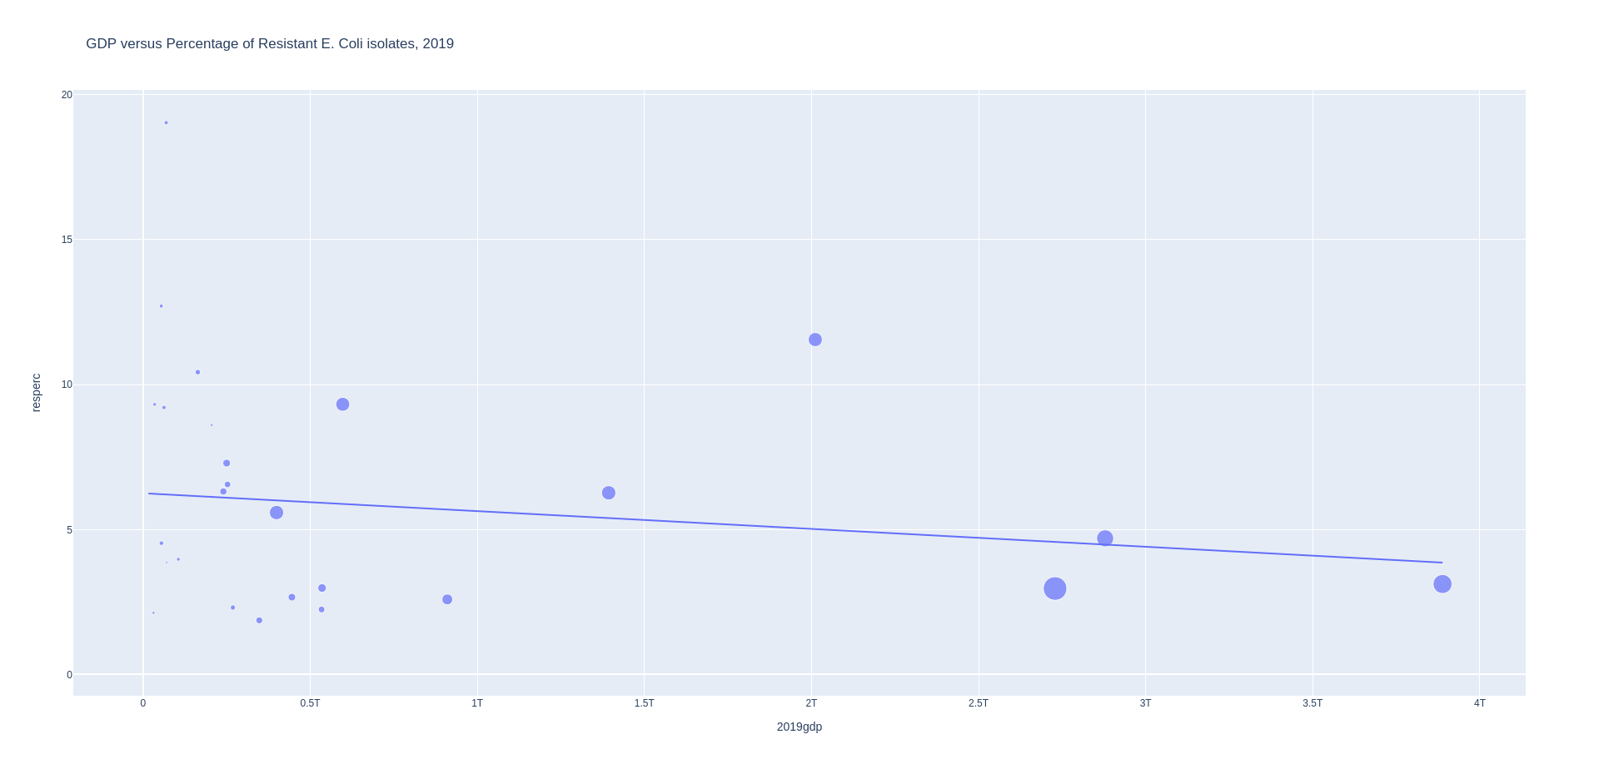

The above figure shows a slight downward slope – as GDP increases, we see mild reductions in the percentages of AMR measurements – but outlier points that fall above the line, having unexpectedly high levels of measured AMR isolates are usually large dots indicating large numbers of livestock being farmed in the country. This tendency is not ironclad, but it is noticeable on this plot. It bears mentioning that the greater medical infrastructure of high-GDP nations may provide more resources for frequent testing, driving down the percentage of positive results, but for the purposes of this analysis I will rely upon the ECDC to not publish data that is statistically meaningless – and the absolute n of the isolates is almost always in the thousands.

Despite these interesting correlations, it must be observed that meaningful confounders exist. For one thing, despite the observed pattern above, the slope of the trend line correlating increased numbers of cattle herds and antimicrobial resistance is actually slightly negative:

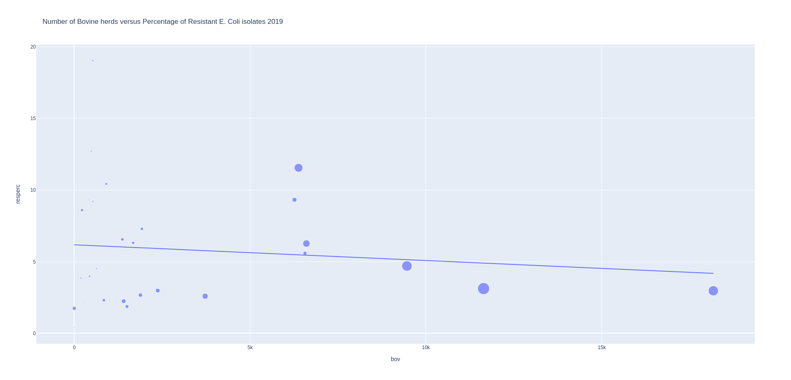

It is also difficult to find an enormous effect from livestock agriculture in continental Europe. While their data is the most legible and accessible, the farming of cattle is quite common across the continent, and despite a few outlier nations, a great many countries have *some* cow herding, which makes it difficult to truly look for total outliers that prove a strong effect, given the below visualized distribution of which nations host what percentage of cattle herds:

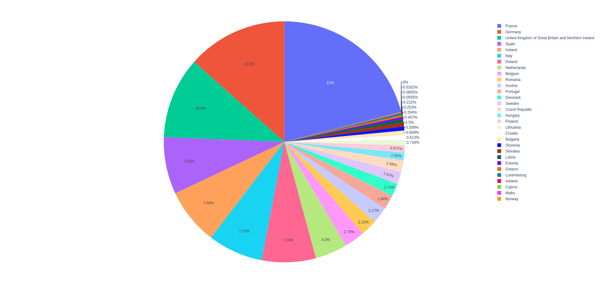

Conclusions

To the extent that these factors of agricultural use and water infrastructure quality are linked and may even influence one another, it becomes substantially harder to trace the responsibility for any one change in environmental AMR rates. Cesoniene et al. (2018) have concluded that the presence of livestock farming places a strain on regional water infrastructure, and that surface water quality is generally degraded surrounding animal farms. Given that these farms are highly likely to utilize antimicrobial agents in one form or another, contributing to the development of resistant genes, these can be expected to enter the environment. However, the counterintuitive negative trend line that shows that more cows are associated with marginally fewer antimicrobial incidents may actually suggest that there is a maximum number of cows that can safely be managed by advanced infrastructure, and that nations with high national GDP, implicitly high quality national health infrastructure, and high numbers of livestock farms can capitalize on a kind of economies of scale to better account for the impact of livestock farming, to better contain the resultant waste, and to better manage its environmental and public health impact.

In short, the association between agricultural activity and antimicrobial resistance is not glaringly profound. While there are apparent effects at scale, within the European Union there are sufficient other factors in play that – although industrial agriculture is responsible for the greatest use of antimicrobial agents – the link between these practices and the prevalence of antimicrobial bacterial strains that are detected in the human population is more complex than many might assume. The literature’s claims that GDP as a proxy for water infrastructure quality is a stronger predictor of improved management of antimicrobial resistance are thus born out by this analysis.

References:

2017 Summary Report on Antimicrobials Sold or Distributed for Use in Food-Producing Animals. (2018). In *FDA.gov*. US Food and Drug Administration. Retrieved December 11, 2022, from https://www.fda.gov/media/119332/download

# *Ban on antibiotics as growth promoters in animal feed enters into effect* (2005) *European Commission - European Commission*. Available at: https://ec.europa.eu/commission/presscorner/detail/en/IP_05_1687 (Accessed: December 1, 2022).

Cesoniene L, Dapkiene M, Sileikiene D. The impact of livestock farming activity on the quality of surface water. Environ Sci Pollut Res Int. 2019 Nov;26(32):32678-32686. doi: 10.1007/s11356-018-3694-3. Epub 2018 Nov 22. PMID: 30467746.

Eurostat. (n.d.). *Bovine population - annual data* [Dataset]. Eurostat Database. https://ec.europa.eu/eurostat/databrowser/view/APRO_MT_LSCATL/default/table?lang=en

Eurostat. (n.d.). *Pig population - annual data* [Dataset]. Eurostat Database. https://ec.europa.eu/eurostat/databrowser/view/APRO_MT_LSPIG/default/table?lang=en

Eurostat. (n.d.). Sheep *population - annual data* [Dataset]. Eurostat Database. https://ec.europa.eu/eurostat/databrowser/view/APRO_MT_LSSHEEP/default/table?lang=en

Karkman, A., Berglund, F., Flach, CF. et al. Predicting clinical resistance prevalence using sewage metagenomic data. Commun Biol 3, 711 (2020). <https://doi.org/10.1038/s42003-020-01439-6>

Fresia, P., Antelo, V., Salazar, C. et al. Urban metagenomics uncover antibiotic resistance reservoirs in coastal beach and sewage waters. Microbiome 7, 35 (2019). https://doi.org/10.1186/s40168-019-0648-z

Fuglie, K. O., Wang, S. L., & Ball, E. (2012). *Productivity Growth in Agriculture: An International Perspective*. CABI.

*GDP - current dollars - European Union, 2019*. (2020). [Dataset]. World Bank. https://data.worldbank.org/indicator/NY.GDP.MKTP.CD?locations=EU

Manyi-Loh C, Mamphweli S, Meyer E, Okoh A. Antibiotic Use in Agriculture and Its Consequential Resistance in Environmental Sources: Potential Public Health Implications. Molecules. 2018 Mar 30;23(4):795. doi: 10.3390/molecules23040795. PMID: 29601469; PMCID: PMC6017557.

Nikolaos I. Rousis, Zhe Li, Richard Bade, Michael S. McLachlan, Jochen F. Mueller, Jake W. O'Brien, Saer Samanipour, Benjamin J. Tscharke, Nikolaos S. Thomaidis, Kevin V. Thomas, Socioeconomic status and public health in Australia: A wastewater-based study, Environment International, Volume 167, 2022, 107436, ISSN 0160-4120, https://doi.org/10.1016/j.envint.2022.107436.

OneHealthTrust. ResistanceMap: Antibiotic resistance. 2022. https://resistancemap.onehealthtrust.org/AntibioticResistance.php. Date accessed: May 31, 2022.

Su, JQ., An, XL., Li, B. et al. Metagenomics of urban sewage identifies an extensively shared antibiotic resistome in China. Microbiome 5, 84 (2017). https://doi.org/10.1186/s40168-017-0298-y

*The world by income, FY2017*. (2018). World Bank. https://datatopics.worldbank.org/sdgatlas/archive/2017/images/figures-png/WLD-income-map.png

Urbaniak C, Sielaff AC, Frey KG, Allen JE, Singh N, Jaing C, Wheeler K, Venkateswaran K. Detection of antimicrobial resistance genes associated with the International Space Station environmental surfaces. Sci Rep. 2018 Jan 16;8(1):814. doi: 10.1038/s41598-017-18506-4. PMID: 29339831; PMCID: PMC5770469.