The UML-Diagrammer program’s right-click feature on the decoration (association) line allows for the creation of composition, aggregation, association, or none.

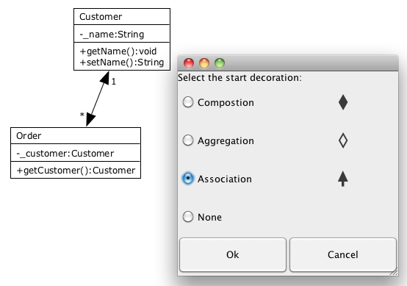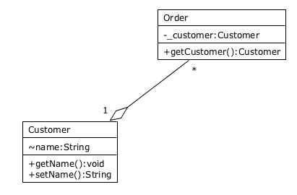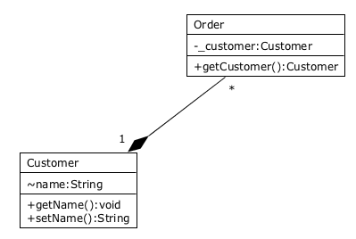

The multiplicities can be added, and manipulated. Notice the right-click feature being utilized to change these as well as the other related features.

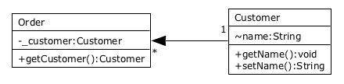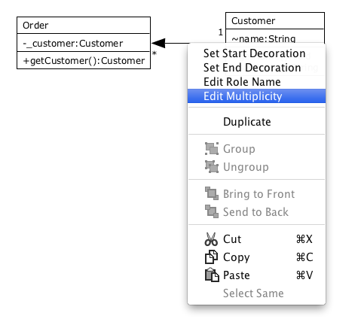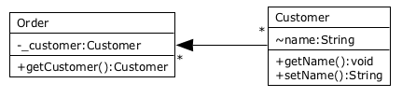

Role names and association names can be added, changed, or removed (blank text). Text-boxes may also be used to add extra text to the diagram.

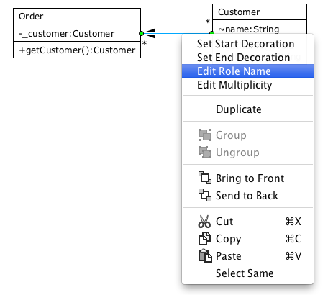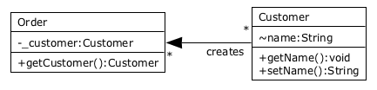

The UML-Diagrammer program allows the ability to create a unidirectional association between two classes, and easily change to a bidirectional association.

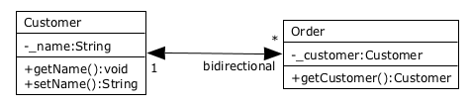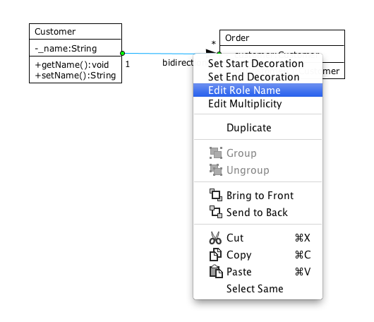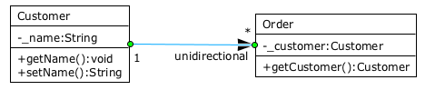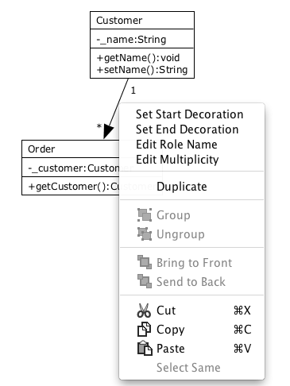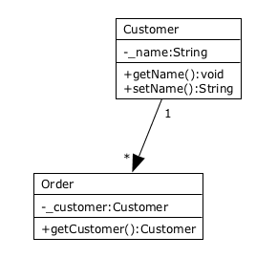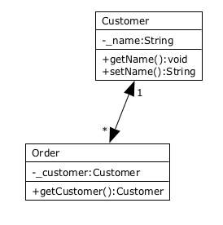

The user may save the created diagram as an xml file, which will appear in both the “open” and “open recent” menus from the drop-down file menu. A new “unnamed” file is made initially. The tmp.xml file is opened (which contains just 2 default classes to show the functionality only) and that file “tmp.xml” is loaded.

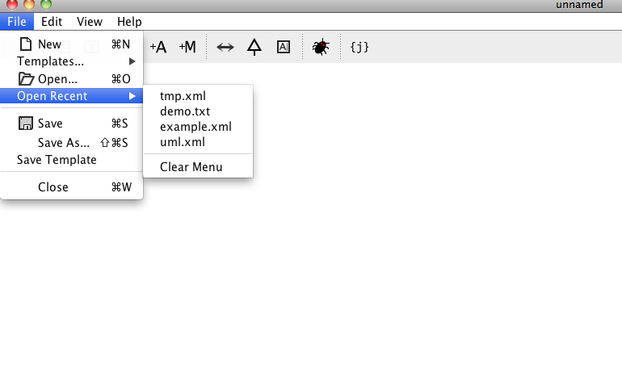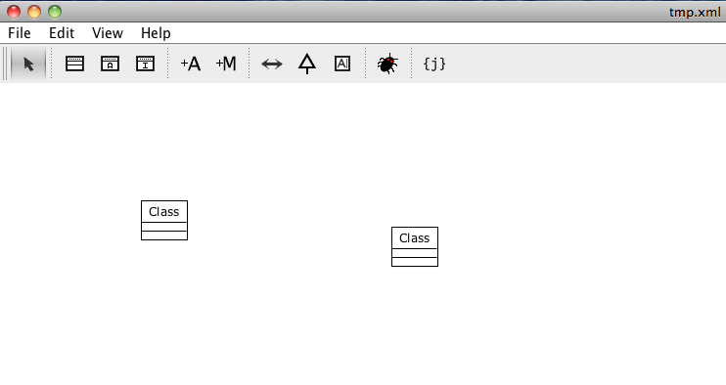

Java code can be generated from a created UML diagram. This shows that the files were created, along with a snippet of the files to show correct code generation.

