Black and White in the 20th-Century US

We use the SR02 to track infant well-being in the US from census counts, to correct a tendency for male-biased age-heaping at age one. Looking at the SR02 for black children offers a number of interesting results. First, based on the SR02, improvements in the well-being of black children were limited in magnitude, and came only in the last three or four decades of the 20th century. At census benchmarks from 1900 to 1940, the black SR02 hovered in a narrow range from 98.4 to 99.2 (see Table and Figure). Until 1990, the black SR02 was consistently some 4 or 5 percentage-points below the white SR02. The sex-ratios offer one more piece of evidence of the well-known racial disparities in well-being in America.

Table 1: The Under-Two Sex Ratios, Blacks & Whites in the 20th-century US
 | 1900 | 1910 | 1920 | 1930 | 1940 | 1950 | 1960 | 1970 | 1980 | 1990 | 2000 | 2010
Black | 98.5 | 99.2 | 98.5 | 98.4 | 98.9 | 101.0 | 99.2 | 100.6 | 101.4 | 102.1 | 103.1 | 102.8
White | 102.8 | 103.2 | 103.2 | 103.6 | 104.2 | 104.6 | 103.9 | 104.6 | 105.5 | 105.4 | 105.3 | 104.7
Gap | 4.3 | 4.0 | 4.7 | 5.2 | 5.3 | 3.6 | 4.7 | 4.1 | 4.2 | 3.3 | 2.3 | 2.0

Sources: US Census Bureau, Population Division, National Intercensal Dataset: 2000-2010; Censuses of Population, 1900-1990 (see appendix).

The sex-ratios for blacks and whites tended to improve after 1960, with some relative improvement in the black SR02, as the gap fell from over 4 percent-points in 1970 and 1980 to well under 3 percent-points in 2000 and 2010. Ignoring the racial disparity, one might focus on the black SR02 reaching a level of about 103 in 2000 and 2010, a substantial improvement over the roughly 99-point values typical before 1950. However, with the white SR02 at about 105 in 2010, a pronounced (if narrower) racial disparity in child well-being is evident.

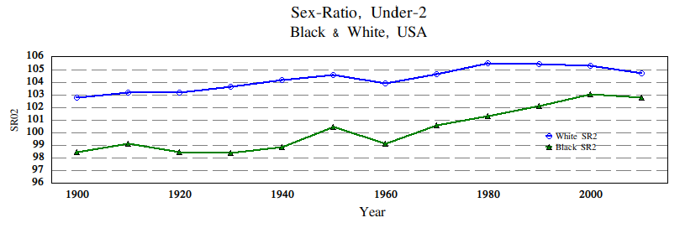
The Black IMR
The SR02 evidence raises questions about existing estimates of black infant mortality. The HSUS series indicates dramatic reductions in black infant mortality across the period 1900 to 1940, falling from 170 per thousand to just to just 73 per thousand. That sort of drop in IMR would cause at least a 2 point rise in the SR1 (from 99.3 to 101.3, for example). However, the black SR2 is roughly stable over those four decades, hovering around 99.

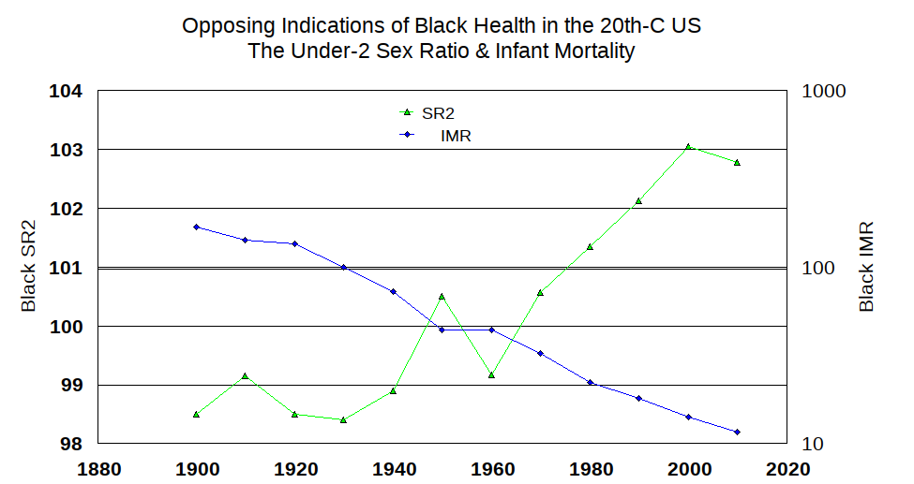
Black and White Sex Ratios at Birth
CDC data has estimates of sex ratios at birth (SRB) by race. There we see a 0.5 percentage point rise in the black SRB from 1970 to 2000. The black SR2 rose by 2.5 percent points in the same period, and we might attribute 1/5 of that gain to the improvement in the SRB. Interestingly, the white SRB fell by 1.1 points in the same period, while the white SR2 increased by seven tenths of a point. On our reading, improvements in both the SRB and infant mortality contributed to a rising black SR2 in those three decades, while for whites a deterioration in the SRB was offset by improvement in infant mortality (which fell from 18 per 1000 to 6 per 1000 in the period). The black-white gap in the SRB narrowed by 1.6 points, and the gap in the SR2 narrowed by 2.4 points. We see the greater narrowing of the SR2 gap (0.8 points) as a result of the narrowing of the black-white IMR gap. But although the gap narrowed, at the close of the century black infant mortality (12%) was double that of whites -- a reminder that modest progress left substantial racial health inequities to be remedied.
Appendix: Sources for the Black and Whites Under-2 Sex Ratios (SR2)
2010&2000: Intercensal Estimates of the Resident Population by Single Year of Age, Sex, Race, and Hispanic Origin for the United States: April 1, 2000 to July 1, 2010. 1990: 1990 Census of Population, General Population Characteristics, United States (1990 CP-1-1), Table 13 (Single Years of Age by Sex, Race, and Hispanic Origin: 1990).
1980: 1980 Census of Population, Vol. 1, Ch. B, Table 41 (Single Years of Age by Race, Spanish Origin, and Sex: 1980). 1970 & 1960: National Intercensal Tables: 1900-1990 (released in 2004); spreadsheets for 1970 and 1960.
1950: Census of Population: 1950, Vol. 2, Tables 94 & 97; Table 94 has sex by single year of age for “White” and for all “Nonwhite”. For our black SR02 in 1950 (100.9), we reduced the nonwhite value by 0.1, based on the difference between the negro and nonwhite sex-ratios for under-age-5 (via Table 97). A 1950 black SR02 of 101.0 results from applying the same correction to the nonwhite SR02 from the 1950 spreadsheet in the National Intercensal Tables: 1900-1990.
1940: Census of Population: 1950, Vol. 2, Table 95 & 1940, Vol. 2, Table 7. Table 94 has sex by single year of age for “White” and “Nonwhite.” For our black SR02 in 1940 (99.1), we reduced the nonwhite value by 0.1, based on the difference between the negro and nonwhite sex-ratios for under-age-1 and under-age-5 (via Table 7). A 1940 black SR02 of 98.9 results from applying the same correction to the nonwhite SR02 from the spreadsheet for 1940 in the National Intercensal Tables: 1900-1990 (released in 2004).
1930: Fifteenth Census of the United States: 1930, Population, Vol. II, Chapter 10, Table 21 (Age by Single Years, By Color, Nativity, and Sex). White and black population counts are given. The black SR02 value is consistent with the nonwhite SR02 value from the spreadsheet for 1930 in the National Intercensal Tables: 1900-1990.
1920: Fourteenth Census of the United States taken in the year 1920, Vol. II, Population, Chapter III, Table 9 (Distribution by Single Years of Age for Population Classes, By Sex).
1910: Thirteenth Census of the United States Taken in the Year 1910, Vol. 1, Population 1910, Chapter IV, Table 29 (Distribution by Single Years of Age of the Population). A nonwhite SR2 of 100.8 comes from the spreadsheet for 1910 in the National Intercensal Tables: 1900-1990 (released in 2004). The counts there are rounded to the thousands, and we ignore those data in favour of the census tabulation.
1900: Twelth Census of the United States, Census Reports Vol. II, Population, Part II, Ages, Table 1 (Ages of the Aggregate Population of the United States, Classified by Sex, General Nativity , and Color). A nonwhite SR2 of 100.0 comes from the spreadsheet for 1900 in the National Intercensal Tables: 1900-1990 (released in 2004). The counts there are rounded to the thousands, and we ignore those data in favour of the census tabulation.

Other References.
Eriksson, Katherine, Gregory T. Niemesh, and Melissa Thomasson (2018). "Revising Infant Mortality Rates for the Early Twentieth Century United States." Demography 55:2001-2024.
Historical Statistics of the US, Series Ab921, Ab923.
Martin, Joyce A., Brady E. Hamilton, Stephanie J. Ventura, Fay Menacker, Melissa M. Park, and Paul D. Sutton. "Births: final data for 2001." National Vital Statistics Reports, Vol. 51, No. 2 (2002).
Mathews, T. J., and Brady E. Hamilton. Trend Analysis of the Sex Ratio at Birth in the United States” National Vital Statistics Reports, Vol. 51, No. 2 (2002).

A part of “Infant Sex-Ratios and Maternal-Infant Health,” Jesse McDevitt-Irwin & James R. Irwin, Sept. 2020
Relative male-baised age-heaping at one-year’s age among blacks is evident in the most of the censuses before 1970. For example, from the counts in the published 1960 census, the black SR1 was 98.8 and the SR1-2 was 99.5; the PUMS sample also shows an elevated SR1-2 vs SR1, at 101.8 and 103.2 respectively. Those samples include fewer than 30,000 children in each age group, and the discrepencies between the levels of sex ratios in the samples relative to the published tabulations is a reminder of the need for large samples to dampen random variation.
The SR02 series is somewhat less inconsistent with Eriksson et al’s (2018) revised estimates of black infant mortality, which are for the period 1915-1940. For 1915, their black IMR (12.6%) is 5.5 percentage points below the HSUS rate (18.1%). Eriksson et al.’s estimates (pp. 2003, 2016) show a lesser decline in the black IMR from 1915 to 1940 -- a drop of just 6.8 %-points compared to a 10.8 point drop in the HSUS series. But both sets of IMR estimates suggest improvement in the health of black infants in the period 1915 to 1940 which is not corroborated by our sex-ratio evidence.

