**John Roy Mag-usara**

Z6358 San Isidro Talisay Cebu 6045

Phone: (+63) 922-9555-710

Email: jrmdevworks@gmail.com

**PROFILE**

Advanced web developer with over 5 years of experience in structuring, developing and implementing web projects. Innovative use of technology in advanced programming and excellent problem solving skills. Able to complete projects efficiently and satisfy customers with attractive, user-friendly web application.

**SKILLS**

* PHP
* MySQL
* HTML
* CSS
* JavaScript
* jQuery
* WordPress
* Bootstrap
* Laravel
* AngularJS
* GIT / BitBucket
* CodeIgniter Framework
* Zend Framework
* Smarty Template Engine
* REST API Integration
* SEO / Google Analytics
* Infusionsoft Marketing
* Paypal Payments
* Authorize.net Payments
* Basic Linux Server Management
* Joomla, Drupal, and Magento Setups
* NodeJs, Express, ReactJs
* Phyton, Pip, vertualenv
* Basic Graphics Editing

**WORK EXPERIENCE**

**SQFACTORY, Florida USA**

***PHP Developer / Wordpress Engineer, 2016 - present (Remote / Homebased)***

* Setup and Managing Wordpress Websites Frontend and Backend
* Building Themes and Plugins
* SEO and Website Security
* Setup and Develop API and Plugins to sync Wordpress site to Mobile App

**ITMED CARE, West Palm Beach FL**

***Senior Web Developer, 2014 - 2016 (Remote / Homebased)***

* Main focus on Admin Backend Programming with PHP and MySQL, AJAX, jQuery, Bootstrap
* Developed Affiliate Program System with Admin Management and Front Office for members
* Made REST API to sync between mobile and website
* Database Analysis and Architecture
* Domain and CPANEL Management
* Experienced Linux Server Setups
* Setup VICIDIAL, BigBlueButton, and other video sharing systems

**BARAK HOSTING, Jacksonville FL**

***Lead Web Developer, 2011 - 2014 (Remote / Homebased)***

* Started to work as remote homebased programmer
* Develop company MVC platform libraries in PHP and MySQL
* Hardcore coding on our CRM projects
* Custom Website Builder for Healthcare Clients
* Made also WordPress Blogs and Themes

**BARAK WEB DESIGN, Cebu PH**

***Web Developer, 2008 – 2009 (Office)***

* Covert PSD mockup to page in HTML and CSS
* Website Logo editing using Fireworks
* Developed company website with admin backend
* OOP Programing PHP, MySQL, AJAX, jQuery

**PROWEAVER COMPANY, Cebu PH**

***PHP Programmer, 2007 – 2008* *(Office)***

***Lead Programmer, 2009 - 2011* *(Office)***

* Developed website using PHP and MySQL
* Worked on Ecommerce Project and Real Estate Website
* Developed company website using Zend Framework and Smarty
* Also experience using Ruby on Rails

**EDUCATION**

**CEBU INSTITUTE OF TECHNOLOGY UNIVERSITY, Cebu City PH**

***Bachelor of Science in Information Technology October 2006***

* 2 years as Non Academic Scholar at CITU MDTC (*Multimedia Development Training Center*)
* Published web community forum website about computer repairs and tutorials.
* Web design internship at FCQ Worldwide.

**WEBSITE URL**

<https://jrmdevworksonline.github.io/profile/>

**LATEST PROJECTS**

https://nylitguide.com

https://floridalitigationguide.com

<https://www.weedtrivia.com>

<https://www.sqfactory.com>

<https://mihclinic.com/>

<http://www.unitrivia.com>

<https://hopeoneworld.com>

<http://sqrlabz.com>

<http://skyjetselite.com>

<http://abbeyk.com>

<http://www.haulawayautotransport.com>

<http://wp.sqfactory.com/americandreamdemo/>

**CUSTOM BACKEND PROJECTS**

**Elite Health Billing**

<http://www.elitehealthbilling.com>

Powered with Bootstrap3, PHP, MySQL, jQuery, Ajax and other 3rd party API

Below is the sample screen on the admin backend. The site has mobile app that will sync data from here using my REST API.

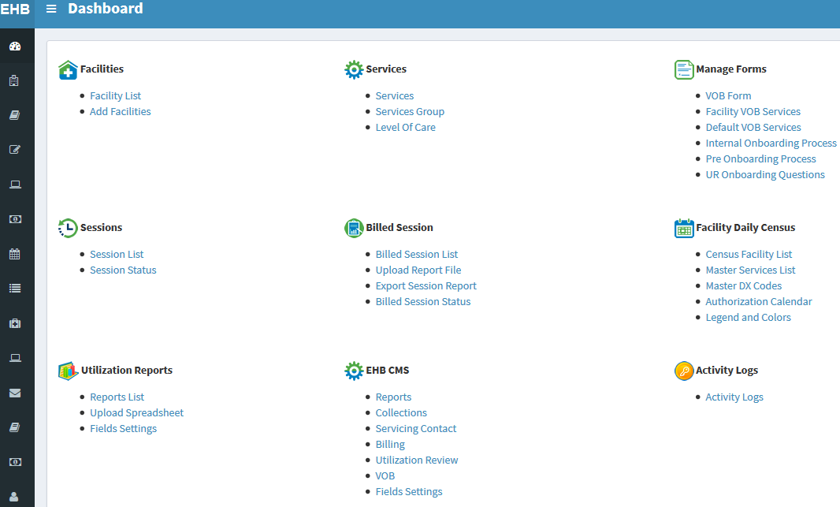

Facility Daily Census is one of the unique feature of the system. This will manage facility activity of their patients and therapist of what services offered or being done and billed in any date and time.

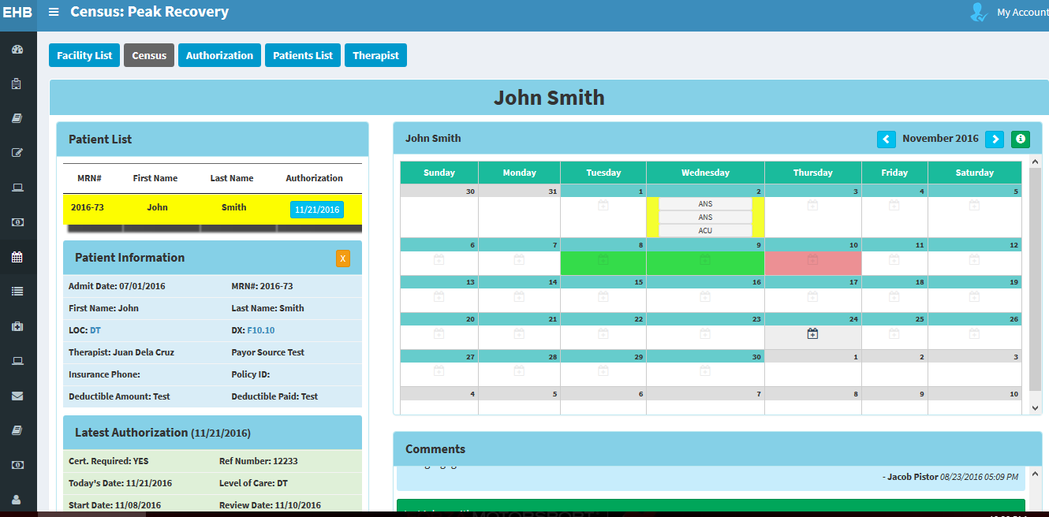

**BBD HealthCare** **Company**

<http://bbdhealthcare.com>

Uses custom admin backend build from scratch with jQuery UI, MySQL Database and OOP programming.

One of the best feature on the system is the Unilevel Group Tree Program.

The site has affiliate program for their “Affiliate Reps”, “Company Managers”, “Company Reps” and “Physician Practice” the tree will display your affiliates users as downlines and it will determine the rank and levels with their colors and totals. It’s very interactive and user friendly it runs with jQuery plugin together with my javaScript codes that will sync to the database.

