**Steps for Using Pre-Processed Evidence for Lab 4**

**Note:** It is recommended that you follow the steps for configuring the processing and ingestion modules, but if you don’t have the compute resources, this process will save you some frustration. Cancel the finishing of processing after reviewing the ingestion modules and their intent, and follow the steps below.

**Adding Evidence:**

1. Open Autopsy and select **Open Case** from the Welcome window
2. Navigate to the respective pre-processed case folder (example: LabAssignment4a1) and double-click the Autopsy filename (example: LabAssignment4a1.aut). The database will then load.

**Lab Assignment 4a1:**

* Note that the keyword lists have already been selected according to the exercise and the keyword search was already performed. Follow along with the notes in the assignment to understand how this was done.
* Once imported, the GCFI-OSX.001 evidence should look similar to this:

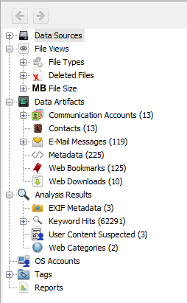

**Lab Assignment 4a2:**

* Note that the keyword lists have already been selected according to the exercise and the keyword search was already performed. Follow along with the notes in the assignment to understand how this was done.
* Once imported, the GCFI-OS9.001 evidence should look similar to this, since Autopsy sees most files on OS9 as unallocated space:

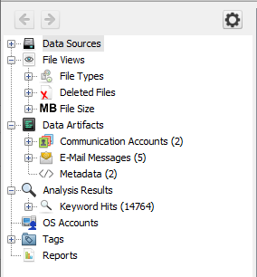

**Lab Assignment 4a3:**

* Note that the keyword lists have already been selected according to the exercise and the keyword search was already performed. Follow along with the notes in the assignment to understand how this was done.
* Once imported, the GCFI-LX.001 evidence should look similar to this:

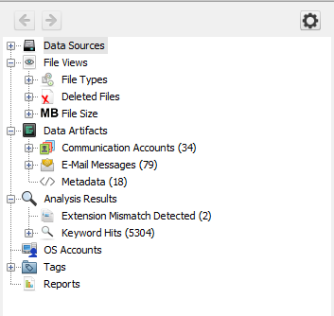

**Lab Assignment 4b1:**

* Note that the keyword lists have already been selected according to the exercise, but the keyword search was not performed. Follow along with the notes in the assignment to understand how this was done.
* Once imported, the Motorola.E01 evidence should look similar to this:

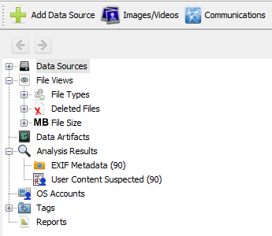

**Lab Assignment 4b2:**

* Processing not required for this step.

**Lab Assignment 4b3:**

* Note that the keyword lists have already been selected according to the exercise, but the keyword search was not performed. Follow along with the notes in the assignment to understand how this was done.
* Once imported, the two evidence files should look similar to this:

