## SUNDAY, APRIL 11, 2010

### [Design Post-Mortem: Three Mistakes](http://replicaisland.blogspot.de/2010/04/design-post-mortem-three-mistakes.html)

While I'm pretty happy with Replica Island, releasing it has definitely been a learning experience.  Some of the design choices Genki and I made were good, others were ok, and a few were bad.  Today I'm going to talk about three mistakes I made in the design of this game.  
  
**Mistake #1**: This particular jump.

[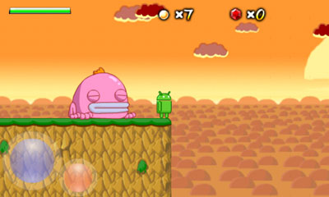](http://www.replicaisland.net/img/blog/problem3.jpg)

Turns out that a lot of players die right here.  Heck, I have the [metrics to prove it](http://replicaisland.net/img/playermetrics/8/Memory%20%23021.png).  This is sort of a difficult jump because you have to make it across a wide pit and then land in a very small space near the top of the screen.  This jump started out a little easier, but it got harder when I compressed the vertical size of this level to deal with some [camera problems](http://replicaisland.blogspot.com/2010/01/elusive-perfect-platformer-camera.html).  The real problem here, though, is the distance.  It turns out that this is the first spot in the game where you are required to use second-order flying skills to reach the other side.

Just what is that skill?  Well, it turns out that some players never realize that they can stay aloft for longer if they let momentum rather than fuel carry them forward.  If you press the jump button and get your speed up in the air, you can release the jump button and stay aloft until gravity overtakes you and you begin to fall.  At that point you can hit the jump button again to combat gravity and maintain your altitude.  You can't do this forever because you'll eventually run out of fuel, but using this method you can jump much greater distances than if you just hold the jump button down constantly.

The real problem is that I never teach players how to fly that way explicitly.  There is lots of tutorial levels designed to make sure you can fly, but it turns out that only the most basic flying skills are required to get passed those sections.  This area is the first in which you cannot progress unless you've figured out how to use the more complex flight mechanics, and people get stuck here.

What can I do about it?  Probably this area itself is fine; a better tutorial on this particular skill is probably in order.

**Mistake #2:**The Case of the Robot Spewing Spawner

[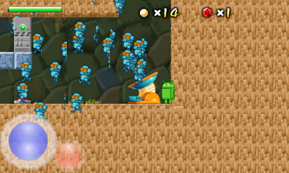](http://www.replicaisland.net/img/blog/problem2.jpg)

When I made the robot spawners, I though it would be a funny easter egg if you could possess them.  Part of the plan was to allow the possession orb to possess any machine, and I thought possessing the spawners would be a little hidden reward for users that experiment.  The problem is, I added this functionality before we understood how the robot puzzles were going to work; in the final game, it's trivially easy to possess a spawner, and most users are confused rather than elated.  Even worse, being able to possess a spawner sometimes gets in the way of possessing a robot, which is pretty annoying.  I realized that this might be a problem before we released the game, but I left it alone because I thought it was funny.  Now there are [multiple](http://www.youtube.com/watch?v=G3xI_vBRdJU) [videos](http://www.youtube.com/watch?v=8JKyY2PxD_0) [about it](http://www.youtube.com/watch?v=X1A8qUyPL5E).  Pretty undeniable proof that I messed this up.

What should I do about it?  I should probably turn the easter egg off or at least find a way to make it much harder to find.

**Mistake #3:** The impossible puzzle.

[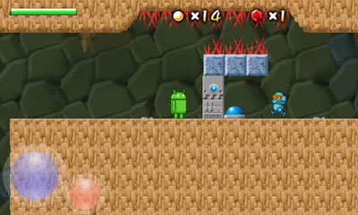](http://www.replicaisland.net/img/blog/problem1.jpg)

You have no idea how many people have e-mailed me about this puzzle.  It's clearly the most difficult part of the game for a huge number of users.

In the first version of the game, this section was missing the red spikes due to a bug in the level data, which made this puzzle even more confusing.  But even after fixing that, I continue to get several e-mails a day asking about this part.

If you don't want this puzzle spoiled for you, stop reading now.

OK, I warned you.  The solution here is to use the Possession Orb to grab the robot and run him into the button.  Pretty simple, I thought; the real challenge in this puzzle's original form was actually just maneuvering the Orb through the spikes before it dissipates (in an update I added a gem to this level, so the Orb survives for longer).  But it turns out that users weren't even figuring out that they could use the Possession Orb here, even though they've seen this pattern several times in slightly different contexts earlier in the game.

I finally realized what the real failure is here: players don't realize that the Orb can fly.  The tutorial says something like, "tilt the phone to control the orb," but if you never try tilting it up, you'll never learn that the Orb can fly.  I think that players also forget that the Orb is in their arsenal, but they'd probably figure that out eventually.  Not expecting it to be able to fly means that many don't even try it.  This is a fundamental teaching failure on my part and makes this puzzle a whole lot harder than it was intended to be.

What can I do about it?  Well, as a first step, the tutorial level should force you to send the ball up at some point.  After that though, the game needs to reenforce the fact that the Orb can fly, so I'll probably need to modify some levels to encourage that behavior.

The great thing about this is, I can fix the problems and send out an update and see if my fixes were successful.  And if not I'll try again.  Traditional video games have never had this sort of ability to iterate interactively with the audience, and I'm really learning a lot from it.

POSTED BY [CHRIS](http://www.blogger.com/profile/16079744366139636224)AT [10:41 AM](http://replicaisland.blogspot.de/2010/04/design-post-mortem-three-mistakes.html) [25 COMMENTS:](http://replicaisland.blogspot.de/2010/04/design-post-mortem-three-mistakes.html#comment-form)

LABELS: [GAME DESIGN](http://replicaisland.blogspot.de/search/label/game%20design)

## FRIDAY, APRIL 9, 2010

### [Replica Island: One Month On](http://replicaisland.blogspot.de/2010/04/replica-island-one-month-on.html)

As of today, Replica Island has been available on Android Market for exactly one month.  I thought this would be a good time to see how it's been doing.

Turns out it's doing pretty well!  It's holding steady at 4.5 stars and it just passed 250,000 installs.  There have been a few bugs; I've made a few updates, and there are a few more fixes in the works.  But most users have been extremely positive about the game.

I've been diligently recording my install numbers from the Android Market Publisher site all month so that I can produce this graph.

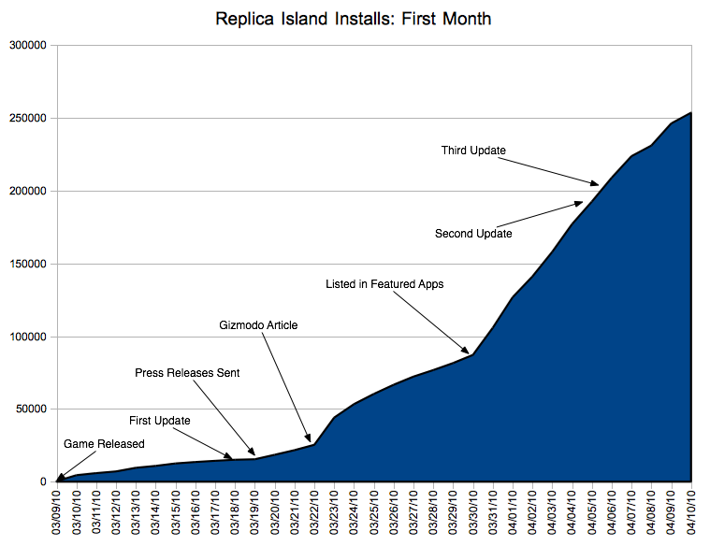

Before I talk about the graph, let me tell you a little bit about my launch plan.

Replica Island is a series of experiments.  I'm trying to learn how games should be made for Android, and part of that process is learning how they should be marketed.  So as part of the experiment, I made the following launch plan:

* First ten days: no PR, no announcements, nothing.  Just upload it and see what happens.
* Day 10: send out press releases, upload YouTube video, post on blog.
* When installs start to slow, prepare a second round of press releases, this time for a different audience.

My marketing budget for this project is $0.00.  I know basically nothing about marketing, and I sometimes think that Nicholai, my PR guy, was dropped on his head as a child.  This plan reflected my need to spend no money and have basically no method of marketing other than trying to get the word out to blogs and news sites.

The first week I made no announcements in order to track the quality of organic growth.  Turns out organic growth was steady and apparently fairly constant; Replica Island was downloaded about 18k times in that first week.

On 3/18/10 I uploaded the first update.  This update fixed a few bugs and added tilt-based controls.

On 3/19/10 Nicholai sent out [press releases](http://replicaisland.net/replica_island_press_release_3_18_10.doc) to a bunch of Android blogs and a few non-Android gaming blogs.  The total number of blogs targeted was small, maybe five or six.  Of those, AndroidGuys.com was the [first to respond](http://www.androidguys.com/2010/03/20/download-replica-island/) (and their report remains one of the most detailed).  A bunch of other blogs copied and pasted the AndroidGuys report (I swear 99% of blogs nowadays are basically retweets of other people).  There was an immediate increase in daily downloads.

On 3/22/10 Gizmodo posted the YouTube video and wrote a [nearly content free report](http://gizmodo.com/5498976/the-android-game-that-every-android-fan-must-get) (though they still managed to work in an anti-iPhone reference, as if part of their editorial goal is to promote fanboyism).  Apparently a lot of people read Gizmodo, as downloads spiked on that day and then continued at increased volume.  Also, the retweeting of the Gizmodo article guaranteed that the first several pages of search results for "Replica Island" were all different sites referring to the same two articles.

On 3/30/10 Replica Island was added to the list of Featured Apps in Android Market (full disclosure: I'm a Google employee but was not involved in the decision to feature this game).  You can see the effect of being featured in the graph; downloads per day shot way up, and have remained high.  Featuring makes apps really visible!

Since app downloads haven't slowed down yet, I haven't implemented the next part of the plan, which is a second round of press releases aimed at different blogs.  I hear that Nicholai has some crazy scheme up his sleeve, but as long as it costs $0.00, I'm fine with it.

So, here's my takeaway from this first month on Market:

* Users want games in traditional genres.  Replica Island gets a lot of love from users just for being a recognizable game genre.
* Updates don't seem to really affect downloads.  Some developers have complained that mixing uploads and new releases in "Just In" allows unscrupulous developers to ship superfluous updates just to increase their visibility, but my data doesn't show any particular advantage to being in Just In.  I think that list moves too quickly.
* Organic growth can work, but even the tiniest bit of marketing goes a long way.  Getting the word out to blogs, even with a simple web site or press release, is huge.  Those people who are expecting direct-to-consumer digital distribution to be the end of marketing are sorely mistaken.
* The YouTube video we made was almost an afterthought, but it's been reproduced in more blogs than any of our screenshots or promotional text.  YouTube will definitely be a big part of our next push.
* Nicholai went to all the trouble to make a press kit, and write press releases, as described in the excellent [Care and Feeding of the Press](http://www.netpress.org/careandfeeding.html), but 99% of blogs just copied and pasted the summary text we put on the front page.  I think less than 10% of the blogs that posted about the game actually tried playing it.
* Development and marketing on a budget of $0.00 totally works!

So that's all for now.  I'll report back when the data reveals some new pattern.  Thanks much to everybody who is playing, and to all of the blogs who covered the game, even those that just copied their text from somebody else.

POSTED BY [CHRIS](http://www.blogger.com/profile/16079744366139636224)AT [10:31 AM](http://replicaisland.blogspot.de/2010/04/replica-island-one-month-on.html) [11 COMMENTS:](http://replicaisland.blogspot.de/2010/04/replica-island-one-month-on.html#comment-form)

LABELS: [ANDROID MARKET](http://replicaisland.blogspot.de/search/label/Android%20Market), [TARGETING ANDROID](http://replicaisland.blogspot.de/search/label/targeting%20Android)

## THURSDAY, APRIL 8, 2010

### [My New Favorite User Feedback](http://replicaisland.blogspot.de/2010/04/my-new-favorite-user-feedback.html)

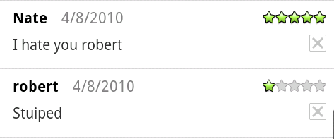

You can't write this stuff!

POSTED BY [CHRIS](http://www.blogger.com/profile/16079744366139636224)AT [7:17 AM](http://replicaisland.blogspot.de/2010/04/my-new-favorite-user-feedback.html) [10 COMMENTS:](http://replicaisland.blogspot.de/2010/04/my-new-favorite-user-feedback.html#comment-form)

LABELS: [TARGETING ANDROID](http://replicaisland.blogspot.de/search/label/targeting%20Android)

fa