## MONDAY, MARCH 29, 2010

### [Replica Island User Comments Are Hilarious](http://replicaisland.blogspot.de/2010/03/replica-island-user-comments-are.html)

**Update**: Blogger apparently isn't advanced enough to deal with images reliably. I moved them to a regular web site.  
  
  
So Replica Island has been out for about three weeks now, and today it reached 85,000 installs, which is pretty cool.  
  
Lots of users have been nice enough to leave feedback, too.  Most of the feedback is overwhelmingly positive, which is fantastic--there's nothing better than knowing that something you made is bringing other people pleasure.  And even the negative comments can be useful; I've identified several bugs and high-value features thanks to the suggestions of users posting on the Market page.  
  
Here's a few of the comments that really made my day.



Flattery will get you everywhere.  I'm preparing a fix as we speak!



That's some high praise right there.



Thanks!

Then there are the useless comments.  These are comments that, typically, contain so little information or are so undecipherable that they don't tell me (or a perspective user) anything useful about the game.  These are mostly comments like, "doesn't work" or "I'm stuck."



First the shift key and now this!



Wait, which is it?  Man, how would you rate a game that you liked?



Thanks for the bug report!  I'll get right on that, uh, wait, what did you say happened again?



Perhaps you missed the text at the very beginning of the game that explained how to move?  It's pretty complicated, I know: "roll the trackball" or "press the d-pad."  I mean, come on, give me a break, right?



Harsh!  Wait, are you saying that the effort is only worth 2 stars, or that the game is so bad that it only warrants 2 stars because we put a lot of effort into it.  Wait, what are you saying again?

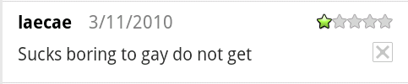

Your feedback has ensured a higher standard of quality for our next app!

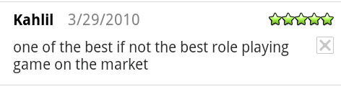

Thanks, but maybe you meant to post on the [Zenonia](http://www.eurodroid.com/2010/03/famed-iphone-rpg-zenonia-hits-android-for-5-99-and-1-6-phones-and-above/) page?

Then there are the hilarious comments.  Sometimes they are sort of innocent, like this one.



Sorry to let you down Etan, but I'm not sure exactly where that expectation came from, as this is our first game and all.  Also, maybe you could have added "mediocre" or "run-of-the-mill" in there somewhere--I'm sure there's some way to fit in another few words meaning "average."

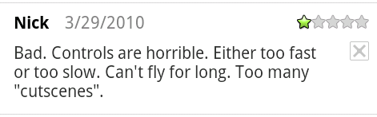

See, this is almost a useful comment!  There really aren't any cutscenes in the game (well, there's one, but I won't spoil it), but there is a lot of dialog--maybe that's what you meant?  I'm not sure how to make the game faster and slower at the same time, though.   
  
There were a bunch of comments with a common theme that I couldn't figure out.



Uh-oh, that sounds like a bad bug!



How could this happen?  I tested the Droid extensively!



Oh no!  This sounds like a real problem!

I was so confused about what these posters were trying to tell me.  Is there some horrible bug in my game that prevents moving forward?  How can that be?  And if that's the case, how come only 4 people out of 1000 have reported it?  I've played the game on the Hero, I*know* that it works fine.

Finally, one final post from a user with this problem suddenly made it clear what was happening.  This post has since been removed by its author, but it lives on forever in the databases of services like AppBrain.

http://replicaisland.net/img/blog/yuck.png

If you've played Replica Island, you might remember the intro sequence.  In it, a character (Wanda) runs through a few short credits, finds the broken Android robot, and says a few words.  Then the game changes to the first level, in which Dr. Kabochanomizu teaches you how to play.  That intro sequence takes, on average, 48 seconds (I know because I have user data from 85k users telling me so).  During that period, you can't control the game.  These users are people who booted the game up and closed it again in less than 48 seconds, and then went back to Android Market and wrote a review.

I actually figured this out before Patricia came along and made it clear, so in the 1.1 update I released about two weeks ago I added a little flashing "Please Wait" message to this part of the game.  Still a few folks (like our friend Patricia here) didn't figure it out and gave up in less than 48 seconds.

I guess I don't have anything to say to people who give an app less than one minute to be awesome.  It might be nice if Market displayed the amount of time each user had the app installed before writing a review.

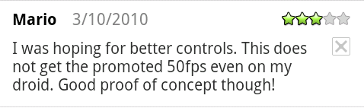

Ah, the good old backhanded complement!  However, this poster is mistaken: I never claimed that the game would get 50 fps on the Droid.  I said it would get 50 fps on the G1, which it does during normal play (it can drop to about 30 in complex scenes).  No game draws faster than 30 fps on the Droid (or Nexus One) because those devices are fill limited.  Sorry about your luck, Mario, but your device is going to be 30 fps for all games forever.  It's still a pretty cool phone, though.

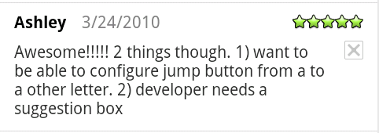

Do you see this!?  THIS is how you write useful feedback!  Both points of feedback are great, particularly the suggestion box.  I am totally going to add that in the next update.  Glad she liked the game, too.

The funniest comment so far, however, wasn't posted on Android Market.  The user was so incensed at the game that he visited the [Replica Island web site](http://replicaisland.net/) and sent e-mail to Nicholai, my PR guy.

By the way, your game sucks big donkey balls. I have spent a Good amount if time playing only to find I am at a part I can't pass. I would tell you what part of this stupid game it is from but I can't go to a reference point. I have also ran into several game glitches and I just can't believe you would publish such a piece of shit. Fuck you.

This is so awesome.  Mr. Russell Hall, whoever you are, you totally made my day.  Hopefully one day you'll figure out wherever it is that you are stuck and continue putting a good amount of time into my donkey-ball-sucking-game.  Seriously, this was the first comment to really make me laugh out loud.  Thanks.

POSTED BY [CHRIS](http://www.blogger.com/profile/16079744366139636224" \o "author profile)AT [10:22 AM](http://replicaisland.blogspot.de/2010/03/replica-island-user-comments-are.html" \o "permanent link) [65 COMMENTS:](http://replicaisland.blogspot.de/2010/03/replica-island-user-comments-are.html" \l "comment-form)

LABELS: [TARGETING ANDROID](http://replicaisland.blogspot.de/search/label/targeting%20Android)

## TUESDAY, MARCH 23, 2010

### [Design Post-Mortem: The Possession Orb](http://replicaisland.blogspot.de/2010/03/design-post-mortem-possession-orb.html)

Rather than write a big long post-mortem of how developing Replica Island went, I'm thinking about writing smaller articles that focus on a single element of development.  Just because the game has shipped does not mean that development is over, and I'm sure that I have much more to learn now than I did before the game shipped.  And speaking of the game's release, it's tearing up the charts, thanks to Nicholai and his crack team of PR ninjas (ok, he doesn't really have any PR ninjas).  [This article](http://gizmodo.com/5498976/the-android-game-that-every-android-fan-must-get), despite being ultra thin on details, seems to have reached a lot of users.  I'll post more details soon.

Ok, so for this first Design Post-Mortem, I thought I would talk about the evolution of the Possession Orb.  The Possession Orb is a special projectile that the Android robot can fire out of his body.  It has the power to possess machines, and running it into, say, an enemy robot will let you control that robot.  The Orb is controlled by tilting the phone, and you can extend its life time by collecting red gems.  
  
The Possession Orb did not originally start out as an orb.  And actually, it didn't originally have anything to do with possession either.  
  
My original design for the Possession Orb was called the Player Ghost.  The idea was that the player could drop the ghost somewhere in the game world, and after a few seconds it would begin to replay the player's recent movement.  At any time the player could click a button and instantly teleport back to the ghost's current location--it was like a way for the player to undo a few seconds of movement.  The ghost, I figured, could also press buttons, so there could be timing challenges involving hitting buttons with the player's body and then again a few seconds later with the ghost.  
  
I got this idea from a crazy Nintendo Entertainment System game called Lot Lot.  Lot Lot is a puzzle game in which two cursors move across a board filled with balls.  One cursor is under the player's direct control, and the second cursor is following the path of the first, but about two seconds delayed.  When the player's cursor is over a grid square that has balls in it, the player can press a button to swap those balls for the ones in the square pointed to by the second cursor.  So game play consists of thinking about where you want the two cursors to be, drawing a path that you know will be correct two seconds into the future, and then hitting the button at the right time to shift balls to the edge of the board before they fill up.  It's very difficult to understand at first but once it clicks the game play is crazy.  Here's a video of Lot Lot in action:  
  
  
  
So, my idea was that the Player Ghost would be like Lot Lot's second cursor: a replay of the player's recent movement that could still affect the game world.  
  
Here's some early design sketches I made about this idea:

[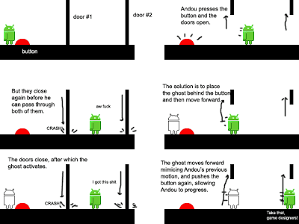](http://1.bp.blogspot.com/_EIf-QLT1Gfk/S6i9094vgdI/AAAAAAAAADc/pUB6-K6pFmI/s1600-h/Ghost-design-2.png)

Sounds cool, right?  I thought it would be cool if you could snap back to the ghost's location too.

[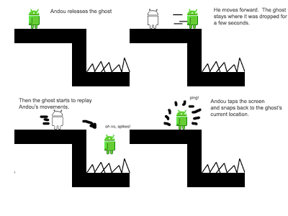](http://2.bp.blogspot.com/_EIf-QLT1Gfk/S6i93ey-BOI/AAAAAAAAADk/4F3_-eaSGuU/s1600-h/Ghost-design-1.png)

I liked this idea, but when I ran it by Genki, my partner in crime, he was skeptical.  He thought that puzzles would be hard to design and that users would have a hard time understanding the mechanic.  But I wanted to try it out so I went ahead and implemented it anyway.

Functionally, the Player Ghost worked exactly as I had imagined.  It wasn't hard to implement and it actually looked pretty cool.  But it quickly became clear that Genki was right: the concept made no sense and designing puzzles was really hard.  It was clear that puzzles were going to require a bunch of different objects just so that the ghost could work (e.g. doors that close immediately after you pass through them, rather than after a fixed duration), which lowered the quality of the idea significantly.  And it was confusing as heck; I wasn't confident that even with supporting game objects the idea would ever really make sense to users.

Genki suggested that instead of the player leaving the ghost behind, the ghost should leave the player behind.  This idea made a lot more sense, but I wasn't sure how to make puzzles out of it.  Eventually we realized that possession is a cool mechanic that the ghost could be useful for (rather than just depressing buttons), and that tilt controls might be a fun way to add diversity to the input system.  Tilt controls implied flying, so the ghost was freed from gravity.  And at that point, it didn't make any sense for it to look like the Android robot any more, so we changed it into an orb (collisions with the background were more believable this way too).

Once we hit on the mechanic a lot of potential avenues for game design immediately presented themselves, which was a good indicator that the idea had more legs than its original version.  Actually, I think that this mechanic is quite under-used in Replica Island.  There's a lot more that we could have done with it, and actually tested with it, that didn't make it into the final game (try running the Possession Orb into a turret, for example).  Maybe this is something to experiment with in a future update.

POSTED BY [CHRIS](http://www.blogger.com/profile/16079744366139636224" \o "author profile)AT [6:37 AM](http://replicaisland.blogspot.de/2010/03/design-post-mortem-possession-orb.html" \o "permanent link) [9 COMMENTS:](http://replicaisland.blogspot.de/2010/03/design-post-mortem-possession-orb.html" \l "comment-form)

LABELS: [GAME DESIGN](http://replicaisland.blogspot.de/search/label/game%20design)

## SATURDAY, MARCH 20, 2010

### [Replica Island Released!](http://replicaisland.blogspot.de/2010/03/replica-island-released.html)

I released Replica Island almost two weeks ago, just before I gave a talk about Android game development at the Game Developers Conference.  Here's the quick details:

* Home page: [replicaisland.net](http://replicaisland.net/)
* Source: <http://code.google.com/p/replicaisland/>

Here's a QR Code you can scan to bring the game up in Market:

[](http://replicaisland.net/img/market_link_qr.png)

And here's a quick trailer video:

Whew, glad to get that stuff out of the way.  
  
You might be wondering why I am posting this now instead of two weeks ago.  Well, I wanted to run an experiment.  I wanted to see what the game would do on Android Market with zero promotion.  So other than mentioning the game in my talk, I've not advertised Replica Island anywhere or done anything (other than a quick update to address control concerns) to make it particularly visible.  I wanted to see what would happen if I just left it alone for a while.  
  
So after 10 days on Market, I'm sitting at about 18k installs and 4 out of 5 stars.  Not bad!  By comparing the data I get from the Market Publisher site to the data coming back via my own reporting system, I can tell that about 15% of users choose to opt-out of the anonymous metrics reporting system.  Which is great--I have tons of data from users who are cool with me having it.   
  
As of today I've had Nicholai, my PR guy, turn on the PR faucet.  He's going crazy with press releases and other promotional tools.  The next experiment is to see what happens to my download growth rate once Nicholai has worked his magic.  Once that experiment has produced enough data, I'll post about it here.  
  
I've also rewritten a lot of my data visualization tools to deal with the huge amount of data I am getting from users.  I'll write a post about the new system I am using to visualize the player death data next.  
  
In the mean time, check the game out and let me know what you think!

POSTED BY [CHRIS](http://www.blogger.com/profile/16079744366139636224)AT [6:58 AM](http://replicaisland.blogspot.de/2010/03/replica-island-released.html) [8 COMMENTS:](http://replicaisland.blogspot.de/2010/03/replica-island-released.html#comment-form)